Computer programming

Final Project

Report

I.E.S. San Vicente
San Vicente del Raspeig (Alicante)
2014/2015

Teacher:
José Ignacio Cabanes

Student:
Jose Antonio Bravo Isidro

1. Introduction
Project name
Sokoban Clone

Made by
Jose Antonio Bravo Isidro

Short description of the project
This will be a clone of the game Sokoban but with added features as 3D scroll, pressure plates, doors and powers ups.
Also will have a map maker.
Using the C# adaptation of SDL library

2. Functionality of the project
After entering the program, a welcome screen will we displayed, where the user can choose between:

• Play a game of Sokoban
• See the list of levels and choose one.
• See controls
• Map making mode.
• See the score for every map.
• Quit the game.

When the users chooses to play a game, the level and starting position of the player will be read from the level file.

The goal of the game is to get the boxes to a winning tile, when every box is on a winning tile, the player will win the game and his score will be saved.

Before quitting the game, the scoreboard will be saved, and it will be retrieved in the next session.

The images for the pieces and the background screen are read from file at the beginning of the game.

3. Screen prototype
The game screen will look like this:

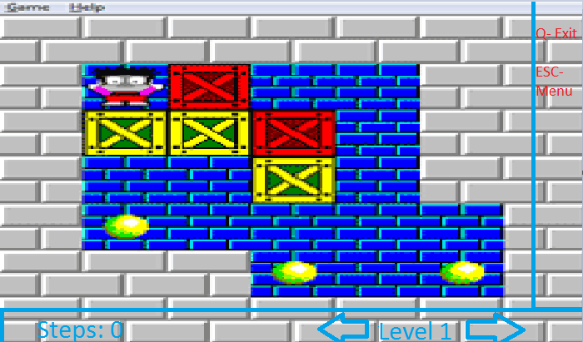

4.Analysis

4a. Requisites
Requisite | Date achieved
The program will allow a player to move around the map. | 27/03/15
The program will allow a player to move the boxes. | 13/05/15
The program will allow a player to play a game of Sokoban. | 15/05/15
The scores of the map will be saved to a file. | 18/05/15
The program will allow a player to beat his scores. | 01/06/15
The program will allow a player to move around the map with 3D scroll. | 25/05/15
The program will show an intro screen | 20/05/15
The intro screen will allow the user to enter a credits screen, which will display data about the programmer | 20/05/15
The game can be paused pressing "P", and then returned by pressing any other key | 26/05/15
The player will need to step on pressure plates to open rooms. | 19/05/15
Be able to user power ups. | 01/06/15
Be able to restart a game | 20/05/15
Be able to open doors. | 19/05/15
Be able to start from another level that's not the first | 02/06/15
The user can create basic maps. | 03/06/15
The user can create more complex maps(With scroll, doors...)

4b. Basic pseudocode

Program body:
Display welcome screen
Wait for user to press a key
If key = ESC, quit program
If key = 1, show menu with levels
Start the level that the player chosed
If key = 2, start last level from where it was left
If key = 3, show controls
If key = 4, show high scores
If key = 5, enter map making mode.

Game:
Display level selection screen
Wait for user to press a key
Check input
If key = p, pause the game
If the key is a movement one(W,A,S,D), move the player
If key = space, use power up
If key = right arrow, load next level
If key = left arrow, load previous level
Check collisions
Move elements
Check if the coditions to win are met
Wait for next frame

Map making mode:
Show an empty screen.
If key = p, show controls.
If key = space, spawn the chosen tile
If the key is a movement, move the tile.

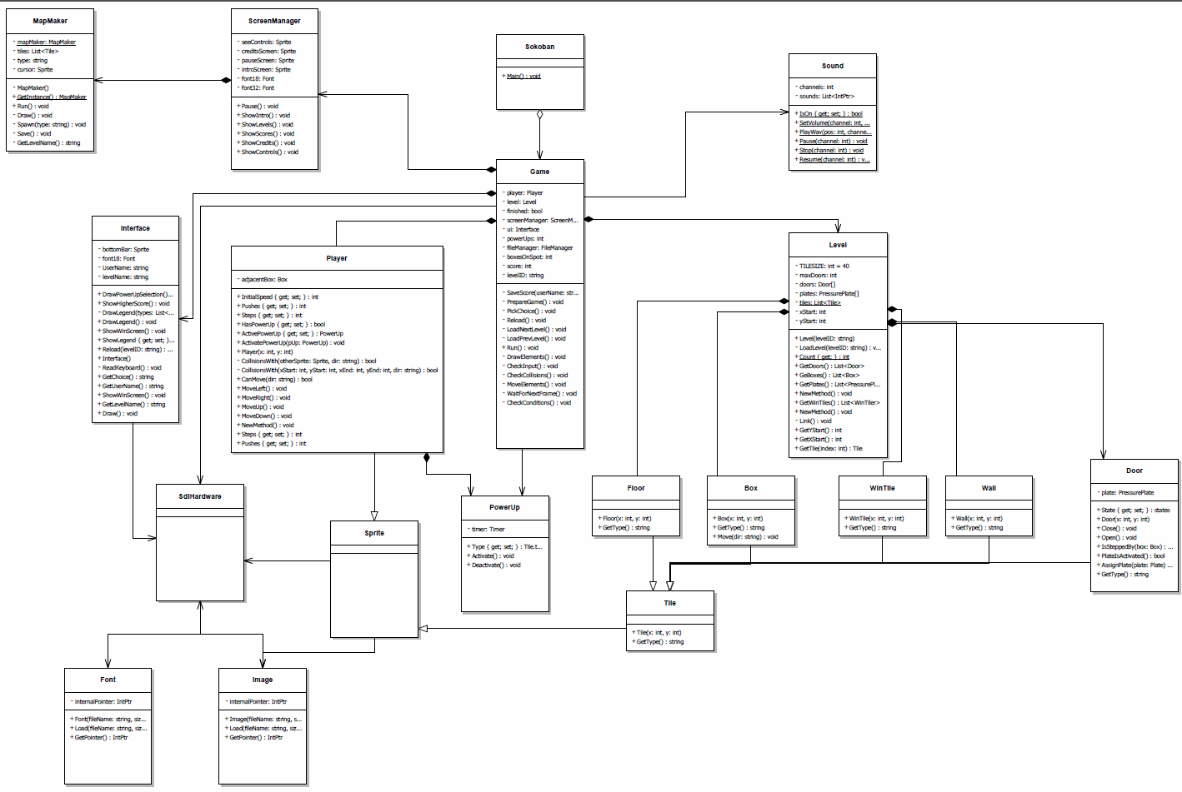
4c. Classes diagram

5. Initial planning and expected deliveries

5a. Expected deliveries ( The ones on bold are done )
- Draw the map and be able to move the player. (27/03/2015)
- Read the level from a file and be able to change the level pressing a key.
Position the player with the position taken from the level file. (27/03/2015)
- Check collisions of the player with the level.(27/03/2015)
- Be able to move the boxes around.(13/05/2015)
- Check collisions of the boxes with the level.(13/05/2015)
- Bar at the bottom with information.(13/05/2015)
- Track steps/pushes and add them to the bottom bar.(13/05/2015)
- Add intro screen and main menu.(13/05/2015)
- Check if the boxes are on the winning spots.(15/05/2015)
- Be able to win the game.(15/05/2015)
- Ask for a name to save the score.(18/05/2015)
- Save the score when the game is over.(18/05/2015)
- Add options to replay the game, go to the next or previous one.(18/05/2015)
- Make pressure plates react to beign stepped.(19/05/2015)
- Open a door when a pressure plate is stepped on.(19/05/2015)
- Be able to have multiple doors and plates. (20/05/2015)
- Add buttons to change level and restart. (20/05/2015)
- Credit and intro screen. (20/05/2015)
- Add sounds. (21/05/2015)
- Show controls screen and be able to return to the menu from credits/controls (21/05/2015)
- Add 3D scrolling. (22/05/2015)
- Improve the collisions with the boxes while the map is scrolling. (22/05/2015)
- Improve the speed of the game by only drawing near tiles. (25/05/2015)
- Change the sounds to use SDL sound system. (25/05/2015)
- Add a pause button. (26/05/2015)
- See top 5 scores for each map.(26/05/2015)
- Show a legend with the types of tiles. (27/05/2015)
- Only show the ones that are active on a given map and option to show/hide it.
(27/05/2015)
- Spawn power ups (Speed type) and be able to use it.(28/05/2015)
- When the conditions are met, show a screen to select the power up that you want and be able to click on the power up icon to select it.(29/05/2015)
- Display on the interface that you can use a power up.(29/05/2015)
- Add the open doors power up. (01/06/2015)
- Add a message when you beat your best score. (01/06/2015)
- Display a list of game levels when the option is selected. (01/06/2015)
- Be able to load the level that has been chosen. (02/06/2015)
- Be able to load a player chosen level or the default one. (02/06/2015)
- Basic map making mode (Not saving the map, only one tile) (03/06/2015)
- Add multiple tiles to the map making mode and be able to save the map. (03/06/2015)
- Add the player starting position and show a legend. (08/06/2015)
- Be able to remove a tile from the map maker. (08/06/2015)
- Be able to link door/plates

6. File formats

6a. Plain files format
The levels will be saves as “levelNUMBER”
In the first line, it will be three numbers, the starting X and Y of the player and the number of doors.
After that there will be X characters separated by an space for every line and Y lines,

Every character means a different tile: B-Box, W-Wall,F-Floor,T-Winning Tile,0-Nothing,
P- Pressure plate, D- Door

Every door and plate will have a single digit number next to it to identify his partner.
Example:
D0 and P0 are linked
Example:
120 447 2
0 0 0 0 0 0 0 0 0 0 0 0 0 0 0 0 0 0 0 0 0 0 0 0 0
0 0 0 0 0 0 0 0 W W W W W W 0 0 0 0 0 0 0 0 0 0 0
0 0 0 0 0 0 0 0 W F F B F W 0 0 0 0 0 0 0 0 0 0 0
0 0 0 0 0 0 0 0 W D5 F P5 F W 0 0 0 0 0 0 0 0 0 0 0
…..............

The scoreboard of each level will be saved at Scores/LEVELNAME.scores
Each try will be saved with this format:
name-steps-pushes
...

7. Problems found and solutions
Problem:
If you try to write an empty string(“”), sdl crashes without an error message
Solution:
Check the string before writing.

Problem:
When checking if a box is on a pressure plate, only the last one created would activate the pressures.
Solution:
Remove the plate from the plates list when checking collisions if it's active.

Problem:
If there's multiple doors/plates, only one of the doors opens.
Solution:
On the level file, add a number next to the D/P to link the pair.

Problem:
Can only play up to 2 sounds at the same time.
Solution:
Yet to be found.

Problem:
When scrolling, the entire map moves with the player causing low frame rates in full screen mode.
Solution:
I had to create a “camera” object and only draw the tiles that are in
his view, not moving the tiles when the player moves.

Problem:
If the player swaps with a box near a wall, the box may get stuck.
Solution:
Yet to be found.

Problem:
Because of the way that the main menu-game loop is made, sometimes
the game skips or does twice the option that it should do.
Possible solution:
Separate the game and the menu and add checks to see in which state the game is.

Problem:
The game feels faster/slower if it's run on a powerful computer or a slower one/in full screen mode.
Possible solution:
Separate the game logic and the drawing logic so the drawing runs in a fixed framerate.

Problem:
When reading the keyboard, sometimes writes multiple keys or nothing.
Possible solution:
Find a balance between too much and too little delay.

8. Improvements or restrictions to the starting design

9. Screenshots of the final project
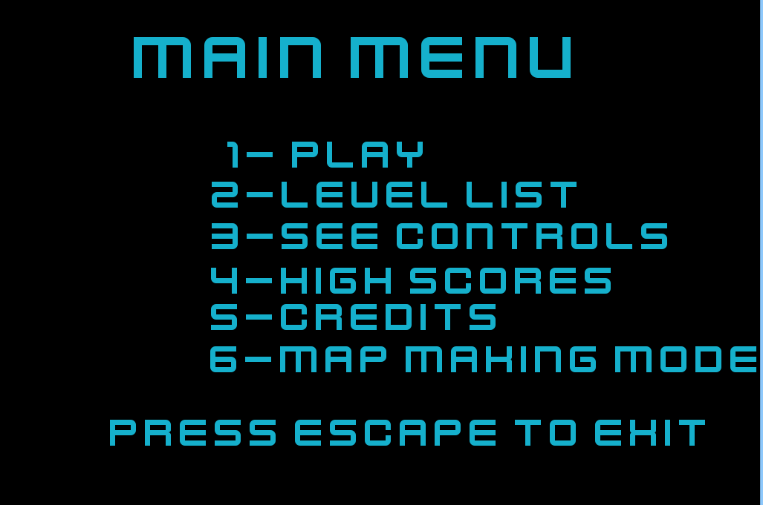
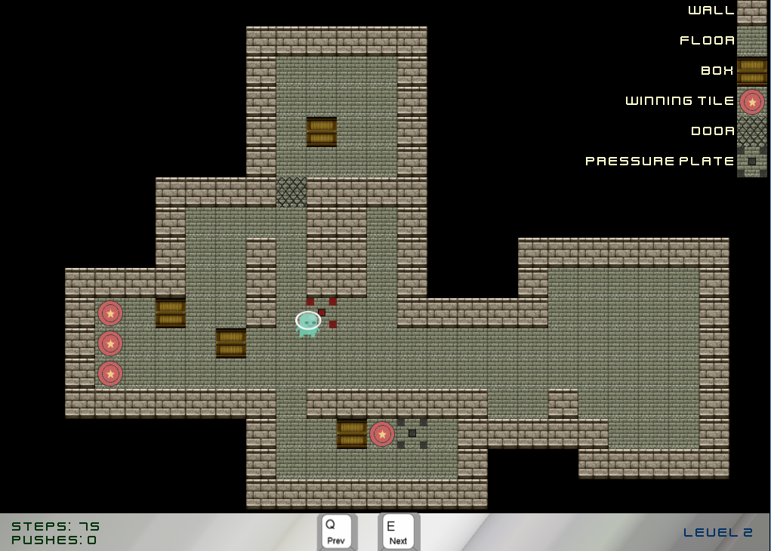
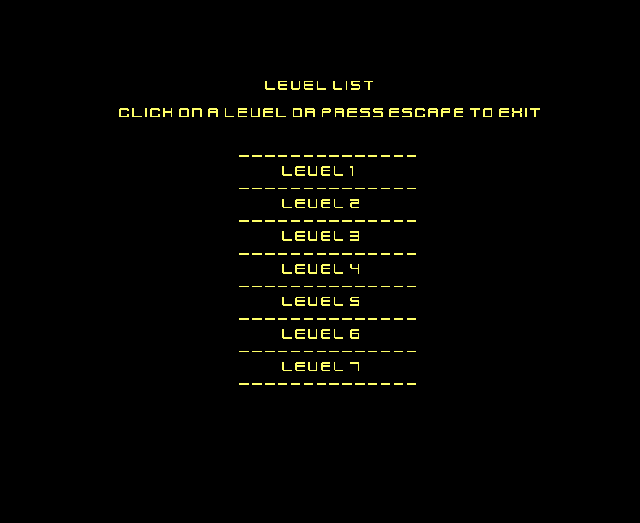
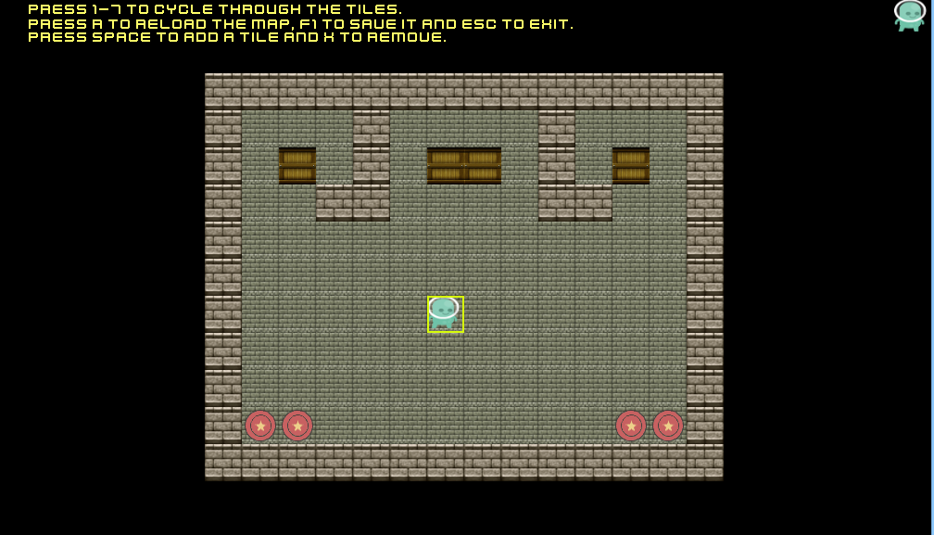

10. Source code of the final project
/*
*
* 06/03/2015 v0.01 - Jose Antonio Bravo:
* Almost empty skeleton.
* */
class Box : Tile
{
public Box(int x, int y)
: base(x, y)
{
width = 40;
height = 40;

xSpeed = 5;
ySpeed = 5;
LoadImage("data/Images/box.png");
Type = types.NOWALKABLE;
}

public void Move(string dir)
{
switch (dir)
{
case "left":
if (CanMove("left"))
{
x -= xSpeed;
}
break;

case "right":
if (CanMove("right"))
{
x += xSpeed;
}
break;

case "up":
if (CanMove("up"))
{
y -= xSpeed;
}
break;

case "down":
if (CanMove("down"))
{
y += xSpeed;
}
break;
}
}

public bool CanMove(string dir)
{
for (int i = 0; i < Level.Count; i++)
{
Tile t = Level.GetTile(i);
if (CollisionsWith(t, dir) && t.Type == Tile.types.NOWALKABLE
&& t != this)
{
return false;
}
}
return true;
}

private bool CollisionsWith(Sprite otherSprite, string dir)
{
return (visible && otherSprite.IsVisible() &&
CollisionsWith(otherSprite.GetX(),
otherSprite.GetY(),
otherSprite.GetX() + otherSprite.GetWidth(),
otherSprite.GetY() + otherSprite.GetHeight(), dir));
}

private bool CollisionsWith(int xStart, int yStart, int xEnd, int yEnd,
string dir)
{
if (dir == "right")
{
if (visible &&
(x + xSpeed < xEnd) &&
(x + width + xSpeed > xStart) &&
(y < yEnd) &&
(y + height > yStart)
)
return true;
}

if (dir == "left")
{
if (visible &&
(x - xSpeed < xEnd) &&
(x + width - xSpeed > xStart) &&
(y < yEnd) &&
(y + height > yStart)
)
return true;
}

if (dir == "up")
{
if (visible &&
(x < xEnd) &&
(x + width > xStart) &&
(y - ySpeed < yEnd) &&
(y - ySpeed + height > yStart)
)
return true;
}

if (dir == "down")
{
if (visible &&
(x < xEnd) &&
(x + width > xStart) &&
(y + ySpeed < yEnd) &&
(y + height + ySpeed > yStart))
return true;
}
return false;

}
public override string GetType()
{
return "Box";
}
}﻿using System;

class Door : Tile
{
public states State { get; set; }
private PressurePlate plate;
public Door(int x, int y)
: base(x, y)
{
width = 40;
height = 40;
LoadImage("data/Images/door.png");
Type = types.NOWALKABLE;
State = states.CLOSED;
}

public void AssignPlate(PressurePlate p)
{
plate = p;
}

public void PowerOpen()
{
State = states.POWEROPEN;
Type = types.WALKABLE;
LoadImage("Data/Images/floor.png");
}

public bool PlateIsActivated()
{
if( plate != null && plate.State == Tile.states.ACTIVATED)
{
return true;
}

return false;
}

public void Open()
{
if(State == states.CLOSED || State == states.POWEROPEN)
{
State = states.OPEN;
Type = types.WALKABLE;
LoadImage("Data/Images/floor.png");
}
}

public void Close()
{
if (State == states.OPEN)
{
State = states.CLOSED;
Type = types.NOWALKABLE;
LoadImage("Data/Images/door.png");
}
}

public override string GetType()
{
return "Door";
}
}
﻿using System;
using System.IO;
using System.Collections.Generic;

class FileManager
{
private static List<string> levels;
private int levelID;
public FileManager()
{
levelID = 0;
levels = new List<string>();
if(!Directory.Exists("Scores"))
{
Directory.CreateDirectory("Scores");
}

LoadLevels();
}

public string GetLevelName()
{
return levels[levelID];
}

public void SetLevelID(int id)
{
levelID = id;
}

public static List<string> GetLevels()
{
LoadLevels();
return levels;
}

public string GetPrevLevelID()
{
if (levelID - 1 >= 0)
{
levelID--;
return levels[levelID];
}
else
{
return levels[levelID];
}
}

public string GetNextLevelID()
{
if(levelID+1 < levels.Count)
{
levelID++;
return levels[levelID];
}
else
{
return levels[levelID];
}
}

private static void LoadLevels()
{
levels.Clear();
List<string> files = new List<string>(
Directory.EnumerateFiles("Data/Levels"));

foreach (string file in files)
{
int fileNameIndex = file.LastIndexOf("\\");
string fileName = file.Substring(fileNameIndex + 1);

if(fileName.StartsWith("level"))
{
levels.Add(fileName);
}
}
}

public static Dictionary<string, int> GetScores()
{
List<string> files = new List<string>(
Directory.EnumerateFiles("Scores"));
Dictionary<string, int> scores = new Dictionary<string, int>();
foreach(string file in files)
{
int fileNameIndex = file.LastIndexOf("\\");
string fileName = file.Substring(fileNameIndex + 1);
StreamReader reader = new StreamReader("Scores/"+fileName);

string line;
do
{
line = reader.ReadLine();
if (line != null && line != "")
{
string[] parts = line.Split('-');
string user = parts[0];
int score = Convert.ToInt32(parts[1]);

if(!scores.ContainsKey(user))
{
scores.Add(user, score);
}
else
{
int oldScore = scores[user];

if(score > oldScore)
{
scores.Remove(user);
scores.Add(user, score);
}
}
}
}
while (line != null);

reader.Close();
}

// Sort them.
List<int> scores2 = new List<int>();
List<string> names = new List<string>();

foreach (string name in scores.Keys)
{
string test = scores[name].ToString();
scores2.Add(scores[name]);
names.Add(name);
}

for (int i = 0; i < scores2.Count; i++)
{
for (int j = 0; j < scores2.Count - 1; j++)
{
if (scores2[j] > scores2[j + 1])
{
int temp = scores2[j + 1];
scores2[j + 1] = scores2[j];
scores2[j] = temp;

string tempName = names[j + 1];
names[j + 1] = names[j];
names[j] = tempName;
}
}
}

scores.Clear();
for (int i = 0; i < names.Count; i++)
{
scores.Add(names[i], scores2[i]);
}

return scores;
}

public void SaveScore(string userName, string level, int score)
{
StreamWriter sw = new StreamWriter("Scores//"+level+".scores", true);

userName = userName.Trim();
string toWrite = userName + "-" + (score > 0?score:0);
sw.WriteLine(toWrite);
sw.Close();
}
}
﻿/*
*
* 06/03/2015 v0.01 - Jose Antonio Bravo:
* Almost empty skeleton.
* */
class Floor : Tile
{
public Floor(int x, int y)
: base(x, y)
{
width = 40;
height = 40;
LoadImage("data/Images/floor.png");
Type = types.WALKABLE;
}

public override string GetType()
{
return "Floor";
}
}﻿/**
* Font.cs - To hide SDL TTF font handling
*
* Changes:
* 0.01, 24-jul-2013: Initial version, based on SdlMuncher 0.02
*/

using System;
using Tao.Sdl;

class Font
{
private IntPtr internalPointer;

public Font(string fileName, short sizePoints)
{
Load(fileName, sizePoints);
}

public void Load(string fileName, short sizePoints)
{
internalPointer = SdlTtf.TTF_OpenFont(fileName, sizePoints);
if (internalPointer == IntPtr.Zero)
SdlHardware.FatalError("Font not found: " + fileName);
}

public IntPtr GetPointer()
{
return internalPointer;
}
}
﻿/*
*
* 06/03/2015 v0.01 - Jose Antonio Bravo:
* Draw Level and Player.
* Player can move.
* Basic game loop.
*
* 06/03/2015 v0.02 - Jose Antonio Bravo:
* Added starting X and Y to the player and the
* levelID to the level.
* Check if the player can move before doing it.
*
* 27/03/2015 v0.03 - Jose Antonio Bravo:
* Improved player collision.
* Start coords are read from the level file.
*
* 21/05/2015 - Jose Manuel Gañan Escobar:
* Added listen to music in the level
* */
using System;
using System.Threading;
using System.Collections.Generic;

class Game
{
private Level level;
private Player player;
private Interface ui;
private FileManager fileManager;
private Menu menu;
private static ScreenManager screenManager;
private bool finished;
private string levelID;
private int boxesOnSpot;
private int powerUps;
private int score;

const int WIDTH = 1024;
const int HEIGHT = 736;
const int LEFT_SCROLL_THRESHOLD = WIDTH / 8;
const int RIGHT_SCROLL_THRESHOLD = WIDTH - LEFT_SCROLL_THRESHOLD;
const int UP_SCROLL_THRESHOLD = HEIGHT / 5;
const int DOWN_SCROLL_THRESHOLD = HEIGHT - UP_SCROLL_THRESHOLD;

public Game()
{
bool fullScreen = false;
menu = new Menu();
SdlHardware.Init(WIDTH, HEIGHT, 24, fullScreen);
PrepareGame();
}

private void WaitForNextFrame()
{
// 16 = 60 fps
SdlHardware.Pause(40);
}

private void DrawElements()
{
//SdlHardware.Lock();
SdlHardware.ClearScreen();
level.Draw();
player.Draw();
ui.Draw(player.Steps, player.Pushes);
ui.DrawLegend();

if(player.HasPowerUp)
{
ui.DrawPowerUp(player.ActivePowerUP);
}
SdlHardware.ShowHiddenScreen();
//SdlHardware.Unlock();
}

private void CheckInput()
{
if (SdlHardware.KeyPressed(SdlHardware.KEY_E))
{
LoadNextLevel();
WaitForNextFrame(); // Wait so it doesn't skip a level
}

if (SdlHardware.KeyPressed(SdlHardware.KEY_Q))
{
LoadPrevLevel();
WaitForNextFrame(); // Wait so it doesn't skip a level
}

if (SdlHardware.KeyPressed(SdlHardware.KEY_R))
{
Reload();
}

if (SdlHardware.KeyPressed(SdlHardware.KEY_ESC))
{
int option = menu.RunMenu();

if (option != -1)
{
LoadLevel(option);
}
else
{
PrepareGame();
}
}

if (SdlHardware.KeyPressed(SdlHardware.KEY_P))
{
screenManager.Pause();
}

if (SdlHardware.KeyPressed(SdlHardware.KEY_SPC))
{
if(player.CanSwap)
{
player.Swap();
}
}

if (SdlHardware.KeyPressed(SdlHardware.KEY_H))
{
ui.ShowLegend = !ui.ShowLegend;
WaitForNextFrame();
}

if (SdlHardware.KeyPressed(SdlHardware.KEY_W))
{
if (player.CanMove("up"))
{
player.MoveUp();
}
else if (player.CollisionsWithBox("up"))
{
player.PushBox("up");
}
}

if (SdlHardware.KeyPressed(SdlHardware.KEY_S))
{
if (player.CanMove("down"))
{
player.MoveDown();
}
else if (player.CollisionsWithBox("down"))
{
player.PushBox("down");
}
}

if (SdlHardware.KeyPressed(SdlHardware.KEY_A))
{
if (player.CanMove("left"))
{
player.MoveLeft();
}
else if (player.CollisionsWithBox("left"))
{
player.PushBox("left");
}
}

if (SdlHardware.KeyPressed(SdlHardware.KEY_D))
{
if (player.CanMove("right"))
{
player.MoveRight();
}
else if (player.CollisionsWithBox("right"))
{
player.PushBox("right");
}
}
}

private void CheckCollisions()
{
List<PressurePlate> plates = level.GetPlates();
List<Box> boxes = level.GetBoxes();

for (int i = 0; i < boxes.Count; i++)
{
Box box = boxes[i];
for (int j = 0; j < plates.Count; j++)
{
PressurePlate plate = plates[j];
if (plate.IsSteppedBy(box) || player.CollisionsWith(plate))
{
plate.Activate();
plates.RemoveAt(j);
}
else
{
plate.Deactivate();
}
}
}

if (Level.HasDoors())
{
List<Door> doors = Level.GetDoors();

foreach (Door door in doors)
{
if (door.PlateIsActivated())
{
door.Open();
}
else if (door.State == Tile.states.OPEN)
{
door.Close();
}
}
}
}
private void CheckConditions()
{
// Scrolling
if(player.GetX() > RIGHT_SCROLL_THRESHOLD )
{
level.ScrollRight();
player.MoveLeft();
}

if (player.GetX() < LEFT_SCROLL_THRESHOLD)
{
level.ScrollLeft();
player.MoveRight();
}

if (player.GetY() < UP_SCROLL_THRESHOLD)
{
level.ScrollUp();
player.MoveDown();
}

if (player.GetY() > DOWN_SCROLL_THRESHOLD)
{
level.ScrollDown();
player.MoveUp();
}

List<WinTile> wTiles = level.GetWinTiles();
List<Box> boxes = level.GetBoxes();

int count = 0;
foreach (Box b in boxes)
{
foreach (WinTile wt in wTiles)
{
if (wt.IsInSpot(b))
{
count++;
}
}
}

if(count > boxesOnSpot)
{
boxesOnSpot = count;
}

if (count == boxes.Count)
{
score = 1000 - player.Pushes - player.Steps;
ui.ShowWinScreen();

Dictionary<String, int> scores = FileManager.GetScores();
if (scores.ContainsKey(ui.GetUserName())
&& score > scores[ui.GetUserName()])
{
ui.ShowHigherScore();
}

SaveScore(ui.GetUserName());

PickChoice();
}

if(boxesOnSpot == boxes.Count/2 && !player.HasPowerUp
&& powerUps == 0)
{
string option = ui.DrawPowerUpSelection();
powerUps++;

PowerUp pUp;
switch(option)
{
case "speed":
pUp = new PowerUp(PowerUp.PowUpType.SPEED);
player.ActivatePowerUp(pUp);
break;

case "open":
pUp = new PowerUp(PowerUp.PowUpType.OPEN);
player.ActivatePowerUp(pUp);
break;

case "swap":
pUp = new PowerUp(PowerUp.PowUpType.SWAP);
player.ActivatePowerUp(pUp);
break;
}

}
}

private void PickChoice()
{
string choice = ui.GetChoice();

switch (choice)
{
case "restart":
Reload();
break;

case "next":
LoadNextLevel();
break;

case "prev":
LoadPrevLevel();
break;
}
}

private void SaveScore(string userName)
{
fileManager.SaveScore(userName, levelID, score);
}

private void LoadPrevLevel()
{
levelID = fileManager.GetPrevLevelID();
level.ChangeLevel(levelID);
player.Reload(level.GetXStart(), level.GetYStart());
ui.Reload(levelID);
boxesOnSpot = 0;
score = 0;
powerUps = 0;
}

private void LoadLevel(int id)
{

if (!Sound.IsLoaded)
{
Sound.Init(12000, 2, 1024);
}

Sound.Stop(1);
Sound.PlayWav(Sound.BACKGROUND, 1, -1);
Sound.SetVolume(1, 64);

levelID = "level" + id;
fileManager.SetLevelID(id - 1);
level.ChangeLevel(levelID);
player.Reload(level.GetXStart(), level.GetYStart());
ui.Reload(levelID);
boxesOnSpot = 0;
powerUps = 0;
score = 0;
}

private void LoadNextLevel()
{
levelID = fileManager.GetNextLevelID();
level.ChangeLevel(levelID);
player.Reload(level.GetXStart(), level.GetYStart());
ui.Reload(levelID);
boxesOnSpot = 0;
powerUps = 0;
score = 0;
}

public void PrepareGame()
{
screenManager = new ScreenManager();
fileManager = new FileManager();
levelID = fileManager.GetLevelName();

level = new Level(levelID);
player = new Player(level.GetXStart(), level.GetYStart());
ui = new Interface(levelID);
finished = false;
boxesOnSpot = 0;
powerUps = 0;
score = 0;
}

private void Reload()
{
level.ChangeLevel(levelID);
player.Reload(level.GetXStart(), level.GetYStart());
boxesOnSpot = 0;
powerUps = 0;
score = 0;
}

public void Run()
{
screenManager.ShowIntro();
int option = menu.RunMenu();

if(option != -1)
{
LoadLevel(option);
}

if (!Sound.IsLoaded)
{
Sound.Init(12000, 2, 1024);
}

Sound.PlayWav(Sound.BACKGROUND, 1, -1);
Sound.SetVolume(1, 64);
do
{
if (!finished)
{
DrawElements();

CheckInput();

CheckCollisions();

CheckConditions();

WaitForNextFrame();
}
}
while (!finished);
}

struct Menu
{
private Sprite screen;
private int option;
public int RunMenu()
{
screen = new Sprite("Data/Images/menu.png");
option = 1;
if(Sound.IsOn)
{
Sound.Stop(1);
Sound.Stop(2);
}
Thread.Sleep(100);
do
{
SdlHardware.ClearScreen();
screen.DrawOnHiddenScreen();
SdlHardware.ShowHiddenScreen();

if (SdlHardware.KeyPressed(SdlHardware.KEY_2))
{
option = screenManager.ShowLevels();
Thread.Sleep(500); // Wait so the game does not exit

if(option != -1)
{
return option;
}
}

if (SdlHardware.KeyPressed(SdlHardware.KEY_3))
{
screenManager.ShowControls();
Thread.Sleep(500); // Wait so the game does not exit
}

if (SdlHardware.KeyPressed(SdlHardware.KEY_4))
{
screenManager.ShowScores();
Thread.Sleep(500); // Wait so the game does not exit
}

if (SdlHardware.KeyPressed(SdlHardware.KEY_5))
{
screenManager.ShowCredits();
Thread.Sleep(500); // Wait so the game does not exit
}

if (SdlHardware.KeyPressed(SdlHardware.KEY_6))
{
screenManager.EnterMapMaking();
Thread.Sleep(500); // Wait so the game does not exit
}

if (SdlHardware.KeyPressed(SdlHardware.KEY_ESC))
{
SdlHardware.Exit();
}

Thread.Sleep(30);
}
while (!SdlHardware.KeyPressed(SdlHardware.KEY_1));

return option;

}
}
}﻿/**
* Image.cs - To hide SDL image handling
*
* Changes:
* 0.01, 24-jul-2013: Initial version, based on SdlMuncher 0.02
*/

using System;
using Tao.Sdl;

class Image
{
private IntPtr internalPointer;

public Image(string fileName) // Constructor
{
Load(fileName);
}

public void Load(string fileName)
{
internalPointer = SdlImage.IMG_Load(fileName);
if (internalPointer == IntPtr.Zero)
SdlHardware.FatalError("Image not found: " + fileName);
}

public IntPtr GetPointer()
{
return internalPointer;
}
}
﻿using System;
using System.Threading;
using System.Collections.Generic;

class Interface
{
private Font font18;
private Sprite bottomBar;
private string userName;
private string levelName;
public bool ShowLegend { get; set; }

public Interface(string levelID)
{
userName = " ";
levelName = levelID;
font18 = new Font("Data/Fonts/kenvector_future.ttf", 18);
bottomBar = new Sprite("Data/Images/ui.png");
ShowLegend = true;

}

public void ShowHigherScore()
{
Thread.Sleep(500);
SdlHardware.WriteHiddenText("New high score!", 360, 380,
0, 180, 102, font18);

SdlHardware.WriteHiddenText("Press enter to continue", 360, 400,
0, 180, 102, font18);
SdlHardware.ShowHiddenScreen();
do
{
Thread.Sleep(50);
}
while (!SdlHardware.KeyPressed(SdlHardware.KEY_RETURN));
}

public void DrawLegend()
{
if(ShowLegend)
{
List<string> types = new List<string>();
for (int i = 0; i < Level.Count; i++)
{
Tile t = Level.GetTile(i);

if (!types.Contains(t.GetType()))
{
types.Add(t.GetType());
}
}

DrawLegend(types);
}
}

public string DrawPowerUpSelection()
{
int backgroundX = 512 - 140 / 2;
string option = "";

SdlHardware.WriteHiddenText("Click to select a power-up",
360, 320, 255, 255, 255, font18);

SdlHardware.DrawHiddenImage(new Image("Data/Images/pUPScreen.png"),
backgroundX, 350);

SdlHardware.DrawHiddenImage(new Image("Data/Images/pUP-Speed.png"),
backgroundX + 10, 350 + 10);

SdlHardware.DrawHiddenImage(new Image("Data/Images/pUp-Swap.png"),
backgroundX + 60, 350 + 10);

SdlHardware.DrawHiddenImage(new Image("Data/Images/pUp-Open.png"),
backgroundX + 110, 350 + 10);
SdlHardware.ShowHiddenScreen();

do
{
if(SdlHardware.MouseClicked())
{
if(SdlHardware.GetMouseX() >= backgroundX+10 &&
SdlHardware.GetMouseX() <= backgroundX+50 &&
SdlHardware.GetMouseY() >= 350 &&
SdlHardware.GetMouseY() <= 350+50)
{
option = "speed";
}

if (SdlHardware.GetMouseX() >= backgroundX + 60 &&
SdlHardware.GetMouseX() <= backgroundX + 100 &&
SdlHardware.GetMouseY() >= 350 &&
SdlHardware.GetMouseY() <= 350 + 50)
{
option = "swap";
}

if (SdlHardware.GetMouseX() >= backgroundX + 110 &&
SdlHardware.GetMouseX() <= backgroundX + 150 &&
SdlHardware.GetMouseY() >= 350 &&
SdlHardware.GetMouseY() <= 350 + 50)
{
option = "open";
}
}
Thread.Sleep(80);
}
while (option == "");

return option;
}

public void DrawPowerUp(PowerUp.PowUpType type)
{
Image image;
switch (type)
{
case PowerUp.PowUpType.SPEED:
image = new Image("Data/Images/pUp-Speed.png");
SdlHardware.DrawHiddenImage(image, 40, 40);
break;

case PowerUp.PowUpType.OPEN:
SdlHardware.WriteHiddenText("The doors are open for: 7.5 secs",
0, 22, 255, 255, 205, font18);
image = new Image("Data/Images/pUp-Speed.png");
SdlHardware.DrawHiddenImage(image,40, 40);
break;

case PowerUp.PowUpType.SWAP:
SdlHardware.WriteHiddenText("Press space to activate",
0, 22, 255, 255, 205, font18);
image = new Image("Data/Images/pUp-Swap.png");
SdlHardware.DrawHiddenImage(image, 40, 40);
break;
}
}

private void DrawLegend(List<string> types)
{
short textY = 8;
foreach (string type in types)
{
switch (type)
{
case "Box":
SdlHardware.WriteHiddenText("Box", 933, textY, 255, 255, 204,
font18);
SdlHardware.DrawHiddenImage(new Image("Data/Images/box.png"),
980, textY - 8);

textY += 40;
break;

case "Door":
SdlHardware.WriteHiddenText("Door", 920, textY,
255, 255, 204, font18);
SdlHardware.DrawHiddenImage(new Image("Data/Images/door.png"),
980, textY - 8);
textY += 40;
break;

case "Plate":
SdlHardware.WriteHiddenText("Pressure plate", 780, textY,
255, 255, 204, font18);
SdlHardware.DrawHiddenImage(new Image("Data/Images/plate.png"),
980, textY - 8);
textY += 40;
break;

case "Wall":
SdlHardware.WriteHiddenText("Wall", 916, textY,
255, 255, 204, font18);
SdlHardware.DrawHiddenImage(new Image("Data/Images/wall.png"),
980, textY - 8);
textY += 40;
break;

case "Floor":
SdlHardware.WriteHiddenText("Floor", 905, textY,
255, 255, 204, font18);
SdlHardware.DrawHiddenImage(new Image("Data/Images/floor.png"),
980, textY - 8);
textY += 40;
break;

case "WinTile":
SdlHardware.WriteHiddenText("Winning tile", 833, textY,
255, 255, 204, font18);
SdlHardware.DrawHiddenImage(new Image("Data/Images/winFloor.png"),
980, textY-8);
textY += 40;
break;
}
}
}

public void Draw(int steps, int pushes)
{
bottomBar.DrawOnHiddenScreen();
SdlHardware.WriteHiddenText("Steps: " + steps, 20, 692, 0, 51, 10,
font18);
SdlHardware.WriteHiddenText("Pushes: " + pushes, 20, 710, 0, 51, 10,
font18);

SdlHardware.WriteHiddenText("Level " + levelName.Replace("level",""),
910, 700, 0, 51, 102,font18);

}

public void Reload(string levelID)
{
levelName = levelID;
}

public void ShowWinScreen()
{
Sprite winScreen = new Sprite("Data/Images/win.png");

do
{
SdlHardware.ClearScreen();
winScreen.DrawOnHiddenScreen();
ReadKeyboard();

// If you try to write an empty string, the games crashes with out
// an error
if(userName != "")
{
SdlHardware.WriteHiddenText(userName, 440, 318, 0, 180, 102,
font18);
}

SdlHardware.ShowHiddenScreen();
Thread.Sleep(50);
}
while (!SdlHardware.KeyPressed(SdlHardware.KEY_RETURN));
}

public string GetChoice()
{
Sprite choiceScreen = new Sprite("Data/Images/choice.png");
SdlHardware.ClearScreen();
choiceScreen.DrawOnHiddenScreen();
SdlHardware.ShowHiddenScreen();

string choice = "";
do
{
if(SdlHardware.KeyPressed(SdlHardware.KEY_R))
{
choice = "restart";
}

if(SdlHardware.KeyPressed(SdlHardware.KEY_E))
{
choice = "next";
}

if (SdlHardware.KeyPressed(SdlHardware.KEY_Q))
{
choice = "prev";
}
Thread.Sleep(100);
}
while (choice != "restart" && choice != "next" && choice != "prev");

return choice;

}

public string GetUserName()
{
return userName;
}

public string GetLevelName()
{
return levelName;

}

private void ReadKeyboard()
{
if (SdlHardware.KeyPressed(SdlHardware.KEY_RM))
{
if(userName.Length >= 1)
{
userName = userName.Substring(0, userName.Length - 1);
}
}

if (SdlHardware.KeyPressed(SdlHardware.KEY_SPC))
userName += " ";

if(SdlHardware.KeyPressed(SdlHardware.KEY_A))
userName += "a";
if (SdlHardware.KeyPressed(SdlHardware.KEY_B))
userName += "b";
if (SdlHardware.KeyPressed(SdlHardware.KEY_C))
userName += "c";
if (SdlHardware.KeyPressed(SdlHardware.KEY_D))
userName += "d";
if (SdlHardware.KeyPressed(SdlHardware.KEY_E))
userName += "e";
if (SdlHardware.KeyPressed(SdlHardware.KEY_F))
userName += "f";
if (SdlHardware.KeyPressed(SdlHardware.KEY_G))
userName += "g";
if (SdlHardware.KeyPressed(SdlHardware.KEY_H))
userName += "h";
if (SdlHardware.KeyPressed(SdlHardware.KEY_I))
userName += "i";
if (SdlHardware.KeyPressed(SdlHardware.KEY_J))
userName += "j";
if (SdlHardware.KeyPressed(SdlHardware.KEY_K))
userName += "k";
if (SdlHardware.KeyPressed(SdlHardware.KEY_L))
userName += "l";
if (SdlHardware.KeyPressed(SdlHardware.KEY_M))
userName += "m";
if (SdlHardware.KeyPressed(SdlHardware.KEY_N))
userName += "n";
if (SdlHardware.KeyPressed(SdlHardware.KEY_O))
userName += "o";
if (SdlHardware.KeyPressed(SdlHardware.KEY_P))
userName += "p";
if (SdlHardware.KeyPressed(SdlHardware.KEY_Q))
userName += "q";
if (SdlHardware.KeyPressed(SdlHardware.KEY_R))
userName += "r";
if (SdlHardware.KeyPressed(SdlHardware.KEY_S))
userName += "s";
if (SdlHardware.KeyPressed(SdlHardware.KEY_T))
userName += "t";
if (SdlHardware.KeyPressed(SdlHardware.KEY_U))
userName += "u";
if (SdlHardware.KeyPressed(SdlHardware.KEY_V))
userName += "v";
if (SdlHardware.KeyPressed(SdlHardware.KEY_W))
userName += "w";
if (SdlHardware.KeyPressed(SdlHardware.KEY_X))
userName += "x";
if (SdlHardware.KeyPressed(SdlHardware.KEY_Y))
userName += "y";
if (SdlHardware.KeyPressed(SdlHardware.KEY_Z))
userName += "z";

if (SdlHardware.KeyPressed(SdlHardware.KEY_1))
userName += "1";
if (SdlHardware.KeyPressed(SdlHardware.KEY_2))
userName += "2";
if (SdlHardware.KeyPressed(SdlHardware.KEY_3))
userName += "3";
if (SdlHardware.KeyPressed(SdlHardware.KEY_4))
userName += "4";
if (SdlHardware.KeyPressed(SdlHardware.KEY_5))
userName += "5";
if (SdlHardware.KeyPressed(SdlHardware.KEY_6))
userName += "6";
if (SdlHardware.KeyPressed(SdlHardware.KEY_7))
userName += "7";
if (SdlHardware.KeyPressed(SdlHardware.KEY_8))
userName += "8";
if (SdlHardware.KeyPressed(SdlHardware.KEY_9))
userName += "9";
if (SdlHardware.KeyPressed(SdlHardware.KEY_0))
userName += "0";
}
}﻿/*
*
* 06/03/2015 v0.01 - Jose Antonio Bravo:
* Hardcoded map
*
* 06/03/2015 v0.02 - Jose Antonio Bravo:
* Removed the hardcoded(array) map and load it
from a file.
* Added levelID to the constructor so it know
which map to load.
* Added a method to return the list of tiles.
*
* 27/03/2015 v0.03 - Jose Antonio Bravo:
* Start coords are read from the level file.
*
* 21/05/2015 - Jose Manuel Gañan Escobar:
* Added listen to music in the level
* */

using System;
using System.IO;
using System.Collections.Generic;
class Level
{
private static List<Tile> tiles;
private Door[] doors;
private PressurePlate[] plates;
private int xStart;
private int yStart;
private const int TILESIZE = 40;
private int maxDoors;

public static int Count
{
get
{
return tiles.Count;
}
}

public void ScrollRight()
{
foreach(Tile t in tiles)
{
t.MoveTo(t.GetX() - 5, t.GetY());
}
}

public void ScrollLeft()
{
foreach (Tile t in tiles)
{
t.MoveTo(t.GetX() + 5, t.GetY());
}
}

public void ScrollUp()
{
foreach (Tile t in tiles)
{
t.MoveTo(t.GetX(), t.GetY()+5);
}
}

public void ScrollDown()
{
foreach (Tile t in tiles)
{
t.MoveTo(t.GetX(), t.GetY() - 5);
}
}

public Level(string levelID)
{
tiles = new List<Tile>();
LoadFile(levelID);
Link();
}

public static Tile GetTile(int i)
{
return tiles[i];
}

public void Draw()
{
// Draw first the non-boxes tiles so the boxes are
// on top when they move.
foreach(Tile t in tiles)
{
if(t.GetType() != "Box" && t.IsOnScreen())
{
t.DrawOnHiddenScreen();
}
}

foreach (Tile t in tiles)
{
if (t.GetType() == "Box" && t.IsOnScreen())
{
t.DrawOnHiddenScreen();
}
}
}

private void Link()
{
for (int i = 0; i < doors.Length; i++)
{
Door door = doors[i];
PressurePlate plate = plates[i];
if (door != null && plate != null)
{
door.AssignPlate(plate);
tiles.Add(door);
tiles.Add(plate);
}
}
}

public static List<Door> GetDoors()
{
List<Door> doors = new List<Door>();

foreach (Tile t in tiles)
{
if (t.GetType() == "Door")
{
doors.Add((Door)t);
}
}

return doors;
}

public static bool HasDoors()
{
foreach (Tile t in tiles)
{
if (t.GetType() == "Door")
{
//player.Stop();
return true;
}
}
return false;
}

public List<WinTile> GetWinTiles()
{
List<WinTile> wTiles = new List<WinTile>();

foreach(Tile t in tiles)
{
if(t.GetType() == "WinTile")
{
wTiles.Add((WinTile)t);
}
}

return wTiles;
}

public List<Box> GetBoxes()
{
List<Box> boxes = new List<Box>();

foreach (Tile t in tiles)
{
if (t.GetType() == "Box")
{
boxes.Add((Box)t);
}
}

return boxes;
}

public List<PressurePlate> GetPlates()
{
List<PressurePlate> plates = new List<PressurePlate>();

foreach (Tile t in tiles)
{
if (t.GetType() == "Plate")
{
plates.Add((PressurePlate)t);
}
}

return plates;
}
public int GetXStart()
{
return xStart;
}

public int GetYStart()
{
return yStart;
}

public void ChangeLevel(string levelID)
{
tiles.Clear();
LoadFile(levelID);
Link();
}

private void LoadFile(string levelID)
{
try
{
StreamReader file = File.OpenText("Data/Levels/" + levelID);

int width = 0;
int heightCount = 0;

string line;
line = file.ReadLine();
string[] firstLine = line.Split(' ');

xStart = Convert.ToInt32(firstLine[0]);
yStart = Convert.ToInt32(firstLine[1]);
maxDoors = Convert.ToInt32(firstLine[2]);

doors = new Door[maxDoors];
plates = new PressurePlate[maxDoors];
do
{
line = file.ReadLine();

if (line != null)
{
string[] parts = line.Split(' ');

foreach (string part in parts)
{
int height = heightCount * TILESIZE;
if (part == "F")
{
tiles.Add(new Floor(width * TILESIZE, height));
}
else if (part == "W")
{
tiles.Add(new Wall(width * TILESIZE, height));
}
else if (part == "T")
{
tiles.Add(new WinTile(width * TILESIZE, height));
}
else if (part.StartsWith("P"))
{
// Add the plate to the plates array with the index
// indicated on the level file. Ej: P5, the index
// would be 5
if (maxDoors > 0)
{
int index = (int)Char.GetNumericValue(part[1]);
plates[index] = new PressurePlate(width * TILESIZE, height);
}
else
{
tiles.Add(new PressurePlate(width * TILESIZE, height));
}
}
else if (part.StartsWith("D"))
{
// Add the door to the doors array with the index
// indicated on the level file. Ej: D5, the index
// would be 5
if(maxDoors > 0)
{
int index = (int)Char.GetNumericValue(part[1]);
doors[index] = new Door(width * TILESIZE, height);
}
else
{
tiles.Add(new Door(width * TILESIZE, height));
}
}
else if (part == "B")
{
/* Add a floor tile so when the box moves
* there's something below
* */
tiles.Add(new Floor(width * TILESIZE, height));
tiles.Add(new Box(width * TILESIZE, height));
}
width++;
}
width = 0;
heightCount++;
}
}
while (line != null);
file.Close();
}
catch(Exception e)
{
SdlHardware.Log("Error at loading the level: " + levelID);
}
}
}﻿using System;
using System.IO;
using System.Threading;
using System.Collections.Generic;

class MapMaker
{
private static MapMaker mapMaker;
private List<Tile> tiles;
private Dictionary<string,string> types;
private Sprite cursor;
private Sprite player;
private Font font16;
private string tileType;
private string levelName;
private string errorMessage;
private int boxes;
private int winningTiles;
private bool showError;

private MapMaker()
{
tiles = new List<Tile>();
types = new Dictionary<string, string>();

tileType = "Floor";
cursor = new Sprite("Data/Images/cursor.png");
cursor.MoveTo(0, 0);

player = null;
boxes = 0;
winningTiles = 0;

font16 = new Font("Data/Fonts/kenvector_future.ttf",16);
showError = false;

levelName = "";
errorMessage = "";
Load();
}

private void Load()
{
types.Add("Floor", "floor.png");
types.Add("Door", "door.png");
types.Add("Box", "box.png");
types.Add("Plate", "plate.png");
types.Add("WinTile", "winFloor.png");
types.Add("Wall", "wall.png");
types.Add("Player", "player.png");
}

public static MapMaker GetInstance()
{
if(mapMaker == null)
{
mapMaker = new MapMaker();
}
return mapMaker;
}

public void Run()
{
do
{
SdlHardware.ClearScreen();
Draw();

if (SdlHardware.KeyPressed(SdlHardware.KEY_F1))
{
if(boxes == winningTiles && boxes > 0)
{
// TODO: Check for errors
Save();

do
{
SdlHardware.WriteHiddenText("Saved at: "+GetLevelName(),
300, 200, 255, 255, 104, font16);

SdlHardware.WriteHiddenText("Press space key to continue",
300, 232, 255, 255, 104, font16);

SdlHardware.ShowHiddenScreen();
Thread.Sleep(40);
}
while (!SdlHardware.KeyPressed(SdlHardware.KEY_SPC));
Thread.Sleep(250);
}
else
{
errorMessage = "Not enough boxes/winning tiles.";
showError = true;
}
}

if (SdlHardware.KeyPressed(SdlHardware.KEY_R))
{
tiles.Clear();
}

if (SdlHardware.KeyPressed(SdlHardware.KEY_1))
{
tileType = "Floor";
showError = false;
}

if (SdlHardware.KeyPressed(SdlHardware.KEY_2))
{
tileType = "Wall";
showError = false;
}

if (SdlHardware.KeyPressed(SdlHardware.KEY_3))
{
tileType = "WinTile";
showError = false;
}

if (SdlHardware.KeyPressed(SdlHardware.KEY_4))
{
tileType = "Box";
showError = false;
}

if (SdlHardware.KeyPressed(SdlHardware.KEY_5))
{
tileType = "Door";
errorMessage = "Not supported yet.";
showError = true;
}

if (SdlHardware.KeyPressed(SdlHardware.KEY_6))
{
tileType = "Plate";
errorMessage = "Not supported yet.";
showError = true;
}

if (SdlHardware.KeyPressed(SdlHardware.KEY_7))
{
tileType = "Player";
showError = false;
}

if (SdlHardware.KeyPressed(SdlHardware.KEY_SPC))
{
Spawn(tileType);
}

if (SdlHardware.KeyPressed(SdlHardware.KEY_X))
{
Remove();
}

if (SdlHardware.KeyPressed(SdlHardware.KEY_D)
&& cursor.GetX() <= 1024 - 40)
{
cursor.SetX(cursor.GetX() + 40);
}

if (SdlHardware.KeyPressed(SdlHardware.KEY_A)
&& cursor.GetX() >= 40)
{
cursor.SetX(cursor.GetX() - 40);
}

if (SdlHardware.KeyPressed(SdlHardware.KEY_W)
&& cursor.GetY() >= 40)
{
cursor.SetY(cursor.GetY() - 40);
}

if (SdlHardware.KeyPressed(SdlHardware.KEY_S)
&& cursor.GetY() <= 736 - 40)
{
cursor.SetY(cursor.GetY() + 40);
}

SdlHardware.ShowHiddenScreen();
Thread.Sleep(90);
}
while (!SdlHardware.KeyPressed(SdlHardware.KEY_ESC));
}

private void Remove()
{
for (int i = 0; i < tiles.Count; i++ )
{
Tile t = tiles[i];
if (t.GetX() == cursor.GetX() &&
t.GetY() == cursor.GetY())
{
if(t.GetType() == "Box")
{
boxes--;
}
if (t.GetType() == "WinTile")
{
winningTiles--;
}
tiles.RemoveAt(i);
}
}
}

private void Draw()
{
SdlHardware.DrawHiddenImage(new Image("Data/Images/" + types[tileType]),
984, 0);
// Draw first the non-boxes tiles so the boxes are
// on top when they move.
foreach (Tile t in tiles)
{
if (t.GetType() != "Box" && t.IsOnScreen())
{
t.DrawOnHiddenScreen();
}
}

foreach (Tile t in tiles)
{
if (t.GetType() == "Box" && t.IsOnScreen())
{
t.DrawOnHiddenScreen();
}
}

if(player != null)
{
player.DrawOnHiddenScreen();
}

if(showError)
{
SdlHardware.WriteHiddenText(errorMessage,
300, 200, 255, 255, 104, font16);
}

SdlHardware.WriteHiddenText("Press 1-7 to cycle through the tiles.",
50, 2, 255, 255, 104, font16);
SdlHardware.WriteHiddenText("Press R to reload the map, F1 to save it and ESC to exit.",
50, 18, 255, 255, 104, font16);
SdlHardware.WriteHiddenText("Press space to add a tile and X to remove.",
50, 32, 255, 255, 104, font16);

cursor.DrawOnHiddenScreen();
}
private void Spawn(string type)
{
// Remove the tile that was below the cursor
for (int i = 0; i < tiles.Count; i++ )
{
Tile t = tiles[i];
if (t.GetX() == cursor.GetX() &&
t.GetY() == cursor.GetY())
{
if (t.GetType() == "Box")
{
boxes--;
}
if (t.GetType() == "WinTile")
{
winningTiles--;
}

tiles.RemoveAt(i);
}
}

if(showError && errorMessage != "Not supported yet.")
{
showError = false;
}

switch (type)
{
case "Player":
if(player == null)
{
player = new Sprite("Data/Images/player.png");
player.MoveTo(cursor.GetX(), cursor.GetY());
}
else
{
player.MoveTo(cursor.GetX(), cursor.GetY());
}
tiles.Add(new Floor(cursor.GetX(), cursor.GetY()));
break;

case "Box":
tiles.Add(new Box(cursor.GetX(), cursor.GetY()));
boxes++;
break;

case "Door":
//tiles.Add(new Door(cursor.GetX(), cursor.GetY()));
break;

case "Plate":
//tiles.Add(new PressurePlate(cursor.GetX(), cursor.GetY()));
break;

case "Wall":
tiles.Add(new Wall(cursor.GetX(), cursor.GetY()));
break;

case "Floor":
tiles.Add(new Floor(cursor.GetX(), cursor.GetY()));
break;

case "WinTile":
tiles.Add(new WinTile(cursor.GetX(), cursor.GetY()));
winningTiles++;
break;
}
}

private void Save()
{
int maxHeight = 1;
int maxWidth = 1;
foreach(Tile t in tiles)
{
if(t.GetY() > maxHeight)
{
maxHeight = t.GetY();
}

if (t.GetX() > maxWidth)
{
maxWidth = t.GetX();
}
}

maxHeight /= 40;
maxWidth /= 40;

maxHeight++;
maxWidth++;

string[,] map = new string[maxHeight, maxWidth];

foreach(Tile t in tiles)
{
int posX = t.GetX() / 40;
int posY = t.GetY() / 40;
string character = "";

switch (t.GetType())
{
case "Box":
character = "B";
break;

case "Door":
character = "D"; //TODO: LINK WITH PLATE
break;

case "Plate":
character = "P"; //TODO: LINK WITH DOOR
break;

case "Wall":
character = "W";
break;

case "Floor":
character = "F";
break;

case "WinTile":
character = "T";
break;
}

map[posY, posX] = character;

for(int i = 0; i < maxHeight; i++)
{
for(int j = 0; j < maxWidth; j++)
{
if(map[i,j] == null)
{
map[i, j] = "0";
}
}
}
}

string levelName = GetLevelName();
StreamWriter sw = new StreamWriter(levelName);

if(player != null)
{
// TODO: Get number of doors.
sw.WriteLine(player.GetX()+" "+player.GetY()+" 0");
}
else
{
// TODO: Get number of doors.
sw.WriteLine("0 0 0");
}

string line = "";
for (int i = 0; i < maxHeight; i++)
{
for (int j = 0; j < maxWidth; j++)
{
line += map[i, j] + " ";
}
sw.WriteLine(line);
line = "";
}

sw.Close();
}

private string GetLevelName()
{
if(levelName == "")
{
List<string> levels = FileManager.GetLevels();
levelName = "Data/levels/level" + (levels.Count + 1);

}

return levelName;
}
}﻿/*
*
* 06/03/2015 v0.01 - Jose Antonio Bravo:
* Player can move.
*
* 06/03/2015 v0.02 - Jose Antonio Bravo:
* Added x and y to constructor, values will be
read from the level file.
* Check if the player collisions with another
sprite before moving.
* Use Level.GetTiles() to check if it
collisions with a tile.
*
* 27/03/2015 v0.03 - Jose Antonio Bravo:
* Improved player collision.
* Start coords are read from the level file.
* */

using System.Collections.Generic;
class Player : Sprite
{
private Box adjacentBox;

public int Steps { get; set; }
public int Pushes { get; set; }

public int InitialSpeed { get; set; }
public bool HasPowerUp { get; set; }
public bool CanSwap { get; set; }
public PowerUp.PowUpType ActivePowerUP { get; set; }

public Player(int x, int y)
{
this.x = x;
this.y = y;

InitialSpeed = 5;
xSpeed = InitialSpeed;
ySpeed = InitialSpeed;
height = 35;
width = 35;
HasPowerUp = false;

Steps = 0;
Pushes = 0;
LoadImage("Data/Images/player.png");
}

public void Draw()
{
DrawOnHiddenScreen();
}

public void Swap()
{
int oldX = x;
int oldY = y;

if (!CanMove("right"))
{
oldX -= 5;
}

if (!CanMove("down"))
{
oldY -= 2;
}

x = adjacentBox.GetX();
y = adjacentBox.GetY();

adjacentBox.MoveTo(oldX, oldY-2);
HasPowerUp = false;
CanSwap = false;
}

public void Reload(int x, int y)
{
MoveTo(x, y);
Steps = 0;
Pushes = 0;
CanSwap = false;
HasPowerUp = false;
}

public void PushBox(string dir)
{
Pushes++;

adjacentBox.SetSpeed(GetSpeedX(), GetSpeedY());
adjacentBox.Move(dir);
Move(dir);
}

public bool CanMove(string dir)
{
for (int i = 0; i < Level.Count; i++)
{
Tile t = Level.GetTile(i);
if (this.CollisionsWith(t, dir) &&
t.Type == Tile.types.NOWALKABLE)
{
return false;
}
}
return true;
}

public bool CollisionsWithBox(string dir)
{
for (int i = 0; i < Level.Count; i++)
{
Tile tile = Level.GetTile(i);

if (CollisionsWith(tile, dir) && tile.GetType() == "Box")
{
adjacentBox = (Box)tile;
return true;
}
}
return false;
}

private bool CollisionsWith(Sprite otherSprite, string dir)
{
return (visible && otherSprite.IsVisible() &&
CollisionsWith(otherSprite.GetX(),
otherSprite.GetY(),
otherSprite.GetX() + otherSprite.GetWidth(),
otherSprite.GetY() + otherSprite.GetHeight(), dir));
}

private bool CollisionsWith(int xStart, int yStart, int xEnd, int yEnd,
string dir)
{
if (dir == "right")
{
if (visible &&
(x + xSpeed < xEnd) &&
(x + width + xSpeed > xStart) &&
(y < yEnd) &&
(y + height > yStart)
)
return true;
}

if (dir == "left")
{
if (visible &&
(x - xSpeed < xEnd) &&
(x + width - xSpeed > xStart) &&
(y < yEnd) &&
(y + height > yStart)
)
return true;
}

if (dir == "up")
{
if (visible &&
(x < xEnd) &&
(x + width > xStart) &&
(y - ySpeed < yEnd) &&
(y - ySpeed + height > yStart)
)
return true;
}

if (dir == "down")
{
if (visible &&
(x < xEnd) &&
(x + width > xStart) &&
(y + ySpeed < yEnd) &&
(y + height + ySpeed > yStart))
return true;
}
return false;

}

private void Move(string dir)
{
switch (dir)
{
case "left":
if (CanMove("left"))
{
MoveLeft();
}
break;

case "right":
if (CanMove("right"))
{
MoveRight();
}
break;

case "up":
if (CanMove("up"))
{
MoveUp();
}
break;

case "down":
if (CanMove("down"))
{
MoveDown();
}
break;
}
}

public void MoveLeft()
{
Steps++;
x -= xSpeed;

if (Steps % 5 == 4)
{
Sound.PlayWav(Sound.STEP, 2, 0);
}
}

public void MoveRight()
{
Steps++;
x += xSpeed;

if (Steps % 5 == 4)
{
Sound.PlayWav(Sound.STEP, 2, 0);
}
}

public void MoveUp()
{
Steps++;
y -= ySpeed;

if (Steps % 5 == 4)
{
Sound.PlayWav(Sound.STEP, 2, 0);
}
}

public void MoveDown()
{
Steps++;
y += ySpeed;

if(Steps % 5 == 4)
{
Sound.PlayWav(Sound.STEP, 2, 0);
}
}

public void ActivatePowerUp(PowerUp pUp)
{
ActivePowerUP = pUp.Type;
pUp.Activate(this);
}
}
﻿using System;
using System.Timers;

class PowerUp : Sprite
{
public enum PowUpType { OPEN, SPEED, SWAP }
public PowUpType Type { get; set; }
private Timer timer;
private Player player;
public PowerUp(PowUpType type)
{
this.Type = type;

timer = new Timer();
timer.Elapsed += new ElapsedEventHandler(OnTimedEvent);
switch (Type)
{
case PowUpType.OPEN:
timer.Interval = 7500; // Time that the power up is active.
break;

case PowUpType.SPEED:
timer.Interval = 5000; // Time that the power up is active.
break;

case PowUpType.SWAP:
break;
}
}

private void OnTimedEvent(object source, ElapsedEventArgs e)
{
Deactivate();
}

public void Activate(Player player)
{
this.player = player;
switch (Type)
{
case PowUpType.OPEN:
player.HasPowerUp = true;
if(Level.HasDoors())
{
foreach (Door door in Level.GetDoors())
{
door.PowerOpen();
}

timer.Start();
}
break;

case PowUpType.SPEED:
player.SetSpeed(player.GetSpeedX() * 2, player.GetSpeedY() * 2);
player.HasPowerUp = true;
timer.Start();
break;

case PowUpType.SWAP:
player.CanSwap = true;
player.HasPowerUp = true;
break;
}
}

private void Deactivate()
{
player.HasPowerUp = false;
switch (Type)
{
case PowUpType.OPEN:
player.HasPowerUp = false;
if(Level.HasDoors())
{
foreach (Door door in Level.GetDoors())
{
door.State = Tile.states.OPEN;
door.Close();
}
timer.Stop();
}
break;

case PowUpType.SPEED:
player.SetSpeed(player.InitialSpeed, player.InitialSpeed);
timer.Stop();
break;

case PowUpType.SWAP:
player.CanSwap = false;
player.HasPowerUp = false;
break;
}
}
}

﻿/*
*
* 06/03/2015 v0.01 - Jose Antonio Bravo:
* Almost empty skeleton.
* */
class PressurePlate : Tile
{
public states State { get; set; }
public PressurePlate(int x, int y)
: base(x, y)
{
width = 40;
height = 40;
LoadImage("Data/Images/plate.png");
Type = types.WALKABLE;
State = states.DEACTIVATED;
}

public void Activate()
{
if(State == states.DEACTIVATED)
{
State = states.ACTIVATED;
LoadImage("Data/Images/plate2.png");
}
}

public void Deactivate()
{
if (State == states.ACTIVATED)
{
State = states.DEACTIVATED;
LoadImage("Data/Images/plate.png");
}
}

public bool IsSteppedBy(Box b)
{
int xEnd = b.GetX() + b.GetWidth();
int xStart = b.GetX();

int yEnd = b.GetY() + b.GetHeight();
int yStart = b.GetY();

// Adding the size/2 to have some leeway on where the boxes
// are counted as in.
if ((x + width / 2 < xEnd) &&
(x + width > xStart + b.GetWidth() / 2) && (y + height / 2 < yEnd)
&& (y + height > yStart + b.GetHeight() / 2))
{
return true;
}

return false;
}

public override string GetType()
{
return "Plate";
}
}﻿/**
*
* 21/05/2015 - Jose Manuel Gañan Escobar:
* Added controls screen
* When you press Escape, return to the menu
* */

using System;
using System.Threading;
using System.Collections.Generic;
class ScreenManager
{
private Sprite introScreen;
private Sprite creditsScreen;
private Sprite pauseScreen;
private Sprite seeControls;
private Font font32;
private Font font18;

public ScreenManager()
{
introScreen = new Sprite("Data/Images/intro.png");
creditsScreen = new Sprite("Data/Images/credits.png");
pauseScreen = new Sprite("Data/Images/pause.png");
seeControls = new Sprite("Data/Images/controls.png");

font32 = new Font("Data/Fonts/kenvector_future.ttf", 32);
font18 = new Font("Data/Fonts/kenvector_future.ttf", 18);
}

public void EnterMapMaking()
{
MapMaker mapMaker = MapMaker.GetInstance();
Thread.Sleep(250); // Wait so it doesnt select the sixth tile.
mapMaker.Run();
}

public int ShowLevels()
{
SdlHardware.ClearScreen();
short x = 460;
short y = 200;
int i = 0;
foreach(string level in FileManager.GetLevels())
{
SdlHardware.WriteHiddenText("--------------",
410, Convert.ToInt16(y-18),255, 255, 104, font18);

SdlHardware.WriteHiddenText("Level "+(i+1),x,y,255,255,104,font18);

SdlHardware.WriteHiddenText("--------------",
410, Convert.ToInt16(y+20),255, 255,104,font18);
i++;
y += 38;
}
SdlHardware.WriteHiddenText("Level List", 440, 100, 255, 255, 104,
font18);
SdlHardware.WriteHiddenText("Click on a level or press escape to exit",
270, 132, 255, 255, 104, font18);
SdlHardware.ShowHiddenScreen();
do
{
if (SdlHardware.MouseClicked())
{
y = 200;
for(int j = 0; j < i; j++)
{
if(SdlHardware.GetMouseX() >= 400 &&
SdlHardware.GetMouseX() <= 600 &&
SdlHardware.GetMouseY() >= y-18 &&
SdlHardware.GetMouseY() <= y+30)
{
return j + 1; // The chosen level
}
y += 38;
}
}
Thread.Sleep(40);
}
while (!SdlHardware.KeyPressed(SdlHardware.KEY_ESC));

return -1; // To indicate that the user didnt choose a level

}

public void ShowControls()
{
SdlHardware.ClearScreen();
seeControls.DrawOnHiddenScreen();
SdlHardware.ShowHiddenScreen();
do
{
Thread.Sleep(40);
}
while (!SdlHardware.KeyPressed(SdlHardware.KEY_ESC));
}

public void Pause()
{
SdlHardware.ClearScreen();
pauseScreen.DrawOnHiddenScreen();
SdlHardware.ShowHiddenScreen();
Thread.Sleep(250);
Sound.Pause(1);
do
{
Thread.Sleep(40);
}
while (!SdlHardware.KeyPressed(SdlHardware.KEY_P));
Thread.Sleep(80);
Sound.Resume(1);
}

public void ShowScores()
{
SdlHardware.ClearScreen();
Dictionary<string, int> scores = FileManager.GetScores();

SdlHardware.WriteHiddenText("===== Top 5 players =====",
200, 100, 255, 255, 102, font32);
int yStart = 120;
int i = 0;
foreach(string name in scores.Keys)
{
int score = 100 - scores[name];
if(score >= 0 && i < 5)
{
SdlHardware.WriteHiddenText((i + 1) + " | " + name+" - "+
score, 350, (short)(yStart + 32), 255, 255, 102, font32);
}
i++;
yStart += 32;
}

SdlHardware.WriteHiddenText("ESCAPE TO EXIT",
350, 525, 255, 255, 102, font32);

SdlHardware.ShowHiddenScreen();
do
{
Thread.Sleep(25);
}
while (!SdlHardware.KeyPressed(SdlHardware.KEY_ESC));
Thread.Sleep(80);
}

public void ShowIntro()
{
introScreen.DrawOnHiddenScreen();
SdlHardware.ShowHiddenScreen();
do
{
if (SdlHardware.KeyPressed(SdlHardware.KEY_ESC))
{
SdlHardware.Exit();
}

Thread.Sleep(30);
}
while (!SdlHardware.KeyPressed(SdlHardware.KEY_SPC) &&
!SdlHardware.KeyPressed(SdlHardware.KEY_1));
}

public void ShowCredits()
{
SdlHardware.ClearScreen();
creditsScreen.DrawOnHiddenScreen();
SdlHardware.ShowHiddenScreen();
do
{
Thread.Sleep(40);
}
while (!SdlHardware.KeyPressed(SdlHardware.KEY_ESC));
}
}﻿/**
* SdlHardware.cs - Hides SDL library
*
* Nacho Cabanes, 2015
*
* Changes:
* 0.17 09-mar-2015: Improved full screen speed; added method "log"
* 0.01, 24-jul-2013: Initial version, based on SdlMuncher 0.14
*/

using System.IO;
using System.Threading;
using Tao.Sdl;
using System;

class SdlHardware
{
static IntPtr hiddenScreen;
static short width, height;

static short startX, startY; // For Scroll

static bool isThereJoystick;
static IntPtr joystick;

static int mouseClickLapse;
static int lastMouseClick;

static DateTime lastDisplayingTime;

public static void Init(short w, short h, int colors, bool fullScreen)
{
width = w;
height = h;

int flags = Sdl.SDL_HWSURFACE | Sdl.SDL_DOUBLEBUF | Sdl.SDL_ANYFORMAT;
if (fullScreen)
flags |= Sdl.SDL_FULLSCREEN;
Sdl.SDL_Init(Sdl.SDL_INIT_EVERYTHING);
hiddenScreen = Sdl.SDL_SetVideoMode(
width,
height,
colors,
flags);

Sdl.SDL_Rect rect2 =
new Sdl.SDL_Rect(0, 0, (short)width, (short)height);
Sdl.SDL_SetClipRect(hiddenScreen, ref rect2);

SdlTtf.TTF_Init();

// Joystick initialization
isThereJoystick = true;
if (Sdl.SDL_NumJoysticks() < 1)
isThereJoystick = false;

if (isThereJoystick)
{
joystick = Sdl.SDL_JoystickOpen(0);
if (joystick == IntPtr.Zero)
isThereJoystick = false;
}

// Time lapse between two consecutive mouse clicks,
// so that they are not too near
mouseClickLapse = 10;
lastMouseClick = Sdl.SDL_GetTicks();

//
lastDisplayingTime = System.DateTime.Now;
}

public static void Lock()
{
if(Sdl.SDL_MUSTLOCK(hiddenScreen) == 1)
{
Sdl.SDL_LockSurface(hiddenScreen);
}
}

public static void Unlock()
{
if(Sdl.SDL_MUSTLOCK(hiddenScreen) == 1)
{
Sdl.SDL_UnlockSurface(hiddenScreen);
}
}

public static void ClearScreen()
{
Sdl.SDL_Rect origin = new Sdl.SDL_Rect(0, 0, width, height);
Sdl.SDL_FillRect(hiddenScreen, ref origin, 0);
}

public static void DrawHiddenImage(Image image, int x, int y)
{
drawHiddenImage(image.GetPointer(), x + startX, y + startY);
}

public static void ShowHiddenScreen()
{
Sdl.SDL_Flip(hiddenScreen);
}

public static bool KeyPressed(int c)
{
bool pressed = false;
Sdl.SDL_PumpEvents();
Sdl.SDL_Event myEvent;
Sdl.SDL_PollEvent(out myEvent);
int numkeys;
byte[] keys = Tao.Sdl.Sdl.SDL_GetKeyState(out numkeys);
if (keys[c] == 1)
pressed = true;
return pressed;
}

public static void Exit()
{
Environment.Exit(0);
}
public static void Pause(int milisegundos)
{
// Instead of waiting exactly "n" milliseconds,
// let's subtract the time taken in drawing and game logic
DateTime currentTime = DateTime.Now;
TimeSpan diff = currentTime - lastDisplayingTime;
if (diff.Milliseconds > 0)
milisegundos -= diff.Milliseconds;
if (milisegundos < 0)
milisegundos = 0;
Thread.Sleep(milisegundos);
lastDisplayingTime = DateTime.Now;
}

public static int GetWidth()
{
return width;
}

public static int GetHeight()
{
return height;
}

public static void FatalError(string text)
{
StreamWriter sw = File.AppendText("errors.log");
sw.WriteLine(text);
sw.Close();
Console.WriteLine(text);
Environment.Exit(1);
}

public static void Log(string text)
{
StreamWriter sw = File.AppendText("log.log");
sw.WriteLine(text);
sw.Close();
}

public static void WriteHiddenText(string txt,
short x, short y, byte r, byte g, byte b, Font f)
{
Sdl.SDL_Color color = new Sdl.SDL_Color(r, g, b);
IntPtr textoComoImagen = SdlTtf.TTF_RenderText_Solid(
f.GetPointer(), txt, color);
if (textoComoImagen == IntPtr.Zero)
Environment.Exit(5);

Sdl.SDL_Rect origen = new Sdl.SDL_Rect(0, 0, width, height);
Sdl.SDL_Rect dest = new Sdl.SDL_Rect(
(short)(x + startX), (short)(y + startY),
width, height);

Sdl.SDL_BlitSurface(textoComoImagen, ref origen,
hiddenScreen, ref dest);
}

// Scroll Methods

public static void ResetScroll()
{
startX = startY = 0;
}

public static void ScrollTo(short newStartX, short newStartY)
{
startX = newStartX;
startY = newStartY;
}

public static void ScrollHorizontally(short xDespl)
{
startX += xDespl;
}

public static void ScrollVertically(short yDespl)
{
startY += yDespl;
}

// Joystick methods

/** JoystickPressed: returns TRUE if
* a certain button in the joystick/gamepad
* has been pressed
*/
public static bool JoystickPressed(int boton)
{
if (!isThereJoystick)
return false;

if (Sdl.SDL_JoystickGetButton(joystick, boton) > 0)
return true;
else
return false;
}

/** JoystickMoved: returns TRUE if
* the joystick/gamepad has been moved
* up to the limit in any direction
* Then, int returns the corresponding
* X (1=right, -1=left)
* and Y (1=down, -1=up)
*/
public static bool JoystickMoved(out int posX, out int posY)
{
posX = 0; posY = 0;
if (!isThereJoystick)
return false;

posX = Sdl.SDL_JoystickGetAxis(joystick, 0); // Leo valores (hasta 32768)
posY = Sdl.SDL_JoystickGetAxis(joystick, 1);
// Normalizo valores
if (posX == -32768) posX = -1; // Normalizo, a -1, +1 o 0
else if (posX == 32767) posX = 1;
else posX = 0;
if (posY == -32768) posY = -1;
else if (posY == 32767) posY = 1;
else posY = 0;

if ((posX != 0) || (posY != 0))
return true;
else
return false;
}

/** JoystickMovedRight: returns TRUE if
* the joystick/gamepad has been moved
* completely to the right
*/
public static bool JoystickMovedRight()
{
if (!isThereJoystick)
return false;

int posX = 0, posY = 0;
if (JoystickMoved(out posX, out posY) && (posX == 1))
return true;
else
return false;
}

/** JoystickMovedLeft: returns TRUE if
* the joystick/gamepad has been moved
* completely to the left
*/
public static bool JoystickMovedLeft()
{
if (!isThereJoystick)
return false;

int posX = 0, posY = 0;
if (JoystickMoved(out posX, out posY) && (posX == -1))
return true;
else
return false;
}

/** JoystickMovedUp: returns TRUE if
* the joystick/gamepad has been moved
* completely upwards
*/
public static bool JoystickMovedUp()
{
if (!isThereJoystick)
return false;

int posX = 0, posY = 0;
if (JoystickMoved(out posX, out posY) && (posY == -1))
return true;
else
return false;
}

/** JoystickMovedDown: returns TRUE if
* the joystick/gamepad has been moved
* completely downwards
*/
public static bool JoystickMovedDown()
{
if (!isThereJoystick)
return false;

int posX = 0, posY = 0;
if (JoystickMoved(out posX, out posY) && (posY == 1))
return true;
else
return false;
}

/** GetMouseX: returns the current X
* coordinate of the mouse position
*/
public static int GetMouseX()
{
int posX = 0, posY = 0;
Sdl.SDL_PumpEvents();
Sdl.SDL_GetMouseState(out posX, out posY);
return posX;
}

/** GetMouseY: returns the current Y
* coordinate of the mouse position
*/
public static int GetMouseY()
{
int posX = 0, posY = 0;
Sdl.SDL_PumpEvents();
Sdl.SDL_GetMouseState(out posX, out posY);
return posY;
}

/** MouseClicked: return TRUE if
* the (left) mouse button has been clicked
*/
public static bool MouseClicked()
{
int posX = 0, posY = 0;

Sdl.SDL_PumpEvents();

// To avoid two consecutive clicks
int now = Sdl.SDL_GetTicks();
if (now - lastMouseClick < mouseClickLapse)
return false;

// Ahora miro si realmente hay pulsación
if ((Sdl.SDL_GetMouseState(out posX, out posY) & Sdl.SDL_BUTTON(1)) == 1)
{
lastMouseClick = now;
return true;
}
else
return false;
}

// Private (auxiliar) methods

private static void drawHiddenImage(IntPtr image, int x, int y)
{
Sdl.SDL_Rect origin = new Sdl.SDL_Rect(0, 0, width, height);
Sdl.SDL_Rect dest = new Sdl.SDL_Rect((short)x, (short)y,
width, height);
Sdl.SDL_BlitSurface(image, ref origin, hiddenScreen, ref dest);
}

// Alternate key definitions

public static int KEY_RM = Sdl.SDLK_BACKSPACE;
public static int KEY_ESC = Sdl.SDLK_ESCAPE;
public static int KEY_SPC = Sdl.SDLK_SPACE;
public static int KEY_F1 = Sdl.SDLK_F1;
public static int KEY_A = Sdl.SDLK_a;
public static int KEY_B = Sdl.SDLK_b;
public static int KEY_C = Sdl.SDLK_c;
public static int KEY_D = Sdl.SDLK_d;
public static int KEY_E = Sdl.SDLK_e;
public static int KEY_F = Sdl.SDLK_f;
public static int KEY_G = Sdl.SDLK_g;
public static int KEY_H = Sdl.SDLK_h;
public static int KEY_I = Sdl.SDLK_i;
public static int KEY_J = Sdl.SDLK_j;
public static int KEY_K = Sdl.SDLK_k;
public static int KEY_L = Sdl.SDLK_l;
public static int KEY_M = Sdl.SDLK_m;
public static int KEY_N = Sdl.SDLK_n;
public static int KEY_O = Sdl.SDLK_o;
public static int KEY_P = Sdl.SDLK_p;
public static int KEY_Q = Sdl.SDLK_q;
public static int KEY_R = Sdl.SDLK_r;
public static int KEY_S = Sdl.SDLK_s;
public static int KEY_T = Sdl.SDLK_t;
public static int KEY_U = Sdl.SDLK_u;
public static int KEY_V = Sdl.SDLK_v;
public static int KEY_W = Sdl.SDLK_w;
public static int KEY_X = Sdl.SDLK_x;
public static int KEY_Y = Sdl.SDLK_y;
public static int KEY_Z = Sdl.SDLK_z;
public static int KEY_1 = Sdl.SDLK_1;
public static int KEY_2 = Sdl.SDLK_2;
public static int KEY_3 = Sdl.SDLK_3;
public static int KEY_4 = Sdl.SDLK_4;
public static int KEY_5 = Sdl.SDLK_5;
public static int KEY_6 = Sdl.SDLK_6;
public static int KEY_7 = Sdl.SDLK_7;
public static int KEY_8 = Sdl.SDLK_8;
public static int KEY_9 = Sdl.SDLK_9;
public static int KEY_0 = Sdl.SDLK_0;
public static int KEY_UP = Sdl.SDLK_UP;
public static int KEY_DOWN = Sdl.SDLK_DOWN;
public static int KEY_RIGHT = Sdl.SDLK_RIGHT;
public static int KEY_LEFT = Sdl.SDLK_LEFT;
public static int KEY_RETURN = Sdl.SDLK_RETURN;
}
﻿// Jose Antonio Bravo Isidro

class Program
{
public static void Main(string[] args)
{
Game g = new Game();

g.Run();
}
}﻿using System;
using Tao.Sdl;
using System.IO;
using System.Collections.Generic;

static class Sound
{
private static List<IntPtr> sounds;
private static int channels;

public static bool IsOn { get; set; }
public static bool IsLoaded { get; set; }

public static void Init(int freq, int channelsNumber, int bytes)
{
IsOn = true;
IsLoaded = true;
channels = channelsNumber;
SdlMixer.Mix_OpenAudio(freq, (short)SdlMixer.MIX_DEFAULT_FORMAT,
channelsNumber, bytes);
SdlMixer.Mix_AllocateChannels(3);
sounds = new List<IntPtr>();
Load();
}

private static void Load()
{
List<string> files = new List<string>(
Directory.EnumerateFiles("Data/Sounds"));

foreach (string file in files)
{
int fileNameIndex = file.LastIndexOf("\\");
string fileName = file.Substring(fileNameIndex + 1);

if (fileName.EndsWith(".wav"))
{
IntPtr sound = SdlMixer.Mix_LoadWAV("Data/Sounds/"+fileName);
sounds.Add(sound);

if (sound == IntPtr.Zero)
{
Console.WriteLine("ERROR AT LOADING: " + fileName);
}
}
}
}

public static void PlayWav(int pos, int channelPos, int repeats)
{
if (pos >= 0 && pos < sounds.Count && channelPos >= 1
&& channelPos <= channels)
{
SdlMixer.Mix_PlayChannel(channelPos, sounds[pos], repeats);
IsOn = true;
}
}

public static void Stop(int channel)
{
IsOn = false;
SdlMixer.Mix_HaltChannel(channel);
}

public static void Pause(int channel)
{
SdlMixer.Mix_Pause(channel);
}

public static void Resume(int channel)
{
SdlMixer.Mix_Resume(channel);
}

public static void SetVolume(int channel, int volume)
{
SdlMixer.Mix_Volume(channel,volume);
}
public static int BACKGROUND = 0;
public static int POWERUP = 1;
public static int STEP = 2;
}﻿/**
* Sprite.cs - A basic graphic element to inherit from
*
* Changes:
* 0.01, 24-jul-2013: Initial version, based on SdlMuncher 0.12
*/

class Sprite
{
protected int x, y;
protected int startX, startY;
protected int width, height;
protected int xSpeed, ySpeed;
protected bool visible;
protected Image image;
protected Image[][] sequence;
protected bool containsSequence;
protected int currentFrame;

protected byte numDirections = 11;
protected byte currentDirection;
public const byte RIGHT = 0;
public const byte LEFT = 1;
public const byte DOWN = 2;
public const byte UP = 3;
public const byte DOWNRIGHT = 4;
public const byte DOWNLEFT = 5;
public const byte UPRIGHT = 6;
public const byte UPLEFT = 7;
public const byte APPEARING = 8;
public const byte DISAPPEARING = 9;
public const byte JUMPING = 9;

public Sprite()
{
startX = -1;
startY = -1;
xSpeed = 1;
ySpeed = 1;
width = 32;
height = 32;
visible = true;
sequence = new Image[numDirections][];
currentDirection = RIGHT;
}

public Sprite(string imageName)
: this()
{
LoadImage(imageName);
}

public Sprite(string[] imageNames)
: this()
{
LoadSequence(imageNames);
}

public void LoadImage(string name)
{
image = new Image(name);
containsSequence = false;
}

public void SetX(int x)
{
this.x = x;
}

public void SetY(int y)
{
this.y = y;
}
public void LoadSequence(byte direction, string[] names)
{
int amountOfFrames = names.Length;
sequence[direction] = new Image[amountOfFrames];
for (int i = 0; i < amountOfFrames; i++)
sequence[direction][i] = new Image(names[i]);
containsSequence = true;
currentFrame = 0;
}

public void LoadSequence(string[] names)
{
LoadSequence(RIGHT, names);
}

public int GetX()
{
return x;
}

public int GetY()
{
return y;
}

public int GetWidth()
{
return width;
}

public int GetHeight()
{
return height;
}

public int GetSpeedX()
{
return xSpeed;
}

public int GetSpeedY()
{
return ySpeed;
}

public bool IsVisible()
{
return visible;
}

public void MoveTo(int newX, int newY)
{
x = newX;
y = newY;
if (startX == -1)
{
startX = x;
startY = y;
}
}

public void SetSpeed(int newXSpeed, int newYSpeed)
{
xSpeed = newXSpeed;
ySpeed = newYSpeed;
}

public void Show()
{
visible = true;
}

public void Hide()
{
visible = false;
}

public virtual void Move()
{
// To be redefined in subclasses
}

public void DrawOnHiddenScreen()
{
if (!visible)
return;

if (containsSequence)
SdlHardware.DrawHiddenImage(
sequence[currentDirection][currentFrame], x, y);
else
SdlHardware.DrawHiddenImage(image, x, y);
}

public void NextFrame()
{
currentFrame++;
if (currentFrame >= sequence[currentDirection].Length)
currentFrame = 0;
}

public void ChangeDirection(byte newDirection)
{
if (!containsSequence) return;
if (currentDirection != newDirection)
{
currentDirection = newDirection;
currentFrame = 0;
}

}

public virtual bool CollisionsWith(Sprite otherSprite)
{
return (visible && otherSprite.IsVisible() &&
CollisionsWith(otherSprite.GetX(),
otherSprite.GetY(),
otherSprite.GetX() + otherSprite.GetWidth(),
otherSprite.GetY() + otherSprite.GetHeight() ));
}

public virtual bool CollisionsWith(int xStart, int yStart, int xEnd,
int yEnd)
{
if (visible &&
(x < xEnd) &&
(x + width > xStart) &&
(y < yEnd) &&
(y + height > yStart)
)
return true;
return false;
}

public void Restart()
{
x = startX;
y = startY;
}

}
﻿/*
*
* 06/03/2015 v0.01 - Jose Antonio Bravo:
* Almost empty skeleton.
* */
class Tile : Sprite
{
public enum types { WALKABLE, NOWALKABLE};
public enum states { OPEN, POWEROPEN, CLOSED, ACTIVATED, DEACTIVATED };
public types Type { get; set; }

public Tile(int x, int y)
{
this.x = x;
this.y = y;
width = 40;
height = 40;
}

public bool IsOnScreen()
{
if ((x < 0 && x + width < 0) || (x > 1024 && x + width > 1024))
{
return false;
}

if ((y < 0 && y + height < 0) || (y > 736 && y + height > 736))
{
return false;
}
return true;
}
public virtual string GetType()
{
return "";
}
}﻿/*
*
* 06/03/2015 v0.01 - Jose Antonio Bravo:
* Almost empty skeleton.
* */
class Wall : Tile
{
public Wall(int x, int y)
: base(x, y)
{
width = 40;
height = 40;
LoadImage("data/Images/wall.png");
Type = types.NOWALKABLE;
}

public override string GetType()
{
return "Wall";
}
}﻿/*
*
* 06/03/2015 v0.01 - Jose Antonio Bravo:
* Almost empty skeleton.
* */
class WinTile : Floor
{
public WinTile(int x, int y)
: base(x, y)
{
width = 40;
height = 40;
LoadImage("data/Images/winFloor.png");
Type = types.WALKABLE;
}

public bool IsInSpot(Box b)
{
int xEnd = b.GetX() + b.GetWidth();
int xStart = b.GetX();

int yEnd = b.GetY() + b.GetHeight();
int yStart = b.GetY();

// Adding the size/2 to have some leeway on where the boxes are counted
// as in.
if ((x + width/2 < xEnd) && (x + width > xStart+b.GetWidth()/2) &&
(y + height/2 < yEnd) && (y + height > yStart+b.GetHeight()/2))
{

return true;
}

return false;
}

public override string GetType()
{
return "WinTile";
}
}

