|  |  |
| --- | --- |
| Print |  |
| \n | Salto de linea |
| \t | Es el carácter “tab horizontal “y se usa para simular sangría de texto |
|  |  |
|  |  |
|  |  |
|  |  |
|  |  |

Taller 1:

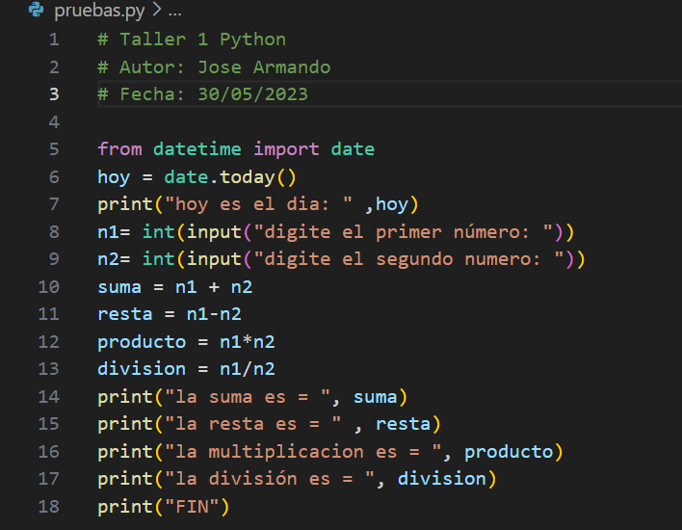

Taller 2



