Jacob Andrew

Professor Volk Miller

WRIT 312

18 July 2023

Blog Post: Red Dead Redemption 2 (2018) – Review

Platforms: Xbox One, Xbox X/S, PlayStation 4, PlayStation 5, PC

Reviewed on: PC

Developer: Rockstar Games

Publisher: Rockstar Games

Single player: yes

Multiplayer: yes

In May of 2010, Rockstar Games released a follow-up to 2004’s Red Dead Revolver in Red Dead Redemption. Instantly, it was a world-wide hit because of its brilliant plot, characters, intuitive and fun mechanics, as well as an amazingly immersive atmosphere. People, like now with Grand Theft Auto V, were begging for a sequel, saying things like “I think Red Dead 2 will come out this year” only for year over year to come with no announcement. When the day of the sequel announcement had come, however, it was met with unbelievably high expectations – which it far, far exceeded. Red Dead Redemption 3 is one of the best games that I have ever played. The mechanics, atmosphere, and customization made me feel like a cowboy living at the end of the west, and it remains the only game to make my cry because of my investment into each character. It has captivated like only very few games have done before I can foresee myself revisiting to replay as different iterations of the protagonist, Arthur Morgan, to see the different endings for him and the rest of the gang.

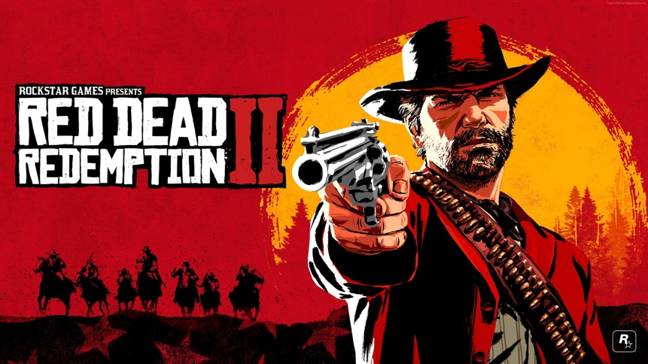

Rockstar is famous for long periods of time between releases with massive payoffs. Most large game studios release new games for their more popular titles annually or biannually, think Assassin’s creed, Call of Duty, or Battlefield. However, Rockstar waits to release their most popular titles like Grand Theft Auto and Red Dead until they have something that is innovative and expectation-shattering. Like the 8 years between Red Dead Redemption and Red Dead Redemption 2, there was a 5-year gap between Grand Theft Auto IV and V, and now there has been an ongoing 10-year gap between V and the highly anticipated GTA VI. Each one of those games mentioned is in the 10 best games of all-time list on Metacritic.com, minus Red Dead Redemption which comes later but is listed as a “Must-Play”.

RDR2, is known for its immersive atmosphere and excellent mechanics. The setting of the game is in the early 20th century west in 5 fictional states: New Hanover, Ambarino, Lemoyne, New Austin, and West Elizabeth. Each with their own unique geography, characters, towns, antagonists, and wildlife. The map is free to explore with no difficulty barrier between zones, so the player can explore without completing portions of the main story. The map feels grounded in real places and not an overexaggerated western desert. There are snowy mountains, swamps, plains, rivers, valleys, and even a Caribbean Island to explore which makes the game feel exciting and new at every turn. The mechanics are also familiar and intuitive, borrowing directly from its predecessor as well as GTA V, which leads to a low learning curve for many players so that they can just jump right in.

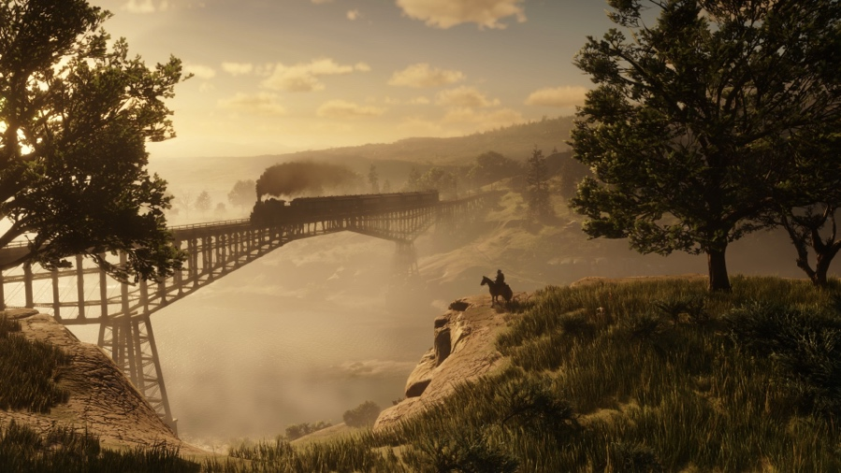

While that’s all phenomenal, the plot is the real breadwinner here. We follow the Van Der Linde Gang through train robberies, bank robberies, fights with rival gangs, all while running from the law, the Pinkerton Detective Agency, and a robber baron named Leviticus Cornwall. I’ll spare the details of the story for the sake of spoilers, but the meat of this plot comes from the relationships between the members of the Van Der Linde Gang, and their finding their way through the industrialization of the west. Our protagonist, Arthur Morgan, deals with the relationships between the leader of the gang, Dutch Van Der Linde, his brother like figure in John Marston (the protagonist from the previous game), and the other members of the gang that come and go like Micah Bell, Charles Smith, Bill Williamson, Javier Escuela and more. Each character has a special relationship with the others and a unique backstory. We get to see these characters evolve and have real agency in the events of the story throughout, which make me care about them—a lot, enough to make me cry at the end.

Red Dead Redemption 2 made me feel like I was playing through an old-western, made me feel like a cowboy by letting me do it my way, and made me feel for the characters like no other game before. It was a transformative gaming experience and something that made me proud of the medium as a whole. I can’t wait to play it again and I can’t wait for my friends and family to experience it as too.