Transportation > SEPTA

**The State of Public Transit in Philadelphia: How it Got Here, Where it is Going, and How to Help**

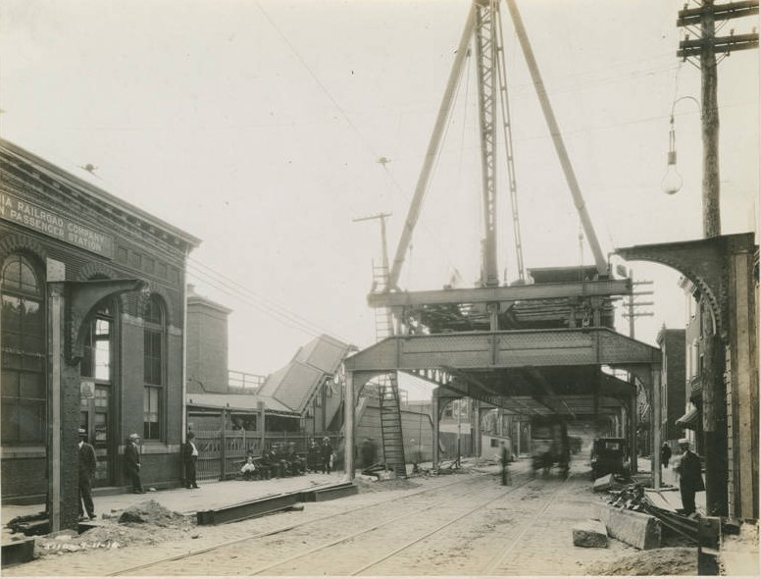

The building of the Market Frankford Subway – Elevated in the early 1900s

By Jacob Andrew

Published August 24th, 2023

Every morning in the fall and winter, Matthew wakes up, gets ready, and leaves for work. He is a student living in Powelton Village that works in center city, so he begins his trek to work by walking to 34th street station. Upon reaching the station, he is greeted whole-heartedly by the smells of fresh urine, the sights of used heroin needles dotting the train tracks, and the sounds of people screaming nonsense at nothing or each other. He dredges through it all, eventually boarding the subway towards 15th street station. As he steps on the train, he knows instinctively to remain standing on the sticky floors by the doors, so as to avoid the strange stains and liquids on the seats and the people actively shooting up heroin on the ends of the car. Only when he gets through 15th street station can he feel safe and continue his day until he makes his return commute later in the day.

For him, this is a normal Tuesday because it has become his norm by living in Philadelphia, but for visitors to the city from places with better, cleaner public transportation systems his commute would seem hellish. Grace, and international student at the University of Pennsylvania from London, specifically avoids SEPTA altogether because she feels that it is an unsafe and inefficient way to get around the city. When asked if she uses public transit in Philadelphia, she said, “In London, our busses and rails are more respected. They’re cleaned regularly and run on a stricter time schedule. Here, they just feel forgotten. I end up avoiding them because I just don’t feel safe”.

It’s an unfortunate situation for Philadelphians, because everything about the city encourages people not to drive through it, however that is contradicted by a seemingly forgotten public transportation network. 100 years ago, Philadelphia was the envy of the world for its vast network of trolleys, streetcars, and modern subways. Fueled by healthy competition between smaller companies, the lines themselves were cleaner and more efficient so each small company could compete with one another. What happened?

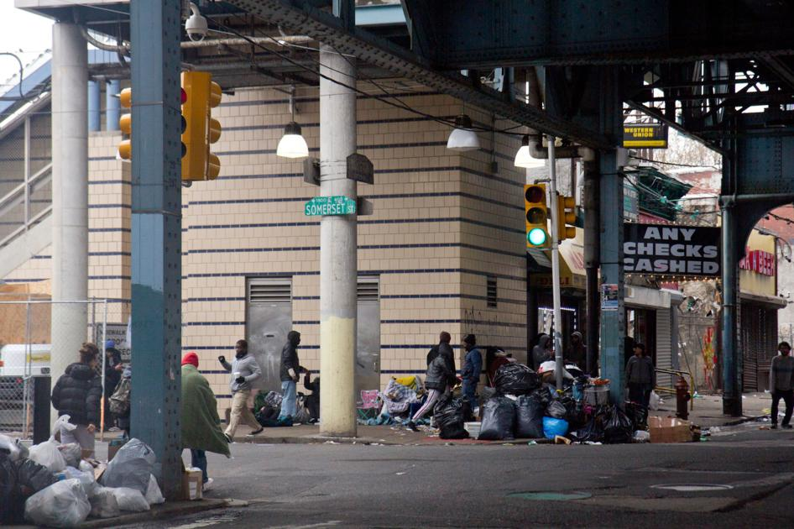

Somerset station in 2020, later to be shut down for a time due to drug abuse and urine breaking the elevator.

**How did we get here?**

Once a marvel of modern technology, now an afterthought to the Prius, how did Philly’s public transit system fall to such a degree? Like most things, to see where we are and where to go, we must know where we came from.

The network began as a lone ferry to then Fort Nassau, now Camden, in 1688 (yes, that old). Over 100 years later, after the city had been through a Revolutionary War, the omnibus (a horse-drawn bus) took over the city as the primary method of getting around besides walking.

From there, the sky was the limit and within the coming years, commuter rails were built along with the invention and addition of the streetcar, cable car, and trolley.

Each line was its own small business, with one company running its own individual line that competed with the others in the area. Competition and innovation were thriving by the early 19th century, which led to the rapid expansion of the trolley network around the city. As it grew, it allowed more people to get around the city quicker and cheaper than any other method at the time, thus the city was allowed to grow in size and population along with it.

The Civil War came and went, and eventually history reached the Industrial revolution, a time of great economic expansion and technological innovation. Industry was booming in the city of brotherly love, with factories springing up everywhere and jobs becoming abundant. The city was caked in a network of trolleys and streetcars, with a map that nearly mirrored that of the streets of which their tracks were laid.

The companies that ran the trolleys were profitable, and in this time of the Gilded age they were beginning to consolidate into medium sized companies that owned a small collection of trolleys that dotted the city. At the same time began the incline of mergers and acquisitions of commuter rails that would eventually summit into the famous Pennsylvania and Reading railroads, which connected the Philadelphia with hundreds of cities from St. Louis, Missouri to Atlantic City, New Jersey.

A map of a portion of the trolley network in Philadelphia circa 1923/A map of the entire trolley network circa 2023

This network of transit is something akin to what modern Europeans have. In London, anyone could use the Underground to get cheaply and quickly to any area of the city or use the National rail to get easily to cities like Glasgow or Brighton. They, along with cities like Berlin or Tokyo, are now the envy of the world, instead of Philadelphia.

Going into the 20th century, the transit system was beginning to hit its peak. By 1908 the city opened the Market Street Subway-Elevated (MFL or “El”) and shortly thereafter came the Broad Street Subway (BSL). Both were one of the first of their kind and allowed for a more rapid-transit type of rail that could take people from one end of the city to another in minutes for the first time. Around the same time as the subways were being built, the eventual downfall of the system was invented, the internal combustion engine, which at the time was a benefit to it in the form of busses.

Despite the rapid growth in popularity of the early automobile, public transportation was still the primary method of transportation in the early 1900s, staying that way for decades – until, like many things, it ended with the Great Depression.

After the glory days of the roaring 20’s came the depression of the 30’s. It came at the crux between the monopolization of the trolley, streetcar and bus network in the city and the rapid popularization of the automobile. Over time until this point, the small companies that competed against each other running individual trolley or bus lines were bought and consolidated into the massive Philadelphia Transportation Company (PTC). At the same time the Pennsylvania and Reading railroads have also reached the peak of their powers, but since people were losing their jobs and the economy was in shambles, nobody was using the network. PTC, PRR and RRR all cut services and expenses at this time to stay afloat, but it was all for naught as the eventual post-war economic boom brought upon the domination of the car, the expansion of the white picket-fenced suburbs and the abandoning of cities by both people and businesses.

While everyone moved to the suburbs, people in the inner cities were forgotten about, and so was the once glorious public transportation network. By the 1960s, PTC, PRR and RRR all went under. In response, Harrisburg created the Southeastern Pennsylvania Transportation Authority (SEPTA) to scoop up the remains. It was immediately crippled by mismanagement, underfunding and strikes, all of which are still problems to this day.

Map of the Pennsylvania Railroad and its connections in 1930. Allowed passengers to travel to nearly every major city in the Northeast and part of the Midwest.

**What’s happening now?**

SEPTA still struggles with the same problems that it did upon its inception in 1963. It remains famous in the city for its ineptitude, and its stations are a symbol for the growing problems of violence and drug abuse citywide. There are several reasons for its lack of control on the situation, but a select few of these issues are key when considering how to fix the broken system.

For one, SEPTA’s board of directors is made up of equal representation from each of the five counties it oversees: Philadelphia, Bucks, Delaware, Montgomery, and Chester. This is a massive issue for Philadelphians because it means that they are underrepresented in their public transit’s controlling board, even though they make up over 40% of all possible riders (not accounting for the fact that people in the other counties are less likely to ride transit because they are more rural). This structure has led to numerous political issues within and outside of SETPA, because the 2 representatives from Philadelphia must argue for programs that the other 8 representatives will never see, which contributes to why the services like the MFL has degraded so much over time.

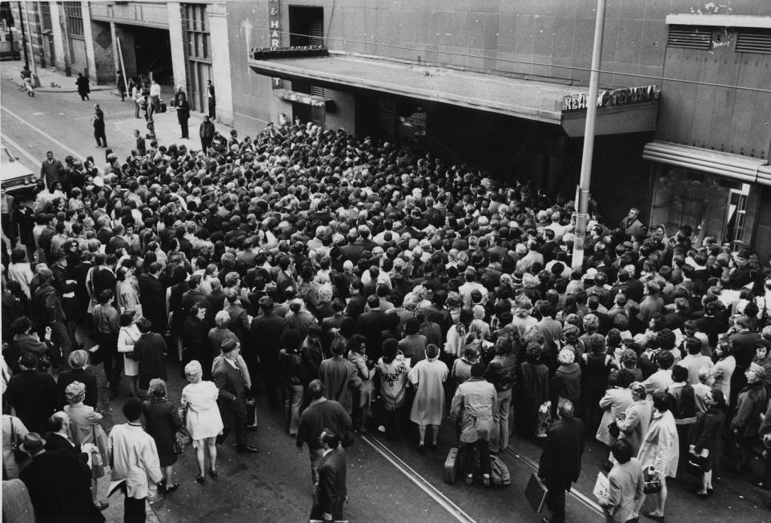

Septa workers on strike between 1971 and 1981.

Another reason is because, despite that it is the largest city in Pennsylvania, the sixth largest city in the country, and 68th largest in the world, Philadelphia’s public transportation network has been criminally underfunded since the 1960s. Right now, since ridership took a massive hit during and after the COVID-19 pandemic, SEPTA has been receiving hundreds of millions of dollars in funding to help pull itself out of that ridership hole. Next year, in 2024, that money will run out and cause a myriad of funding issues for transit.

SEPTA is now attempting to ask Harrisburg if they could come up with new methods for funding, like being able to impose local taxes to support transportation efforts or receiving more money from sales-tax revenue.

This continues a long history of underfunding for SEPTA by the state and city, and has severely impacted its decline over the past few decades.

Not surprisingly, Philadelphians are outraged at the state of their public transit network, and many avoid it altogether. Alexa, a commuter who lives in New Jersey and works in Fishtown, says “I gave SEPTA a shot when I started working in the city. I got into 8th street station one time and was immediately harassed. I even saw someone shooting up something with a needle a couple feet away from me. It was scary, so I never went back, and I tell all of my friends to avoid it”.

Her story is not uncommon. It is so common in fact, that in 2021 SEPTA had to shut down Somerset station in the Northeast of the city (not far from where she worked) because of the unbelievable state of the station. In an interview with NBC10, SEPTA general manager Leslie Richards said that the elevator in the station was broken because “The mechanics have been damaged by urination, by discarded needles being jammed into floorboards”.

NBC10 also did a survey which showed that COVID-19 had a massive impact on ridership for SEPTA. “At the beginning of the pandemic, in April, the agency saw an 88 percent drop in ridership compared to the year before. That number has risen slightly – now, ridership is at 35 percent – but still is far below normal levels”, noted NBC10’s Matt DeLucia, highlighting how long-standing ridership and funding issues due to it have been exacerbated by the pandemic.

**What do we do now?**

To combat this bleak reality, the city of Philadelphia in cooperation with SEPTA released the Philadelphia Transit Plan in February of 2021, creating plans that last all the way out until 2045. The highlights of the plan include adding more bus lanes to make buses more efficient on city streets, improving safety and cleanliness at all transit stops/stations, modernizing and expanding the aging trolley network, restructuring fares to make the system more equitable, adding new stops every few years to the MFL and BSL, and reimagining the way regional rail works by having 2-car trains run every 15 minutes instead of a 6-car train running every 60 minutes.

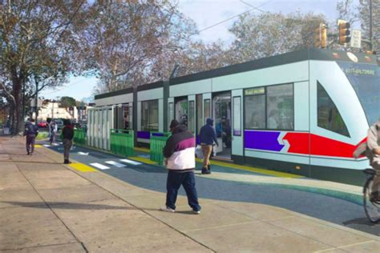

An early concept of the trolley modernization program. Trolleys would be updated, more accessible, and the lines would be extended to reach more people.

While the plan sounds exactly what people like Alexa, Grace and Matthew have been waiting for, neither the city nor SEPTA have given any clear plans for how to fund these expansive efforts.

These plans are reminiscent of the once proud King of Prussia Rail Project, which sought to extend the Norristown High Speed Line to the growing business hub. An article from the Philadelphia Inquirer’s Katie Kraczek and Thomas Fitzgerald outlined how the plan was originally conceived in 2012, with an early estimated cost of about $500 million, which eventually rose to $1 billion 4 years later, and by the time it was cancelled in March of 2023 it had peaked at twice that already inflated figure.

“By 2022, the financial plan was still not complete, and estimated costs for the KOP rail costs had jumped to roughly $2 billion”, the article goes on to say. SEPTA eventually applied for funding from the FTA’s New Start Program but was denied in the same month the project was cancelled.

While the KOP Rail Project and Philadelphia Transit plans sound like great ideas, and they are, SEPTA needs to overcome their deep-seated issues before any of these ideas can become reality.

One of those issues is lack of ridership, and to attain that they need to appeal to Philadelphians – not to people from their surrounding counties. They are working towards that goal of shifting attention to the city, with a FY2023 budget outlining that $1.5 billion through 2034 will be dedicated to the Trolley modernization program and $800 million to revitalize the MFL’s railcars. They also noted in the report that 2023’s capital budget was the largest in SEPTA’s history, with an operating budget for the year at $1.1 billion, a figure aided by the Federal Infrastructure Investment and Jobs Act.

SEPTA also needs to restructure the way that its counties are represented in its board. The equal representation among each county has only led to political issues and severe mismanagement of some of its largest assets. The MBTA, which operates Boston’s public transportation network and is of a similar size and capability to SEPTA, is a department of the Massachusetts Department of Transportation instead of its own independent organization. It is overseen by a board of 7 members, appointed and headed by the acting state’s Secretary of Transportation, members appointed by the secretary, as well as a “rider and resident of an environmental justice population, and a representative recommended by the President of the AFL-CIO” (MBTA).

A structure such as this allows for heavier cooperation between each of the board members as well as between them and state legislature for funding, it also encourages a more unified vision for the MBTA because the board members are all tied to the same seat instead of different counties all competing with one another. This more streamlined approach to leadership could liberate SEPTA from its currently divided and isolated structure, which could then help push for more funding and allow for better planning.

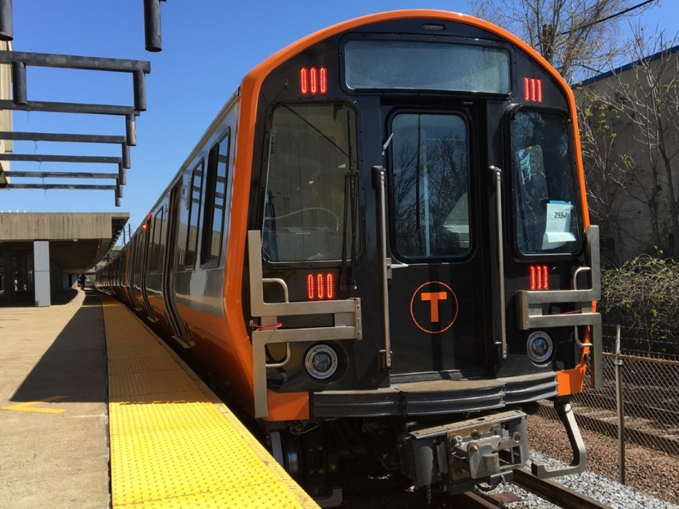

New orange line train which rolled out on tracks early in 2022.

**How to help**

Having a better public transportation system can alleviate a lot of problems facing Philadelphia today. Issues such as the environment, equity and inflation could all be helped through providing people low-cost, reliable transportation around the city. It has also been linked to causing noticeable economic growth, which has historical precent for the city.

What Philadelphians had in the early 20th century was special, and something that cities around the world like London, Berlin, and Tokyo now have. Returning Philadelphia’s public transit network to its former glory could help spur economic growth to the city, helping all current residents and attracting more from around the region.

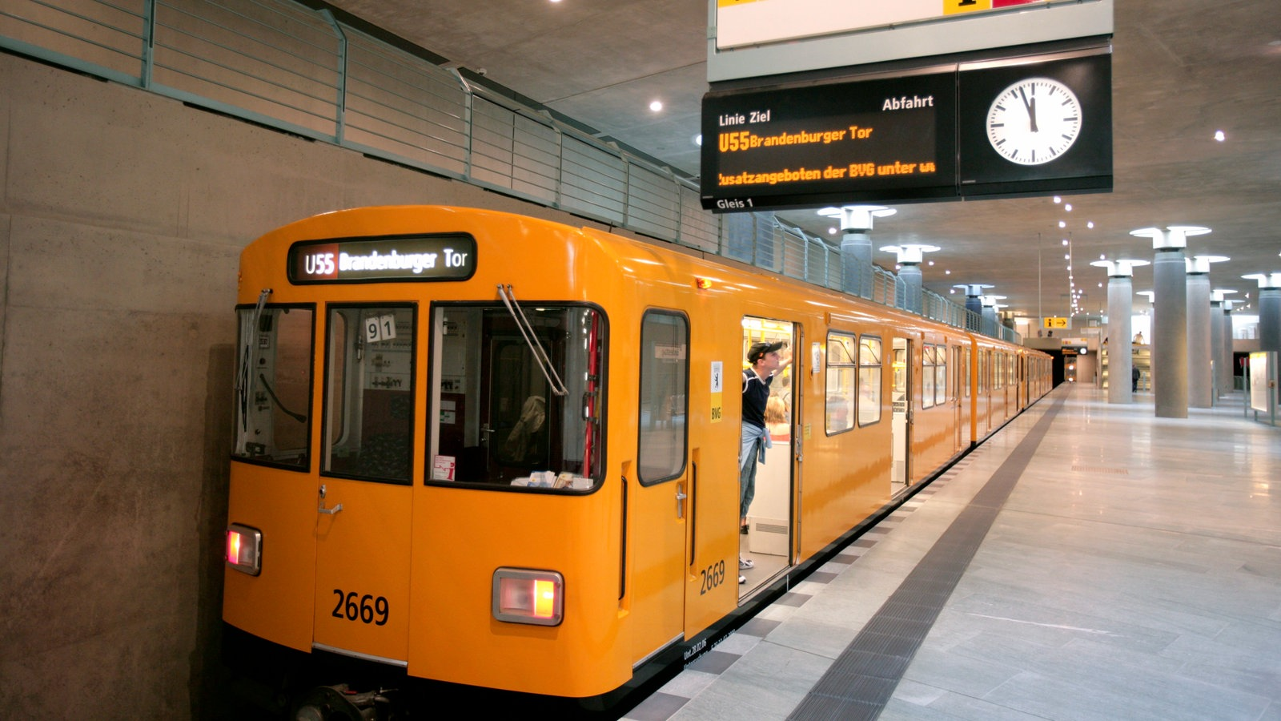

German U-Bahn in Berlin.

SEPTA’s board meetings are public, held at 3:00pm on the fourth Thursday of each month virtually. To join the meeting and speak, anyone can pre-register by 9:00am on the day of the meeting by going to SEPTA’s meeting calendar and filling out a form.

The Pennsylvania House Majority/Minority leaders are both on SEPTA’s board as well, so by contacting them anyone can express their concerns or requests to the people that represent them on the board. Anyone could also contact any one of the members of the board that represent each county.

I would also recommend voting for local, state, and federal representatives that support public transportation infrastructure projects to put the right people in power to make a change.

The famous line “government of the people, by the people, for the people” was coined by President Lincoln during the Gettysburg Address in this state of Pennsylvania, and the government that he referenced was created right here in the city of Philadelphia. The people have full power to create change, and should use that power to help create a better future for each other.