### Lab Setup

This lab requires you to connect to **VCL** (***not*** vcenter.cci.drexel.edu). Once you have logged into VCL create and connect to the Ubuntu version 22.04 virtual environment provided by VCL.

This lab involves answering lab questions in LEARN for parts… As you perform the steps in each part of the lab you may want to record your results to assist with answering the lab questions. The lab questions in LEARN will provide you **two attempts** for submitting your answers.

### Overview

This lab explores the Ubuntu desktop briefly.

Using the command line interface.

Basic shell commands.

Installing software using apt.

Linux commands that may be helpful for completing this lab: ls, pwd, echo, man, mkdir, tree

**References**

* Chapter 2, Mastering Ubuntu Server, Fourth Edition by Jay LaCroix, Packt Publishing, 2022
* [www.ubuntu.com](http://www.ubuntu.com)

### Part 1

The Ubuntu desktop includes software and a GUI interface. Let’s explore using the Ubuntu desktop environment.

1. Connect to VCL, obtain an Ubuntu image to perform this lab exercise. Open and connect to your VCL Ubuntu image.
2. Log into your Ubuntu system.

|  |
| --- |
| Important note about the mouse pointer:  If you are not able to see your mouse pointer on the screen, press <Shift> <Return> at the same time. Some keyboards require you to press the shift key on the left and some require the shift key on the right. |

1. Click on the system settings icon as depicted below:

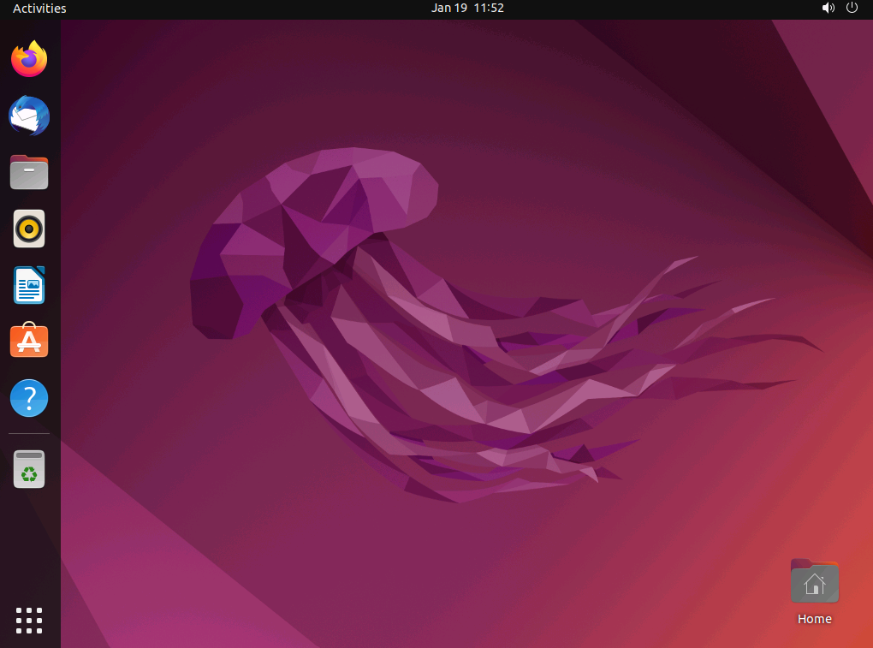

1. Now let’s use the search icon to locate the disk utility. Click on the search icon located in the top left hand corner of your desktop.



1. Enter disk in the search bar to locate the disk utility. The search bar can be used to find all of the utilities and applications available on an Ubuntu system.

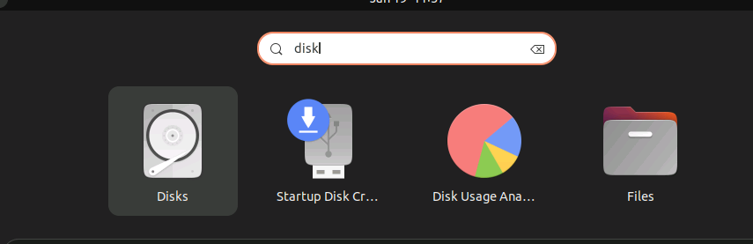

1. The “Disks” utility should appear from your search. Click on the “Disks” utility as depicted below:

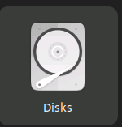

1. After launching the disk utility, examine the “Hard Disk” details. Record the different partitions. Make sure you record the size of the partition(s) displayed.

**Take a screen shot** of the Hard Disk details revealed by the Disk Utility. You will need this to turn in as part of this assignment.

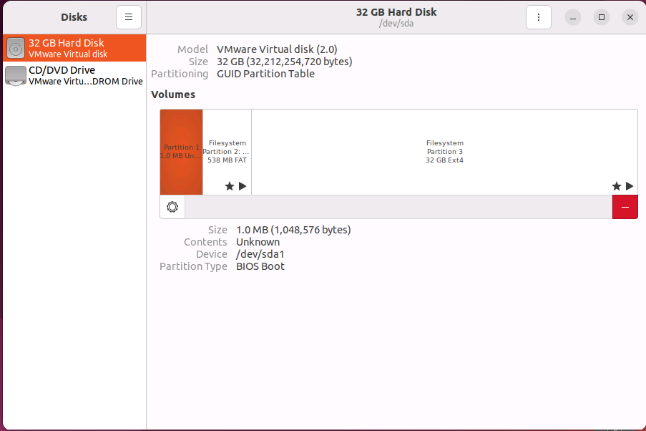

Now use the CLI (command-line interface) to find out more about your system. Use the search bar to locate the icon for the terminal as depicted here:

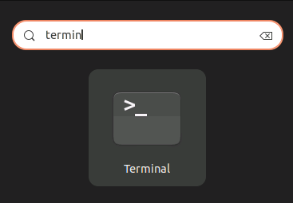

1. Open a terminal emulator by clicking on the terminal icon:

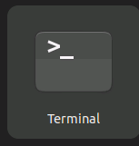

1. A terminal window will appear on your desktop. Click on the terminal window so you can begin to learn commands used at a terminal prompt.
2. Use the command below to find out how much total RAM, memory, your system contains.

sudo cat /proc/meminfo | less

The very first lines of output will show you the total amount of memory on your system. Make a note of the value for MemTotal stored in KiB.

1. There are files in the /proc directory that describe the CPU also. Type the command below.

sudo cat /proc/cpuinfo

It may be easier to re-direct the ourput of this cat command to grep to search more specific items Try the commands below.

sudo cat /proc/cpuinfo | grep model

sudo cat /proc/cpuinfo | grep MHz

1. Now find out some information about network related items on your system. Use this command to find the default gateway. Compare the default gateway address with the ip address of your system that is displayed in the top of the window you are using to connect to your system.

ip route | grep default

1. Computers need to resolve server names and domain names to ip addresses using a dns server. Find out where your system sends dns queries using the command below:

sudo cat /etc/resolv.conf

**Answer the part 1 questions in LEARN.** 83

**Place your part 1 screen shot of the Hard Disk details as your answer for question 1 in the part 2 answer sheet.**

### Part 2

**Record you answers to the Part 2 questions inside the answer sheet provided in LEARN.**

This portion of the lab will explore comments and package management using apt.

1. First type in the following command.

$ pwd

This command will show you the directory you are in.

1. Now type in the following command

$ ls –x

This command lists the files in your directory.

1. On the command line and in shell scripts, the hashmark (#) special character starts a comment. Try typing in this command

$ # this is a comment

1. Add a comment to the end of a command as follows.

ls -x # this is also a comment

Q2: Did the terminal try to process the text after the # character? Explain your observation.

1. Now type some words on a command line without pressing <RETURN>. Type in the command below without pressing return:

$ ls –al

Now delete a character, a word and the entire line. The default erase key is <BACKSPACE>. Use the <BACKSPACE> key twice to delete the characters “al”. Retype the characters “al” and now press the default key for deleting a word. This is <CONTROL-W>. Record what happens.

1. Next experiment with the default key to delete a line. This is <CONTROL-U>. Type in the follow command followed by a <CONTROL-U>.

$ ls –al <CONTROL-U>

Record what happens

1. Learn more about the echo command using the manual pages. Type in:

$ man echo –al

1. Quit the man program. Next use the up-arrow key to recall a previously typed in command. Type in the following sequence of commands to reveal this useful feature at the command line interface.

$ ls –al

$ echo “Display this text to the screen”

$ pwd

$ <up arrow>

After pressing the up arrow key the pwd command will appear on the command line. Now press the <up arrow> a second time. The echo command will now appear on the command line.

1. Another way to learn more about what commands can do is by using the --help parameter. Experiment with this parameter by typing in the following:

$ ls –-help

$ mkdir --help

1. Try installing a package with the the Advance Package Tool. First perform an update to update the software dependancies data store.

$ sudo apt update

Q3: How many kB or MB of data was Fetched?

Q4: What does the latter part of the status message specify was completed? Look for messages followed by the text “… Done”

1. Now search for the tree command in the two directories where command executables are stored.

$ ls -al /bin/tree

$ ls -al /sbin/tree

Q5: What message gets displayed when looking for the tree command?

1. Download and install the tree command using apt.

sudo apt install tree

1. Always examine the messages that get displayed when installing a package. Make sure they are all informational messages and not error messages.

Q6: How much additional disk space will be used by installing the tree command utility?

Q7: Why would a server engineer use the “Disks” utility, explored in part 1, before installing a package using apt? Explain.

1. See if the tree command now resides in /bin or /sbin.

Q8: Where is the tree command located?

1. Try using the tree command as follows.

sudo tree /home

Q9: Describe the output of using the tree command on the home directory.

### Now use the menu displayed by clicking on the “power” icon in the upper right hand corner to shut down your system properly. It is important to shutdown systems using the provided shutdown commands or menu choices.

### 

### Once your system is shut down, you can close your console window. Next return to the VCL window and check that your virtual machine is powered down.

### Once you have verified that your system is powered down, log out of VCL.

### What is Due?

* Answers to the Part 1 questions in LEARN.
* Screen shot of Hard Disk details requested in Part 1 to place in the Part 2 answer sheet.
* A completed Part 2 answer sheet submitted via LEARN.