Place answers in the boxes provided for each question. Name: Jacob Andrew

Keep in mind that Ubuntu Linux, (used in this course), may differ then other distributions of Linux.

Assessment Policy for this assignment:
Use items provided in this assessment only.  No use of lecture materials, textbooks, notes, search engines or AI tools. | Permitted to use lecture materials, textbooks, and notes to complete this assessment. | Permitted to use lecture materials, textbooks, notes, and search engines for limited research to complete this assessment. | Permitted to use all tools. This includes the use of lecture materials, notes, textbooks, search engines, and AI tools to complete this assessment.

- (8 points) Describe (2) ways to find out who is logged in on some of the other machines attached to your network.
One good way is to use “who”, which describes who is on the network.
Another good way is to use the popular networking tool, nmap.

- (4 points) Provide a command that lists the first 20 lines in /etc/services that describe TCP ports.
grep ‘TCP’ /etc/services | head -n 20

- (8 points) Learn more about the file utility using the man pages. Experiment by calling the file utility with the names of files in /bin. How many different types of files are there? List the file types below; need to identify at least 4 for full credit.
Shell script
Symbolic Link
Executable
Directory

- (9 points) Examine the image below to help you answer this question.
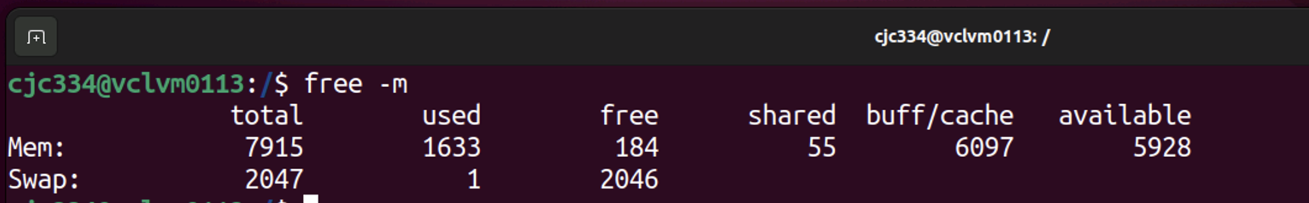
  - How much free memory is available (include units)?
The total amount of free memory is 2230 mebibytes.

  - What size swap file does this system have?
The size of the swap file is the sum of the used and free swap memory, which is 2047 mebibytes.

  - What is meant by the column labelled “available”
The “Available” column is described in the free command’s man page as an estimation for how much memory will be available for starting new applications without swapping.

- (15 points) What (3) items related to IPv4 are required to configure a network interface for attaching an application server to an enterprise network.
IPv4 Address
Subnet Mask
Default Gateway

- (10 points) List two commands that help determine if you can connect to a server using the icmp protocol:
ping
traceroute

- (10 points) Answer the questions below about Ubuntu directories:
  - (5) A server engineer installs a package for attaching a new piece of hardware to a server that includes device drivers. List the directory that was most likely updated with new device drivers.
/lib/modules/5.15.0-56-generic/kernel/drivers
  - (5) Which directory houses the binary executable files that root privilege users may use.
/usr/sbin

- (12 points) This question involves the ps command and the renice command.
  - In the context of the ps command, what does PID stand for?
Process ID

  - Examine the image below to help you answer this question.

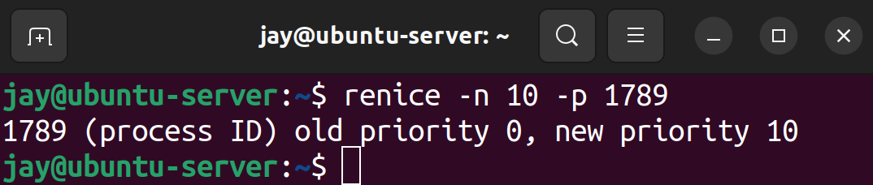

Describe what the renice command accomplished. Use complete sentence(s).
Renice changes the priority of processes given a PID.

  - Examine the image below to help you answer this question.
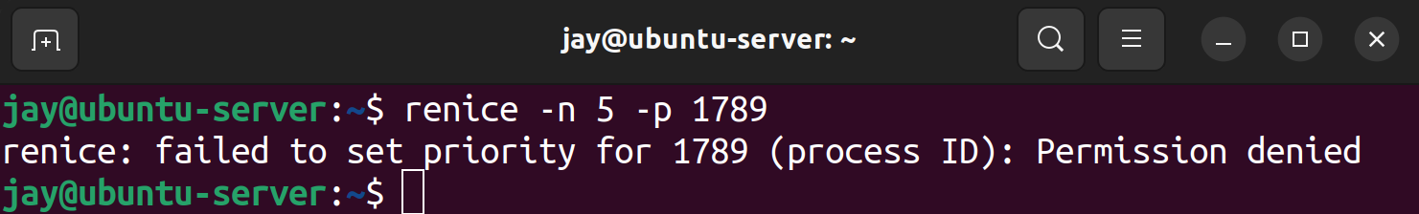

Deduce and explain why the “Permission denied” message was displayed?
The process with PID 1789 may be some root level process or essential system function that any user may not be able to change the priority of.

  - Explain the importance of the answer you provided for c) as it relates to the integrity of a running server.

It’s very important to protect core processes behind root privileges so users or bad actors cannot manage the priority of different processes.

- (4 points) Provide the best command to check the health of the daemon for ssh:
Systemctl status sshd

- (8 points) Examine the image below to answer this question.
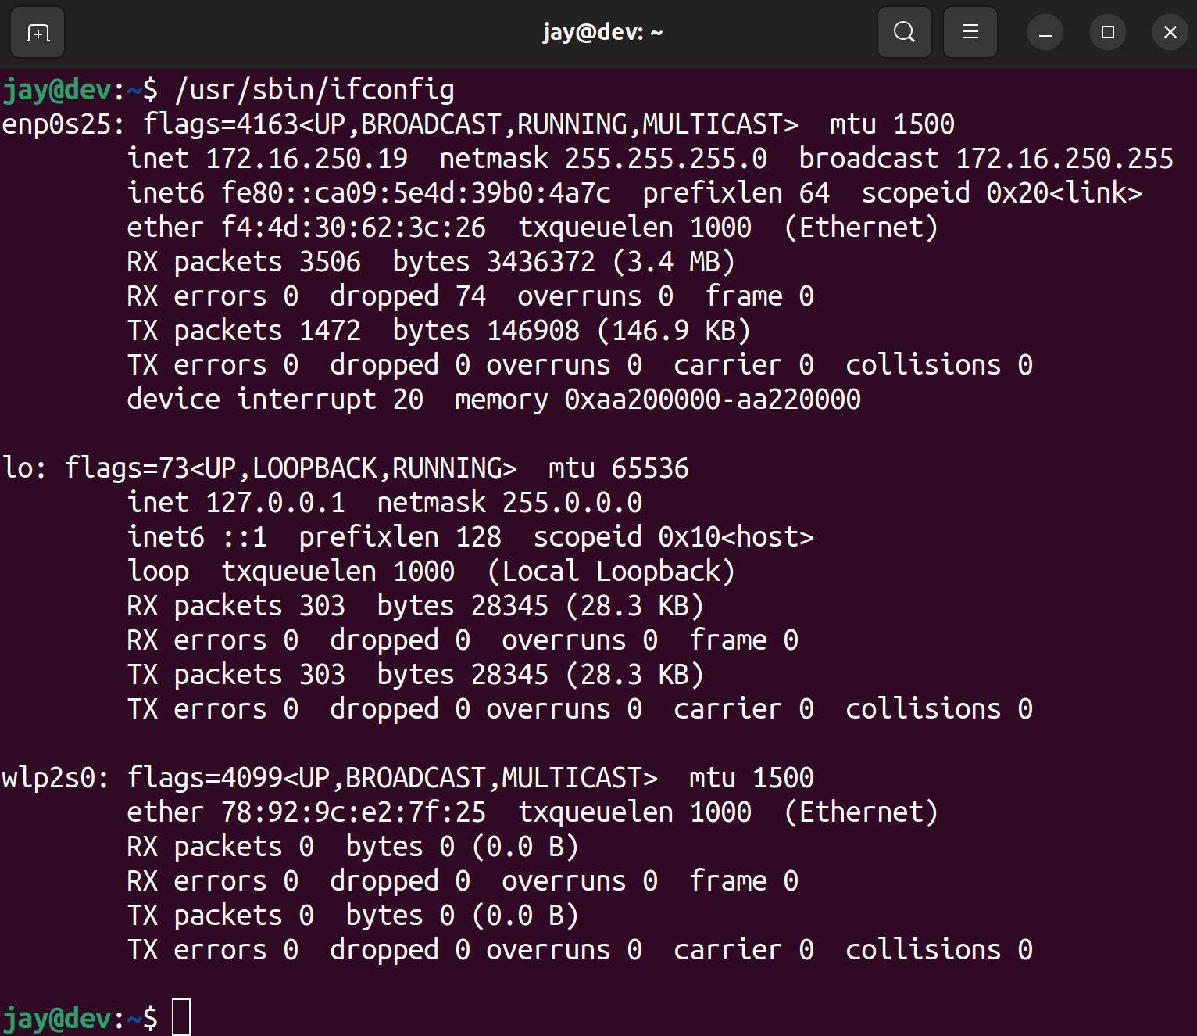

What is the IPV4 and IPV6 addresses assigned to the loopback interface?
IPv4: 127.0.0.1
IPv6: fe80::ca09:5e4d:39b0:4a7c

- (4 points) Explain why it is important to define where a server sends dns lookup requests.
It’s important to define where a server sends DNS lookups because not configuring it could cause several issues. Its common to have multiple DNS servers within an organization, so not configuring where a server sends its lookup requests could lead to incorrect name resolution. Also, it could be a security concern if a bad actor is able to conduct DNS spoofing or poisoning attacks.

- (8 points) Match the terms that belong together. Use each item just once in your matched pairs.
Overnight delivery
RAM
Opposite of pattern
fallocate
server performance
grep -v
vmstat
htop
Federal Express
/swapfile

Overnight delivery, Federal Express
Grep -v, opposite of pattern
Fallocate, /swapfile
Vmstat, RAM
Htop, server performance

