Place answers in the boxes provided for each question. Name: Jacob Andrew

Assessment Policy for this assignment:
Use items provided in this assessment only.  No use of lecture materials, textbooks, notes, search engines or AI tools. | Permitted to use lecture materials, textbooks, and notes to complete this assessment. | Permitted to use lecture materials, textbooks, notes, and search engines for limited research to complete this assessment. | Permitted to use all tools. This includes the use of lecture materials, notes, textbooks, search engines, and AI tools to complete this assessment.

- (5 points) What does the echo command do?
Echo prints whatever arguments its given out to the console.

- (10 points) Concerning the cp command.
  - A file named textfile.txt exists in the /home/bob directory and is owned by bob. What happens when bob types in the following commands?
$ cd /home/bob
$ sudo cp /var/syslog .

Bob will change directories to his home directory, then use root privileges to copy the syslog file to his pwd, which would be his home.

  - (5) A file named newtextfile.txt does not exist in the /home/bob directory. What happens when bob types in the following command?
$ touch newtextfile.txt
A new empty file newtextfile.txt will be placed in the pwd of the user.

- (10 points) Alice enters the commands below in a bash shell interface.
$ ls –l
$ echo Hi
$ info ls
$ history

  - What happens when she types this command next?
$!3
Assuming that Alice’s command history is empty before these commands were run, executing !3 will run the third command in Alice’s history, which would be “info ls”.

  - … followed by this command:
$!!
By following the previous command with “!!”, bash will run the most recently run command which would now be “info ls”.

- (5 points) Describe what these commands will do when typed into the bash CLI logged into the bob account. Be specific:
$ cat > test-script
#!/bin/bash
echo ‘begin’
ls –l /home/bob
CONTROL D

The result of these commands will create a file called test script and insert the lines “#!/bin/bash”, “echo ‘begin’”, and “ls -l /home/bob” consecutively until CTL-D is entered. This effectively creates a short bash script that will first print the line “begin” to the console, then output the results of the ls -l command on /home/bob to the console.

- (10 points) Describe what text editor is associated with key sequences below:
:wq
:q!
dd
These are Vi commands. The first one writes then quits the editor, the second quits without saving (override), and the third deletes a line while in visual or normal mode.

What does the key sequence dd do?
dd in Vi will delete the currently selected line in either visual or normal mode.

- (10 points) Refer to the image below to answer these questions.

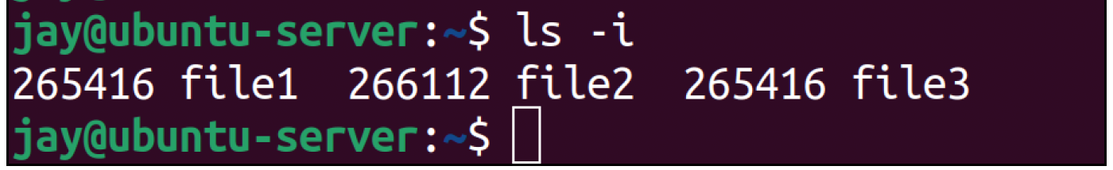

  - What information the command ls -i provide?
The -i option associated with the ls command prints each file’s inode number along with the file name.

  - How is file1 and file3 related?
One could be a hard link to the other. Hard links make references to an exact inode, so it could be that the inode is copied over when creating the link.

- (15 points) A server engineer types in the command below:
$ alias c=clear

  - What happens now after typing in the letter c?
Typing the letter c will now clear the console.

  - Suggest another alias that may be useful to a server engineer.
I personally use the following aliases on my mac and linux machines:
alias ll='LC_COLLATE=C ls -lahF'
alias l='LC_COLLATE=C ls -lF'

The LC_COLLATE part sorts the output according to the type of file, with dot files being at the top, then directories, then files. For less output I use l and for more output I use ll in case I want to see everything. I think this would be useful for server engineers because these are frequently used commands and it helps keep the output organized.

  - What command removes an alias?
Unalias will remove an alias.

- (10 points) A variable named count is needed inside a simple script and it needs to be initialized to the value 0.
  - Provide the command to initialize count:
Count=0

  - Provide the command to display the contents of the variable count to the screen:
Echo $count

- (5 points) What does the #!/bin/bash signify when it appears as the first line in a simple script?

It signifies the path in which the bash command is located on a given filesystem. Different versions of Unix or Linux will place it in different places, and if it’s not placed at the top of the file the interpreter will automatically use the default shell (which should be zsh or fsh or anything), so signifies to the interpreter which shell to use.

- (20 points) Match the terms that belong together. Use each item just once in your matched pairs.
Overnight delivery
script
$HOST
nano
$USER
Changing text in a file
syslog
chmod a=x
/var/log
Federal Express
hostname
whoami

Overnight delivery, Federal Express
/var/log ,syslog
Whoami , $USER
Hostname, $HOST
Nano, changing text in a file
Script, chmod a=x

