Lab Setup
This lab requires you to connect to VCL. Once you have logged into VCL create and connect to the Ubuntu version 22.04 virtual environment provided by VCL.

This lab involves answering lab questions in LEARN for parts 1 and 2. It also requires you to submit an answer sheet for part 3. As you perform the steps in each part of the lab you may want to record your results to assist with answering the lab questions. The lab questions in LEARN will provide you two attempts for submitting your answers.

Overview
Linux commands that may be used in this lab: cd. ls , find, diff, head, tail, echo, file, cut, >
References
- Chapters 6,7, and 8 in the textbook Mastering Ubuntu Server, Fourth Edition by Jay LaCroix, Packt Publishing, 2022
- www.ubuntu.com
- For the find command: http://www.binarytides.com/linux-find-command-examples/

Part 1
- After you have created and logged into your VCL Ubuntu machine, bring up a Firefox browser on Ubuntu (not your own browser, use the browser on VCL). Log into LEARN from the Firefox browser and download the labfile located in the lab exercises folder.

- After the file downloads from LEARN, check to see if the fil is in your “Downloads” subdirectory. See below:

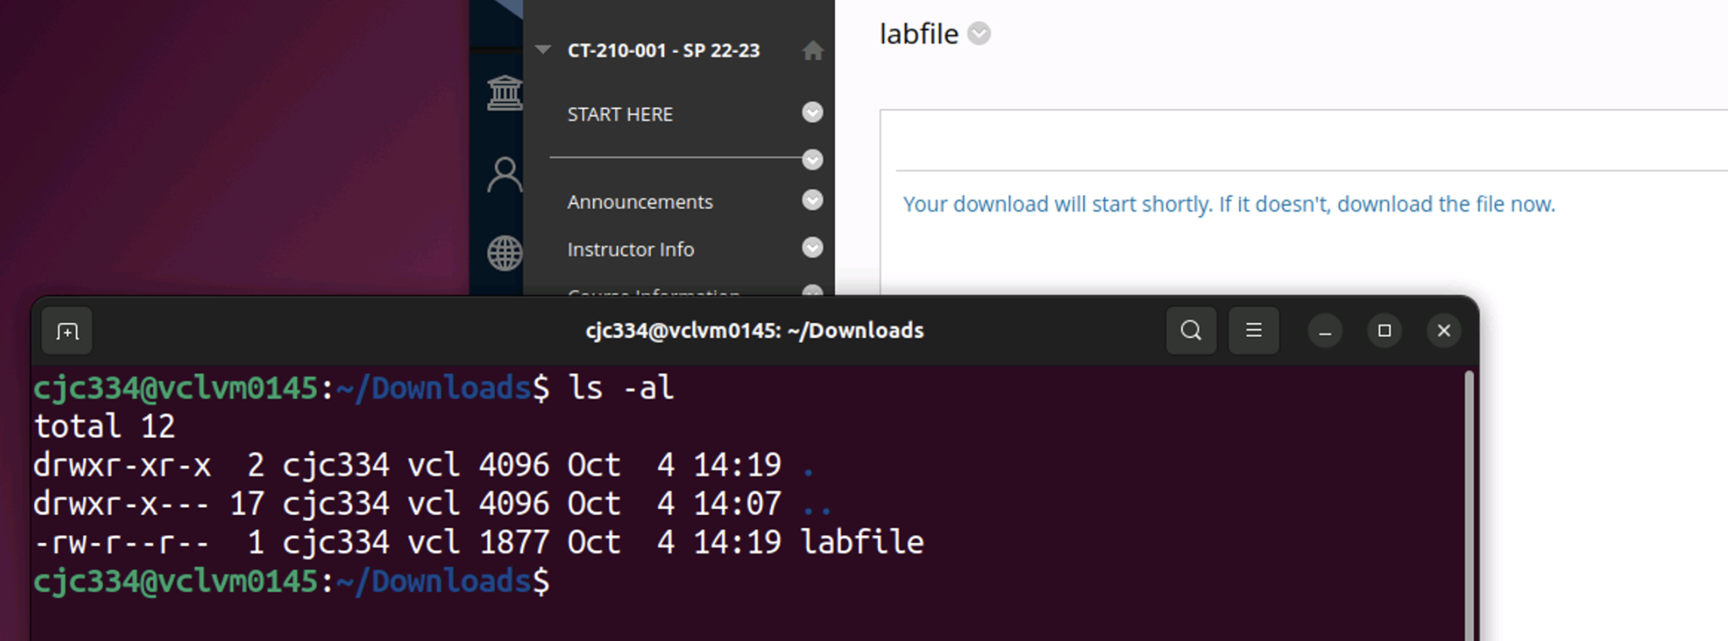

- Create a terminal so you can use command line. When you logged into your Ubuntu machine you will be in your home directory. Next type in the commands below to move to your Downloads directory and verify that the file was downloaded.
$ cd Downloads
$ ls –al

- The cut command can extract fields from standard input. Type in the commands below to extract fields from the date command and display the month followed by the day:
$ date
$ date | cut -d' ' -f2,3,4

- Type in the commands below to learn more about the diff command. Make sure you use the labfile that you downloaded in an earlier step in this lab exercise. The output from the diff command, $ diff file1 file2 provides ed line editor commands to change file1 to look like file2. The ed editor is a utility that can be used to create/modify text files. For example, output of line1 a line2 line3 stands for “append line2 from file2 after line1 in file1”. Output of line1,line2 c line3,line4 stands for “change line1 through line2 in file1 to line3 through line4 from file2”.

$ grep 'color' labfile > logfile1
$ grep 'color' labfile > logfiletwo
$ echo 'color-purple' >> logfiletwo
$ diff logfile1 logfiletwo

Record your results.

Answer the Part 1 questions in LEARN.

This part of the lab requires you to explore the head and tail commands

- The head command is used to display the first part of a text file. This is often used to view the first few lines of a program or configuration file. Type in the command below:
$ sudo head -3 /etc/adduser.conf

This should reveal information about the purpose of the file.

- The tail command is used to display the last part of a text file. The tail command is often used to view that last few entries of a log file because the most recent entries written to a log file appear at the end of the file. Note that many log file record entries always begin with the date and time they were written. Type in the tail commands below:
$ sudo tail -4 /var/log/syslog
$ sudo tail -8 /var/log/syslog

Answer the Part 2 questions in LEARN.

- Type in these file commands:
$ file ~/Downloads
$ file ~/Downloads/labfile

- The find command is very powerful especially if you use the -exec option. Let’s find all of the files that are less than 10 Megabytes in our home directory tree. Use this command:
$ sudo find /var -size 5M

- Now let’s use the find command with the -exec option. So for each file that is returned by the find command the file command will be executed on it.
$ sudo find /var -size +1M -exec file '{}' \;

- Now let’s pipe the output from the find command to cut and extract the complement of field one, (all fields other than the field one).
$ sudo find /var -size +1M -exec file '{}' \; | cut -d' ' --complement -f1

- Next let’s find commands from the / partition down greater than 1 M and pipe the output to the sort command and then to more. This command will take some time and may generate a few “no such..” error messages.
$ sudo find /var -size +1M -exec file '{}' \; | cut -d' ' --complement -f1 | sort
Try it use the uniq command and less
$ sudo find /var -size +1M -exec file '{}' \; | cut -d' ' --complement -f1 | sort | uniq | less

- Next save this output to a file for later use. To do this substitute the “| less” with “> filetypes”
in the command above. To make sure your file was created type:
$ ls -al filetypes

Part 3
- This part of the lab requires you to utilize the commands you learned in the earlier parts of this lab exercise
Question 1: Construct a find command that, “finds all the files in your home directory tree using a relative pathname that are greater than 2 megabytes and changes all of these files to have read execute permissions for owner only. Include a screen capture showing that your command worked; see example below:

- Research the uniq command using the man pages.
Question 2: Now construct a command that parses the output from the displaying the labfile for the log entries related to node A and node B and consolidates row entries with the same date (IE oct-03, oct-02). You may need to use grep and sort in order to answer this question correctly.
Again, include a screen capture showing that your command worked; see example below:
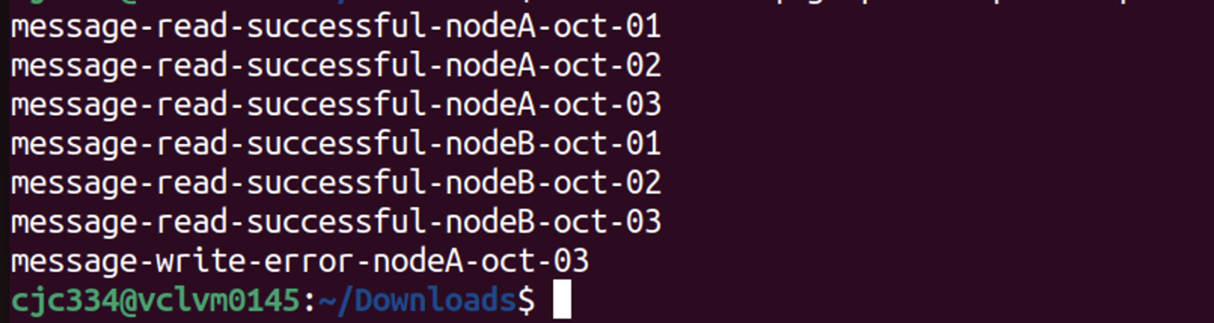

This next exercise covers:
- Creating a batch script
- Creating an entry in cron to run a batch script in the background
- Verifying a cron script ran successfully

- Change back to your home directory.
cd ~/

- Create a script using the commands below. Use the editor, (gedit, nano, vi..), to put the commands in a text file named labscript. Do not cut the text from these instructions and paste them in an Ubuntu text file. This will cause text format mismatch issues.

#!/bin/bash
fil=$(ls lablog.?)
echo $fil # debug statement to ensure logfile name was captured
num=$(echo $fil | grep –o .$)
lastnum=$num
let num++
if [ $num –eq 5 ]
then
num=’1’
fi
mv lablog.$lastnum lablog.$num

- Make sure your text file has execute permissions.

Question 3: What command did you use to change your text file to have execute permissions? Be specific.

- Use the touch command to create the first log file named lablog.1

$ touch lablog.1

- Now, create an entry in the crontab file to run this script every minute from your user id. Do this by editing the file /etc/crontab. Make sure you substitute the user id that you used to log into Ubuntu for ‘userid’ wherever it appears below. If you are using VCL, this will be your Drexel user id. You will need to use sudo to access the /etc/crontab file.

# m h dom mon dow user command
* * * * * userid /home/userid/labscript

- Check your lablog file after a few minutes go by.

Question 4: What is the highest number that will be used for the lablog files extension?

Question 5: Describe what this script does?

Question 6: Provide the output below from typing this command to prove that your crontab entry ran
successfully. Note that you will need use your user id. Find your cron log entries in the log file and provide a small screen capture or cut and paste the log entries. The command below will help you find your log entries, but it may need some modifications to display what you are looking for.

$ sudo cat /var/log/syslog | grep <your user id>

What is Due?
- Answers to the Part 1 questions in LEARN.
- Answers to the Part 2 questions in LEARN.
- A completed Part 3 answer sheet.

