Lab Setup
This lab involves answering lab questions in an answer sheet provided in LEARN. This lab requires you to connect to VCL. Once you have logged into VCL create and connect to the Ubuntu version 22.04 virtual environment provided by VCL.

Overview
This lab explores system administration with a focus on commands used to diagnose server problems.
It involves checking disk space, CPU utilization, memory usage and checking log files. Here are some of the Linux commands that may be useful for this lab exercise: ps, top, ls, cat, cp, cd, head, tail, grep, |, >, >>, touch, df.

This lab is designed to test all of the Linux skills you have accumulated in the Open Server course to troubleshoot problems on a server. Server engineers are often faced with server problems and use the command line to display information about the health of a server. This lab will cover methods used to diagnose server problems.

Follow the instructions carefully to make sure you run the sys-admin-setup script properly to provide the environment to setup this lab exercise. If you need to start over, it is best to delete your Ubuntu machine, request a new one and start over following the instructions from the very beginning of this document. Note that the health of the server will degrade more and more after 30-40 minutes passes. Let your server run for at least 15 minutes to see the server degrade. Note your server may hang after 25 minutes. If this happens before you complete your analysis, delete your VCL vm and start the lab all over again.
References

Chapter 8 Mastering Ubuntu Server textbook by Jay LaCroix
http://askubuntu.com/questions/104903/how-do-i-kill-processes-in-ubuntu
https://help.ubuntu.com/lts/serverguide/network-configuration.html
http://askubuntu.com/questions/484510/how-to-run-top-command-1-time-and-exit
Standard Linux system log files /var/log/syslog or /var/log/rsyslog
Names of normal Ubuntu running processes:
Process Name | Description
gnome* | Related to the Ubuntu desktop being displayed
kworker* | Kernel work threads (part of os)
rcc* | Related to packages
systemd | service manager process (part of os)
tracker | Related to reading metadata of files (part of os)
vmtools* | Related to VMware that is used to provide VCL images
xrdp | Related to remote desktop connections to the VCL system
Xorg | Related to the windowing system that displays the desktop
*Signifies process names may begin with the specified text followed by other unique text

Part 1
This lab exercise involves a situation where you have been contacted as a server engineer to investigate a performance problem on a production server. This server has more than one critical application running on it and these applications are running so slow that the server has been turned over to you to resolve the performance issues by the business. You were also told about a change that recently occurred on the server by a new contract application programmer. However, there are no details available about exactly what changed.

- After you have created and logged into your VCL Ubuntu machine, bring up a Firefox browser on your Ubuntu machine. Log into LEARN from the Firefox browser and download the sys-admin-setup3 script located in the lab exercises folder.

- Click the “Save File” button to save this file in your Downloads subdirectory.

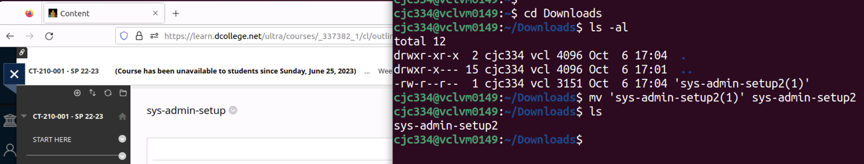

- Before running the script type in these commands:
$ sudo apt update

- When you logged into your Ubuntu machine you will be in your home directory. Next, open the terminal and type in the commands below to move to your Downloads directory and run the setup script. Note that LEARN may append a version number to downloaded files such as (2) or (3). It may make it easier to rename your sys-admin-setup3 file to remove the version number. Remember case matters in Linux. It is also important to point out that the sys-admin-setup script needs to run from the Downloads directory.
$ cd Downloads
$ chmod +x sys-admin-setup3
$./sys-admin-setup3

- The script may take a few minutes to run to completion. The script will install some software and you may be asked to confirm that it is OK to use up disk space for the install. Type in a “Y” to any questions. See the screen capture below.

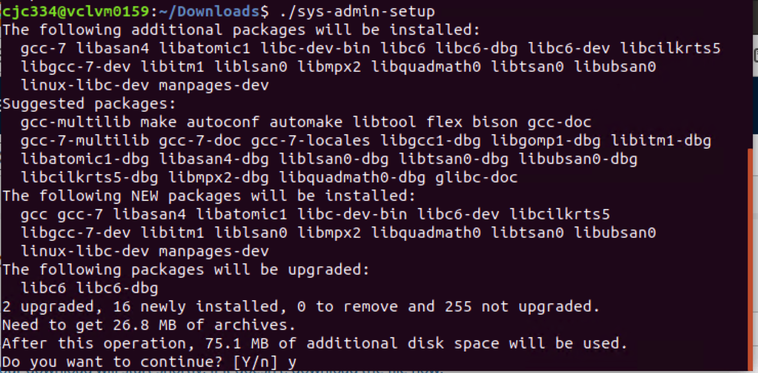

Make sure you receive the message below after it runs:

Script successful - Check the log

After running the script you should have a log file named lablog in your home directory.

Throughout this lab you will use log files to obtain clues about what processes are using up resources on the server. Check the lablog file often in your home directory by typing the commands below:
$ cd ~
$ cat $HOME/lablog
$ tail lablog

The first entry in the lablog file should have an informational message reporting that the sys-admin-setup script ran successfully. Note that most of the messages written to log file in this lab exercise will adhere to the following format:
MSG—I—Description
MSG—E—Description
where
MSG – message
I – Informational
E – Error
Description – description on the logged event

- Checking resources on a server. The resources that need to be checked initially to diagnose the health of a server are CPU utilization, memory utilization, network interface counters, and disk space utilization. It is suggested that you record information about resources on the server to a text file to assist with identifying all of the problems. You can do this by creating a log file to record the status of the server from time to time to assist in troubleshooting.
$ cd ~
$ touch statuslog

Examine and record disk utilization using the df command.
$ df
$ date >>statuslog
$ df >> statuslog

You can ignore the devices listed by df with the”Mounted on” prefix /snap or /run. Focus on the root partition / and the /dev partition.

- At this point you may want to open up an additional (2) terminal windows to assist you with your troubleshooting efforts. In one of these windows use the top command to display an ongoing status of the processes using the most resources.

You can also use these (2) ps commands to provide more specific information about the processes using the most memory. Note that there are (2) dashes in front of the sort parameter in the commands listed below. This command displays the top 8-10 processes using the most memory percentagewise:
$ ps au --sort -%mem | head

This command displays the top 9 processes using the most memory in Kbytes:
ps au --sort -rss | head

Use one of these commands to record the state of processes currently using lots of memory:
$ date >> statuslog
$ ps au --sort -rss >> statuslog

- Check the network interfaces for errors. Use the netstat –i command
$ netstat -i
or
$ ip -s link

Check the eth0 and eth1 interfaces for errors, (the values under RX-ERR and TX-ERR. Another way to check network interface error is by using the ifconfig –a command and pipe the output from this command for the word errors. See below.
$ sudo ifconfig –a | grep errors
or
$ sudo ip -d addr

- The (6) steps prior to this one have provided you some initial methods for diagnosing the problems on the server. You may need to examine log files and resource utilization data for 10-15 minutes to better understand what the problems are with the server.

Continue to: check log files, check and record the CPU, memory and disk utilization and do the following:
- Eliminate troubleshooting any resources that you feel are working properly.
- Identify the processes that are using system resources and appear to be abnormal. By abnormal they do not appear to be things like: firefox, gnome-terminal, init, nautilis, xrdp, unity,…

Question 1:
Use the man page for ps (all the way towards the end) or google to find out what rss stands for in this command:
$ ps aux --sort -rss

Question 2:
In the steps above that demonstrate recording the status to the statuslog, explain:
- what the “$ date >> statuslog” command is doing?
- why this is this helpful for troubleshooting?

Question 3:
What resources have you observed that are being consumed? This is an example of the type of answer I am looking for, “The /dev disk percentage use keeps increasing”

Question 4:
Name at least two abnormal processes that you feel are using too many resources. Provide the name of these processes. Make sure you study the table with information about Ubuntu processes in the Reference section at the beginning of the lab instructions before developing your answer.

- Now that you have identified the abnormal processes, you need to identify the source of these processes. Note that there are at least (2) problems on the server and these problems may appear as many problems that start and stop from time to time.

- Continue to: check log files, check and record the CPU, memory and disk utilization. This will help provide clues for identifying the source of the resource problems.

Question 5:
What resource did you observe to be healthy, thus eliminating it as a root cause for the problems on the server. Your answer should be one of the following: (CPU, Memory, Disk utilization, or Network interface).

Question 6:
- Provide a description of the problems occurring on the server. Your answer should include a description of more than one problem.
- Provide a suggested action for resolving the performance problem(s) that only addresses the items associated with the performance problems. (Hint, rebooting the system is NOT a good idea because it disrupts ALL activity, (not just the items causing the problems), on the system.

What is Due?
- Answers to the questions using the answer sheet for this lab in LEARN.

