CR REVIEW #3
12–3 Should key milestones be established at points where trade-offs are most likely to occur?(5 points)
Key milestones should absolutely be established at points where trade-offs are most likely to occur for lots of reasons. One reason is visibility, where milestones can provide clear cut checkpoints to reach in the project timeline to asses progress and better make decisions on potential trade offs. Another reason could be Risk management, where for the same reason as visibility, having clear checkpoints in the project could make risk going forward easier to assess and less vague.

12–4 Would you agree or disagree that the cost of accelerating a project rises exponentially, especially as the project nears completion? (5 Points)
I do agree that the cost of accelerating a project rises exponentially near project completion. From personal experience alone, I’ve worked in settings that deal with government contracts that have strict deadlines and deliverables, and when it comes near the deadlines of those contracts everyone in is in the office working hard to ensure that the deliverables meet requirements on time. Outside of my experience, I know that as project completions approaches there is lots of pressure from both inside and outside of the team to ensure the quality of the deliverables and to not go over budget when most of it has likely been expended.

12-6 Draw the network and identify the critical path. Also calculate the earliest–latest starting and finishing times for each activity: (10 Points)
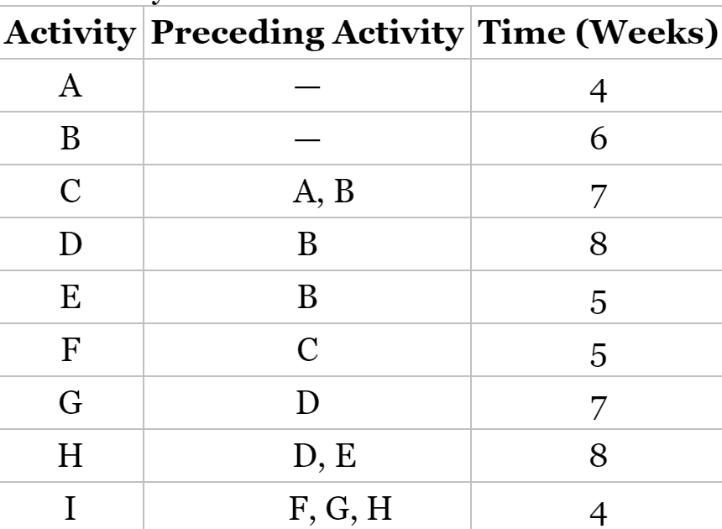
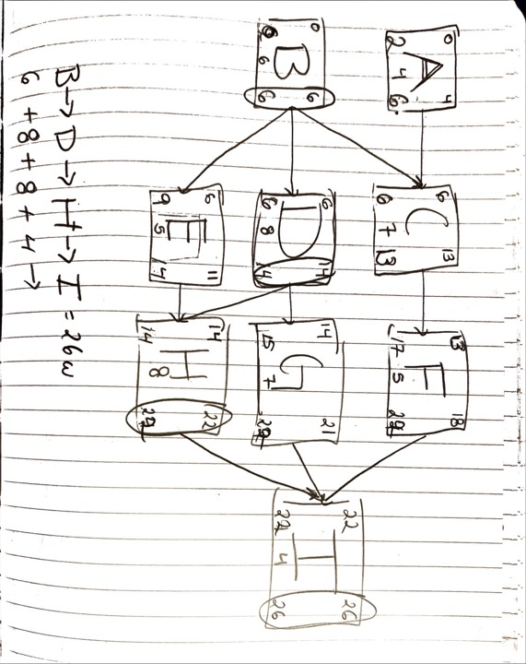
In this image, I have drawn the network for the given activites and identified the critical path of the network as B->D->H->I and the project duration as 26 weeks. For the starting and finishing times for each activity, I have denoted each value in the corner of each activity “box”. Going clockwise starting from the top left, the values are defined as the earliest starting time, earliest finishing time, latest finishing time, and latest starting time.
12–7 Identify the critical path for the following network for a small MIS project (all times are in days; network proceeds from node 1 to node 10): (20 points)
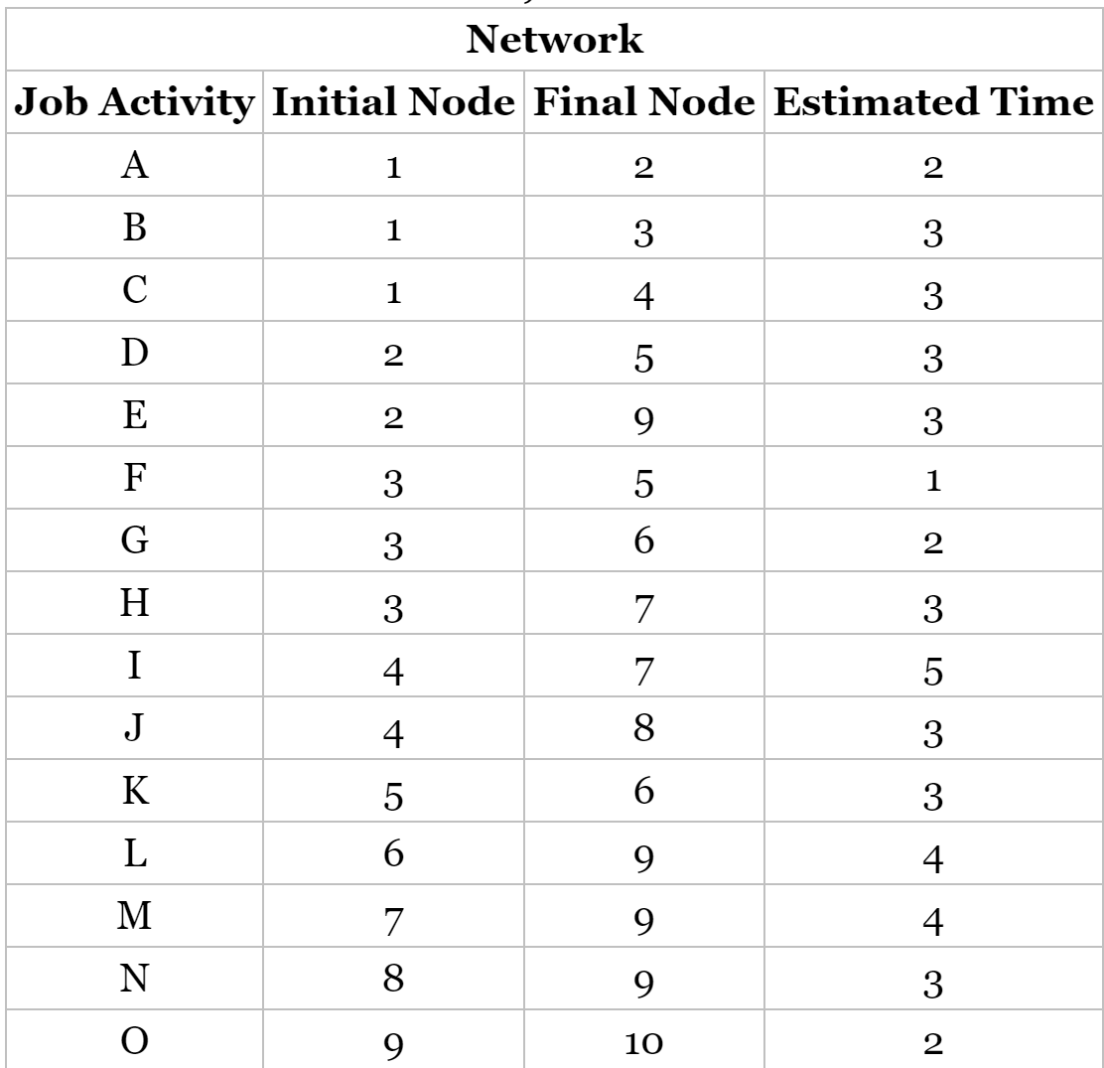

Job Activity | Initial Node | Final Node | Estimated Time | ES | EF | LS | LF | Float
A | 1 | 2 | 2 | 0 | 2 | 0 | 2 | 0
B | 1 | 3 | 3 | 0 | 3 | 0 | 3 | 0
C | 1 | 4 | 3 | 0 | 3 | 0 | 3 | 0
D | 2 | 5 | 3 | 2 | 5 | 2 | 5 | 0
E | 2 | 9 | 3 | 2 | 5 | 6 | 9 | 4
F | 3 | 5 | 1 | 3 | 4 | 4 | 5 | 1
G | 3 | 6 | 2 | 3 | 5 | 4 | 6 | 1
H | 3 | 7 | 3 | 3 | 6 | 5 | 8 | 2
I | 4 | 7 | 5 | 3 | 8 | 5 | 10 | 2
J | 4 | 8 | 3 | 3 | 6 | 7 | 10 | 4
K | 5 | 6 | 3 | 5 | 8 | 6 | 9 | 1
L | 6 | 9 | 4 | 6 | 10 | 6 | 10 | 0
M | 7 | 9 | 4 | 8 | 12 | 8 | 12 | 0
N | 8 | 9 | 3 | 6 | 9 | 6 | 9 | 0
O | 9 | 10 | 2 | 12 | 14 | 12 | 14 | 0

Here, I have created a table that represents the network through its earliest starting time (ES), earliest finishing time (EF), latest starting time (LS), latest finishing time (LF), and float (Amount of time that that a task can be delayed before it impacts the project schedule). The critical path can be found on this table by identifying the float values equal to 0. That would make the critical path A->D->L->M->O.
12–9 For the network shown in Figure P12–9 with all times indicating weeks (20 points)
- What is the impact on the end date of the project if activity B slips by two weeks?
The end date of the project will not be affected if activity B slips by two weeks because B is not on the critical path and has a float value of 9 weeks.

- What is the impact on the end date of the project if activity E slips by one week?
The end date of the project will slip by 1 week because activity E is on the critical path and does not have any float or slack value that allows it to slip.

- What is the impact on the end date of the project if activity D slips by two weeks?
The end date of the project will not be affected by activity D slipping by two weeks because it is not on the critical path and has a float value of 3 weeks.
- If the customer offered you a bonus for completing the project in 16 weeks or less, which activities would you focus on first as part of compression (“crashing”) analyses?
I would focus on the activities in the critical path first as a part of compression analyses, with those activities being A, C, and E. These are the most important activites to focus on because they do not allow for any slack, so focusing on them first would be the most important first step to fast-tracking the project by 2 weeks.

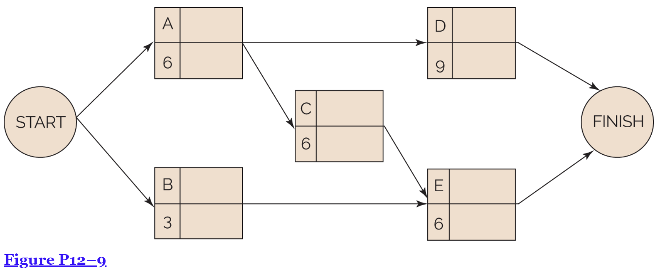
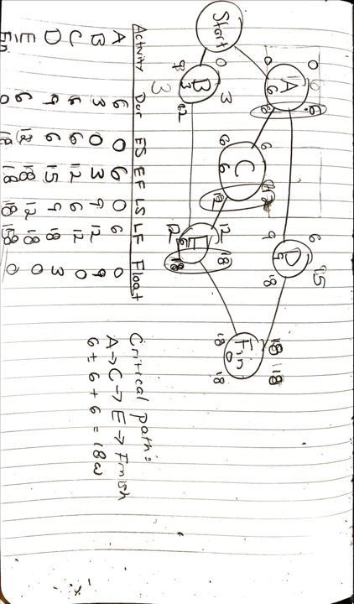
Here I have provided my diagram that I drew to calculate the critical path and such used to find out the impact of delays on each on each of the activities.
11-5 Below are 12 instructions. Which of the below are best described as planning, and which are best described as forecasting? (20 points)
- Give a complete definition of the work. -- Planning
- Lay out a proposed schedule. -- Planning
- Establish project milestones. -- Planning
- Determine the need for different resources. -- Planning
- Determine the skills required for each WBS task or element. -- Planning
- Change the scope of the effort and obtain new estimates. -- Forecasting
- Estimate the total time to complete the required work. -- Planning
- Consider changing resources. -- Forecasting
- Assign appropriate personnel to each WBS element. -- Forecasting
- Reschedule project resources. -- Forecasting
- Begin scheduling the WBS elements. -- Planning
- Change the project priorities. -- Forecasting
CASE STUDY - THE INVISIBLE SPONSOR (20 points) – Answer the 4 Case study questions
Background
Some executives prefer to micromanage projects whereas other executives are fearful of making a decision because, if they were to make the wrong decision, it could impact their career. In this case study, the president of the company assigned one of the vice presidents to act as the project sponsor on a project designed to build tooling for a client. The sponsor, however, was reluctant to make any decisions.

Assigning the VP
Moreland Company was well-respected as a tooling design-and-build company. Moreland was project-driven because all of its income came from projects. Moreland was also reasonably mature in project management. When the previous VP for engineering retired, Moreland hired an executive from a manufacturing company to replace him. The new VP for engineering, Ashley Zink, had excellent engineering knowledge about tooling but had worked for companies that were not project-driven. Ashley had very little knowledge about project management and had never functioned as a project sponsor. Because of Ashley's lack of experience as a sponsor, the president decided that Ashley should “get her feet wet” as quickly as possible and assigned her as the project sponsor on a medium-sized project. The project manager on this project was Fred Cutler. Fred was an engineer with more than 20 years of experience in tooling design and manufacturing. Fred reported directly to Ashley administratively.
Fred's dilemma: Fred understood the situation; he would have to train Ashley on how to function as a project sponsor. This was a new experience for Fred because subordinates usually do not train senior personnel on how to do their job. Would she be receptive? Fred explained the role of the sponsor and how there are certain project documents that require the signatures of both the project manager and the project sponsor. Everything seemed to be going well until Fred informed Ashley that the project sponsor is the person that the president eventually holds accountable for the success or failure of the project. Fred could tell that Ashley was quite upset over this statement.
She realized that the failure of a project where she was the sponsor could damage her reputation and career. Ashley was now uncomfortable about having to act as a sponsor but knew that she might eventually be assigned as a sponsor on other projects. She also knew that this project was somewhat of a high risk. If she could function as an invisible sponsor, she could avoid making any critical decisions.
In the first meeting between Fred and Ashley where Ashley was the sponsor, she asked Fred for a copy of the schedule for the project. Fred responded:
I'm working on the schedule right now. I cannot finish the schedule until you tell me whether you want me to lay out the schedule based on best time, least cost, or least risk.
Ashley stated that she would think about it and get back to Fred as soon as possible.
During the middle of the next week, Fred and Ashley met in the company's cafeteria. Ashley asked Fred again, “How is the schedule coming along?” and Fred responded as before:
I cannot finish the schedule until you tell me whether you want me to lay out the schedule based on best time, least cost, or least risk.
Ashley was furious, turned around, and walked away from Fred. Fred was now getting nervous about how upset she was and began worrying if she might remove him as the project manager. But Fred decided to hold his ground and get her to make a decision.
At the weekly sponsor meeting between Fred and Ashley, once again Ashley asked the same question, and once again Fred gave the same response as before. Ashley now became quite angry and yelled out, “Just give me a least-time schedule!”
Fred had gotten her to make her first decision. Fred finalized his schedule and had it on Ashley's desk two days later, awaiting her signature. Once again, Ashley procrastinated and refused to sign off on the schedule. She believed that if she delayed making the decision, Fred would take the initiative and begin working on the schedule without her signature.
Fred kept sending emails to Ashley asking when she intended to sign off on the schedule or, if something was not correct, what changes needed to be made. As expected, Ashley did not respond. Fred then decided that he had to pressure Ashley one way or another into making timely decisions as the project sponsor. Fred then sent an email to Ashley that stated:
I sent you the project schedule last week. If the schedule is not signed by this Friday, it could affect the end date of the project. If I do not hear from you, one way or another, by this Friday, I will assume you approve the schedule and I can begin implementation.
The president's email address was also included in the CC location on the email. The next morning, Fred found the schedule on his desk, signed by Ashley Zink.

QUESTIONS – short answers please
Why do some executives refuse to function as project sponsors?
Some executives refuse to function as project sponsors for multiple reasons. Higher level executives that oversee multiple areas of the company may not have the bandwidth to focus on being a good project sponsor. They may also be apprehensive out of fear of being accountable for the project, or just not understanding project management as it can be daunting.

Can an executive be “forced” to function as a sponsor?
Executives could be “forced” to function as a project sponsor if someone higher up than them in the company assigns them to that role. However, in the case of “forcing” someone to take up a role that they may not be comfortable with, it could lead to several problems for the project.
Is it right for the sponsor to be the ultimate person responsible for the success or failure of the project?
It is typically the case that the project sponsor is the person ultimately responsible for the success or failure of a project. They are the person that makes the ultimate decisions, provides the necessary resources, and are accountable for meeting deadlines. Since they are taking on the risk, it is fair for them to be responsible for the project’s outcome.
Were Ashley Zink's actions that of someone trying to be an invisible sponsor?
Ashley Zink’s actions were definitely that of someone attempting to be an invisible sponsor. She delayed decision making on the project which caused stress on the Project Manager Fred, she avoided taking ownership of the project, and became angry throughout the process when simply trying to create a schedule.

