Use data available in the following table (each row corresponds to a different patient from whom weight and obesity related indicators have been collected – each patient identified by a distinct PATIENT_ID):

- SELECT * FROM hc848. OBESITY_DATA;

First, use the SELECT statement above to look at the content of this table and get familiar with its structure (columns).

Then, write SQL query using the SELECT statement to respond to the following questions:

Question 1 | What is the probability of people being obese (any type) in each transportation method? List probabilities from highest to lowest.
SQL | SELECT  TRANSPORTATION_METHOD,  ROUND((COUNT(CASE WHEN WEIGHT_STATUS LIKE '%Obesity%' THEN 1 END) / COUNT(*)) * 100, 2) AS obese_probability  FROM  hc848.OBESITY_DATA  GROUP BY  TRANSPORTATION_METHOD  ORDER BY  obese_probability  DESC  ;
Result | 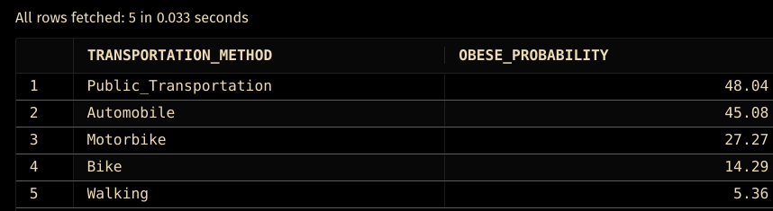  * Notice there are not many patients using bikes and motorbikes.

Question 2 | Do the same splitting results for each gender.
SQL | SELECT  TRANSPORTATION_METHOD,  GENDER,  ROUND((COUNT(CASE WHEN WEIGHT_STATUS LIKE '%Obesity%' THEN 1 END) / COUNT(*)) * 100, 2) AS obese_probability  FROM  hc848.OBESITY_DATA  GROUP BY  TRANSPORTATION_METHOD,  GENDER  ORDER BY  obese_probability  DESC  ;
Result | 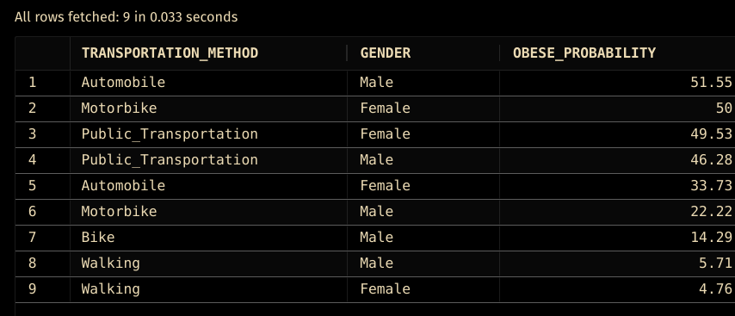  * Notice there are not many patients using bikes and motorbikes, so how to interpret the result for female patients?

