**Exercise 1**

*Create a simple JSON HTTP server*

**Prior Knowledge**

Unix Command Line Shell

Some simple JavaScript (node.js)

**Learning Objectives**

Understand the basics of a Web Server

**Software Requirements**

Node.js

Npm

A Text Editor (e.g. Atom)

Creating a node.js program

1. Node.js is an effective framework for writing server-side programs using the JavaScript language. In this exercise we are going to create a simple program that returns a random number between 1 and 100.  
     
   Because we expect the result to be read by a machine not a human, we will return this as a JSON not as an HTML.
2. Make a directory called ex1. You can do this by starting a terminal window and typing:  
   mkdir ~/ex1  
   cd ~/ex1
3. Now we need to create a new node.js project:  
   npm init

This creates a simple JSON file that the Node Package Manager uses to keep track of your project. We need to fill in some details (but actually we can just accept the defaults.   
Just hit **Enter** for all the entries, except **test.**For test, type **jest** which is a JavaScript test framework.

This utility will walk you through creating a package.json file.

It only covers the most common items, and tries to guess sensible defaults.

See `npm help json` for definitive documentation on these fields

and exactly what they do.

Use `npm install <pkg>` afterwards to install a package and

save it as a dependency in the package.json file.

Press ^C at any time to quit.

package name: (ex1)

version: (1.0.0)

description:

entry point: (index.js)

test command: jest

git repository:

keywords:

author:

license: (ISC)

About to write to /home/oxsoa/ex1/package.json:

{

"name": "ex1",

"version": "1.0.0",

"description": "",

"main": "index.js",

"scripts": {

"test": "jest"

},

"author": "",

"license": "ISC"

}

Is this ok? (yes)

1. This uses a library called express.js which is a very popular framework for writing REST applications in JS. Let’s install that:  
   npm install express --save

You will see a lot of colourful text scroll by, ending in a couple of warnings:

npm WARN ex1@1.0.0 No description

npm WARN ex1@1.0.0 No repository field.

+ express@4.16.2

added 48 packages in 4.652s

You can ignore these warning messages.

1. Now we need to create a file and code the server.  
   In the terminal window type:  
   atom index.js

*Hint: If you have another text editor on Ubuntu that you prefer, switch to that instead.*

1. You should see an Atom editor window. You may need to close various welcome windows: 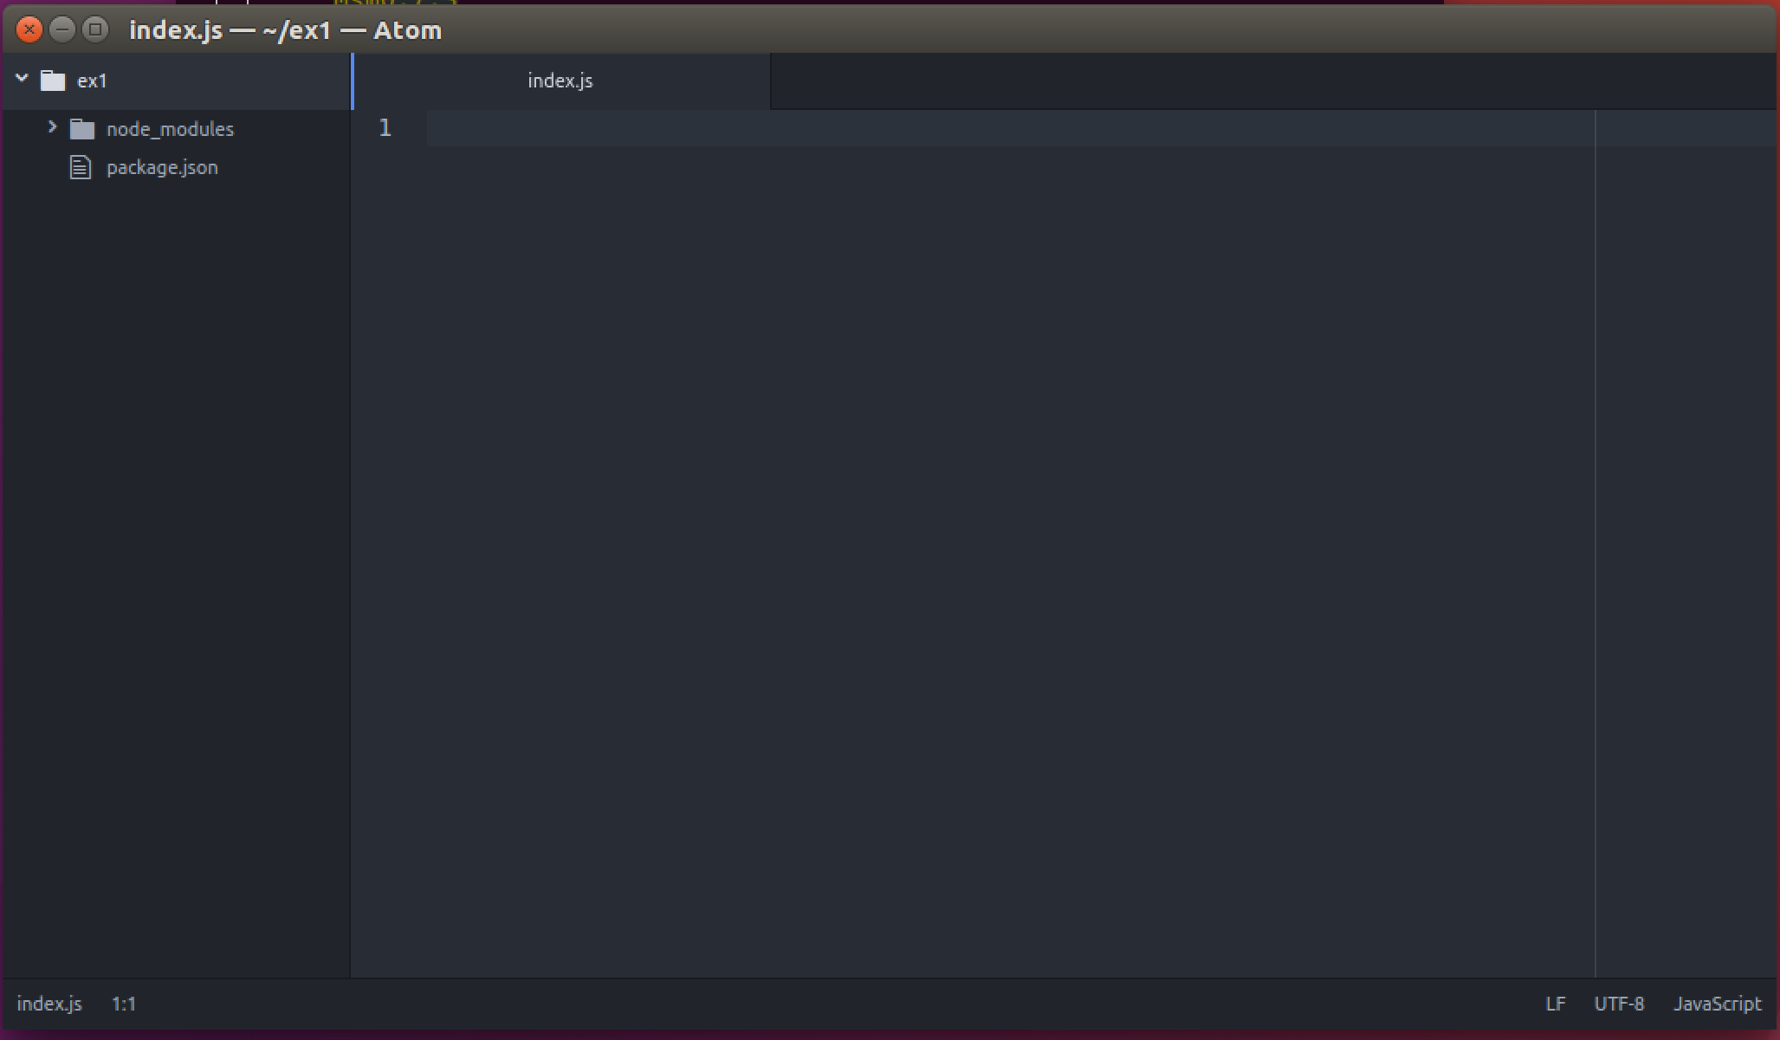
2. Type (or copy and paste) the following code.

The code is at <http://freo.me/ex1-js>

*If you copy and past please make sure you understand the code.*

var http = require('http'),

express = require('express'),

app = express();

app.get("/",function(req,res){

var obj = {random : Math.floor((Math.random() * 100) + 1)};

res.json(obj);

});

var server = app.listen(8080, function() {

console.log("Random server listening on port 8080");

});

1. This code creates an HTTP server that responds to any HTTP GET request in the same way. It will instantiate a JavaScript object containing a random number and then return that as a JSON string.
2. To run this code, you need to type the following into a terminal window:  
   cd ~/ex1

node index.js  
  
You should see the server respond:  
oxsoa@oxsoa:~/ex1$ nodejs index.js  
Random Server listening on: http://localhost:8080

1. You can test this code by pulling up a browser window (e.g. Chromium or Firefox) and then browsing to <http://localhost:8080>  
     
   The result is this:  
   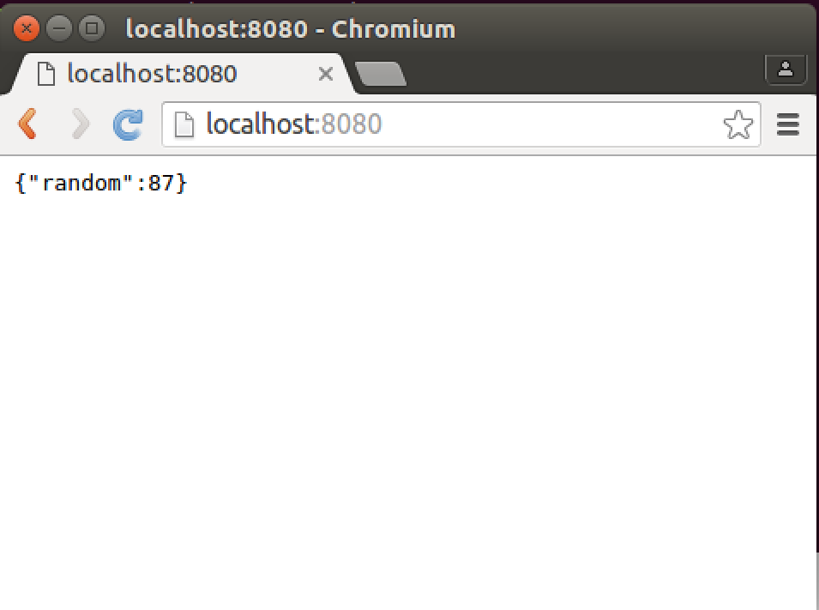
2. However, we do not want a human-/browser-enabled service. We want to call this service from machine-based clients. Let’s first try curl (a command-line URL / HTTP tool).  
     
   **Start a new terminal window** (hint Right-click on the icon) and then type:  
   curl http://localhost:8080  
     
   You should see:  
   curl http://localhost:8080  
   {"random":71}oxsoa@oxsoa:~/ex1$  
     
   Hint: Because the HTTP response has no ‘\n’ line ending, the result is a bit hard to read as the next line merges with the output.
3. curl provides a useful debug facility. If you turn on verbose output, you can see the actual network messages as they are sent on the wire:  
     
   curl –v http://localhost:8080   
   You should see output similar to this:  
   The lines beginning with > indicate that these are sent to the server and < are received from the service.

* Rebuilt URL to: http://localhost:8080/

* Trying 127.0.0.1...

* Connected to localhost (127.0.0.1) port 8080 (#0)

> GET / HTTP/1.1

> Host: localhost:8080

> User-Agent: curl/7.47.0

> Accept: */*

>

< HTTP/1.1 200 OK

< Content-Type: application/json

< Date: Tue, 24 May 2016 09:04:03 GMT

< Connection: keep-alive

< Content-Length: 13

<

* Connection #0 to host localhost left intact

{"random":33}oxsoa@oxsoa:~/ex1$

1. Another way of testing this is to use a tool called the Advanced Rest Client (ARC) in Chrome/Chromium. Start Chromium and open up a new window or tab. In the corner is a little button called Apps   
   Click on that and then choose the ARC button:
2. 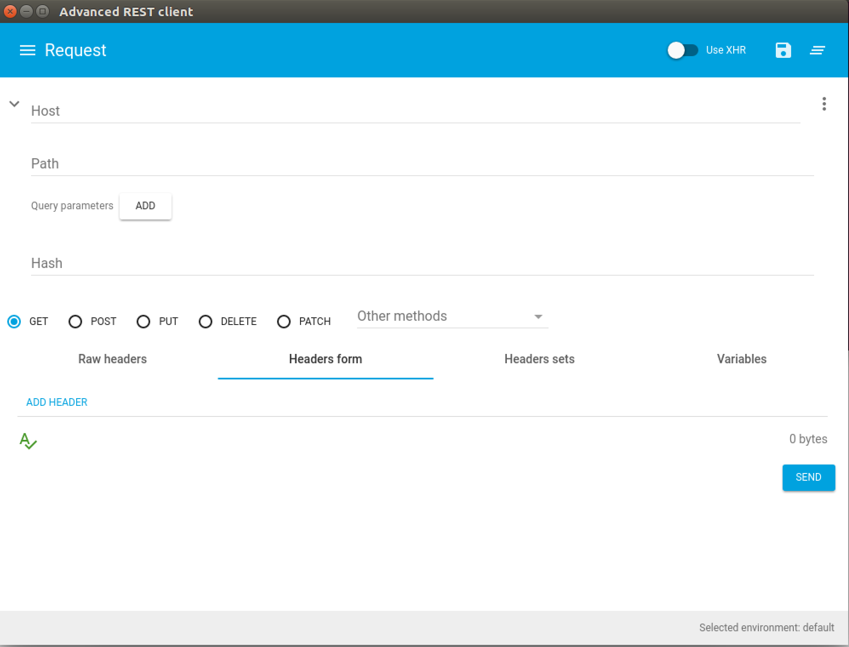You should see a window like this. There may be some old history in there.
3. Type <http://localhost:8080> into the Request URL field. Choose GET and then click Send. You should see:

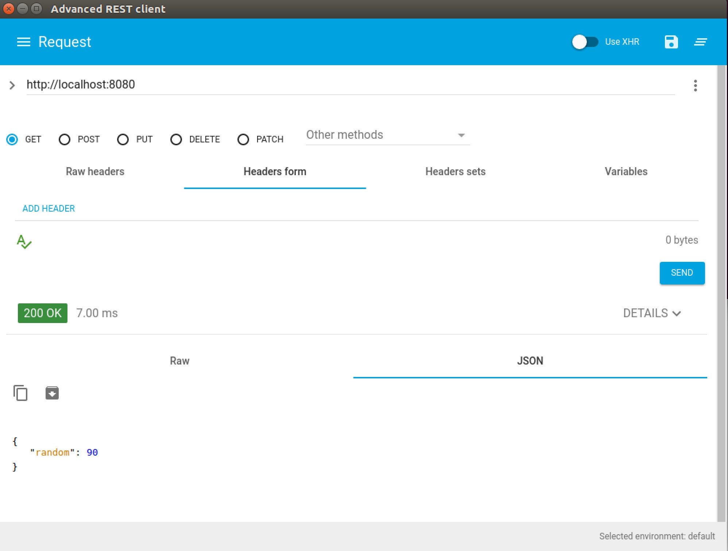

1. *Automated testing of the service*  
   We want this service to meet a set of behavior requirements. To ensure this, we can use a set of tests. There are a number of testing frameworks for SOA services. For this example, we are going to use a JavaScript tool called Frisby (<http://frisbyjs.com/>).  
     
   I have written a test script for this service. It is available as a gist on Github. You can download it onto your VM using the following command:  
   cd ~/ex1  
   curl -L https://freo.me/ex1-frisby -o index.spec.js

The test script looks like this:  
The test does an HTTP GET on the URL and then validates the following aspects:  
a. The return code is 201

var frisby = require('frisby');

const Joi = frisby.Joi;

it('test random number service', function(done) {

frisby.get('http://localhost:8080/')

.expect('status',201)

.expect('header', 'Content-Type', 'application/json; charset=utf-8')

.expect('jsonTypes', '/', { random: Joi.number() })

.then(function(res) {

expect(res.json.random).toBeGreaterThan(1);

expect(res.json.random).toBeLessThan(100);

}

).done(done)

});

b. The Content-Type header is “application/json”

c. The JSON type of the result is a tag random, with type number

d. The JSON contains a tag called random, with a value >1 and <100

1. Before running this, we need to install jest and frisby:  
     
   cd ~/ex1  
   npm install jest --save-dev  
   npm install frisby
2. You can run this test using:  
   npm test
3. *Does the result match your expectations?*
4. Let’s fix the server so that it passes the test, or the test to match the server. I’ll leave this up to you.

*Hint: you will need to stop and restart the node server once you have edited the code.*

1. Is there anything else wrong with the test spec?
2. Once the tests are passing, this exercise is complete.   
    *Recap:*We have created a simple http server that returns a JSON output. We have tested this service in a number of ways – including via browser, ARC, curl and through a proper automated test.  
     
   In our next exercise we will create a client for this service.