**Exercise 5**

*Documenting your service with Swagger*

**Prior Knowledge**

Basic understanding HTTP verbs, REST architecture

Some Java coding skill

**Objectives**

Understanding Swagger and how to embed support into JAX-RS

**Software Requirements**

(see separate document for installation of these)

* Exercise 4 + requirements
* Swagger UI

**Overview**

Swagger - also now known as the Open API Initiative specification - is a simple JSON model for describing RESTful services.

We are going to use some Java tools to create a Swagger description of our API and then use the Swagger tooling to view this.

Steps

1. Start with your **ex4** directory from Exercise 4.
2. Edit the build.gradle to add the following new dependencies:  
     
   implementation('io.swagger.core.v3:swagger-jaxrs2:2.0.6')

implementation('io.swagger.core.v3:swagger-jaxrs2-servlet-initializer:2.0.6')

1. If you do this in vscode, it should automatically refresh the dependencies and download them.
2. We now need to tell the Spring Boot about Swagger and get Swagger’s code running in our microservice.
   1. In PurchaseConfiguration, we need to add a resource to configure Swagger. Underneath the existing *register(..) line,* add a line with:

register(OpenApiResource.class);  
  
If the gradle / vscode plugin has worked, vscode will help you add the import line.  
  
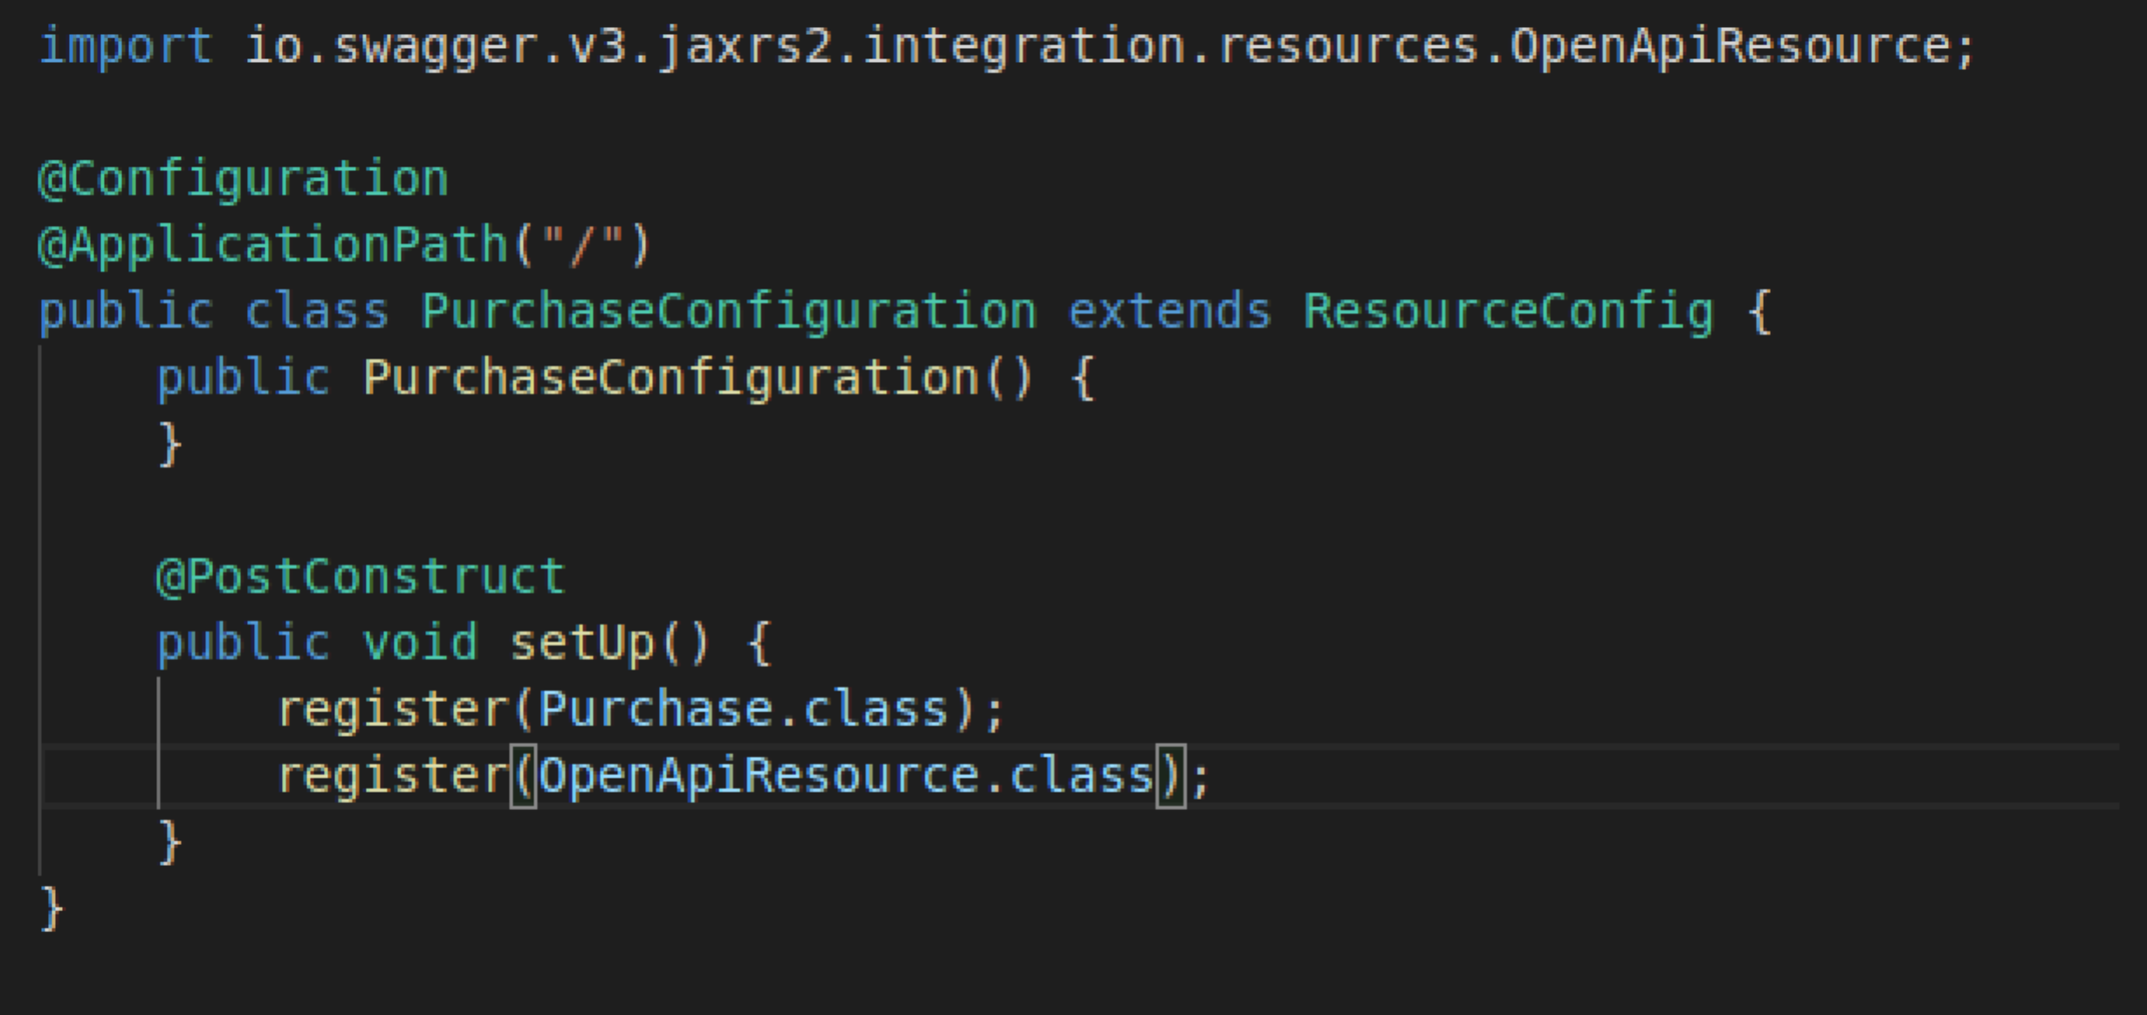

1. We also want the Swagger system to be able to generate a nice tool from our Swagger output. There are two ways to do this. We could embed the whole SwaggerUI into our app but this is complex and would make the lab overly confusing. Instead, we are going to run the Swagger UI and point it to our Swagger definition. This looks like a cross-site scripting attack, and so we need to use the CORS spec to avoid this problem.
2. To allow the SwaggerUI to read our JSON, we need to add some headers into the responses given by Tomcat. We can do this with a servlet filter.
3. Create a new Java class org.freo.purchase.CORSFilter.java

Copy the following code into the file.  
This is available at: <https://freo.me/soa-cors>

package org.freo.purchase;

import java.io.IOException;

import javax.servlet.Filter;

import javax.servlet.FilterChain;

import javax.servlet.FilterConfig;

import javax.servlet.ServletException;

import javax.servlet.ServletRequest;

import javax.servlet.ServletResponse;

import javax.servlet.http.HttpServletRequest;

import javax.servlet.http.HttpServletResponse;

import org.springframework.stereotype.Component;

@Component

public class CORSFilter implements Filter {

@Override

public void doFilter(ServletRequest req, ServletResponse res, FilterChain chain)

throws IOException, ServletException {

HttpServletResponse response = (HttpServletResponse) res;

HttpServletRequest request = (HttpServletRequest) req;

response.setHeader("Access-Control-Allow-Origin", request.getHeader("Origin"));

response.setHeader("Access-Control-Allow-Methods", "POST, GET, OPTIONS, PUT, DELETE");

response.setHeader("Access-Control-Max-Age", "3600");

response.setHeader("Access-Control-Allow-Credentials", "true");

response.setHeader("Access-Control-Allow-Headers", "Foo, Bar, Baz");

chain.doFilter(req, res);

}

@Override

public void init(FilterConfig filterConfig) {}

@Override

public void destroy() {}

}

1. Rebuild the app using **gradle build**
2. Start the Jar using:  
   java -jar build/libs/purchase-0.0.2.jar
3. Browse to <http://localhost:8080/openapi.json>  
     
   If this has all worked properly, you should see a lot of JSON like this:  
   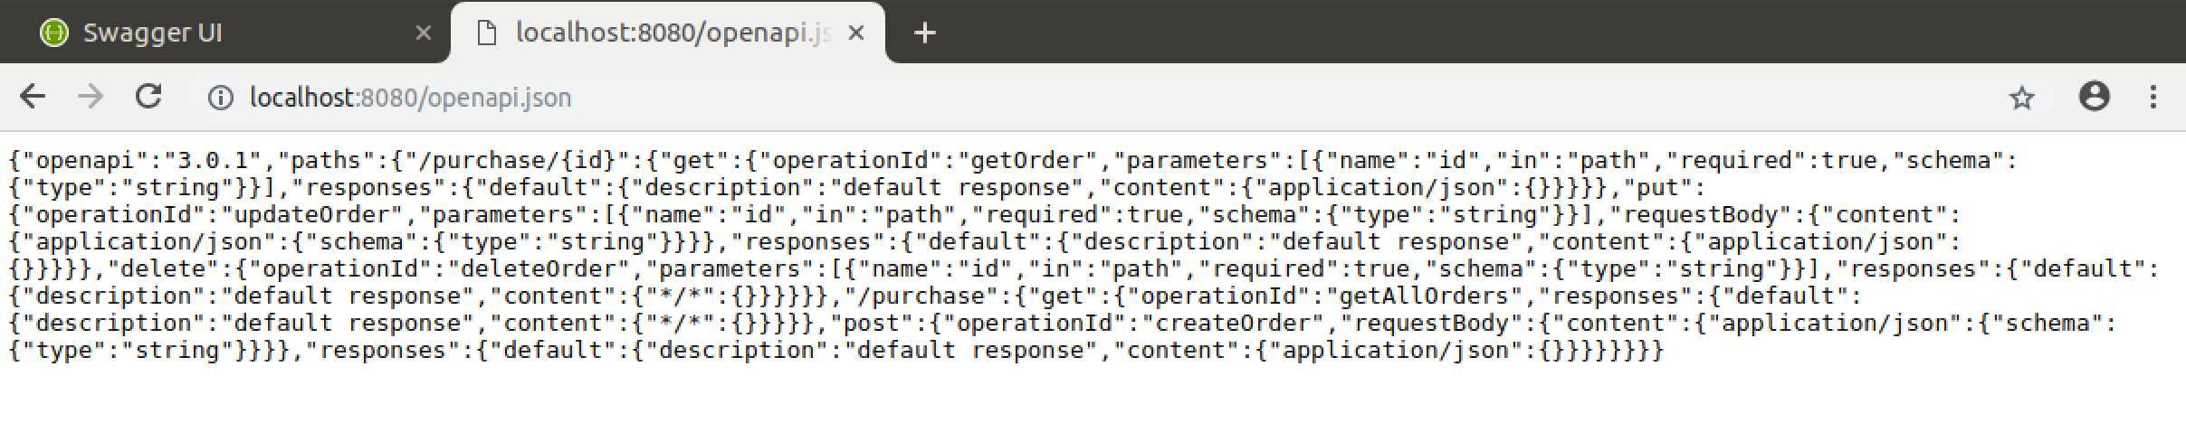

We will use Docker to run the Swagger UI (this will be explained in another exercise).  
  
In a new shell window, type:  
docker pull swaggerapi/swagger-ui   
docker run -p 80:8080 swaggerapi/swagger-ui

1. This will start the Swagger UI running on port 80. Browse to:  
   <http://localhost>   
   You should see a nice UI like this:
2. 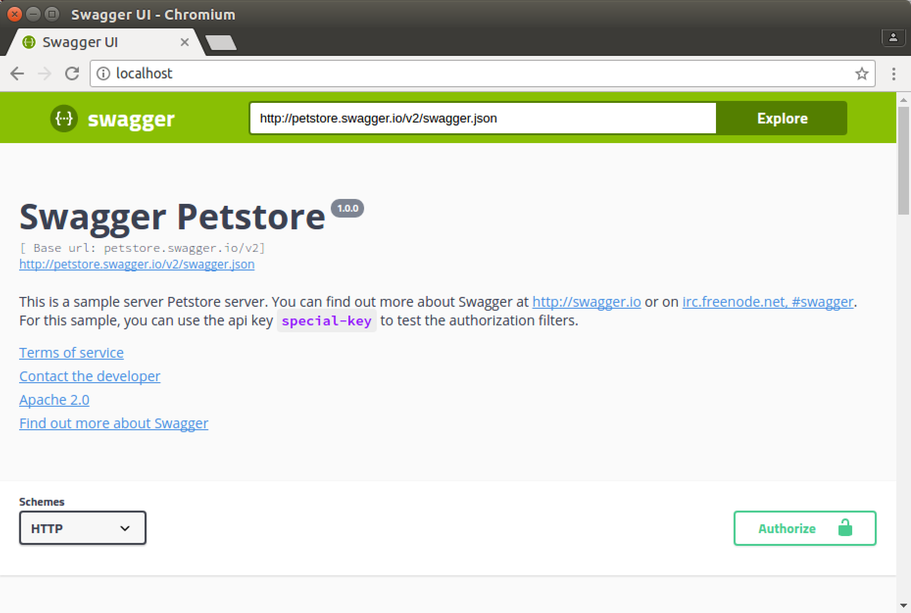In the URL box set the URL to be <http://localhost:8080>/openapi.json
3. You should see this:  
   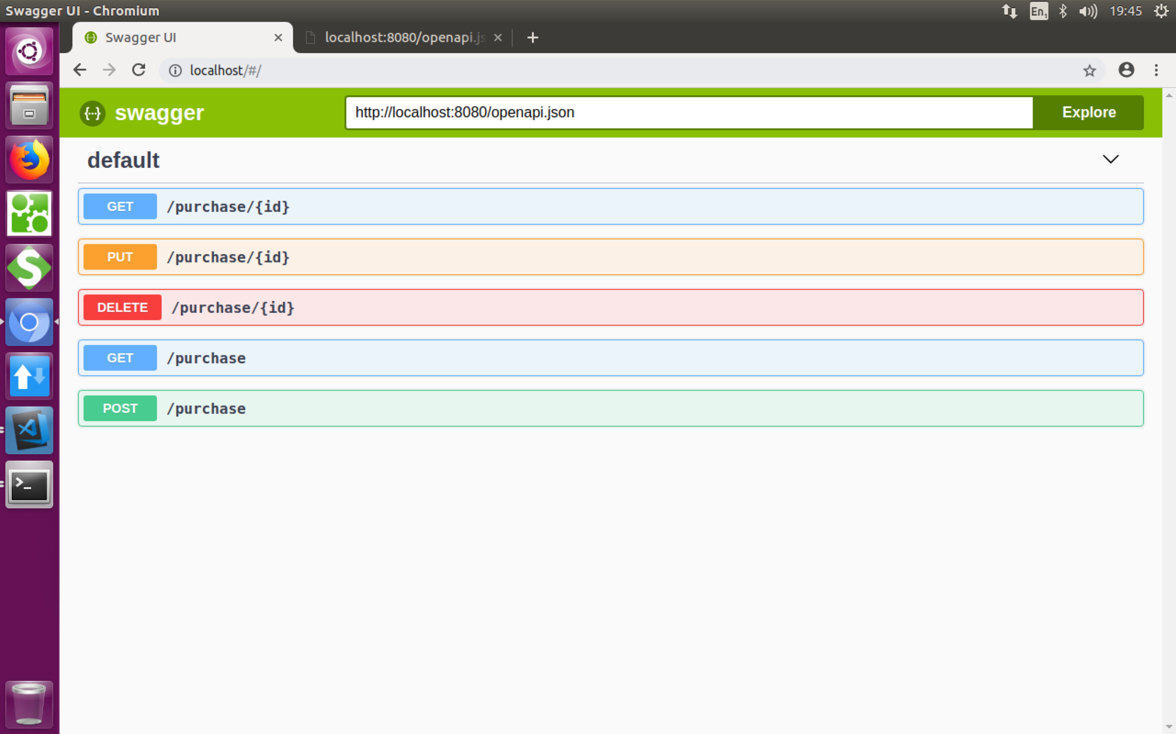
4. Explore the API and try it out using the Swagger test tool.
5. That’s all!