**Exercise 14**

*Messaging and MQTT, Wire Tap pattern, MongoDB*

**Pre-reqs**

ESB configuration from Exercise 10

**Objectives**

In this lab we are going to explore some alternatives to what we’ve covered so far.

We are going to use a message pub/sub protocol (MQTT) and store messages into a NoSQL database MongoDB. The plan is to use the Wire Tap pattern to grab the messages as they flow through the ESB and then pass them over to a pub/sub broker. Once they are there we can easily subscribe to them and store them in the Database.

**Install MQTT sender support into the WSO2 ESB**

1. Before we can implement the wire tap, we need to enable the ability to send MQTT messages in the WSO2 ESB. Let’s add the required libraries.

Download the following two files (in each case, follow the link and then click **Download** to start the download).  
<http://freo.me/mqtt-jar>  
<http://freo.me/mqtt-axis2>  
  
Now (each cp is all one line!):  
cp ~/Downloads/mqtt-client-0.4.0.jar ~/servers/wso2esb-4.9.0/repository/components/lib  
  
cp ~/Downloads/axis2-transport-mqtt-1.0.0.jar ~/servers/wso2esb-4.9.0/repository/components/lib

1. Edit axis2.xml:  
   atom ~/servers/wso2esb-4.9.0/repository/conf/axis2/axis2.xml  
     
   On line 453 remove the comment marks <!-- and --> so that the MQTT transport sender is enabled.
2. Restart the ESB (or start it) the same as in Exercise 10.  
   cd ~/servers/wso2esb-4.9.0/  
   bin/wso2server.sh
3. **Install Mosquitto**  
   In a new terminal window:  
   sudo apt-get install -y mosquitto mosquitto-clients
4. This will automatically start mosquitto but I’d rather see the verbose debug, so:  
     
   sudo service mosquitto stop  
   mosquitto -v
5. I have updated the PayAPI from Exercise 10 to add the wiretap code.
6. You can deploy this by downloading the .car file from:  
   <http://freo.me/pay-wiretap>  
     
   Click View Raw to download it.
7. You can deploy this API CAR file via the console, or you can simply copy it into the right place:  
   cp ~/Downloads/WireTapProject_1.0.0.car ~/servers/wso2esb-4.9.0/repository/deployment/server/carbonapps
8. You can look at the changes from the previous API in the console.   
   The main change is the addition of this mediation XML *before* we convert the payload body to XML.

<clone continueParent=”true”>

<target>

<sequence>

<call>

<endpoint>

<address

uri=

"mqtt:/local?mqtt.server.host.name=localhost&amp;mqtt.server.port=1883&amp;mqtt.client.id=esb.test.sender&amp;mqtt.topic.name=/pay&amp;mqtt.subscription.qos=0&amp;mqtt.blocking.sender=true" />

</endpoint>

</call>

</sequence>

</target>

</clone>

1. Make sure the backend is running.  
   If not then you can do:  
   sudo docker run -d -p 8080:8080 pizak/pay
2. Start a subscriber to MQTT in a new terminal window so you can see any messages to the MQTT server:  
     
   mosquitto_sub -v -t "/#"

If you look at the mosquitto server window you should see this happen.

This subscribes to all topics and uses a verbose output.

1. Now try out the API using the Advanced REST client  
   Everything is the same as in Exercise 10, except that the URI is  
   <http://localhost:8281/paywire>  
     
   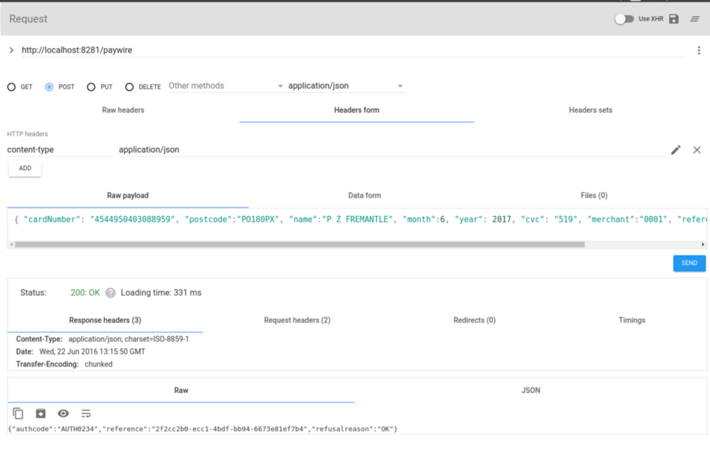
2. You should see a copy of the JSON now appear in your subscriber window:  
   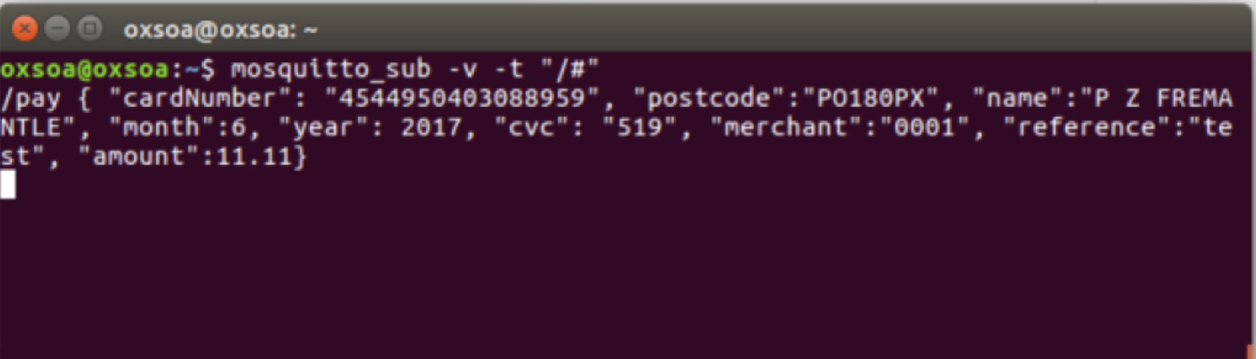

1. **Part B - storing the messages from the wiretap into MongoDB**
2. We are going to write a very simple Node.js app to grab the messages from the MQTT broker and save them into MongoDB.
3. Firstly we need some dependencies installed:  
   sudo apt-get install -y mongodb
4. Create a new directory:

mkdir ~/ex14

cd ~/ex14

1. Here is a really simple node app which will listen on MQTT /pay and save those messages to Mongo:

<http://freo.me/ex14-mqtt>

var mqttClient = require('mqtt').connect('mqtt://localhost');

var uuid = require('uuid');

mqttClient.on('connect', function () {

mqttClient.subscribe('/pay', {qos:0});

});

var mongoClient = require('mongodb').MongoClient.connect("mongodb://localhost/test", function(err, db) {

if (err==null) {

mqttClient.on('message', function (topic, message) {

json = JSON.parse(message);

json.uuid = uuid.v4();

insertJSON(db, 'pay', json, function(result) { console.log(result);});

});

}

});

var insertJSON = function(db, collection, json, callback) {

var collection = db.collection(collection);

collection.insertOne(json, function(err, result) {

if (err) console.log(err);

callback(result);

});

}

1. Create a file mqtt-mongo.js and copy this code into it.
2. Use npm init to create a new package for this code:

> **npm init**

This utility will walk you through creating a package.json file.

It only covers the most common items, and tries to guess sensible defaults.

See `npm help json` for definitive documentation on these fields

and exactly what they do.

Use `npm install <pkg> --save` afterwards to install a package and

save it as a dependency in the package.json file.

Press ^C at any time to quit.

name: (ex14) **mqtt-mongo**

version: (1.0.0)

description:

entry point: (mqtt-mongo.js)

test command:

git repository:

keywords:

author:

license: (ISC)

About to write to /home/oxsoa/ex14/package.json:

{

"name": "mongo-mqtt",

"version": "1.0.0",

"description": "",

"main": "mqtt-mongo.js",

"scripts": {

"test": "echo \"Error: no test specified\" && exit 1"

},

"author": "",

"license": "ISC"

}

Is this ok? (yes) yes

1. Add the required libraries:  
   npm install mqtt mongodb uuid --save

m

1. Run this:  
   node mqtt-mongo.js
2. Now push some messages through the ESB and see them appear in Mongo.
3. You can look at the mongo database by doing:

