**Exercise 14**

*Using SOAPUI to interact with a sample SOAP Service*

**Prior Knowledge**

XML

**Objectives**

Deploy a ready built service in Docker

Call the service using SOAP message

See sample SOAP messages

**Software Requirements**

These are already installed on the VM.

* Docker
* SOAPUI 5.0.0 or later

1. Firstly, you can make sure all previous servers (tomcat, purchase, node, mitmdump, etc) are closed down as we don’t need them for this exercise.
2. We are going to use Docker to run a SOAP service. In this lab, we are going to take a WSDL/SOAP payment service that is loosely modeled on a real SOAP API.  
    (Barclaycard SmartPay <https://www.barclaycard.co.uk/business/accepting-payments/website-payments/web-developer-resources/smartpay#tabbox1>).
3. Use docker to run the SOAP service

docker run -d -p 8888:8080 pizak/pay  
  
This offers the docker based service (which is a WAR file running in Tomcat) at port 8888 (mapped from the original 8080 that the Docker image offers).

1. Check to see if its running:   
   Browse: <http://localhost:8888/pay/services>
2. You should see a SOAP Web Service listed with a link to the WSDL.

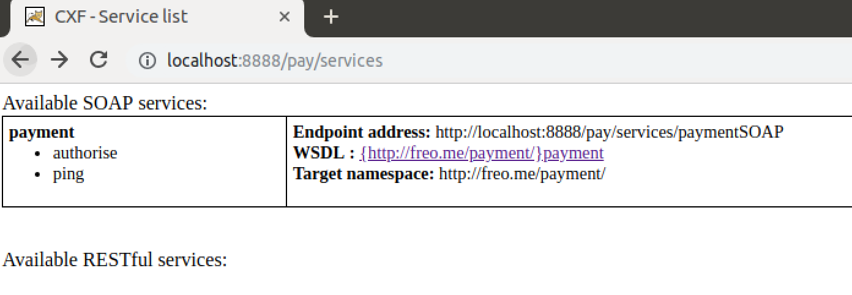

1. Click on this link. You should see a WSDL  
   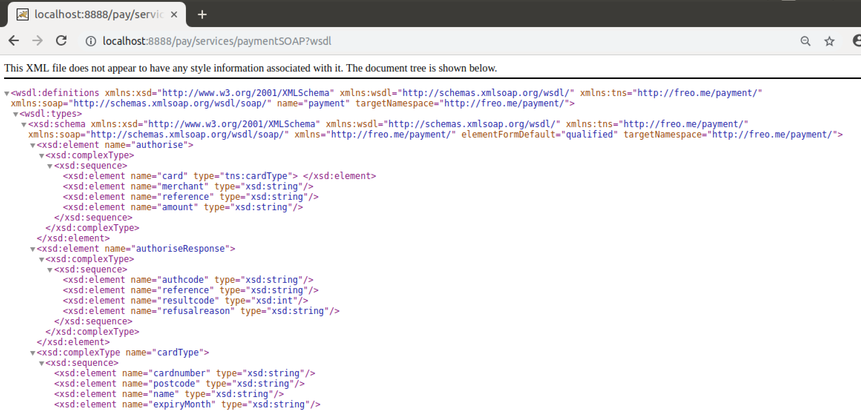
2. Copy the WSDL link (<http://localhost:8888/pay/services/paymentSOAP?wsdl>) into the clipboard.
3. Now start up SOAPUI from the launcher:  
     
   You should see a screen like this:  
   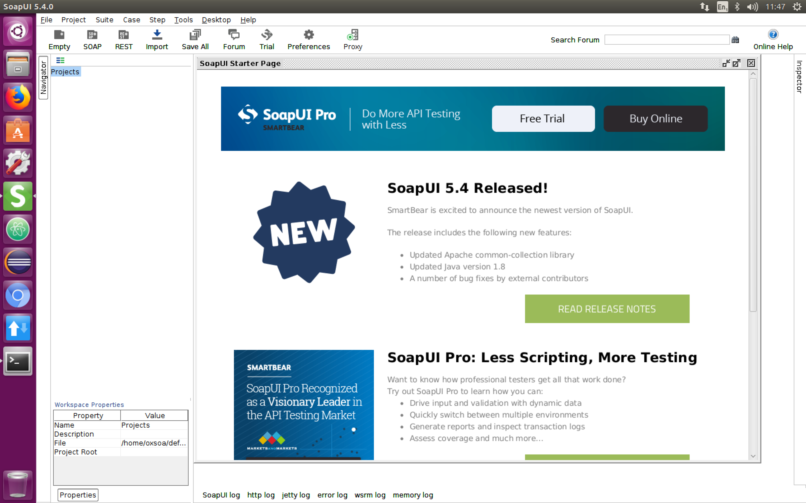
4. Start a new SOAP Project: **File->New SOAP Project  
   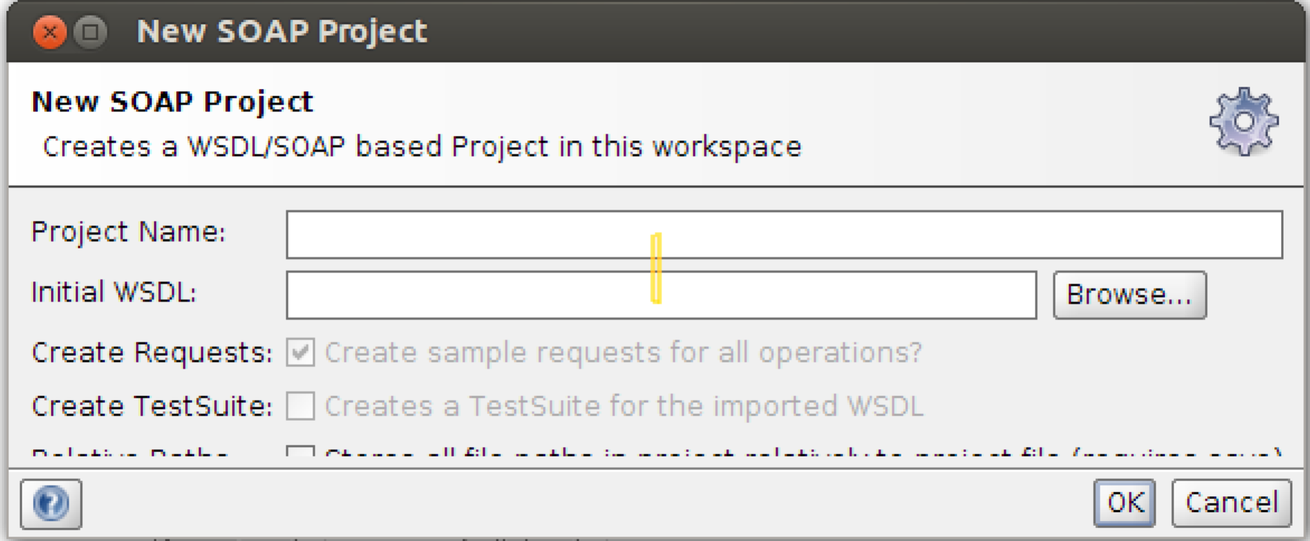**
5. Type in a name for the project (e.g. Payment)  
   Paste the WSDL URI into the **Initial WSDL field**Hit **OK**
6. Now open up the Request editor for one of the operations. You can do this by navigating the service tree in the left window until you see a Request object and click on that.
7. Choose the **ping** request  
   In the XML Payload, change the ‘?’ field into “hello”.   
   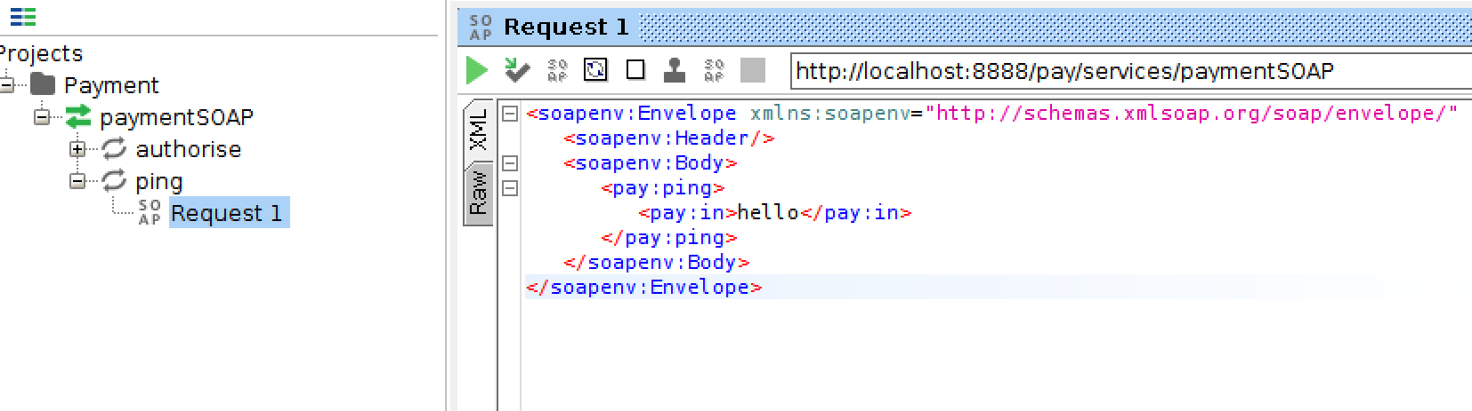
8. Now hit the little green arrow (Run) button.
9. You should see a response from the service.   
   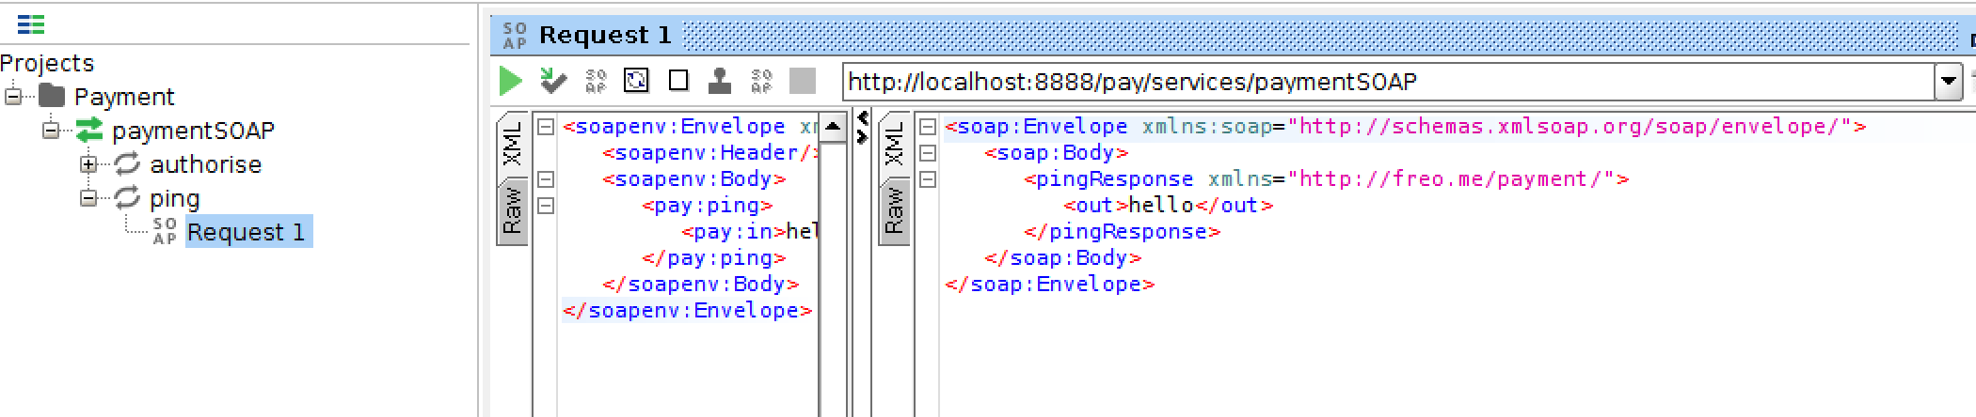
10. Now do the same for the Authorise method. Fill in some data. e.g. 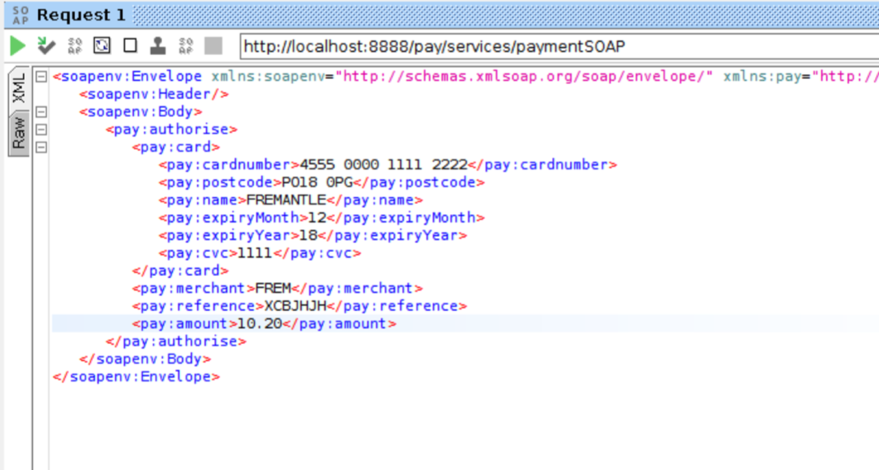
11. You should see a response (either success or failure) like:  
    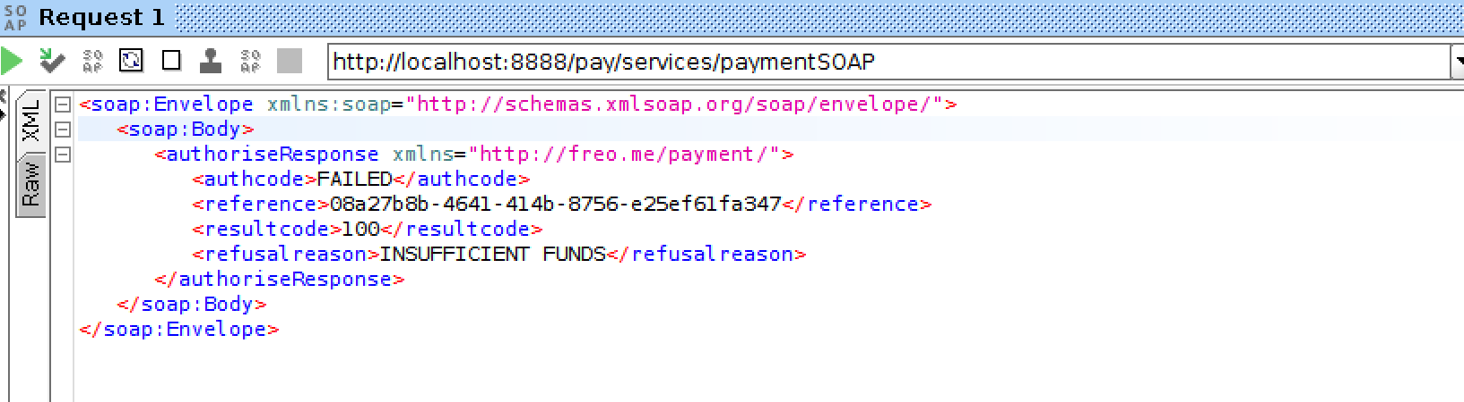
12. Take a look at the HTTP Headers and the other data SOAPUI gives you.  
    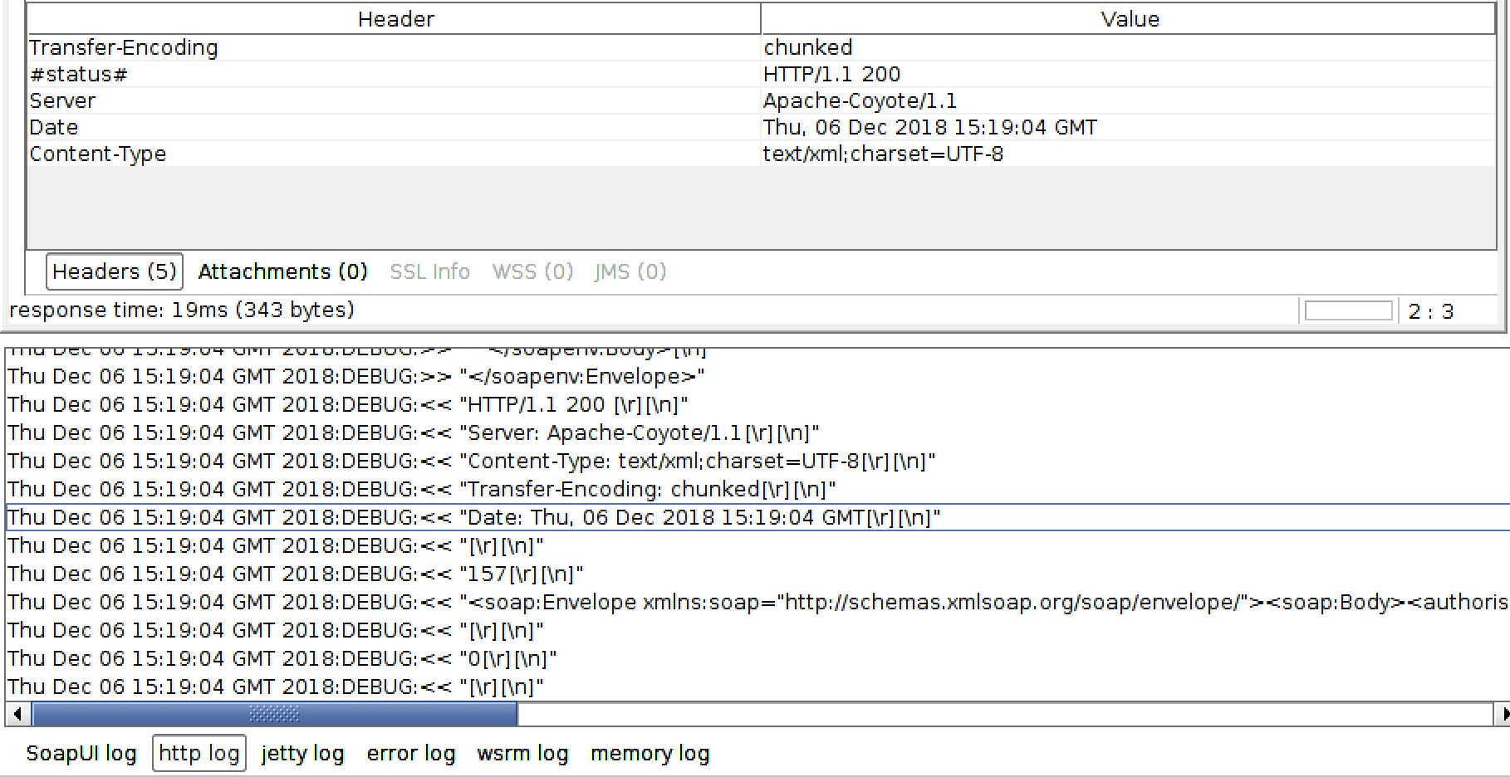
13. That’s all.
14. **Extension:** get the interaction to go via MITMDUMP.