**Julia Language Final Report**

**海洋環境資訊系4A曾鈺皓**

****Julia code

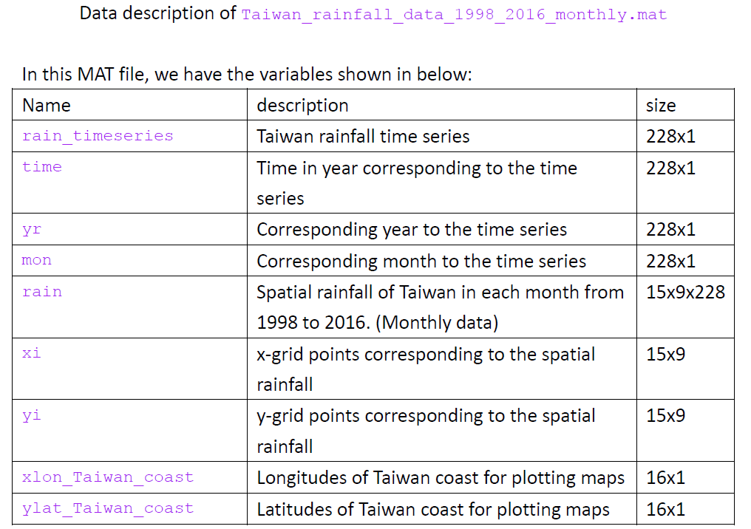

**1) Try to reproduce two figures shown above. For the left figure, it is the total mean** **of rainfall on each grid. For the right figure, it is plotted by using the MATLAB**

**variable called "rain_timeseries" in the given mat file (see the table next page).** **Remember to add in some labels to the figures.**

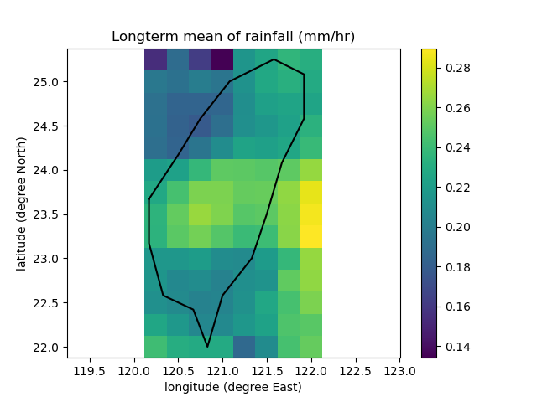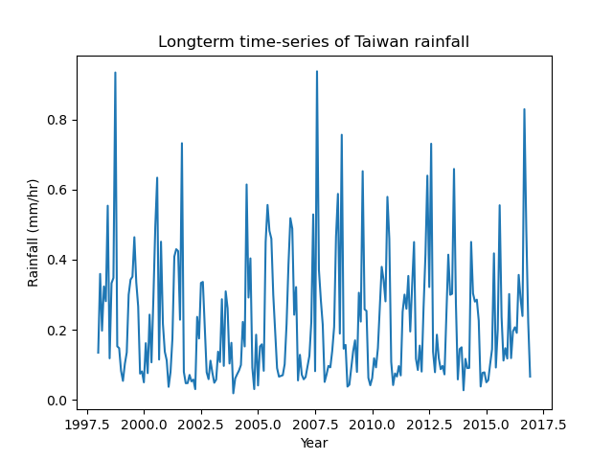

**2) What does the spatial distribution of Taiwan rainfall look like in January and June?** **To solve this question, we first need to calculate the average of rainfall on each** **grid in January and June. Then, plot a figure with two sub-plots to separately** **show the spatial distribution of rainfall in January and June. Remember to add in** **some labels to the sub-plots.**

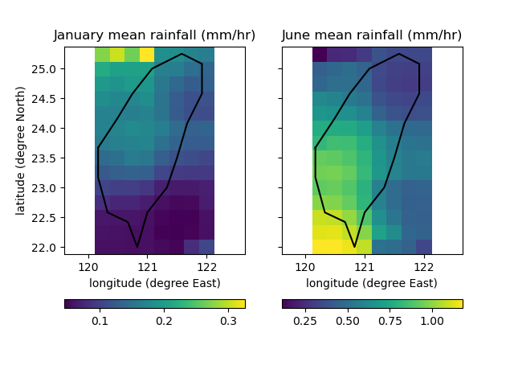

**3) In which months that we generally have the maximum and minimum rainfall in a** **year? (Need to prove and show the answer in a figure)**

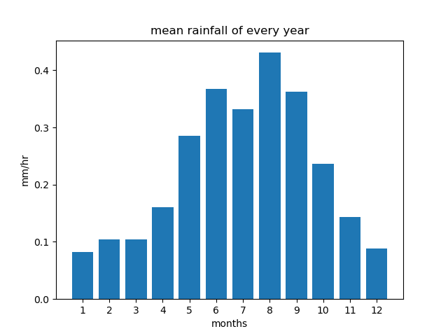

maximum rainfall：August

minimum rainfall：January

**4) In which year that we have the most rainfall in June? (Need to prove and show** **the answer in a figure)**

2012 have the most rainfall in June.

