**Permanent Service for Mean Surface Level (PSMSL)**

Cheng, kai-ho

1. Download RLR monthly data
2. Load the dataset to Matlab and comprehend its contents..
3. Plot the location of all stations on the map

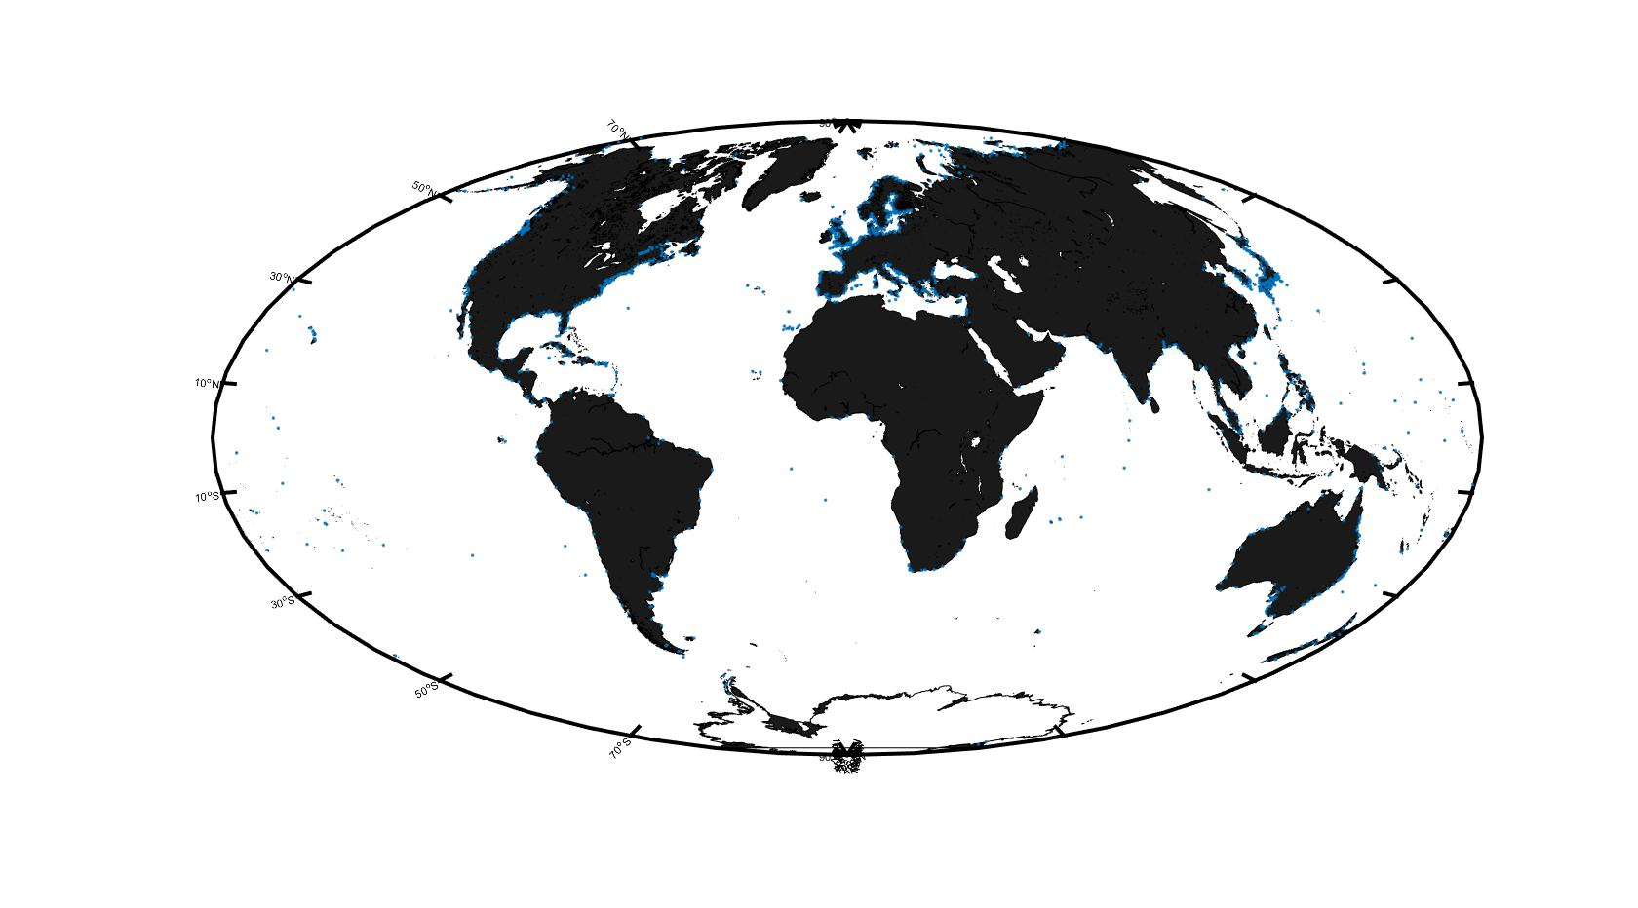

1. Please use different colors to plot the stations of coastline 612 and 642 on the map. 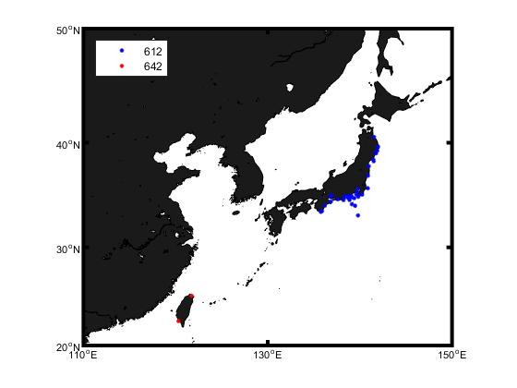
2. Then, choose Keelung and Kaohsiung stations to plot the time series of sea surface height. 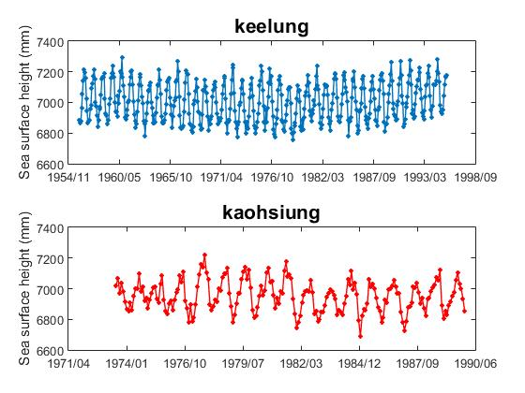
3. Plot the location of the stations where was located from 100°E to 160°E and 0°N to 60°N on the map.

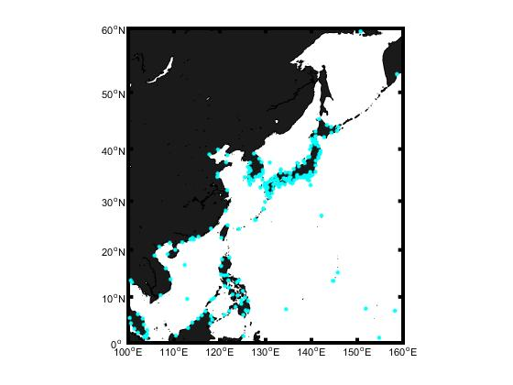

1. Plot the location of the stations where was located from 100°E to 100°W and 0°N to 60°N on the map.

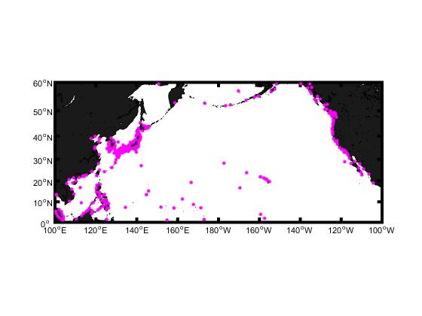

1. Continuously, use different colors to divide the time series length into more than 100 years, 50 to 100 years, 25 to 50 years and less than 25 years .

