**洋流觀測分析作業2 00781035 曾鈺皓**

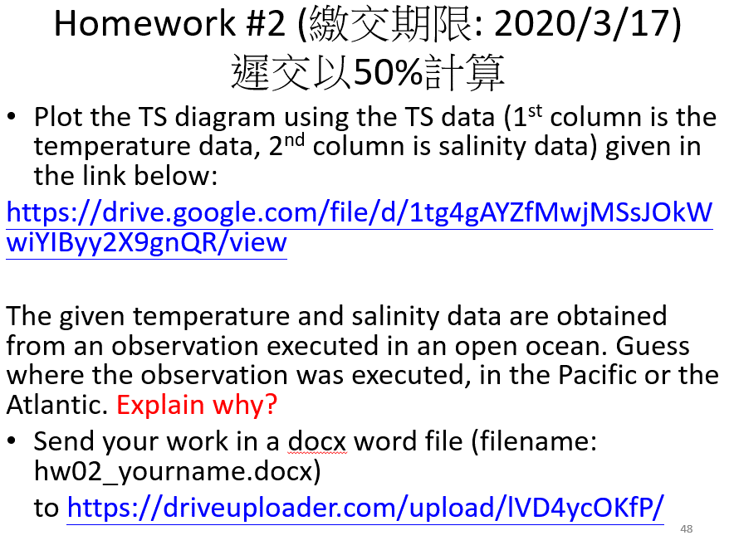

1. 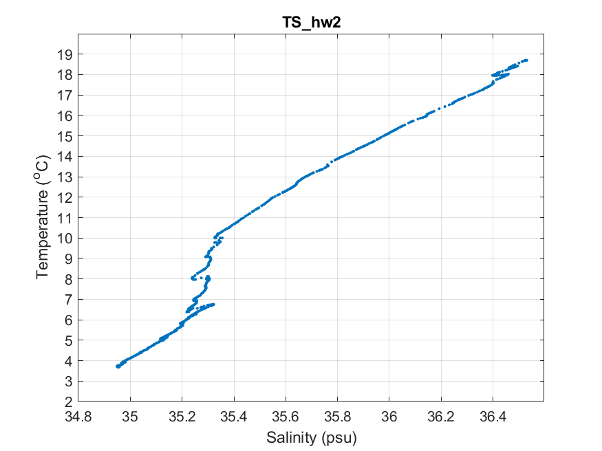
2. 根據觀測資料所繪製出來的T-S diagram，我認為這份資料是在大西洋進行觀測。因為在圖TS_hw2當中散佈的資料點可以對應到下圖的「N.ATLANTIC CENTRAL WATER」帶狀區間內。According to the T-S diagram from the given data, I think the observation was executed in the Atlantic Ocean because the data points of the plot TS_hw2 located in the interval of the band of N.ATLANTIC CENTRAL WATER.

