**洋流觀測分析作業3 00781035 曾鈺皓**



1. 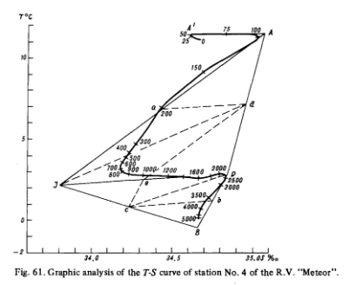**The earliest station of the T-S curves I found were located at No.4 of R.V.“Meteor”stations along the eastern coast of South America(Atlantic Ocean).These station were chosen on 7-8 June,1925 in coordinates 41∘27’S 52∘47’W.**

**My answer to the question have some uncertainty because there are too many different searching results on Google.**

1. 參考資料

<https://divediscover.whoi.edu/history-of-oceanography/>

<http://w3.oc.ntu.edu.tw/chap6/chap6.htm>

<https://drive.google.com/file/d/1WvyJJuf-QYL537e_y5GmvZ6t_Sy_z-N_/view?usp=sharing>

<https://oceanobservatories.org/2011/06/ctd-101/>

<https://www.whoi.edu/press-room/obituary/neil-brown/>

<https://www.researchgate.net/publication/276849288_A_brief_history_of_Physical_Oceanography_In_Ocean_Digest_Quarterly_Newsletter_of_Ocean_Society_of_IndiaISSN2394-1928_042015_Volume_228-12>

<https://www.sciencedirect.com/topics/earth-and-planetary-sciences/physical-oceanography>

<https://www.uv.es/hegigui/Kasper/por%20Robert%20H%20Stewart.pdf>

<https://books.google.com.tw/books?id=UYk7UE6Cov8C&pg=PA119&lpg=PA119&dq=the+first+t-s+diagram+in+the+world&source=bl&ots=VKLpsztL0G&sig=ACfU3U1DG5qTivjyUOoLoNOJnzR5YGrJKA&hl=zh-TW&sa=X&ved=2ahUKEwjksrqk8bDoAhWO-2EKHa7-AicQ6AEwAHoECAQQAQ#v=onepage&q=station&f=false>