**洋流觀測分析作業4 00781035 曾鈺皓**

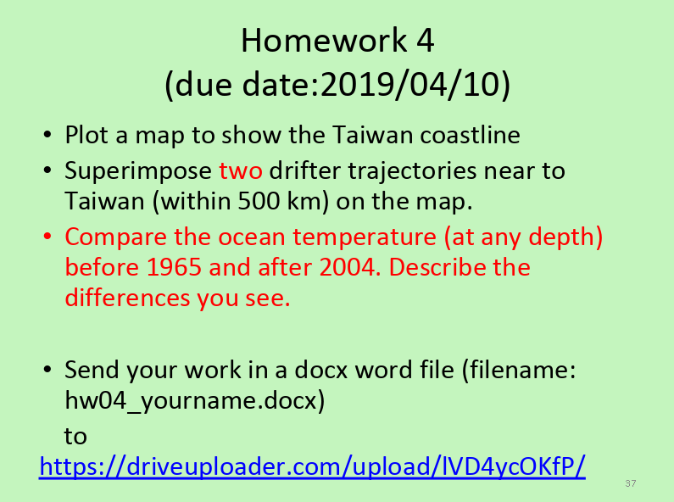

MATLAB CODE : [W4_hw_Taiwan_two_trajectories.m](https://drive.google.com/open?id=1NGxA31hBEkynwjajy0JTl5dQ_VqFPjWZ)

1. [**https://drive.google.com/file/d/1KADyXVnopDsT5kbAGlDhrCgGLuPW-0EH/view?usp=sharing**](https://drive.google.com/file/d/1KADyXVnopDsT5kbAGlDhrCgGLuPW-0EH/view?usp=sharing)

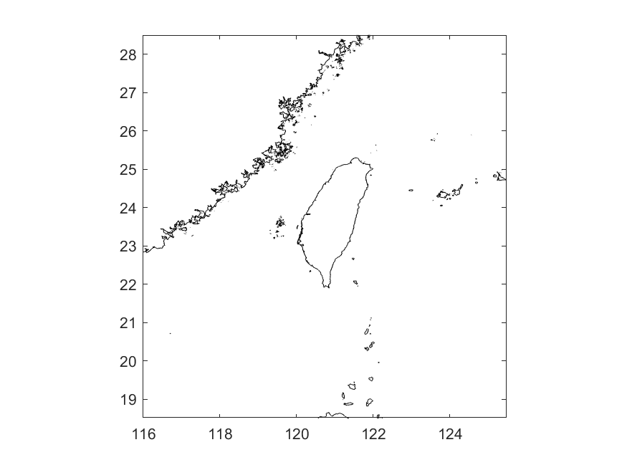

1. <https://drive.google.com/file/d/1mfvlcmgf46LRpQrTP6h0ZksLvqNajfhV/view?usp=sharing>

