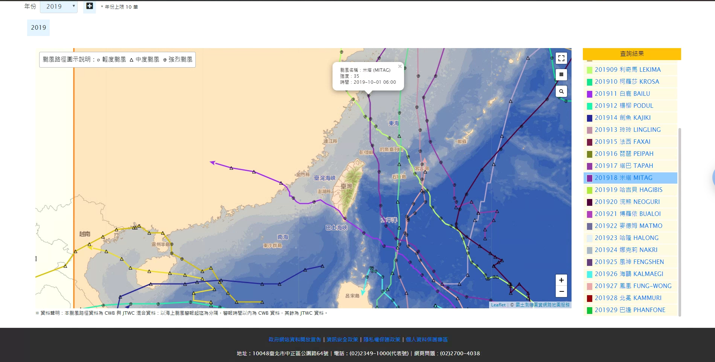

<https://rdc28.cwb.gov.tw/TDB/public/advanced_query/>

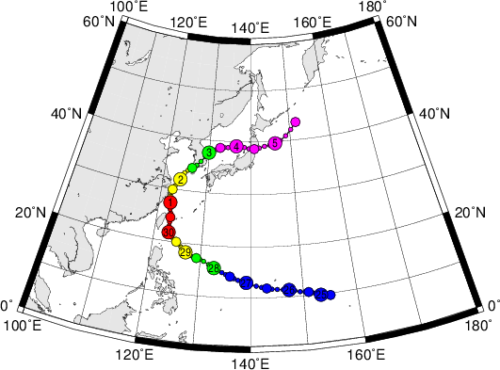

<http://agora.ex.nii.ac.jp/digital-typhoon/summary/wnp/s/201918.html.en>

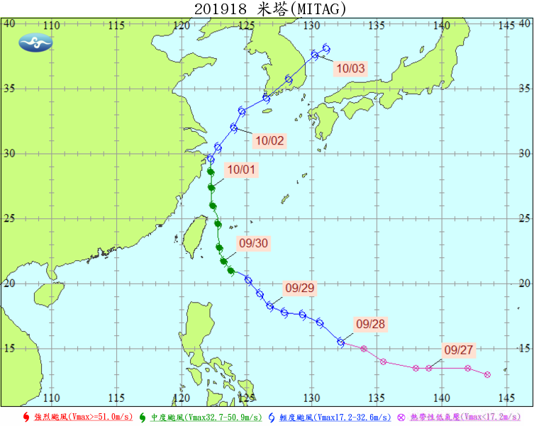

<https://rdc28.cwb.gov.tw/TDB/public/typhoon_detail?typhoon_id=201918>

2019/09/27 ~ 2019/10/03

Figure :

<https://drive.google.com/open?id=1NX90bOpiIVxhwem-KBr4niekOhLSJ7ZK>

Code :

<https://drive.google.com/open?id=1qe57tlfkIBX5BAdJxXSY2_qz0kdywVvG>