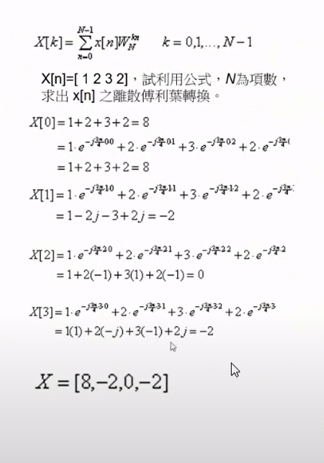

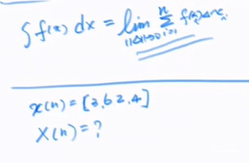

x = [3, 6, 2, 4]

Solution :

X = [15 , 1 - 2i , -5 , 1 + 2i]