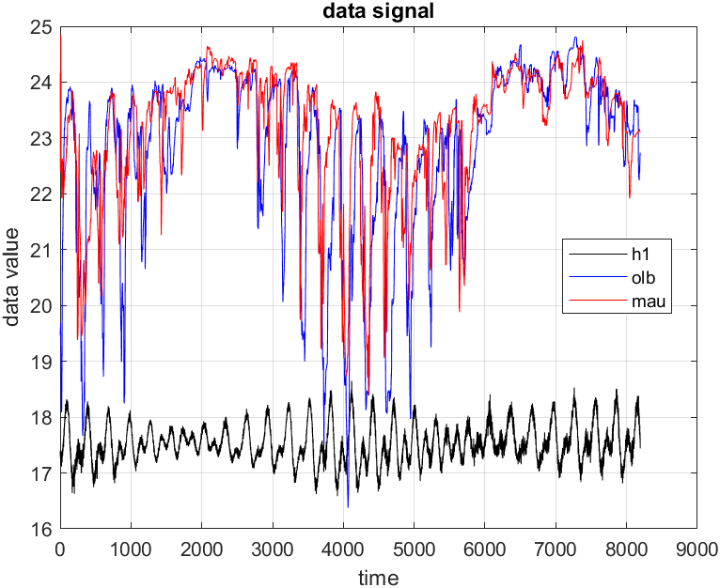W5_HW3 00781035 曾鈺皓

1. Cross-correlation of **detrended h1** and **detrended olb**

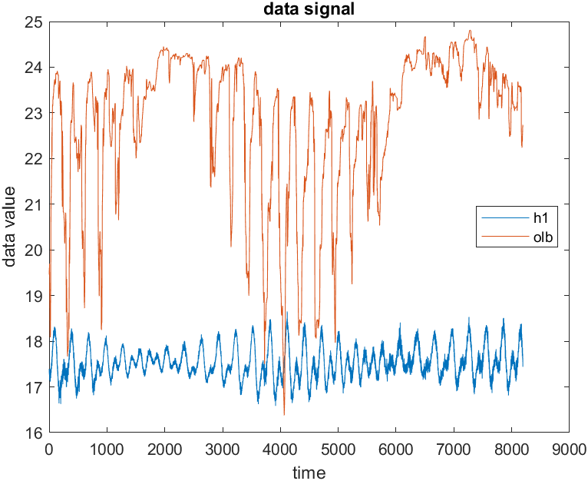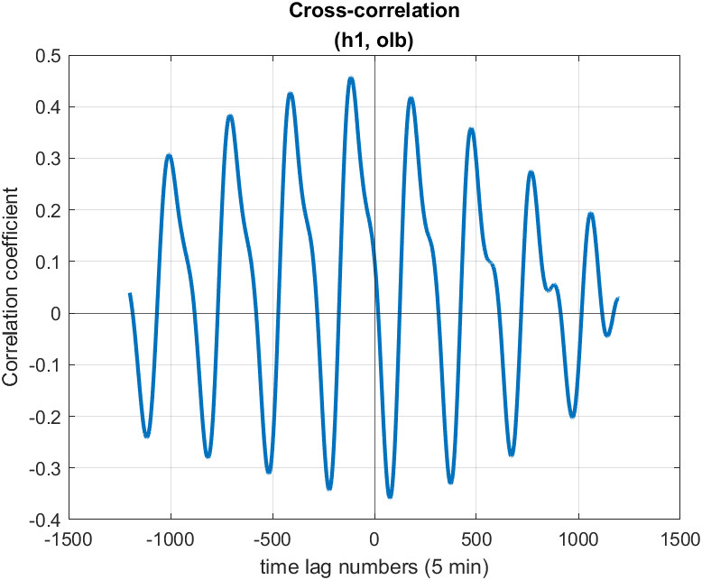

|  |  |
| --- | --- |
| Maximum correlation coefficient | 0.4570 |
| Corresponding time lag | The signal h1 leads 575 minutes relative to the signal olb. |
| Corresponding r square | 0.2089 |

1. Cross-correlation of **detrended h1** and **detrended mau**

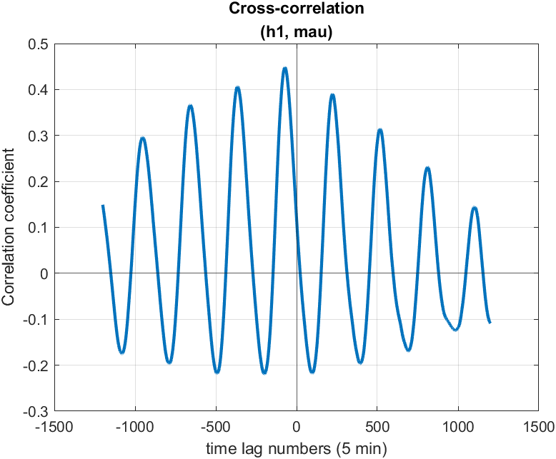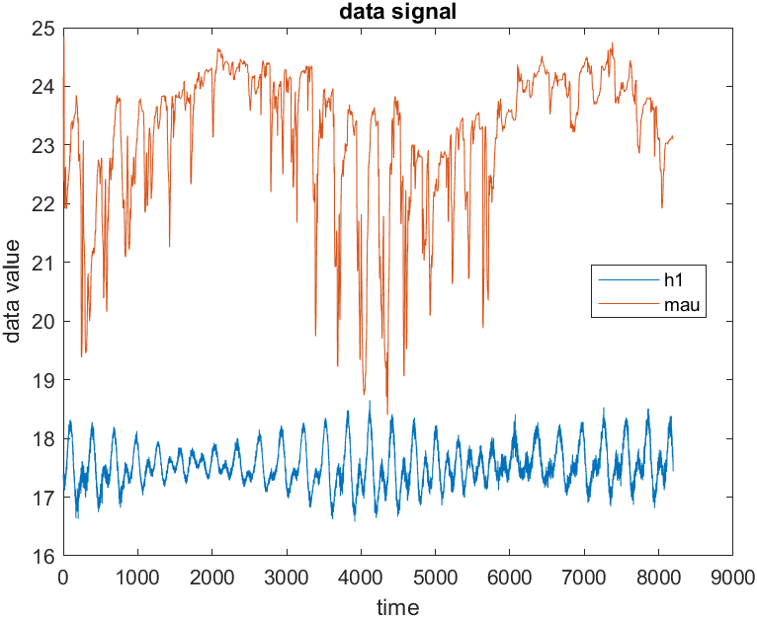

|  |  |
| --- | --- |
| Maximum correlation coefficient | 0.4484 |
| Corresponding time lag | The signal h1 leads 360 minutes relative to the signal mau. |
| Corresponding r square | 0.2010 |

1. Cross-correlation of **detrended olb** and **detrended mau**

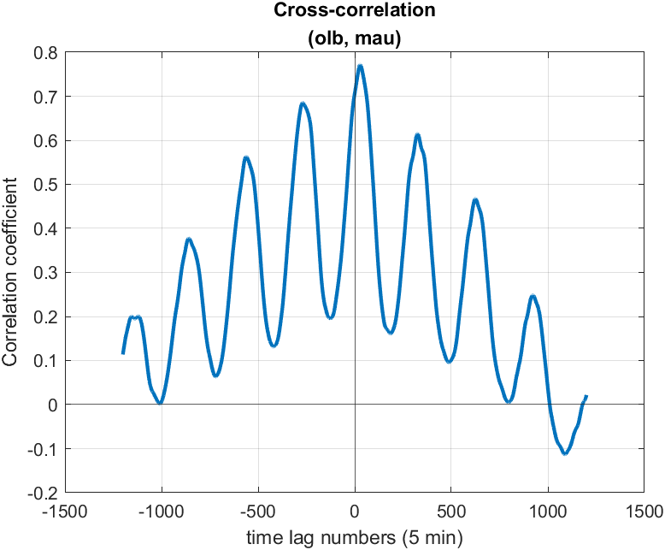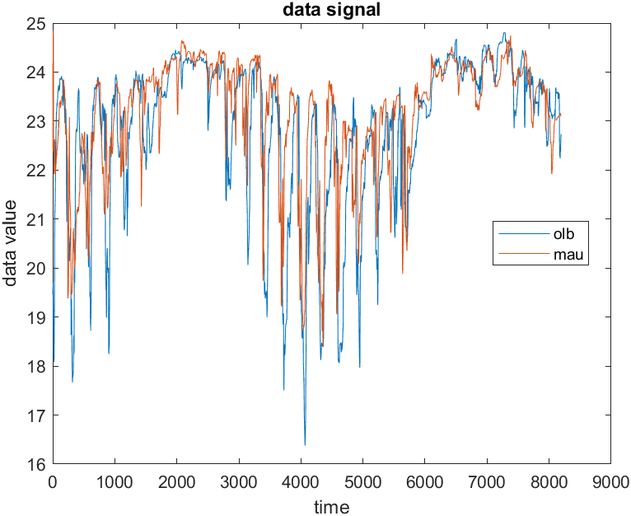

|  |  |
| --- | --- |
| Maximum correlation coefficient | 0.7714 |
| Corresponding time lag | The signal olb lags 140 minutes relative to the signal mau. |
| Corresponding r square | 0.5950 |