W7_HW5_00781035_曾鈺皓

x1 = [0, 2, 2.5, 1, 4, 7]

x2 = [0, 1, 2, 3, 6, 2]

y = [3, 6, 3, -8, -11, 21]

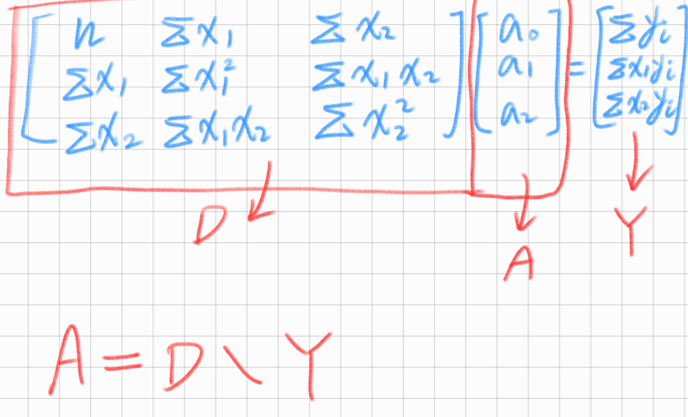

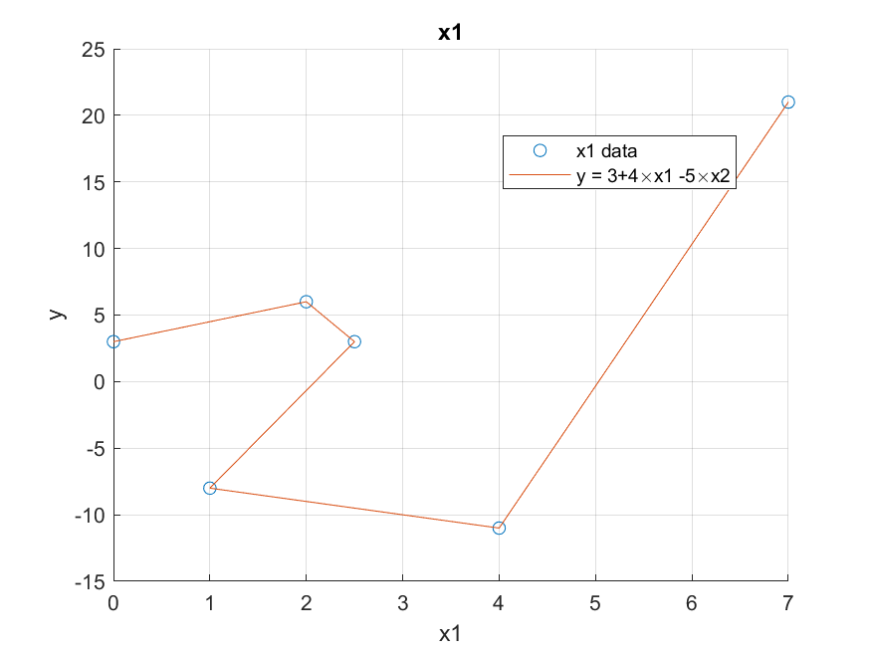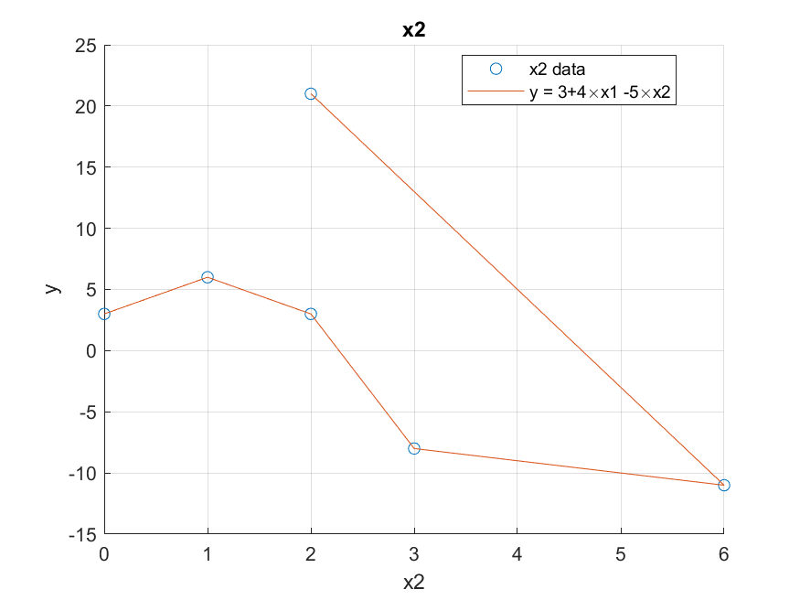

a0 = 3

a1 = 4

a2 = -5

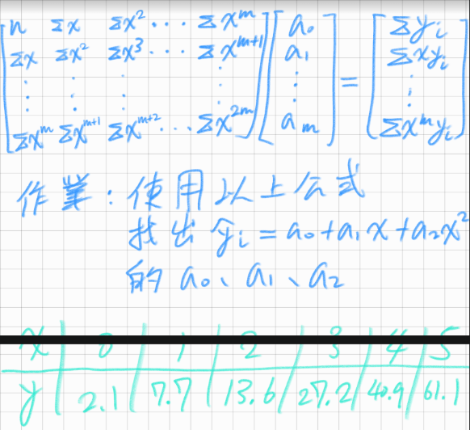

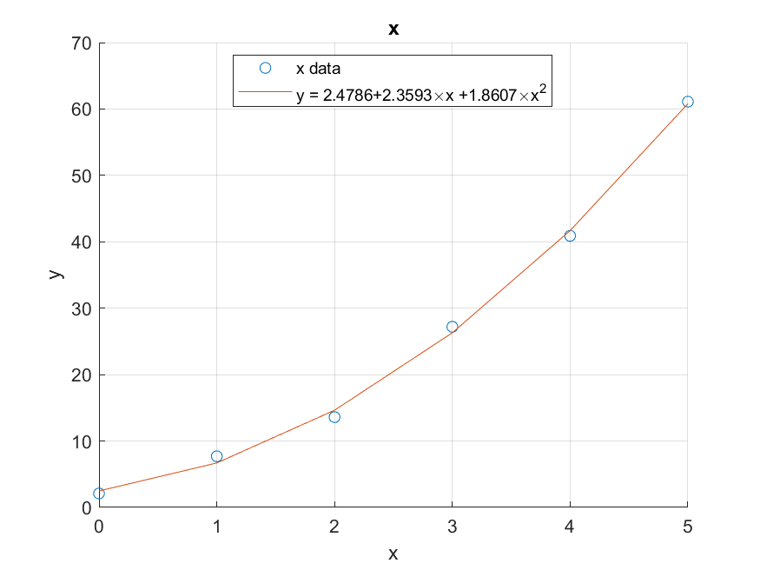

a0 = 2.4786

a1 = 2.3593

a2 = 1.8607