**Juber Ahmed**

**CS 389**

GitHub Tutorial

**Part 1:**

Install GitHub bash http://git-scm.com/downloads and browse the documentation. Create an account if you do not have one.



**Part 2:**

What is GitHub? When was it created? Why? By who? What similar platforms exist? Why would you use such a platform? (Answer between 5 and 10 lines)

Github is a web-based Git repository which offers revision control and source code management. The development of the GitHub platform began on October 1, 2007. The site was launched in April 2008 by Tom Preston-Werner, Chris Wanstrath and PJ Hyett. Similar platforms exist, to name a few: SourceForge, Bitbucket and Redmine. One would use these any of these platforms for group coding projects.

**Part 3:**

Go through the Git tutorial here: https://try.github.io/levels/1/challenges/1. While doing the tutorial, save your work in a Word file called FirstnameLastnameGitTutorial-mm-dd-yyyy.docx.

Commands Learned:

git init - quickest way to initialize a repository

git status - to check if any changes were made in the repo

git add - add the contents of the repo to your local file

git commit - save the changes in the repo

git log - journal that remembers all the changes that was committed

git push - push local changes into original repo

git pull - pull any new changes that have occurred in the repo

**Part 4:**

* Repository - a central location in which data is stored and managed
* Commit - a message describing what we changed
* Push - push command tells Git where to put our commits when ready
* Branch - a copy (aka. branch) of their code they can make separate commits to
* Fork - A fork is a copy of a repository
* Merge - After you have finished implementing a new feature on a branch, you want to bring that new feature into the main branch, so that everyone can use it.
* Clone - to clone a repository means that you will download the whole code of the repository
* Pull - Pull refers to when you are fetching in changes and merging them
* Pull request - Pull requests let you tell others about changes you've pushed to a repository on GitHub

**Part 5:**

Push the Word file in your GitHub account in a repository called *cs389spring2015*. You will use this repository this semester.

**Part 6:**

Retrieve the file README.md at: https://github.com/paceuniversity/courses

Add your name (firstname lastname) in the file, add a comment, and update the file README.md at: <https://github.com/paceuniversity/courses>. List the commands and strategy you use to do this part of the exercise. Please note that the changes must be in https://github.com/paceuniversity/courses (my repository). Please note that I may have to accept the change before it appears for you.

1. Fork the repo
2. git pull to save the repo on my local computer
3. Open the README.md and added my name
4. git commit
5. git pull request to ask the repo owner to add my changes.

**Part 7:**

Add an issue with title “GitHub training” in your repository called cs389spring2015. Issues will be used for tasks and bug reports.

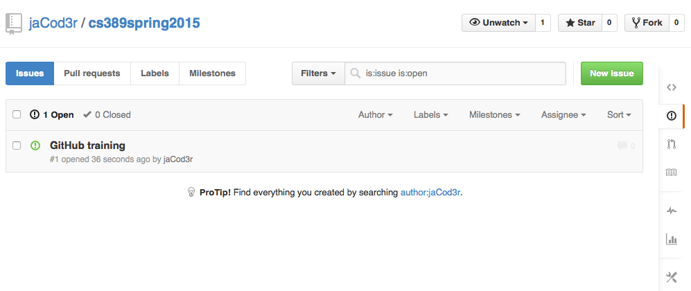

**Part 8:**

Edit the main page of the wiki in your repository called cs389spring2015. Add the title “CS 389 Spring 2015” to the page. The wiki will be used for documenting the project.

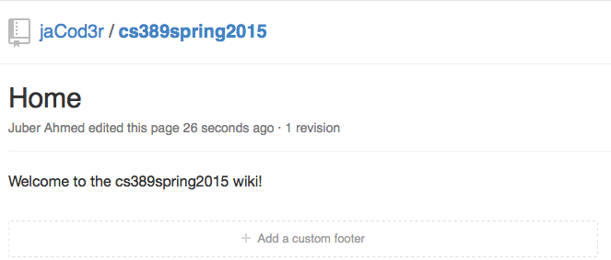

**Part 9:**

Put the information about your GitHub account in the file here:

https://docs.google.com/spreadsheets/d/14vYl8zjw_AX6mJZ5DzLwTObvtDs4hqCtxK6fPWWfgWY/edit#gid=0

The link you will put should be of the form: https://github.com/yourpseudo/cs389spring2015.

I will check your work directly on GitHub using the information you provided.

Please note that the file needs to be organized in alphabetical order.

