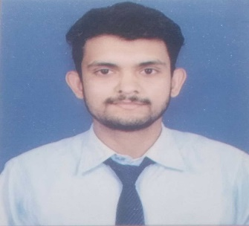

**ADDRESS**

Mohammad pura ward no 4 Dhamangaon Railway District Amravati

444709

**CONTACT**

Mob: +91 7498054724

Mail:. [shindejagdish186@gmail.com](mailto:shindejagdish286@gmail.com)

ABOUT ME

Engineering graduate who is seeking to find opportunity to work in fun and challenging environment that will encourage me to improve and learn new necessary skills as well as to get motivate by company to do my best for sake of helping company.

Jagdish Shinde

# EDUCATION

State Board Maharashtra

2013-2014 | SSC

State Board Maharashtra

2015-2016 | HSC

Amravati University

2016-2020 | B.E

# ACADEMIC DETAIL

|  |  |  |  |
| --- | --- | --- | --- |
| Course | Year | University/ Board | Percentage |
| SSC | 2014 | Maharashtra State Board | 90.60% |
| HSC | 2016 | Maharashtra State Board | 69.38% |
| BE  (Electrical) | 2020 | Amravati University | 70% |

# SKILLS

Technical Skill

Basic Knowledge of Programming.

Good knowledge of in python. Basic Knowledge of C.

Logical and Structural thinking.

Soft Skill

Problem Solving.

Good Communication.

Personal Skill

Personal Skil Ready to work harmoniously with other members of the team.

possess great analytical and problem solving skill.

Certification

I have got certificate for good work in project in my field.