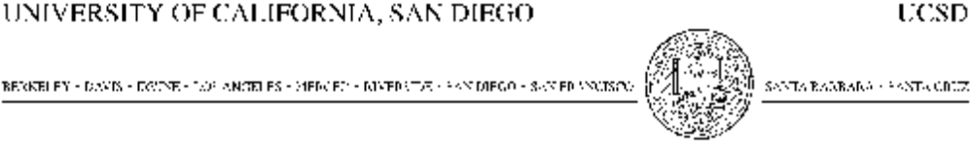
OFFICE OF CONTRACT AND GRANT ADMINISTRATION 9500 GILMAN DRIVE
SCRIPPS INSTITUTION OF OCEANOGRAPHY LA JOLLA, CALIFORNIA 92093-0210
TEL: (858) 534-4571 EMAIL: nwilson@UCSD.EDU
FAX: (858) 534-9642 URL: WWW.UCSD.EDU

USE CURRENT DATE HERE

Your Name
Name of Organization

Name of Organization has permission to use the SRTM30_PLUS V8 global bathymetry as well as the 1-arc second global bathymetry (V15.1) grids developed at Scripps Institution of Oceanography-University of California San Diego for non-commercial purposes on its web site and in its publications. This permission is dependent on the appropriate display of attribution of the developers of the grid as follows:

Data: SIO, NOAA, U.S. Navy, NGA, GEBCO

For publications, please include the following two references:

Becker, J. J., D. T. Sandwell, W. H. F. Smith, J. Braud, B. Binder, J. Depner, D. Fabre, J. Factor, S. Ingalls, S-H. Kim, R. Ladner, K. Marks, S. Nelson, A. Pharaoh, G. Sharman, R. Trimmer, J. vonRosenburg, G. Wallace, P. Weatherall., Global Bathymetry and Elevation Data at 30 Arc Seconds Resolution: SRTM30_PLUS, Marine Geodesy, 32:4, 355-371, 2009.
Smith, W. H. F., and D. T. Sandwell, Global seafloor topography from satellite altimetry and ship depth soundings, Science, v. 277, p. 1957-1962, 26 Sept., 1997.

The Regents of the University of California retain all rights to the provided content. The permission set forth herein is effective as of the date of this letter and shall continue for two (2) years, and then automatically renew for additional one year terms unless either party notifies the other party in writing of its intent not to renew at least 90 days prior to the end of the then-current term. The Regents of the University of California may terminate this letter agreement in the event of material failure by (NAME OF ORGANIZATION) to display the attribution information and fails to cure such failure within 30 days after receiving written notice from the Regents of the University of California.

Please acknowledge your agreement with the foregoing by completing the information below and signing a copy of this letter, keep one for your files, and return a copy via pdf to nwilson@ucsd.edu.
Sincerely,

Nancy Wilson
Director

ACKNOWLEDGED AND AGREED:

I hereby agree to include attribution as described above in websites, products, and publications that contain SRTM30_PLUS V7 Global Bathymetry content.

_______________________________________
Authorized Signature

_______________________________________
Printed Name

_______________________________________
Title

_______________________________________
Date

