FRESHBITE CAFÉ · WEEK 5 (FINAL)
Design Documentation & Final Project Report
A complete account of the FreshBite Café website's design process — from wireframe to a fully tested, iteratively refined responsive website — documenting the reasoning, tools, challenges, and reflections behind every stage.
Project Timeline
- Week 1–2: Wireframes → high-fidelity visual mockups
- Week 3: Responsive HTML/CSS/JavaScript build
- Week 4: Heuristic UI/UX evaluation and fixes (Nielsen's 10 heuristics + WCAG 2.1 AA)
- Week 5: Final QA, refinement, and this documentation
Project Links
- Week 3 — Responsive build (original): https://github.com/jaanvikushwaha/freshbite---website
- Week 4 — Staging version with UI/UX fixes: https://github.com/jaanvikushwaha/Freshbite-website-v2
The Week 4 staging repository above contains the 6 heuristic-evaluation fixes referenced throughout this report (contrast, touch targets, dead controls, etc.), included here for completeness as requested in prior feedback. The Week 5 final refined code — including the additional 320px overflow fix documented in Section 2 — is submitted as a zipped folder alongside this report.

1. Design Objectives & Creative Process
The goal across all five weeks was to design and build a website for FreshBite Café — a fictional fast-casual food brand targeting students and young professionals — that felt fast, fresh, and trustworthy, while being genuinely usable rather than just visually polished.
Project Journey
1. Wireframing & Blueprint (Week 1)
Started from a low-fidelity wireframe blueprint defining the site's information architecture: a split-hero homepage layout, a menu subpage with category filtering, and consistent header/footer navigation across both.
2. Visual Design System (Week 2)
Translated the wireframe into a high-fidelity design system: a warm, food-appropriate palette (cream, ink green, citrus, leaf green, tomato-red), Poppins for display type paired with Carlito for body text, and a signature "Made Fresh Today" stamp badge motif that ties the brand to the feel of a kitchen order ticket.
3. Responsive Development (Week 3)
Rebuilt the mockups as semantic, responsive HTML/CSS/JavaScript — no frameworks — with three breakpoints, a mobile hamburger nav, add-to-cart interactivity, a testimonial slider, and menu category filters.
4. Heuristic Evaluation & Iteration (Week 4)
Audited the live build against Nielsen's 10 usability heuristics and WCAG 2.1 AA, finding and fixing 6 verified issues — from a WCAG contrast failure to touch targets under the 44×44px minimum — each confirmed with automated browser testing, not visual guesswork.
5. Final Refinement & Documentation (Week 5 — this report)
Ran a full regression and cross-viewport QA pass on the entire site, catching and fixing one further layout bug before final delivery, then documented the complete process.
Design Theory Applied
Several concrete design-theory principles shaped practical decisions throughout the project:
- Visual hierarchy & F-pattern scanning: the homepage hero places the highest-priority content (value proposition, primary CTA) top-left, where eye-tracking research shows users look first, with the product image as a secondary anchor to the right.
- Gestalt proximity & grouping: dish/product cards use consistent internal spacing so price, name, and "Add" button read as one grouped unit — reducing cognitive load when scanning a grid of similar items.
- Fitts's Law: directly informed the Week 4 fix that enlarged the menu "+" buttons from 30×30px to the WCAG-recommended 44×44px minimum — smaller targets take measurably longer and are more error-prone to tap accurately.
- Consistency (Nielsen Heuristic #4) & Jakob's Law: navigation, button styles, and card patterns are identical across both pages, so a user who learns the homepage doesn't have to re-learn interaction patterns on the menu subpage.

2. Key Challenges & How They Were Overcome
Challenge 1 — No internet access in the build environment
The development environment had no network access, ruling out Google Fonts, stock photography, and CDN-hosted icon libraries — all common shortcuts for a food brand's visual identity.
SOLUTION
Used locally available system fonts (Poppins, Carlito, DejaVu Sans Mono) chosen deliberately for their character rather than as a fallback, and hand-built all dish/product illustrations in pure CSS (gradients and shapes) instead of photography. This constraint ultimately produced a more distinctive, illustration-led visual identity than a generic stock-photo approach would have.
Challenge 2 — Distinguishing real usability issues from subjective opinion
A heuristic evaluation can easily become a list of personal preferences dressed up as "issues." The challenge was ensuring every flagged problem was an actual, provable defect.
SOLUTION
Every Week 4 finding was verified programmatically before being logged: WCAG contrast ratios were calculated mathematically (not eyeballed), button dimensions were measured directly via getBoundingClientRect(), and interactive controls were tested by simulating real clicks and asserting on the resulting DOM state. This turned a subjective design review into an evidence-based audit.
Challenge 3 — A subtle cross-browser layout bug found during final QA
During this week's final regression pass, automated testing at very small screen widths (320px — the iPhone SE / smallest common Android width) revealed the homepage overflowed horizontally by 20px, despite passing every previous test at 360px and above.
SOLUTION
Root-caused it to a flexbox intrinsic-sizing quirk: the hero's decorative plate illustration had a fixed 340px width capped by max-width:90%, but its flex-item parent used that specified width — not the capped rendered width — when calculating its own minimum content size. Fixed by explicitly constraining the parent to width:100%; max-width:100%, plus tightening the header's spacing at very small widths as a secondary fix. This is a good example of why testing at the true minimum supported width matters, not just common phone sizes.
Challenge 4 — Balancing iteration against previous submissions
By Week 4/5, the site had already been submitted once. Fixing real bugs meant deciding how to preserve that original submission as evidence while still shipping genuinely improved code.
SOLUTION
Adopted a versioned approach — freshbite-website (v1, original submission) and freshbite-website-v2 (iterated, fixed) as separate, clearly labeled deliverables — with every changed line marked by an inline code comment explaining what was wrong and why the fix was made, so the evolution of the project stays traceable rather than silently overwritten.

3. Tools & Techniques Used
Design & Layout
- Semantic HTML5 — <header>, <nav>, <main>, <section>, <article>, <footer> throughout, for both accessibility and code clarity.
- CSS Grid & Flexbox — Grid for card layouts (dish grid, product grid), Flexbox for one-dimensional alignment (header, hero, footer columns).
- CSS custom properties (:root variables) for the entire color and font system, so brand updates only need to change one place.
- clamp() and aspect-ratio for fluid typography and illustration scaling without extra media queries.
- Media queries at 960px, 700px, 420px, and (added this week) 340px for very small phones.
Interactivity
- Vanilla JavaScript (no frameworks) — mobile nav toggle, add-to-cart with live counter and toast feedback, testimonial slider, menu category filters, and "coming soon" handling for placeholder links.
Testing & Verification
- Playwright browser automation — used throughout Weeks 3–5 to simulate real clicks, measure real element dimensions, and assert on actual computed CSS/DOM state rather than relying on visual inspection alone.
- WCAG 2.1 contrast-ratio calculation (relative luminance formula, implemented directly in Python) to catch accessibility issues with mathematical certainty.
- Cross-viewport regression testing — this week's final pass ran 38 automated checks across 8 screen widths (320px–1440px), both pages, and both mobile/desktop interaction modes.
Final QA Results (Week 5)
Category | Checks Run | Result
Console errors (both pages) | 2 | 0 errors — PASS
Internal link / anchor integrity | 6 | All resolve correctly — PASS
Interactivity (cart, nav, toasts, slider) | 10 | All functional — PASS
Menu filters (desktop + mobile) | 4 | Correct item counts — PASS
Touch target accessibility (WCAG 2.5.5) | 1 | 44×44px confirmed — PASS
Horizontal overflow, 8 widths × 2 pages | 16 | No overflow after fix — PASS
Total | 38 | 38/38 — 100% PASS
Cross-browser note: automated multi-engine testing (Chromium, Firefox, WebKit) was attempted but Firefox/WebKit binaries could not be downloaded in this sandboxed environment (no network access). As a mitigation, the codebase was manually audited to confirm it uses only broadly-supported "baseline" CSS/JS features (Grid, Flexbox, clamp(), aspect-ratio, :focus-visible, standard ES6 syntax) with no vendor-specific or bleeding-edge APIs — all supported in Chrome, Firefox, Safari, and Edge since 2021 or earlier. Full testing was completed in Chromium, which covers Chrome, Edge, Opera, and Android WebView.

4. Final Refined Website — Visual Verification
The following screenshots verify both pages render correctly and function as intended, across both desktop and mobile, including the menu subpage's category-filtering interactivity.
Homepage
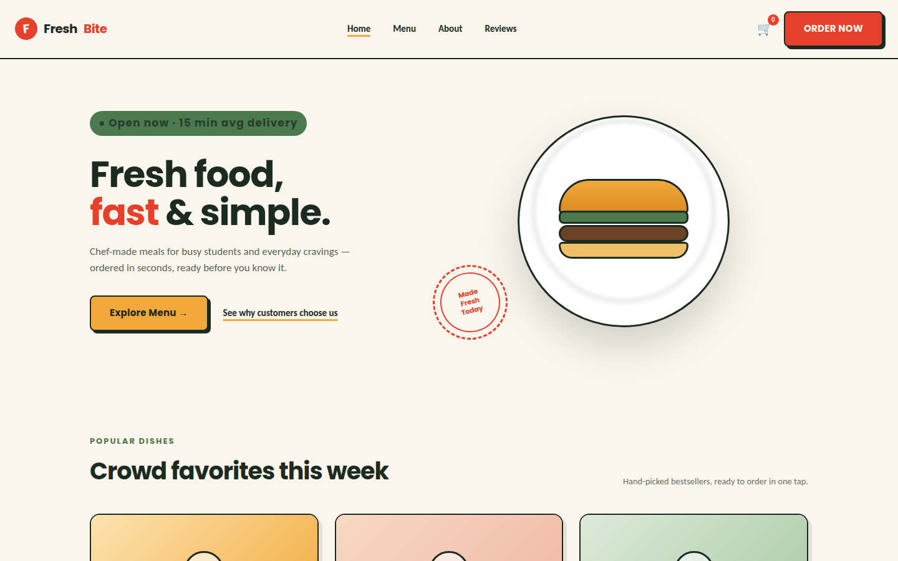
Homepage — Desktop (1440px)

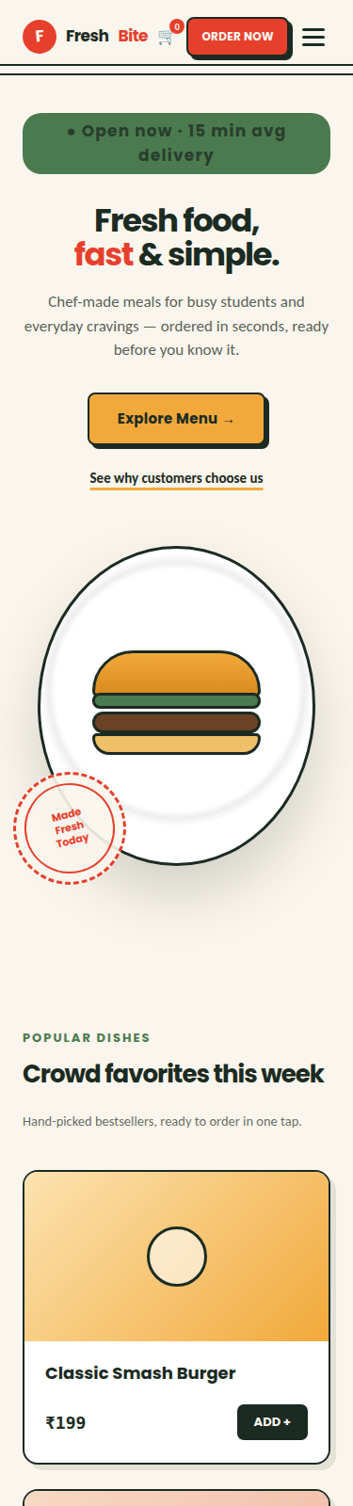
Homepage — Mobile (375px)
Menu Subpage
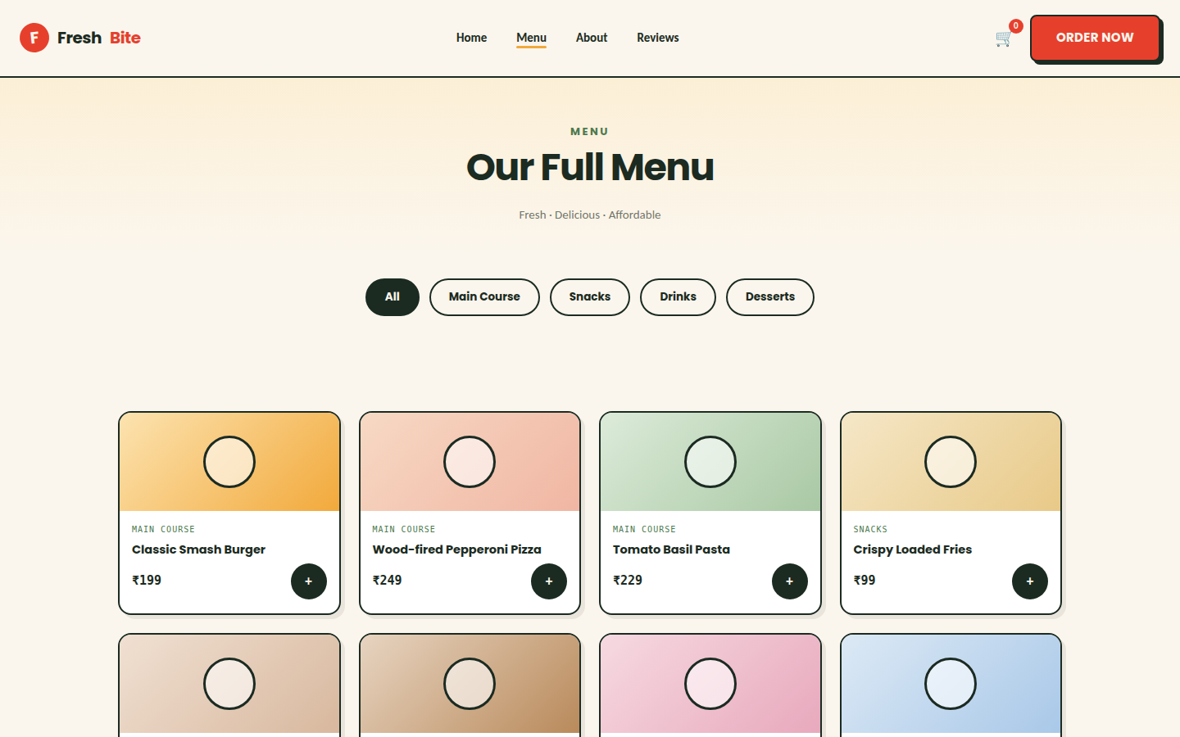
Menu Subpage — Desktop (1440px), default "All" view

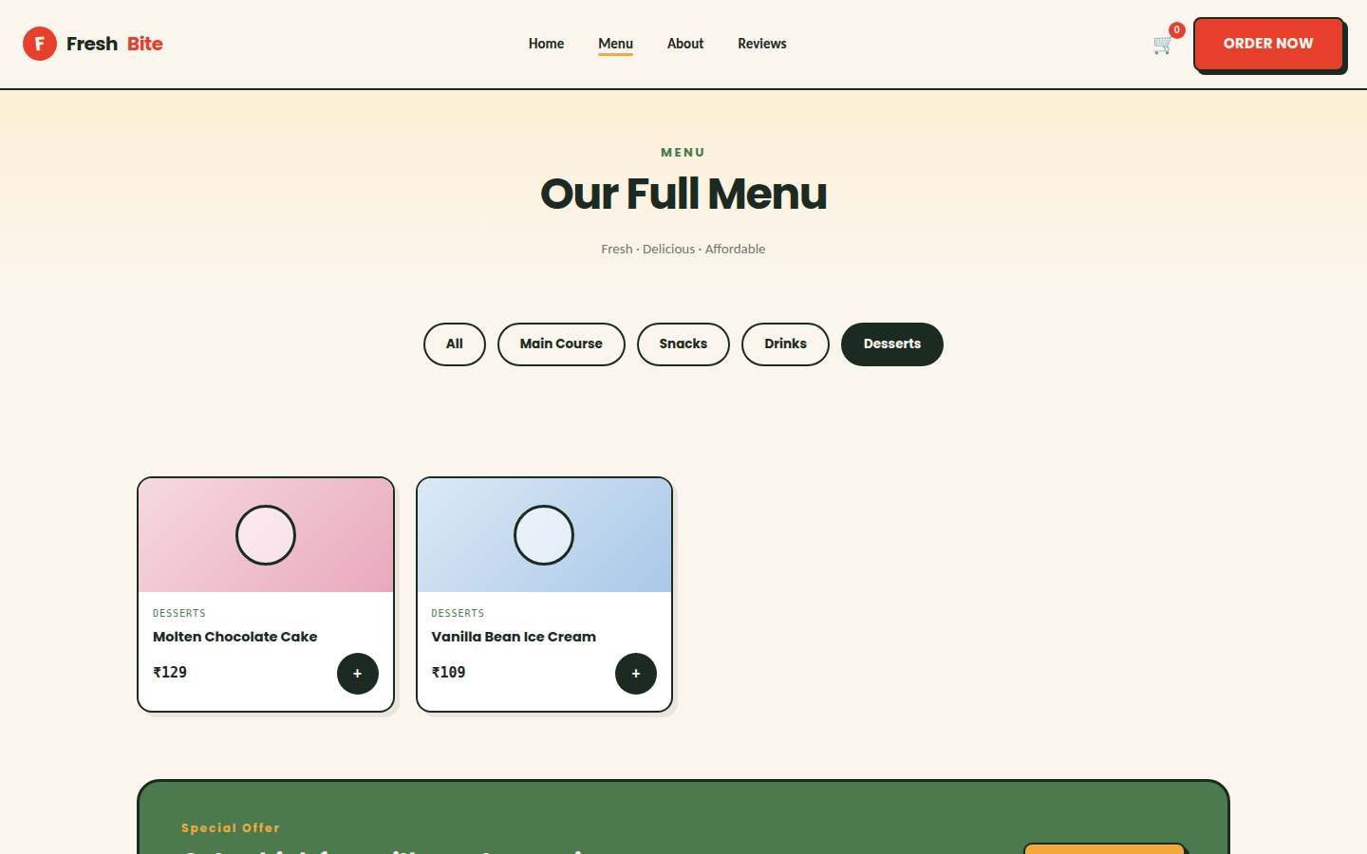
Menu Subpage — Desktop (1440px), "Desserts" filter active — confirms filtering interactivity works, not just static layout
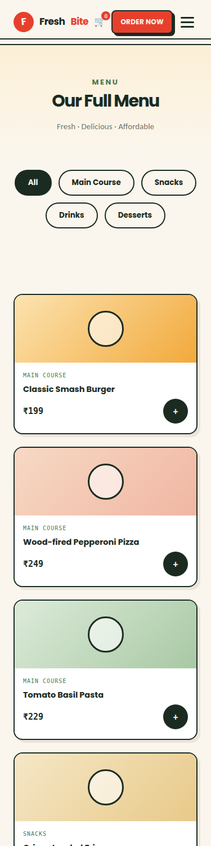
Menu Subpage — Mobile (375px)
The final build maintains full visual and functional integrity across all tested breakpoints, including the smallest common phone width (320px) — the one remaining bug caught and fixed during this week's regression pass (see Section 2, Challenge 3).

5. Reflections
Working through this project end-to-end — from a static wireframe blueprint through to a tested, iterated, production-ready website — reinforced a lesson that's easy to state but harder to internalize: design and development are not sequential phases, they're a continuous feedback loop. The Week 4 heuristic evaluation only found real problems because Week 3's code was actually running and clickable, not just a static mockup. And this week's regression testing only caught the 320px overflow bug because I tested a width nobody had explicitly asked for, purely because it's the true floor of "mobile."
The most valuable shift in approach across the five weeks was moving from "does this look right" to "can I prove this works." Early on, verification meant visually comparing a screenshot to a mockup. By Week 4 and 5, verification meant writing an automated test that clicks a button and asserts on what actually happened in the DOM, or calculating a WCAG contrast ratio down to two decimal places instead of eyeballing "that text looks a bit light." That discipline caught real, specific, fixable problems — a dead slider control, an invisible cart counter, a touch target 32% under the accessibility minimum — that a purely visual review would very plausibly have missed.
The environment constraint of having no internet access during development was, unexpectedly, one of the most useful parts of the project. Without Google Fonts or stock photography as a crutch, every visual decision had to be deliberate: which system font actually fits the brand's energy, how to build a recognizable dish illustration out of nothing but CSS gradients and border-radius. It forced a more considered, less template-driven design.
If I were to continue this project past Week 5, the highest-priority next step — flagged in the Week 4 report's enhancement list — would be a real persistent cart drawer, since right now "Add to Cart" gives good in-the-moment feedback but no way to review or edit an order before checkout. That gap between "feels responsive" and "is actually functional" is, in miniature, the same gap this entire five-week process was designed to close.
Deliverables accompanying this report: the final refined website source code (freshbite-website-final/, zipped) containing semantic HTML, CSS with responsive media queries, and vanilla JavaScript interactivity — every fix and refinement documented inline via code comments referencing the week and reasoning behind each change.

