**Pokémon Royale**

**CS 371 – Final Project**

**Members:**

Daniel Burris

Zachary Johnson

Jairo Arreola

John Mullen

Concept

* What is this game about?
  + This game is going to be a Pokémon Arena. When a new game is initiated from the menu, the player will be able to select 1 of 3 random Pokémon, once he selects his Pokémon, he will be able to select another Pokémon from another set of 3 random Pokémon. This continues until the user has six Pokémon. Once he has his deck of Pokémon, he will battle against enemy trainers and see how many he can beat. The project is going to focus on core mechanics first, then focus on adding variety to the game, such as multiple trainers, lots of Pokémon with unique stats and hit points, etc.
* Genre
  + Pokémon is generally an instance-based RPG, in this case it’s going to have an RPG style combat, but arena (royal rumble) based gameplay.
* Character Design and Sketch

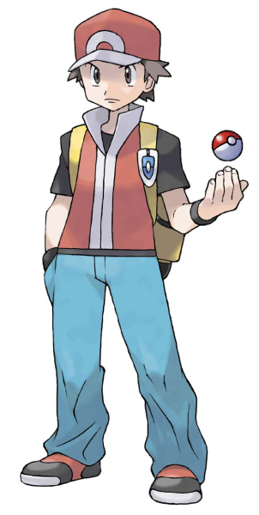

**Main Character**

* Target audience
  + Pokémon players; which is anyone aged 3-99.
* Key Features
  + RPG-Style combat.
  + Sudo-random Pokémon matchups / Arena style Pokémon selection.
  + Items commonly found in Pokémon games.
* References
  + Hearthstone
  + Pokémon Stadium
  + Pokémon Gameboy games

Game Mechanics

* This game is played using a Pokémon style menu loaded with tap events to navigate options such as fight, Pokémon switch, and item use. You can see a basic idea of what the menu will look like in Figure 1. The battle scenes will look like Figure 2. The Pokémon select screen will look like Figure 3.
* Screenshot and artwork

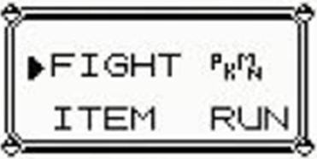

**Figure 1 – Menu during Battle Scene**

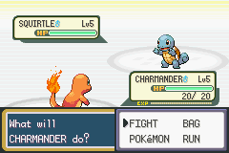

**Figure 2 – Battle Scene**

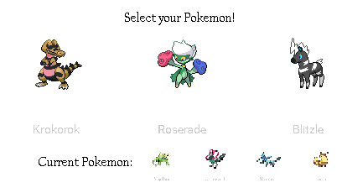

**Figure 3 – Pokémon** **Select Scene**

* Gameplay example
  + Gameplay will mimic the following video as we see fit.
  + <https://www.youtube.com/watch?v=tRHeJztnuX4>
* Control Scheme and Interface
  + The overall control scheme can be seen in the following video.
  + <https://www.youtube.com/watch?v=VR4sY2OokIE>
* Scoring System and Achievements
  + Scoring is going to be based on how far the player can go without losing. He will get an achievement every time he beats a specific trainer.
* Screen Flow
  + Screen flow can be seen in Figure 2

Tech

* Issues
  + **Graphics** will not be an issue. Pokémon has a really big following and as such as a lot of community driven repositories that contain sprites for all the characters, maps, backgrounds, animations, and logos.
  + **Camera** won’t be an issue because this game doesn’t have any screen scrolling, it will all be scene based.
  + **Control** **Interface** may be an issue, but only because of the lack of design space available on a mobile device. We will do our best to keep the tap listeners away from each other so that the user doesn’t accidentally tap the wrong buttons.
* Target Platform
  + Android platform, native resolution, portrait only, no landscape because of design space issues.
* Graphics Assets

|  |  |  |  |
| --- | --- | --- | --- |
| 2D |  |  |  |
|  | **Menu Background** |  |  |
|  |  | Menu |  |
|  |  |  | Menu Background |
|  | **Fight Scene Backgrounds** |  |  |
|  |  | Fight scene 1 |  |
|  |  |  | Fight scene 1 BG |
|  |  | Fight scene 2 |  |
|  |  |  | Fight scene 2 BG |
|  | **Pokémon** |  |  |
|  |  | Pokémon 1 |  |
|  |  |  | Pokémon 1 Sprite Sheet |
|  |  | Etc. |  |
|  | **Trainers** |  |  |
|  |  | Trainer 1 |  |
|  |  |  | Trainer 1 Sprite Sheet |
|  |  | Etc. |  |
|  | **Action Selector Menu (Fight scene)** |  |  |
|  |  | Action Menu |  |
|  |  |  | Action Menu Outline |

* Audio Assets

|  |  |  |  |
| --- | --- | --- | --- |
| Music |  |  |  |
|  | **Trainer Fight 1** |  |  |
|  |  | Fight Music |  |
|  |  |  | Pokémon Gen 1 Music |
|  | **Trainer Fight 2** |  |  |
|  |  | Fight Music |  |
|  |  |  | Pokémon Gen 2 Music |
|  | **Etc.** |  |  |
| Sound FX |  |  |  |
|  | **Pokémon** |  |  |
|  |  | Dying |  |
|  |  |  | Dying sound |
|  |  | Appear |  |
|  |  |  | Appear |
|  |  | Hit |  |
|  |  |  | Hit |
|  |  | Attacking |  |
|  |  |  | Attacking |
|  | **UI** |  |  |
|  |  | UI Sounds |  |
|  |  |  | Menu Select Sound |

* Required Resources
  + Software
    - Corona SDK
    - GIMP
    - Texture Packer
    - GitHub Repository
    - Advance Map (<http://www.pokecommunity.com/showthread.php?t=127348>)
  + Sprite resources
    - Poke Stadium (<http://www.pokestadium.com/tools/sprites>)
    - Pokémon Trainers Sprite Sheet (<http://kyogremaster.deviantart.com/art/All-Pokemon-Trainer-Sprites-137787432>)
* Work Division and Schedule.

|  |  |  |  |
| --- | --- | --- | --- |
| Members | Week 1 | Week 2 | Week 3 |
| Daniel | Menu Scene + Pokémon Select | Animations | Adding additional fight scenes + Adding LOTS of comments. |
| Jairo | Main Pokémon Class | Defining Pokémon + adding animation | Testing Game |
| Jonathan | Battle Scene | Background Audio + Graphics | Making more trainers + Documentation |
| Zach | Main Trainer Class | Defining Pokémon | Making more Pokémon |