DRAFT 03-01-2002

Standard Practice/Guide for

XML DTD Design, Architecture and Implementation
This standard is issued under the fixed designation E 2183-02; the number immediately following the designation indicates the year of original adoption or, in the case of revision, the year of last revision. A number in parentheses indicates the year of last reapproval. A superscript epsilon (ε) indicates an editorial change since the last revision or reapproval.

- Scope
  - Recently there has been widespread use of the Internet by the health care industry to represent information. Much of the success of the Internet can be attributed to the World Wide Web (WWW) and its browsing system, which make it possible to navigate the Internet by pointing and clicking. Web pages, electronic documents located on the Internet, are “published” to a computer screen by a browser. These pages are developed using HTML or HyperText Markup Language.
The next generation of the WWW and web pages has arrived with the specification of XML or eXtensible Markup Language. Just like HTML, XML can define how pages appear in web browser. Additionally XML provides a context for information. While HTML tells the browser what a page should look like, XML defines what the piece of information actually means. Both HTML and XML are markup languages; that is, they insert markup, or additional information, into text. The markup is known as a “tag”. For example, HTML marks up text on a page by inserting a <B> tag when the text should be bolded and by inserting a <H1> tag around the first heading of a web page. In HTML, there is no way to distinguish between a medical record number or an telephone number because they are both tagged <B> for bold. XML, on the other hand, marks each item with special tags so that computers can tell the difference. With XML, humans and computers can tell the difference between a <DIAGNOSIS> tag and <SYMPTOM> or a <Medical.Record.Number> from a <Phone.Number>
The names of the tags and the rules for using them are contained in the DTD or Document Type Definition. The DTD describes the structure of the document and defines the names of tags it contains. Additionally the DTD declares the order in which the tags occur and how often the tags can appear; i.e., the DTD defines the hierarchy of the tags. A DTD for a prescription might contain structural elements for the medication prescribed, the dosage, the form, the quantity, etc.

  - This standard provides a compendium of information for the use of ASTM E2183 XML DTDs within health care. This standard describes design considerations, the architecture of the DTDs and implementing systems using the E2183 DTDs.

  - This standard refers to and makes use of recommendations from the World Wide Web consortium, the W3C (http://www.w3.org ).

  - This standard does not purport to address all of the safety concerns, if any, associated with its use. It is the responsibility of the user of this standard to establish appropriate safety and health practices and to determine the applicability of regulatory limitations prior to use.

- Referenced Documents
  - ASTM Standards:
- E1239 Standard Guide for Description of Reservation/Registration-Admission, Discharge, Transfer (R-ADT) Systems for Automated Patient Care Information Systems
- E1384 Standard Guide for Content and Structure of the Electronic Health Record (EHR)
- E1633 Standard Specification for Coded Values Used in the Electronic Health Record
- E2182-02 Standard Specification for Clinical XML DTDs in Healthcare

  - W3C World Wide Web Consortium Recommendations (http://www.w3.org)
- XML 1.0 Recommendation http://www.w3.org/TR/REC-xml
- XHTML Basic Recommendation http://www.w3.org/TR/xhtml-basic
- XML Linking (Xlink) 1.0 Recommendation http://www.w3.org/TR/xlink
- XML Namespaces Recommendation http://www.w3.org/TR/REC-xml-names
- XPointer http://www.w3.org/TR/xptr
- XSLT http://www.w3.org/TR/xslt

  - HL7 Standards (http://www.HL7.org)
- Informative Document: Using XML as an Alternative Message Syntax for HL7 Version 2.3.x
- Clinical Document Architecture: Level 1

  - IETF Specifications (http://www.ietf.org)
- RFC 2396: Uniform Resource Indentifiers (URI). http://ietf.org/rfc/rfc2396

- Terminology
  - Definitions:
CLINICAL DOCUMENT ARCHITECTURE (CDA): The HL7 CDA is a document markup standard for the structure and semantics of exchanged "clinical documents". A clinical document is a documentation of observations and other services with the following characteristics: Persistence, Stewardship, Potential for authentication, Wholeness and Human readability. A clinical document is a defined and complete information object that can exist outside of a message, and can include text, sounds, and other multimedia content.

CLINICAL DOCUMENT: This standard defines clinical document in terms of the native XML and hypertext architecture. The Document Type Definition (DTD) is the base method of defining the structure of a clinical document. XML schema languages such as the W3C XML Schema Language, and the OASIS RELAXNG Schema language provide alternative methods of defining clinical document structures.

DOCUMENT TYPE DEFINITION (DTD): A DTD is the formal definition of the elements, structures, and rules for enabling platform independent data access via XML or for marking up a given type of SGML document.

EXTENSIBLE MARKUP LANGUAGE (XML): A standard from the World Wide Web Consortium (W3C) that provides for tagging of information content within documents, offering a means for representation of content in a format which is both human and machine readable. Through the use of customizable "style sheets" and "schemas" information can be represented in a uniform way, allowing for interchange of both content (data) and format (metadata).

HEALTH LEVEL 7 (HL7): HL7 is a standards organization traditionally focused on message-oriented standards for healthcare. HL7 messages are the dominant standard for peer-to-peer exchange of clinical, text-based information. HL7 has recently introduced a document oriented standard, the Clinical Document Architecture.

HYPERTEXT MARKUP LANGUAGE (HTML): The language used in creating a web page. Its origin is an implementation of SGML DTD, but whose most recent update is defined in XML (XHTML). It provides tags regarding the way a document should be displayed in the text of an HTML document, which act as commands that a browser interprets when downloading an HTML file.

NAMESPACES: XML Namespaces provide a simple method for qualifying element and attribute names used in XML documents. This is accomplished by associating a particular tag set by associating a prefix with a URI reference. XML Namespaces provides a mechanism for authoring compound documents (documents consisting of elements and attributes from multiple DTDs or schemas) in such a way that will provide global identification without collisions of names that are the same but are used differently.

PARSER: A Parser is a specialized software program that recognizes markup in a document and differentiates the content from the markup. A Parser that reads a DTD and checks and reports on markup errors is a validating XML Parser. A Parser can be built into an XML editor to prevent incorrect tagging and to check whether a document contains all the required elements.

SCHEMA: The schema defines the elements that can appear within the document and the attributes that can be associated with an element. It also defines the structure of the document: which elements are child elements of others, the sequence in which the child elements can appear, and the number of child elements. It defines whether an element is empty or can include text. The schema can also define default values for attributes. Schema is a W3C term for the next generation of DTDs.

STYLESHEET: The XSL Transformations (XSLT) describes a vocabulary recognized by an XSLT processor to transform information from an organization in the source file into a different organization suitable for continued downstream processing. The Extensible Stylesheet Language (XSL) describes a vocabulary recognized by a rendering agent to reify abstract expressions of format into a particular medium of presentation.

URI: A URI identifies a Web resource according to IETF RFC 2396. Used in practice to form links between, to name and to locate web documents. Also used to name XML namespaces.

VALID XML DOCUMENT: Well-formed with internal or DOCTYPE reference to element definition of tags within the document.

W3C: The World Wide Web Consortium (W3C) develops interoperable technologies (specifications, guidelines, software, and tools) to lead the Web to its full potential as a forum for information, commerce, communication, and collective understanding.

WELL-FORMED XML DOCUMENT: A XML document that conforms to the syntax as specified by the W3C XML 1.0 recommendation.

XHTML: HTML documents that are well formed and can be processed by an XML Parser.

XLINK: The W3C XML Linking Language defines a method for specifying links between documents and parts of documents using URIs. Links may be simple representing a 1:1 mapping, or extended representing an N:N mapping.

XPOINTER: XPointer, the XML Pointer Language, defines how individual parts of a document are addressed. Xlinks point to a URI (in practice, a URL) that specifies a particular resource. The URL may include an XPointer part that more specifically identifies the desired part or section of the targeted resource or document. XPointer, the XML Pointer Language, defines an addressing scheme for individual parts of an XML document. XLinks point to a URI (in practice, a URL) that specifies a particular resource. The URI may include an XPointer part that more specifically identifies the desired part or element of the targeted resource or document. XPointers use the same XPath syntax you're familiar with from XSL transformations to identify the parts of the document they point to, along with a few additional pieces.

- Summary of Practice
  - Philosophy of E31 XML DTDs
The philosophy of the E31.25 subcommittee was initially based on the premise that a set of document types for healthcare does not exist. It is not known if health care documents have common and identifiable structures. It is generally accepted that some regularity exists and that this regularity could be used to create standard high level structures. These standard structures could then be easily manifested in XML DTDs. Regularity in document structure is identified by document analysis, review of health care informatics standards and research and complementary technology standards.
Two workshops were held to design and develop the DTDs. The results of the workshops identified the following:
the sections or categories that exist in clinical documents
The order of the sections, if the sequence is important
The number of times the different sections appear in clinical document types
The supporting materials and knowledge of clinical documentation was used to determine the sections, the order of the sections and the number of times the sections appeared in document. This included a review of transcribed reports for common areas, sections and sub-sections, government forms for categories for data entry, and demographic information contained within the header of the Clinical Document Architecture. Using the results of the workshop, this practice guide, Standard Practice for XML DTDs for Health Care: GEM: A Document Model for Clinical Practice Guidelines and the Standard Specification for Clinical DTDs in Healthcare and other DTDs would be developed.

The philosophy in DTD design includes the following:
Simplicity of XML document structure
Agreement on high level structures in clinical documents
Ability for International Representations in the XML
Make use of existing standards where possible
Maintain readability

  - Architecture and Design of DTDs
The ASTM DTDs have been designed to have a common architecture. This architecture defines a document to consist of a document header and a document body.

DTD Architecture
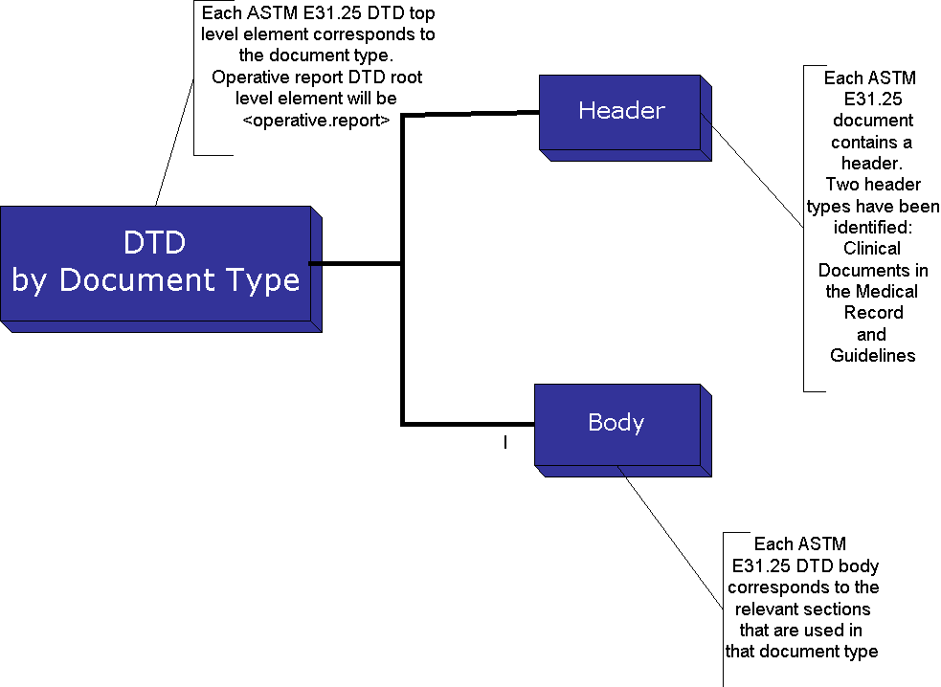
The header may be specific to a particular document type. For instance, the Standard Practice for XML DTDs for Health Care: GEM: A Document Model includes a header that is specific to guidelines in Health Care.

  - Format and Common Features
Formatting information and common features frequently found in these documents include:

- Basic text (including headings, paragraphs, and lists)
- Hyperlinks and links to related documents
- Forms
- Tables
- Images
- Meta information
The design provides for tags that represent common items such as paragraphs, images and tables. This is provided by inclusion of the XHTML Basic DTD and the tags, which it contains. XHTML Basic is designed as a common base that may be extended. The motivation for using XHTML Basic is to incorporate an XHTML document type that can be shared across communities, that is rich enough to be used for simple content authoring and that has the ability to be extended as future versions of this standard are developed.

Architecture and Inclusion of XHTML Basic

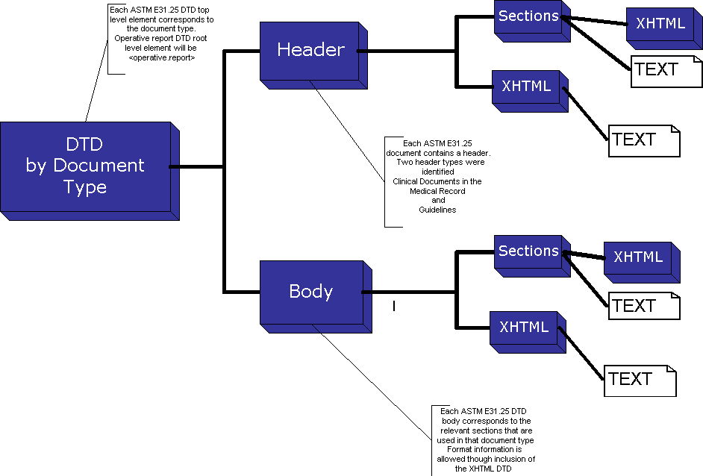

By allowing the inclusion of XHTML tags format information may be included within the documents in a standard way. The author of the DTD determines which parts of the XHTML standard is to be used. A subset of XHTML has been developed for use in ASTM E2183 DTDs and is included in this practice guide. Some modules of XHTML were not included in the ASTM XHTML. These modules include forms and web specific tags (such as the <HTML> tag itself). Additionally, some attributes of XHTML, which specify the language of the document, are used to indicate sections that are in different languages (such French or German). Below is an example operative report, which makes use of the ASTM E21.25 architecture and XHTML within the sections.

Use of XHTML in XML Clinical Documents
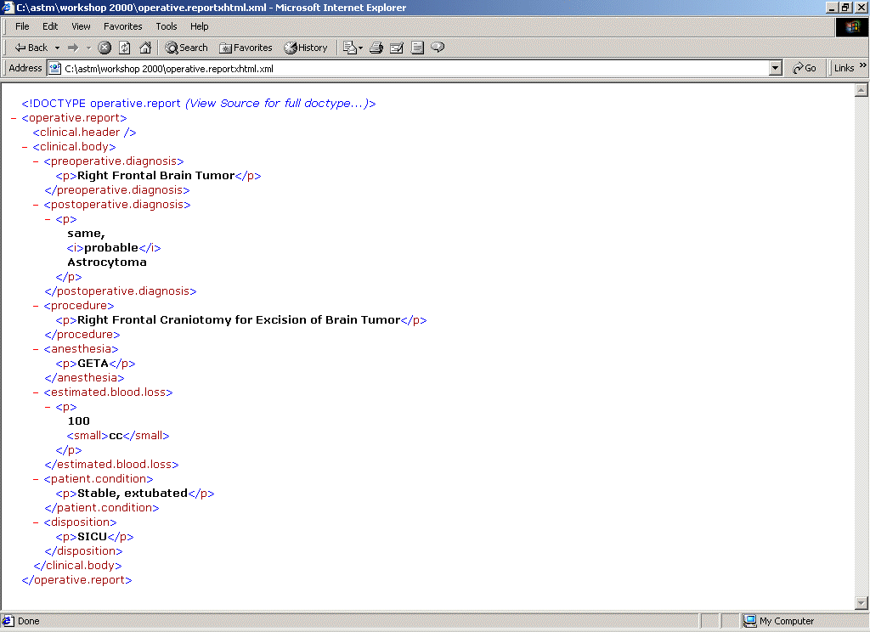

  - XML Namespaces
XML Namespaces is a W3C recommendation that allows for a single XML document to contain elements and attributes that are defined for and used by multiple software modules. For instance, the following XML tags listed below are both valid <Citation> elements. The Citation elements are defined differently in the DTDs. One representation makes use of elements and the other makes use of attributes.

<Citation
Author=“Tunstall-Pedoe, H.”
Title=“What’s in a name?”
Source= “W3C, 1999 Nov; 317:1-4”/>

<Citation>
<Author>
Tunstall-Pedoe, H.
</Author>
<Title>
What’s in a name?
</Title>
<Source>
W3C, 1999 Nov;
317:1-4
</Source>
</Citation>

Both versions are defined in a DTD and are defined differently.
The January 1999 W3C recommendation on Namespaces solves the problem of different content models. Namespaces allow for a prefix to be added to the element. This prefix allows for tag names to be unique. Conflicts are avoided for elements and attributes with the same name

<Citation.List xmlns:Pub1="http://WimeTarner.com/cit.dtd"
xmlns:Pub2="http://Smiley.com/C.dtd">

<Pub1:Citation Pub1:Author="Tunstall-Pedoe, H."
Pub1:Title="What’s in a name?"
Pub1:Source= "W3C, 1999 Nov; 317:1-4"/>
<Pub2:Citation>
<Pub2:Author>Tunstall-Pedoe, H.</Pub2:Author>
<Pub2:Title>What’s in a name?</Pub2:Title>
<Pub2:Source>W3C,1999 Nov;317:1-4</Pub2:Source>
</Pub2:Citation>
</Citation.List>

The ASTM E2183 DTDs may make use of Namespaces to resolve conflicts with other XML standards and XHTML tags.

  - XLink
XLink defines the XML Linking Language (XLink), which allows elements to be inserted into XML documents in order to create and describe links between resources. It uses XML syntax to create structures that can describe the simple unidirectional hyperlinks of today's HTML, as well as more sophisticated links. The XLink specification defines the XML Pointer Language (XPointer), the language to be used as a fragment identifier for any URI-reference that locates an XML resource . XPointer supports addressing into the internal structures of XML documents. It allows for traversals of a document tree and choice of its internal parts based on various properties, such as element types, attribute values, character content, and relative position. The base E2183 DTD includes the XLink namespace

- Significance and Use
  - Naming Conventions
E2183 DTDs will use the following Naming Conventions:
- Tag names are in English
- Tag names are not shortened; readability is of utmost importance
- Tag names are lowercase except for appropriate abbreviations and acronyms (US, ASTM)
- Tag names with multiple words are separated with a period “.”; e.g., patient.name
  - Architecture
The following architecture is to be used by ASTM DTDs:

ROOT LEVEL: The root level tag will contain the name of the document type. For instance the root level element for an operative report will be <operative.report> and for a guideline document <guideline>.
HEADER AND BODY: The root level element will contain two children elements: a document header and a document body. The document header will contain sections that are relevant for the document. In a guideline document the header may contain information about the guideline developer and meta-information about the guideline such as its title, release date and whether or not there are companion documents.
FORMAT: Format information may be expressed by inclusion of any XHTML tag.
BODY SECTIONS: The DTDS will create section level tags.
  - XHTML Basic
XHTML Basic consists of the following XHTML modules:

- Structure Module: body, head, html, title
- Text Module: abbr, acronym, address, blockquote, br, cite, code, dfn, div, em, h1, h2, h3, h4, h5, h6, kbd, p, pre, q, samp, span, strong, var
- Hypertext Module: a
- List Module: dl, dt, dd, ol, ul, li
- Basic Forms Module: form, input, label, select, option, textarea
- Basic Tables Module : caption, table, td, th, tr
- Image Module: img
- Object Module: object, param
- Metainformation Module: meta
- Link Module link
- Base Module base
A modularized XHTML Basic DTD was developed for use with the ASTM DTDs. This modularized DTD does not contain the following modules:

- Structure Module: body, head, html, title
- Basic Forms Module: form, input, label, select, option, textarea
- Metainformation Module: meta
- Base Module base
  - Namespaces
The Namespaces recommendation was specified after the XML Version 1.0 Recommendation and there are some issues merging DTDs and Namespaces.
DTDs and validity are concepts defined in XML 1.0. The XML namespace recommendation came after the XML 1.0 recommendation and is layered on top of XML 1.0. The XML Namespaces recommendation does not redefine validity. The implication of this is that validity is the same for a document that uses XML Namespaces and one that doesn't. Because of this, XML documents that are expect to be valid are not and documents that are expected to be invalid are valid. The guidelines for writing documents that are both valid and conform to the XML Namespaces recommendation are:

- Declare all xmlns attributes in the DTD.
- Use the same qualified names in the DTD and the body of the document.
- Use one prefix per XML namespace.
- Do not use the same prefix for more than one XML namespace.
- Use at most one default XML namespace

  - Header Requirements
The ASTM Clinical Header DTD was designed to be compatible with the HL7 CDA Header in order to facilitate conversion of an ASTM Clinical Header to the HL7 CDA Header using an XSLT transform.
The ASTM Subcommittee develops header specific to the needs of the ASTM documents. Different document types will require different document specific information. A common clinical header is included in this practice/guide but its use is not required.

- Reagents Procedure
  - None

test methods

- Scope
  - Valid XML Documents with DTDs
A document is tested for conformance to this practice/guide by referencing an ASTM DTD defined by using this proactive/guide and using a validating XML Parser according to theW3C XML 1.0 recommendation, http://www.w3.org/TR/2000/REC-xml-20001006 . A conformant document must validate without errors according to XML 1.0.
When developing software to create and edit clinical documents, it is desirable to customize DTDs according to the specific needs of the editing or other software. This is advisable. It is not required nor even encouraged that the standard DTDs be used unmodified during the editing process. It is the final document output or the editor, or other transformation software which must conform to the standard DTDs.

  - Conformant XML DTDs and Documents
A conformant document must also conform to constraints expressed within the prose of this specification however this practice/guide does not express a formal means of testing conformance to such additional constraints such as adherence to the architecture. The E2183 DTDs must conform to the architecture, naming conventions, inclusion of XHTML and allow for namespace usage as defined in this practice/guide.

- Significance and Use
  - The intended use of this practice/guide is as an outline for the development of ASTM E2183 DTDs.

- Hazards
  - None

- Procedure
This Practice/Guide is to be used as the template for E2183 DTD design, architecture and development. E2183 architecture DTDs have the following DTDs:
- The top level DTD that is named appropriately and according to its document type. For instance, an operative report DTD will have a top level DTD named “operative.report.dtd”
- The E2182/E2183 base DTD includes the ASTM modularization of XHTML. The inclusion of the ASTM XHTML DTD allows the top level DTD to include XHTML elements within the header and body elements. For instance a section element such as <guideline.title> may make use of the XHTML heading elements such as <h1> and <h2> or other format elements such as bold <b> and italic <i>.
- When appropriate, the clinical header defined as a non-mandatory part of this practice/guide may be used.
- The sections of the body of the ASTM E2183 document are then assigned as appropriate for the document type.
- For example, the ASTM E2182 Clinical XML DTDs for Healthcare have been designed according to E2183

- Precision and Bias
  - Precision to the DTD architecture is determined by XML validating parsers and conformance to this document.
  - The DTDs have been tested against several validators. An online XML document validator produced by the Brown University Scholarly Technology Group (STG) is available at the URL: http://www.stg.brown.edu/service/xmlvalid/ .
  - Other online validators include:
-Language Technology Group at University of Edinburgh: http://www.ltg.ed.ac.uk/~richard/xml-check.html
-The W3C web validator: http://validator.w3.org
  - In order to facilitate such online testing the DTDs and sample documents have been placed in the directory http://www.openhealth.org/ASTM/; e.g., operative.report.example.xml. This directory will contain links software demonstrating use of the ASTM E2183 DTDs and Schemata as they are developed.
  - There is a good deal of inconsistency in parsing and validating against the W3C XHTML Basic 1.0 recommendation. In particular XML Authority 2.0 reports many warnings as errors (e.g. undefined elements). Many warnings are generated from the XHTML Basic DTDs, e.g. regarding DTD defaulted namespace declarations. These are correctly warnings not errors and do not affect document validity.
  - Furthermore Microsoft's IE5 frequently hangs when attempting to parse XML files with external DTD subsets. The solution is to remove the <!DOCTYPE> declaration when browsing XML files using IE5 and use the MSXML as a non-validating parser. For this reason compliant documents must not depend on DTD attribute defaulting and must explicitly include attribute values for #FIXED attributes.
- Report

- Keywords
  - XML, DTD, Health Care, Healthcare, Architecture, XHTML, XLink, XPointer, Namespaces

aNNEX
(Mandatory Information)
A1. E2183 ARCHITECTURE DTDs
  - Modularization of XHTML BASIC

<!-- file: astm-xhtml.dtd -->
<!-- This is the driver file for version 1.0 of the ASTM XHTML 1.0 DTD as an extension of XHTML Basic 1.0.

This DTD is identified by the PUBLIC and SYSTEM identifiers:

PUBLIC: "-//ASTM//DTD XHTML ASTM 1.0//EN"
SYSTEM: "http://www.openhealth.org/ASTM/astm-xhtml.dtd"
-->

<!-- ASTM XHTML Basic 1.0 DTD

This DTD is derived from the W3C XHTML Basic Driver DTD:

This is XHTML Basic, a proper subset of XHTML.

The Extensible HyperText Markup Language (XHTML)
Copyright 1998-2000 World Wide Web Consortium
(Massachusetts Institute of Technology, Institut National de
Recherche en Informatique et en Automatique, Keio University).
All Rights Reserved.

Permission to use, copy, modify and distribute the XHTML Basic DTD
and its accompanying documentation for any purpose and without fee is
hereby granted in perpetuity, provided that the above copyright notice
and this paragraph appear in all copies. The copyright holders make
no representation about the suitability of the DTD for any purpose.

It is provided "as is" without expressed or implied warranty.

Editors: Murray M. Altheim <mailto:altheim@eng.sun.com>
Peter Stark <mailto:Peter.Stark@ecs.ericsson.se>
Revision: $Id: xhtml-basic10.dtd,v 2.13 2000/12/18 12:56:23 mimasa Exp $ SMI

-->

<!ENTITY % XHTML.version "-//ASTM//DTD XHTML ASTM 1.0//EN" >

<!-- Use this URI to identify the default namespace:

"http://www.w3.org/1999/xhtml"

See the Qualified Names module for information
on the use of namespace prefixes in the DTD.
-->
<!ENTITY % NS.prefixed "IGNORE" >
<!ENTITY % XHTML.prefix "" >

<!ENTITY % XLINK.prefix "xlink">
<!ENTITY % XLINK.prefixed "INCLUDE">
<!-- Reserved for use with the XLink namespace:
-->
<!ENTITY % XLINK.xmlns "http://www.w3.org/1999/xlink" >
<!--
don't declare this because then it gets declared in Common.attrib
rather put directly on the resource element (see below)
-->
<!ENTITY % XLINK.xmlns.attrib "" >

<!-- For example, if you are using XHTML Basic 1.0 directly, use
the FPI in the DOCTYPE declaration, with the xmlns attribute
on the document element to identify the default namespace:

<?xml version="1.0"?>
<!DOCTYPE html PUBLIC "-//W3C//DTD XHTML Basic 1.0//EN"
"http://www.w3.org/TR/xhtml-basic/xhtml-basic10.dtd" >
<html xmlns="http://www.w3.org/1999/xhtml"
xml:lang="en" >
...
</html>
-->

<!-- reserved for future use with document profiles -->
<!ENTITY % XHTML.profile "" >

<!-- Bidirectional Text features
This feature-test entity is used to declare elements
and attributes used for bidirectional text support.
-->
<!ENTITY % XHTML.bidi "IGNORE" >

<?doc type="doctype" role="title" {ASTM XHTML Basic 1.0 } ?>
<!-- don't include forms stuff -->
<!ENTITY % xhtml-form.module "IGNORE" >
<!ENTITY % xhtml-link.module "IGNORE" >
<!ENTITY % xhtml-meta.module "IGNORE" >
<!-- no need for html, head stuff-->
<!-- <!ENTITY % xhtml-struct.mod
PUBLIC "-//W3C//ELEMENTS XHTML Document Structure 1.0//EN"
"" >
%xhtml-struct.mod;-->
<!ENTITY % title.element "IGNORE">
<!ENTITY % title.attlist "IGNORE">
<!ENTITY % head.element "IGNORE">
<!ENTITY % head.attlist "IGNORE">
<!ENTITY % body.element "IGNORE">
<!ENTITY % body.attlist "IGNORE">
<!ENTITY % html.element "IGNORE">
<!ENTITY % html.attlist "IGNORE">
<!-- :::::::::::::::::::::::::::::::::::::::::::::::::::::::::::::::::::::: -->

<!ENTITY % xhtml-events.module "IGNORE" >
<!-- jb: XML names doesn't like PIs with colons e.g.
<?IS10744:arch xhtml

so default this out
-->
<!ENTITY % xhtml-arch.module "IGNORE" >
<!ENTITY % xhtml-bdo.module "%XHTML.bidi;" >

<!ENTITY % xhtml-basic10-module.dtd
PUBLIC "-//W3C//DTD XHTML Basic 1.0//EN"
"http://www.w3.org/TR/xhtml-basic/xhtml-basic10.dtd">
%xhtml-basic10-module.dtd;

<!-- end of ASTM XHTML Basic 1.0 DTD ........................................... -->

  - ASTM Base DTD
<!--
PUBLIC "-//ASTM//DTD E2182 Base 1.0//EN"
SYSTEM "http://www.openhealth.org/ASTM/ASTM.E2182.dtd"
-->

<!-- default: don't prefix elements -->
<!ENTITY % NS.prefixed "IGNORE">
<!-- prefix xlink attributes -->
<!ENTITY % XLINK.namespace.prefixed "INCLUDE">

<!-- include ASTM XHTML Basic Module -->
<!ENTITY % ASTM-XHTML-module.dtd PUBLIC "-//ASTM//DTD ASTM XHTML 1.0//EN" "astm-xhtml.dtd">
%ASTM-XHTML-module.dtd;
<!-- define %astm.content as text or XHTML -->
<!ENTITY % ASTM.Mix "%Flow.mix;">
<!ENTITY % astm.content "(#PCDATA | %ASTM.Mix;)*">

<!ENTITY % ASTM.xlink-module.mod PUBLIC "-//ASTM//ENTITIES XLink 1.0//EN" "astm-xlink.mod">
%ASTM.xlink-module.mod;
<!-- end xlink-module -->
<!-- clinical header attributes -->
<!ENTITY % ch.attrib "
ID ID #IMPLIED
confidentiality IDREF #IMPLIED
note CDATA #IMPLIED
xml:lang NMTOKEN #IMPLIED
">
<!-- include clinical header module -->
<!ENTITY % ASTM.clinical.header.dtd PUBLIC "-//ASTM//DTD Clinical Header 1.0//EN" "clinical.header.dtd">
%ASTM.clinical.header.dtd;

<!ENTITY % astm.content.attrib "%ch.attrib; %xlink.attrib;">
<!ENTITY % astm.document.attrib "
xml:base CDATA #IMPLIED
xml:lang NMTOKEN #IMPLIED
%xlink.namespace.attrib;
">
  - ASTM XLink Module
<!--
The content of ASTM Healthcare documents may include XLinks
PUBLIC -//ASTM//ENTITIES Xlink 1.0//EN"
SYSTEM "http://www.openhealth.org/ASTM/astm-xlink.mod"
-->
<!ENTITY % xlink.namespace.uri "'http://www.w3.org/1999/xlink'">

<!ENTITY % no.namespace.support "IGNORE">
<!ENTITY % XLINK.namespace.prefixed "INCLUDE">

<![ %no.namespace.support; [
<!ENTITY % xlink.namespace.attrib "">
]]>

<!ENTITY % xlink.namespace.attrib "xmlns:xlink CDATA #FIXED 'http://www.w3.org/1999/xlink'">

<![ %XLINK.namespace.prefixed; [
<!ENTITY % XLINK.pfx "xlink:">
<!ENTITY % XLINK.sfx ":xlink">
<!ENTITY % xlink.type.qname "xlink:type">
<!ENTITY % xlink.arcrole.qname "xlink:arcrole">
<!ENTITY % xlink.href.qname "xlink:href">

<!ENTITY % xlink.attrib "
xlink:type (simple|extended|locator|arc|resource|title) #IMPLIED
xlink:arcrole CDATA #IMPLIED
xlink:href CDATA #IMPLIED
xlink:role CDATA #IMPLIED
xlink:title CDATA #IMPLIED
">
<!ENTITY % xlink.simple.attrib '
xlink:type (simple|extended) "simple"
xlink:arcrole CDATA #IMPLIED
xlink:href CDATA #IMPLIED
xlink:role CDATA #IMPLIED
xlink:title CDATA #IMPLIED
'>
<!ENTITY % xlink.extended.attrib '
xlink:from CDATA #IMPLIED
xlink:to CDATA #IMPLIED
xlink:label CDATA #IMPLIED
'>
]]>

<!ENTITY % XLINK.pfx "">
<!ENTITY % XLINK.sfx "">

<!ENTITY % xlink.type.qname "type">
<!ENTITY % xlink.arcrole.qname "arcrole">
<!ENTITY % xlink.href.qname "href">

<!ENTITY % xlink.attrib "
type (simple|extended) #IMPLIED
arcrole CDATA #IMPLIED
href CDATA #IMPLIED
">
<!ENTITY % xlink.simple.attrib '
type (simple|extended) "simple"
arcrole CDATA #IMPLIED
href CDATA #IMPLIED
'>

appendix
(Nonmandatory Information)

X1.CLINICAL HEADER
  - Clinical Header
<!--
PUBLIC "-//ASTM//DTD Clinical Header 1.0//EN"
SYSTEM "http://www.openhealth.org/ASTM/clinical.header.dtd

This DTD defines an ASTM E2182 Clinical Document Header,
this DTD is included by the Base ASTM DTD.
-->

<!ENTITY % NS.prefixed "IGNORE">
<!ENTITY % CH.prefixed "%NS.prefixed;">

<!ENTITY % astm-xlink.mod
PUBLIC "-//ASTM//ENTITIES XLink 1.0//EN"
"astm-xlink.mod">
%astm-xlink.mod;
<!ENTITY % ch.namespace.uri "'http://www.openhealth.org/ASTM/clinical.header'">
<!ENTITY % ch "ch">

<![ %CH.prefixed; [
<!ENTITY % ch.prefix "%ch;:">
<!ENTITY % ch.namespace.attrib "
xmlns:%ch; CDATA #FIXED 'http://www.openhealth.org/ASTM/clinical.header'
">
]]>

<!ENTITY % ch.prefix "">
<!ENTITY % ch.namespace.attrib "
xmlns CDATA #FIXED 'http://www.openhealth.org/ASTM/clinical.header'
">

<!ENTITY % ch.attrib "
ID ID #IMPLIED
confidentiality IDREF #IMPLIED
note CDATA #IMPLIED
xml:lang NMTOKEN #IMPLIED
">
<!--<!ENTITY % ch.xmlns.attrib.name "xmlns:%ch;">-->
<!ENTITY % ch-qname.mod
PUBLIC "-//ASTM//ENTITIES Clinical Header QName Module 1.0//EN"
"clinical.header-qname-1.mod">
%ch-qname.mod;

<!ENTITY % ch.person.type "%person.name.qname;,(%id.qname;)*,(%addr.qname;)*">
<!ENTITY % ch.organization.type "(%organization.name.qname;)?,(%id.qname;)*,(%addr.qname;)*">
<!ENTITY % ch.actor.type "%ch.person.type;,(%type.code.qname;)?,(%date.time.qname;)?">
<!ENTITY % ch.authenticator.type "%ch.actor.type;,(%signature.qname;)?">

<!ENTITY % ch.datetime.model "(#PCDATA)">
<!ENTITY % coded.value.model "(#PCDATA)">
<!ENTITY % coded.value.attrib.list "
code.system NMTOKEN #IMPLIED
code.system.name CDATA #IMPLIED
version NMTOKEN #IMPLIED
">
<!ENTITY % clinical.header.model "(
(%id.qname;)*,
(%version.number.qname;)?,
(%confidentiality.code.qname;)*,
(%patient.encounter.qname;)?,
(%authenticator.qname;)*,
(%legal.authenticator.qname;)*,
(%intended.recipient.qname;)*,
(%originator.qname;)?,
(%originating.organization.qname;)?,
(%transcriptionist.qname;)?,
(%provider.qname;)+,
(%service.actor.qname;)*,
%patient.qname;,
(%events.qname;)?,
(%codes.qname;)?,
(%related.document.qname;)*
)">

<!ENTITY % text.model "(#PCDATA)">
<!ENTITY % id.attribs "%ch.attrib;
root CDATA #IMPLIED
authority CDATA #IMPLIED
type CDATA #IMPLIED
valid.time CDATA #IMPLIED
">
<!ENTITY % patient.encounter.model "(
(%id.qname;)?,
(%practice.setting.qname;)?,
(%date.time.qname;)?,
(%location.qname;)?
)">
<!ENTITY % patient.encounter.attrib "%ch.attrib;">
<!ENTITY % service.actor.model "(
(%person.name.qname;|%organization.name.qname;),
(%id.qname;)*,
(%addr.qname;)*,
(%type.code.qname;)?,
(%function.qname;)?,
(%date.time.qname;)?
)">
<!ENTITY % provider.model "(%ch.actor.type;,(%function.qname;)?)">
<!ENTITY % service.target.model "(
%ch.actor.type;,
(%birth.date.qname;)?,
(%gender.qname;)?
)">
<!ENTITY % events.model "(%event.qname;)*">
<!ENTITY % event.model "(%event.name.qname;,%date.time.qname;,(%staff.qname;)?,(%comments.qname;)?)">
<!ENTITY % person.name.model "(
%family.qname;|
%given.qname;|
%middle.qname;|
%prefix.qname;|
%suffix.qname;|
%delimiter.qname;
)*
">
<!ENTITY % addr.model "(
%country.qname;|
%city.qname;|
%state.qname;|
%street.qname;|
%zip.qname;|
%house.number.qname;|
%direction.qname;|
%post.office.box.qname;|
%telephone.qname;|
%uri.qname;|
%delimiter.qname;
)*"
>

<!ELEMENT %clinical.header.qname; %clinical.header.model;>
<!ATTLIST %clinical.header.qname;
%ch.attrib;
%ch.namespace.attrib;
>
<!-- id -->
<!ELEMENT %id.qname; %text.model;>
<!ATTLIST %id.qname; %id.attribs; %xlink.attrib;>
<!ELEMENT %version.number.qname; %text.model;>
<!ATTLIST %version.number.qname; %ch.attrib;>

<!ELEMENT %confidentiality.code.qname; %coded.value.model;>
<!ATTLIST %confidentiality.code.qname; %ch.attrib; %coded.value.attrib.list;>
<!ELEMENT %patient.encounter.qname; %patient.encounter.model;>
<!ATTLIST %patient.encounter.qname; %patient.encounter.attrib;>
<!-- service actors -->
<!ELEMENT %authenticator.qname; (%ch.authenticator.type;)>
<!ATTLIST %authenticator.qname; %ch.attrib;>
<!ELEMENT %legal.authenticator.qname; (%ch.authenticator.type;)>
<!ATTLIST %legal.authenticator.qname; %ch.attrib;>
<!ELEMENT %originator.qname; (%ch.actor.type;)>
<!ATTLIST %originator.qname; %ch.attrib;>
<!ELEMENT %intended.recipient.qname; (%ch.actor.type;)>
<!ATTLIST %intended.recipient.qname; %ch.attrib;>
<!ELEMENT %transcriptionist.qname; (%ch.actor.type;)>
<!ATTLIST %transcriptionist.qname; %ch.attrib;>
<!ELEMENT %provider.qname; %provider.model;>
<!ATTLIST %provider.qname; %ch.attrib;>
<!ELEMENT %service.actor.qname; %service.actor.model;>
<!ATTLIST %service.actor.qname; %ch.attrib; %xlink.attrib;>
<!-- service targets -->
<!ELEMENT %patient.qname; %service.target.model;>
<!ATTLIST %patient.qname; %ch.attrib; %xlink.attrib;>
<!ELEMENT %events.qname; %events.model;>
<!ATTLIST %events.qname; %ch.attrib;>
<!ELEMENT %codes.qname; (%coded.value.qname;)*>
<!ATTLIST %codes.qname; %ch.attrib;>
<!ELEMENT %related.document.qname; ANY>
<!ATTLIST %related.document.qname; %xlink.simple.attrib;>

<!ELEMENT %practice.setting.qname; %text.model;>
<!ATTLIST %practice.setting.qname; %ch.attrib;>
<!ELEMENT %date.time.qname; %ch.datetime.model;>
<!ATTLIST %date.time.qname; %ch.attrib;>
<!ELEMENT %location.qname; %text.model;>
<!ATTLIST %location.qname; %ch.attrib;>

<!ELEMENT %event.qname; %event.model;>
<!ATTLIST %event.qname; %ch.attrib;>
<!ELEMENT %event.name.qname; %text.model;>
<!ATTLIST %event.name.qname; %ch.attrib;>
<!ELEMENT %staff.qname; (%ch.person.type;)>
<!ATTLIST %staff.qname; %ch.attrib;>
<!ELEMENT %comments.qname; %text.model;>
<!ATTLIST %comments.qname; %ch.attrib;>
<!--
person.name
-->
<!ELEMENT %person.name.qname; %person.name.model;>
<!ATTLIST %person.name.qname;
%ch.attrib;
type CDATA #IMPLIED>
<!ELEMENT %family.qname; %text.model;>
<!ATTLIST %family.qname; %ch.attrib; type CDATA #IMPLIED>
<!ELEMENT %given.qname; %text.model;>
<!ATTLIST %given.qname; %ch.attrib; type CDATA #IMPLIED>
<!ELEMENT %middle.qname; %text.model;>
<!ATTLIST %middle.qname; %ch.attrib; type CDATA #IMPLIED>
<!ELEMENT %prefix.qname; %text.model;>
<!ATTLIST %prefix.qname;
%ch.attrib; type CDATA #IMPLIED>
<!ELEMENT %suffix.qname; %text.model;>
<!ATTLIST %suffix.qname;
%ch.attrib; type CDATA #IMPLIED>
<!ELEMENT %delimiter.qname; %text.model;>
<!ATTLIST %delimiter.qname;
%ch.attrib; type CDATA #IMPLIED>
<!-- organization -->
<!ELEMENT %organization.name.qname; %text.model;>
<!ATTLIST %organization.name.qname; %ch.attrib;>
<!--
addr
-->
<!ELEMENT %addr.qname; %addr.model;>
<!ATTLIST %addr.qname; %ch.attrib;
type CDATA #IMPLIED>
<!--
elements required for addr
-->
<!ELEMENT %country.qname; %text.model;>
<!ATTLIST %country.qname; %ch.attrib;
type CDATA #IMPLIED>
<!ELEMENT %city.qname; %text.model;>
<!ATTLIST %city.qname; %ch.attrib;
type CDATA #IMPLIED>
<!ELEMENT %state.qname; %text.model;>
<!ATTLIST %state.qname; %ch.attrib;
type CDATA #IMPLIED>
<!ELEMENT %zip.qname; %text.model;>
<!ATTLIST %zip.qname; %ch.attrib;
type CDATA #IMPLIED>
<!ELEMENT %street.qname; %text.model;>
<!ATTLIST %street.qname; %ch.attrib;
type CDATA #IMPLIED>
<!ELEMENT %house.number.qname; %text.model;>
<!ATTLIST %house.number.qname; %ch.attrib;
type CDATA #IMPLIED>
<!ELEMENT %direction.qname; %text.model;>
<!ATTLIST %direction.qname; %ch.attrib;
type CDATA #IMPLIED>
<!ELEMENT %address.locator.qname; %text.model;>
<!ATTLIST %address.locator.qname; %ch.attrib;
type CDATA #IMPLIED>
<!ELEMENT %post.office.box.qname; %text.model;>
<!ATTLIST %post.office.box.qname; %ch.attrib;
type CDATA #IMPLIED>
<!--
allows <uri type="email">jonathan@openhealth.org</uri>
<uri type="homepage">http://www.openhealth.org</uri>

alternatively
<uri type="home">mailto:jonathan@openhealth.org</uri>
<uri type="work">mailto:jborden@lifespan.org</uri>
-->
<!ELEMENT %uri.qname; %text.model;>
<!ATTLIST %uri.qname; %ch.attrib;
type CDATA #IMPLIED>
<!ELEMENT %telephone.qname; %text.model;>
<!ATTLIST %telephone.qname; %ch.attrib;
type CDATA #IMPLIED>

<!ELEMENT %coded.value.qname; %coded.value.model;>
<!ATTLIST %coded.value.qname; %ch.attrib; %coded.value.attrib.list; %xlink.attrib;>

<!ELEMENT %signature.qname; %coded.value.model;>
<!ATTLIST %signature.qname; %ch.attrib; %coded.value.attrib.list;>

<!ELEMENT %type.code.qname; %coded.value.model;>
<!ATTLIST %type.code.qname; %ch.attrib; %coded.value.attrib.list; %xlink.attrib;>
<!ELEMENT %function.qname; %coded.value.model;>
<!ATTLIST %function.qname; %ch.attrib; %coded.value.attrib.list; %xlink.attrib;>

<!ELEMENT %birth.date.qname; %ch.datetime.model;>
<!ATTLIST %birth.date.qname; %ch.attrib;>
<!ELEMENT %gender.qname; %text.model;>
<!ATTLIST %gender.qname; %ch.attrib;>

<!ELEMENT %originating.organization.qname; (%ch.organization.type;)>
<!ATTLIST %originating.organization.qname; %ch.attrib;>

This Practice/Guide is under the jurisdiction of ASTM Committee Committee E31 on Healthcare Informatics and is the direct responsibility of Subcommittee E31.28 on Electronic Healthcare Records.. Current edition approved XXX. XX, XXXX. Published XX XXXX.

