CS6640 A5

Jake Bergquist

11/7/2018

1. As per usual I used video1 and the matching M1 from the A6 directory. For my active contours I first grayscaled and binarized the masks from the movie structure. I then used these as the input masks for the activecontours function as well as the grayscale for each frame. Lets focus on Frame 11 like we usually do, shown in **Figure 1**. **Figure 2** shows the initial segmentation given by the movie structure. **Figure 3** shows the active contours segmentation with the default 100 iterations and default settings. As can be seen the active contour wraped around the nearby objects that were in front of the cars such as the trees. By changing to the ‘edge’ mode of activecontours we get **Figure 4** which seems to zero in a little better on the moving cars, but still suffers from the things in front of them like the trees blocking the segmentation. When we run with default parameters but half the number of iterations (from 100 to 50) we get **Figure 5**) which again wraps around the trees, but not as much. In all it would seem that the edge method yields the best results and thus is the preferred method. However it does not get around the issue of things being in front of the cars we want to segment as it is agnostic to which edges to care about.

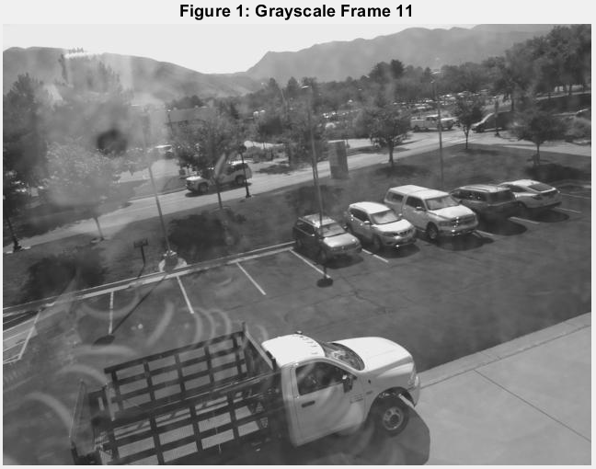

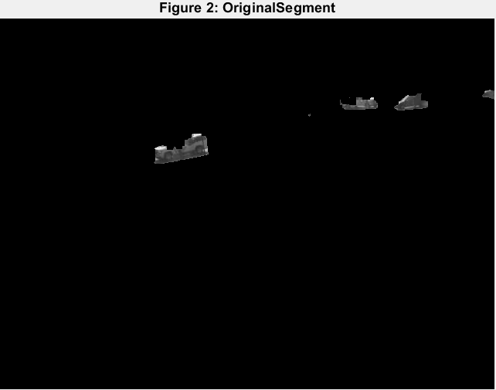

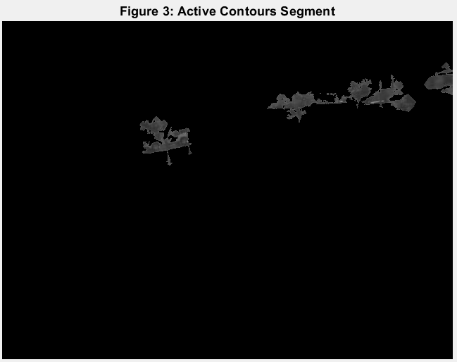

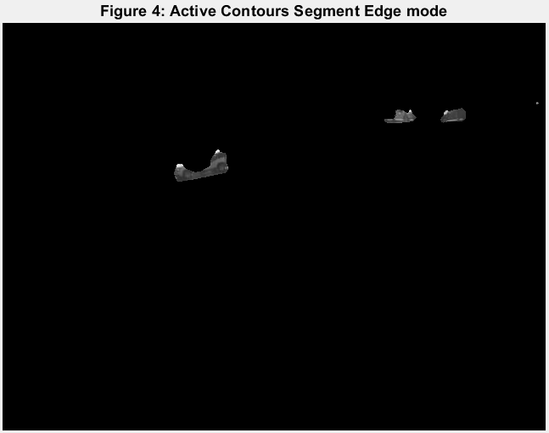

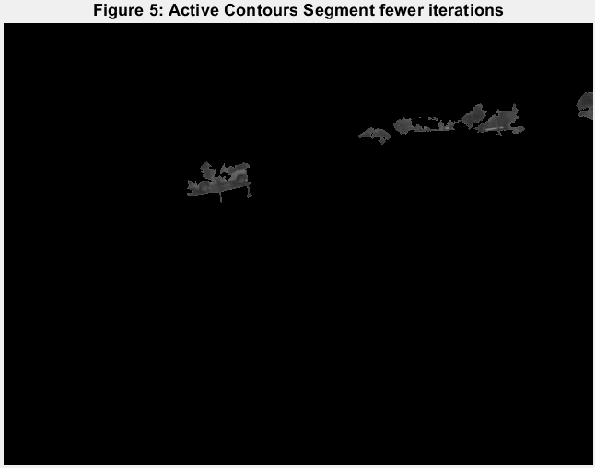

2) For level set I first considered the simple test case shown in **Figure 6** where the outer area is 0 and the inner is 255. Thus the gradient is steep at this interface and should yield a suffidient edge to stop the propogation of the level set function. The start location was set to the center of the test image. When we examine the initial phi values as a surf (**Figure 7**) we see that it is as expected, a cone centered around the starting point. **Figure 8** shows the final values for phi after the level sets had completed 100 iterations. As expected there is a vally in the center then steep edges around it (also steep edges at the edge of our image). When we fill in this low region we get **Figure 10** segmentation of the center area, as expected. **Figure 9** shows the values of the phi matrix dropping (the sum value) but not plateauing, meaning that while we did get a good segmentation, possibly we could have gotten a better one by adding more iterations until this plateaued. However this will do for now as a test case. **Figures 11-13** show the results of performing this level set on a location within a car from frame 11. As can be seen the level set values seem to begin to plateau but the area gets stuck within the car. The gradients within the car seem to be too great for it to pass. **Figure 14-16** show the same location for starting but with 500 iterations in stead of 100. Again the curve does not quite plateau but the region does seem to grow a bit showing that more iterations might help. **Figure 17-19** show a different location on the same car as the start and again we have similar issues. **Figures 20-22** show a starting location on the truck in the foreground where there is less of a gradient on the hood of that truck. Here it would seem that the curve decays rapidly but does not plataue in 500 iterations, however the area covered seems better/easier to grow in. **Figure 23-25** show the same area but with 5000 iterations. Now we are reaching some kind of plataue and seem to have well segmented the dash of the car. So that is cool. Finally **Figure 26-28** she the results of 500 iterations after first smoothing the image (median filter) using a seed point from the car in the background/on the road.



