CS6640 A8

Jake Bergquist

12/12/18

1. The first step was to take the 9 videos (3 cars, 3 trucks, and 3 busses) and segment them for moving objects using the CS6640_MM function I developed which uses a combination of filtering, background subtracting, and frame to frame imaging to find moving vehicles and people. I then went though each frame and extracted the largest moving object to exclude moving persons and utilized this to get my feature vectors. I got Area, major axis length, minor axis length, and perimeter length as feature vectors to train the 5 layer net. I trained using the first two videos from each vehicle type first using all 4 of the feature vectors. The resulting confusion table for reentering the inputs is shown in **Table 1** while the confusion table for using the 3rd video for each vehicle type is show in **Table 2**. As can be seen, using 4 feature vectors on the testing data, while not perfect, did pretty good and as we might expect. The net usually said Car when there was actually a car, although it often said something else (usually truck) even if it was a car. However it is mostly right on all of its predictions using the training data. This of course degrades when we use the testing data, as we see that both cars and busses lose in their respective categories, and the algorithm is mostly happy to call anything a truck. As expected the use of only one feature, in this case the perimeter, performed worse (**Tables 3 and 4**). **Table 3** shows the results of re inputing the training data and **Table 4** shows the testing data results. However we can still notice some trends. In the testing data the net never calls a true bus a car and it is still mostly good at differentiating a car from a bus. However as before, it likes to call most things Trucks, but in this case the bus and the car won in their own categories, thus there might be a feature we are using in the 4 feature set that is confusing for the net. Overall the best use of this would be to classify busses from cars. If the network says it is a truck then it is probably a medium sized car or small bus/a bus that is behind something during that frame.

|  |  |  |  |  |
| --- | --- | --- | --- | --- |
| Table 1 | Predicted Car | Predicted Truck | Predicted Bus |  |
| Actual Car | 258 | 141 | 4 | 403 |
| Actual Truck | 48 | 271 | 23 | 342 |
| Actual Bus | 4 | 107 | 419 | 530 |
|  | 310 | 519 | 446 |  |

|  |  |  |  |  |
| --- | --- | --- | --- | --- |
| Table 2 | Predicted Car | Predicted Truck | Predicted Bus |  |
| Actual Car | 26 | 35 | 30 | 91 |
| Actual Truck | 11 | 136 | 77 | 224 |
| Actual Bus | 0 | 133 | 122 | 255 |
|  | 37 | 304 | 229 |  |

|  |  |  |  |  |
| --- | --- | --- | --- | --- |
| Table 3 | Predicted Car | Predicted Truck | Predicted Bus |  |
| Actual Car | 222 | 174 | 7 | 403 |
| Actual Truck | 44 | 202 | 96 | 342 |
| Actual Bus | 29 | 171 | 330 | 530 |
|  | 295 | 547 | 433 |  |

|  |  |  |  |  |
| --- | --- | --- | --- | --- |
| Table 4 | Predicted Car | Predicted Truck | Predicted Bus |  |
| Actual Car | 47 | 34 | 10 | 91 |
| Actual Truck | 32 | 134 | 58 | 224 |
| Actual Bus | 0 | 115 | 140 | 255 |
|  | 79 | 283 | 208 |  |

1. Ok this is probably the most fun I have had messing with Matlab. Fisrt I gave the alexnet a picture of a mason jar with my livingroom as a background. It classified that as a radiator. I guess the blinds in the background threw it off. This can be seen in **Figure 1**. I then tried taking a picture of a pensile in **Figure 2** but again it noticed the blinds which makes sense as these are the predominant feature. This time it got it right though, so that was neat. I then took a picture of my huskey who was on the couch. She was labeled as an Egyptian cat in **Figure 3**. I suppose her face looks a little cat like but I thought the fur would make it a different kind of cat if any. Next I took a picture of one of my guitars. This one is on a white background which I think helped a lot as there was not distracting features to identify. **Figure 4** shows that it called it not only a guitar, but an acoustic guitar, which it is. I was impressed. I then took a picture of my mandolin, which it called a banjo (**Figure 5**). This is close enough I guess as they are both stringed instruments but I think a violin would have been a better call if not to call it correctly. Finally I took a picture of my other dog, who is a border collie Australian shepherd mix but he was recently shaved, so I wanted to see if 1) he would be called a dog, and 2) what kind. **Figure 6** shows that he was called an English Springer which, I guess, given his coloring makes sense a bit, although the ears do not match. **Figure 7** shows an actual English springer for comparison

Overall this was an amusing exploration of the classification capabilities of this neural net and I find that I will be playing with this more in the future.

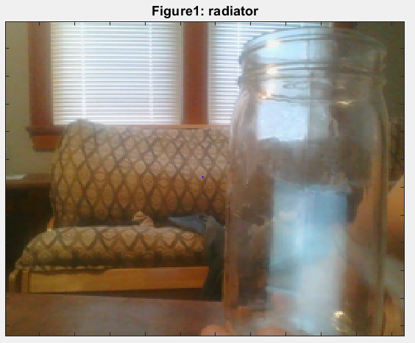

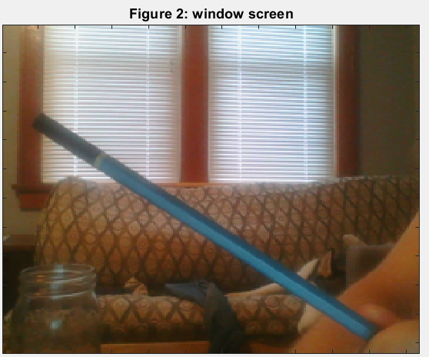

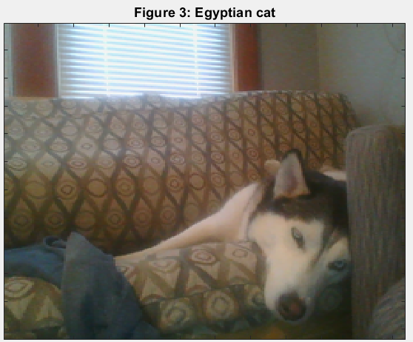

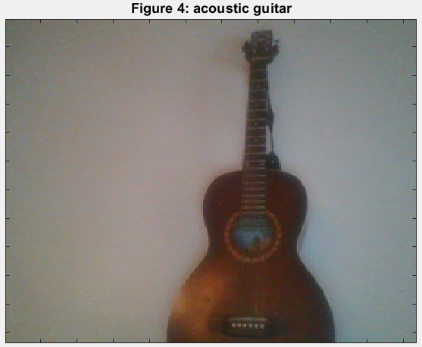

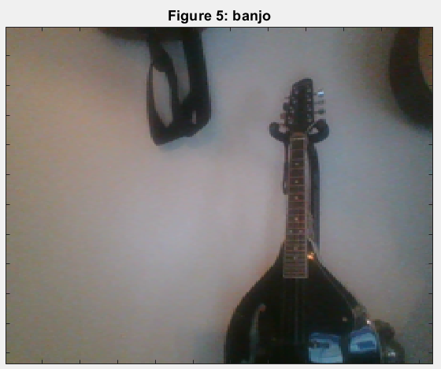

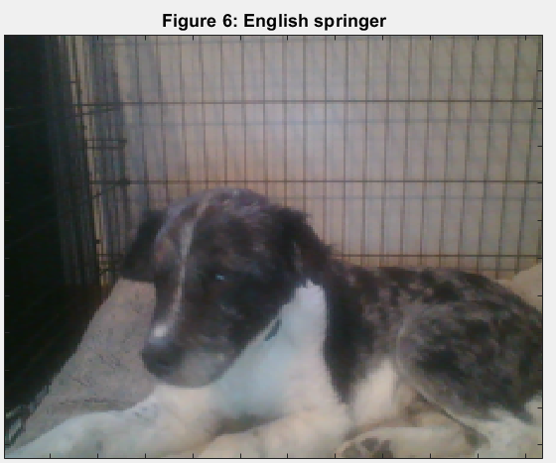

**Figure 7**

