Analytics-Driven Centralized Admin-Client Order, Inventory, and Distribution Management System for Multi-Branch Supermarkets

A Capstone Project presented to the College of Information
Technology Education PHINMA University of Iloilo
Iloilo City

Submitted in partial fulfillment of the requirements for the
degree of
Bachelor of Science in Information Technology
Business Analytics Management

Bagaforo, Jasmen
Nobleza, Aira
Panganiban, Angela
Segodine, Thea Anne
Sumayo, Giah Anne

March 2026

Abstract

The increasing complexity of managing inventory, customer orders, and product distribution across multiple supermarket branches has created significant operational challenges for retail businesses. Manual processes and decentralized information systems often result in inaccurate inventory records, delayed order processing, inefficient distribution planning, and limited access to real-time operational data. These challenges can lead to stock shortages, overstocking, delayed deliveries, and reduced customer satisfaction. To address these issues, this study designed and developed an Analytics-Driven Centralized Admin-Client Order, Inventory, and Distribution Management System for Multi-Branch Supermarkets. The proposed system was developed specifically for the business operations of Mrs. Joan Castro Bagaforo to improve the management of inventory, branch orders, and product distribution through a centralized and automated platform.

The study employed the Agile Software Development Methodology, which emphasizes iterative planning, development, testing, and continuous improvement throughout the software development process. Data were gathered through interviews, direct observations, and consultations with the client to identify existing operational challenges and system requirements. Based on the collected data, the researchers developed a web-based system featuring a centralized database that consolidates inventory records, order transactions, and distribution information from multiple supermarket branches. The system includes automated order processing, real-time inventory tracking, branch stock monitoring, distribution scheduling, inventory movement tracking, demand forecasting, stock trend analysis, inventory optimization, interactive dashboards, and automated report generation. These features enable administrators and branch personnel to access accurate and up-to-date operational information, improving coordination and supporting timely business decisions.

The developed system was evaluated using the ISO/IEC 25010 Software Quality Model, focusing on functionality, usability, reliability, efficiency, and security. The evaluation results demonstrated that the system successfully met the operational requirements of the client by improving inventory accuracy, reducing manual workloads, enhancing order coordination, streamlining distribution planning, and providing analytics-driven insights for decision-making. The study concludes that the implementation of a centralized and analytics-driven management system can significantly improve operational efficiency, inventory control, and distribution management in multi-branch supermarket environments. Furthermore, the proposed system provides a scalable and practical solution that may serve as a reference for other retail businesses seeking to modernize their operational processes through integrated information systems.

Keywords: Analytics-Driven System, Centralized Database, Inventory Management, Order Management, Distribution Management, Multi-Branch Supermarket, Demand Forecasting, Business Analytics, Web-Based Information System, Operational Efficiency.

Table of Contents
Abstract 2
Chapter 1 6
Introduction to the Study 6
Statement of the Problem 11
Objectives of the Study 11
General Objectives 11
Specific Objectives 12
Significance of the Study 13
Definition of Terms 14
Scope and Limitations 15
Chapter 2 18
Review of Related Literature and Studies 18
Foreign Studies 18
Related Literature 34
Synthesis of the Reviewed Literature 39
CHAPTER 3 42
METHODOLOGY 42
Research Design 43
System Architecture 45
User Interface Wireframe Design 46
Tools and Technologies Used 53
Data Gathering Techniques 53
Testing Procedures 54
SUPPORTING DIAGRAMS 61
Entity Relationship Diagram (ERD) 61
Data Flow Diagram Level 0 (ERD) 65
Use Case Diagram Actors: 68
CHAPTER 4 71
4.2 Overview of the Developed System 71
Figure 4.1 72
System Interface 72
Client Registration 72
Deliveries 74
The branch delivery information allows the client side to retrieve delivery-related information associated with the branch. Use delivery records to compare received stock with physical quantities. When a delivery arrives, verify the number of big and small trays before relying on the record for inventory checking. 74
Orders 75
On the Sales/Record Sale section, the system calculates the egg quantity from the tray quantities and records the transaction with its total amount(optional/ you can leave it blank). Confirm that the quantities do not exceed the branch's available inventory. 75
75
Requesting Additional Stocks 75
76
Stocks 76
Returns 77
Profile 78
4.3 System Development Methodology 79
Requirements Gathering 79
System Planning 80
System Design 80
Software Development 81
4.3.5 Testing 81
Deployment 81
Maintenance 82
System Architecture 82
Figure 4.2 82
Presentation Layer 82
Application Layer 83
Data Layer 83
4.5 Hardware and Software Requirements 84
4.5.1 Hardware Requirements 84
4.5.2 Software Requirements 85
4.6 Database Design 85
Analytics Table 86
CHAPTER 5 87
CONCLUSION AND RECOMMENDATIONS 87
5.1 Introduction 87
5.2 Summary of Findings 87
5.3 Conclusion 88
5.4 Recommendations 88
System Improvements 88
Future Research 89
Implementation Recommendations 89
5.5 Impact of the Study 89
5.6 Summary 90

Chapter 1

Introduction to the Study

In today’s highly competitive and technology-driven retail industry, supermarkets are expected to provide fast, efficient, and reliable services to customers while maintaining accurate inventory control and effective distribution management. As consumer demands continue to increase, retail businesses must ensure product availability, timely replenishment, accurate order processing, and efficient coordination among branches and suppliers. The rapid growth of the retail industry has encouraged many supermarkets to expand their operations by establishing multiple branches in different locations to serve a larger customer base and increase market presence. Multi-branch supermarkets provide businesses with opportunities to improve accessibility, increase sales, and strengthen competitiveness within the retail sector. However, as organizations continue to expand, managing operations across several branches becomes increasingly challenging. Each branch generates its own data related to orders, inventory levels, product movement, and customer demand, resulting in a significant increase in the volume of information that must be monitored and managed by administrators.

Business expansion introduces several operational challenges, particularly in maintaining consistency, coordination, and communication among branches. Administrators must ensure that products are available in the right quantities at the right locations while avoiding stock shortages and overstocking situations. Coordinating inventory replenishment, approving branch orders, and monitoring product distribution become more difficult as the number of branches increases. Without an effective management system, delays in information sharing and decision-making may occur, negatively affecting operational efficiency and customer satisfaction.

Furthermore, the expansion of supermarket operations leads to increased operational complexity due to the interconnected nature of ordering, inventory management, and distribution activities. Decisions made in one branch can directly affect stock availability and distribution schedules in other locations. Managing these processes manually or through separate systems often results in fragmented information, duplicated records, and limited visibility across the organization. Consequently, administrators may find it difficult to obtain accurate and real time information necessary for making timely business decisions. These challenges highlight the need for integrated and centralized solutions capable of supporting the growing operational requirements of multi-branch supermarkets.

However, many supermarkets, particularly those operating multiple branches, still rely on manual processes, disconnected systems, and traditional inventory monitoring methods. These outdated practices often lead to operational problems such as stock shortages, overstocking, delayed deliveries, inaccurate inventory records, inefficient order processing, and poor coordination between branches. Such challenges negatively affect productivity, profitability, decision-making, and customer satisfaction. Consequently, the adoption of centralized and technology-based management systems has become essential for supermarkets to remain competitive and sustainable in the modern retail environment. [3], [8], [16]

Inventory management plays a significant role in the overall performance and operational success of supermarkets because it directly influences product availability, sales performance, customer satisfaction, and organizational efficiency. Effective inventory management enables businesses to maintain the right quantity of products at the right time while minimizing operational costs and inventory-related losses. However, supermarkets with multiple branches often encounter difficulties in monitoring inventory movement, processing branch requests, and coordinating distribution activities due to fragmented operational data and the absence of centralized systems. In many cases, each branch maintains separate records using spreadsheets, handwritten logs, or isolated databases, making it difficult to access accurate and real-time information. Despite the continuous advancement of information technology, many supermarkets still rely on manual inventory management practices and traditional record-keeping methods to monitor stock levels and product movement. These methods often involve the use of spreadsheets, handwritten logs, paper-based forms, and isolated databases maintained separately by each branch. While such approaches may be manageable for small-scale operations, they become increasingly inefficient and difficult to maintain as businesses expand and handle larger volumes of transactions and inventory data. [3], [8], [12]

One of the major challenges associated with manual inventory management is the occurrence of human errors during data entry, recording, and inventory updates. Employees may unintentionally input incorrect quantities, duplicate transactions, or fail to record inventory movements accurately. Even minor mistakes in stock records can accumulate over time and result in discrepancies between actual inventory levels and system records. These inaccuracies can negatively affect purchasing decisions, inventory replenishment, and product distribution planning, ultimately reducing operational efficiency. [8], [12]

Another issue commonly encountered in manual systems is the existence of duplicate records caused by multiple employees updating inventory information independently or maintaining separate copies of inventory files. The lack of synchronization among branches often leads to inconsistent data and conflicting inventory reports. Duplicate records not only create confusion among administrators and inventory personnel but also make it difficult to determine the actual quantity of products available across different branches. Consequently, management decisions based on inaccurate or duplicated information may lead to inefficient resource allocation and unnecessary operational expenses.

Delayed reporting is also a significant limitation of manual inventory management systems. Since inventory data must be manually consolidated and submitted to administrators, obtaining updated information often requires considerable time and effort. As a result, decision-makers may rely on outdated reports when planning inventory replenishment or approving branch orders. The inability to access real-time inventory information limits the organization's responsiveness to fluctuations in customer demand and changes in market conditions. [3], [8]

Furthermore, inaccurate inventory records and delayed reporting frequently contribute to problems such as overstocking and stock shortages. Overstocking occurs when businesses purchase or distribute products in quantities that exceed actual demand, leading to increased storage costs, wasted resources, and potential product expiration, particularly for perishable goods. On the other hand, stock shortages arise when inventory levels are insufficient to meet customer demand, resulting in lost sales opportunities and reduced customer satisfaction. Both situations negatively impact business profitability and operational performance.

These challenges highlight the limitations of traditional inventory management approaches and emphasize the need for more efficient and integrated solutions. The implementation of centralized and analytics-driven inventory management systems can provide real-time visibility into stock levels, improve data accuracy, reduce manual intervention, and support more informed decision-making processes across multiple supermarket branches. As a result, inconsistencies in stock records, duplication of data, delayed updates, and communication gaps commonly occur, leading to inefficient business operations and poor managerial decision-making.

The rapid advancement of information technology has significantly transformed retail operations by introducing modern systems capable of automating and integrating various business processes. Technologies such as cloud-based platforms, automated inventory systems, Enterprise Resource Planning (ERP) systems, and analytics-driven management tools provide organizations with the ability to monitor inventory levels in real time, streamline operational workflows, and improve coordination across multiple branches. The rapid advancement of information and communication technologies has accelerated the digital transformation of businesses across various industries, including the retail sector. Digital transformation refers to the integration of digital technologies into business processes to improve operational efficiency, enhance decision-making, and provide better services to customers. In the supermarket industry, digital transformation has become increasingly important as businesses seek to manage growing volumes of transactions, inventory records, and distribution activities across multiple branches. Modern retail organizations are gradually replacing traditional and manual processes with technology-driven solutions that enable faster, more accurate, and more efficient operations.

One of the key technological developments supporting digital transformation in supermarkets is the adoption of cloud computing. Cloud-based systems allow organizations to store, manage, and access information through internet-based platforms rather than relying solely on local servers or individual branch databases. Through cloud computing, administrators and branch personnel can access real-time information regardless of their location, facilitating better communication and coordination among different branches. Additionally, cloud-based solutions provide scalability, data security, and centralized access to information, making them highly suitable for multi-branch supermarket operations that require continuous monitoring and data sharing.

Another significant aspect of digital transformation is the implementation of automation and business intelligence tools. Automation technologies help reduce manual intervention in routine tasks such as inventory updates, order processing, report generation, and stock monitoring. By automating these processes, businesses can minimize human errors, improve data accuracy, and increase operational efficiency. Meanwhile, business intelligence tools enable organizations to collect, process, and analyze large volumes of data, transforming raw information into meaningful insights that support strategic decision-making.

The increasing use of data-driven approaches has also changed the way retail organizations manage their operations. Data-driven retail operations involve the use of historical and real-time data to identify trends, forecast demand, monitor performance, and optimize business processes. By analyzing inventory movements, customer purchasing patterns, and branch performance, supermarket administrators can make informed decisions regarding inventory replenishment, product distribution, and resource allocation. The ability to leverage data for decision-making allows businesses to respond more effectively to changing market conditions and customer demands while improving overall organizational performance.

As the retail industry continues to embrace digital transformation, the adoption of cloud computing, automation, and business intelligence technologies has become essential for maintaining competitiveness and ensuring efficient operations. These technological advancements provide organizations with greater visibility into their business processes and enable more accurate, timely, and data-driven decision-making. Consequently, implementing an analytics-driven and centralized management system becomes a practical solution for addressing the operational challenges encountered by multi-branch supermarkets.

These systems also enhance data accessibility and operational visibility, allowing administrators and managers to make timely and informed decisions. Through centralized management systems, supermarkets can improve communication among branches, suppliers, warehouse personnel, and distribution staff while reducing manual errors, operational delays, and inefficiencies in inventory handling and order processing.

In addition, efficient distribution management and logistics coordination are essential in ensuring the continuous flow of products from suppliers and warehouses to supermarket branches. A well-coordinated distribution system minimizes delivery delays, inventory losses, and disruptions in daily operations. However, without a centralized platform, supermarkets often struggle to synchronize distribution schedules, allocate stocks properly, and monitor deliveries effectively. The lack of real-time visibility in distribution activities may result in delayed replenishment, inaccurate stock allocation, and inefficient delivery planning. Integrating inventory management, order processing, and distribution coordination into a single centralized platform can significantly improve supply chain efficiency, operational performance, and resource utilization. Furthermore, centralized systems enable supermarkets to optimize delivery scheduling, monitor stock movement efficiently, and ensure timely replenishment of products across all branches.

Moreover, the integration of analytics-driven technologies has become increasingly important in modern retail operations as businesses seek to improve decision-making and enhance operational efficiency. Through the use of advanced analytical tools, organizations can transform large volumes of operational data into meaningful information that supports strategic planning and resource management. Analytics-driven systems provide administrators with valuable insights into inventory movement, branch performance, and customer demand patterns, enabling more proactive and informed decision-making processes.

One important application of analytics in retail operations is predictive analytics, which involves the use of historical and current data to identify trends and anticipate future events. By analyzing previous sales transactions, inventory movement, and seasonal purchasing patterns, supermarkets can predict future customer demand and prepare accordingly. Predictive analytics allows organizations to anticipate fluctuations in demand, minimize uncertainties, and improve the accuracy of business planning activities.

Closely related to predictive analytics is demand forecasting, which enables businesses to estimate future product requirements based on historical sales performance and market trends. Accurate demand forecasting helps administrators determine the appropriate quantity of products that should be procured and distributed to each branch. This reduces the likelihood of stock shortages during periods of high demand and minimizes excess inventory during slower periods. Consequently, demand forecasting contributes to improved customer satisfaction, reduced inventory costs, and more efficient utilization of organizational resources.

Another significant advantage of analytics-driven systems is inventory optimization. Inventory optimization involves maintaining the appropriate balance between product availability and inventory costs by ensuring that stock levels remain sufficient to meet customer demand without creating excessive surplus inventory. Through analytical techniques, supermarkets can identify fast-moving and slow-moving products, determine optimal reorder points, and establish effective replenishment strategies. This enables organizations to improve inventory turnover, reduce waste, and enhance overall operational efficiency.

Furthermore, data visualization tools and interactive dashboards have become essential components of modern management systems. Dashboards present complex operational data in a visual and easy-to-understand format using charts, graphs, and performance indicators. Through data visualization,
administrators can monitor inventory levels, track branch orders, analyze sales trends, and evaluate distribution performance in real time. The availability of visual insights enables faster interpretation of information and supports timely decision making, particularly in dynamic retail environments where rapid responses to operational issues are necessary.

The integration of predictive analytics, demand forecasting, inventory optimization, and data visualization technologies enables supermarkets to transition from reactive decision-making to proactive and data-driven management practices. These analytical capabilities provide organizations with greater visibility into their operations and contribute to improved efficiency, reduced costs, and enhanced competitiveness within the retail industry. [5], [9], [32]
Analytics tools enable organizations to collect, process, and analyze large volumes of operational data to identify sales trends, forecast customer demand, evaluate inventory movement, and optimize replenishment strategies. Predictive analytics and data visualization technologies also provide administrators with valuable insights that support faster, more accurate, and data-driven decisions. By utilizing analytics within a centralized order, inventory, and distribution management system, supermarkets can reduce operational costs, minimize inventory related losses, improve forecasting accuracy, and enhance customer satisfaction through better product availability and service efficiency. The use of analytics-driven systems also allows managers to evaluate business performance comprehensively and respond effectively to changing market demands and operational challenges.

Considering these operational challenges and technological advancements, there is a growing need for an integrated and automated management system specifically designed for multibranch supermarket operations. A centralized system that combines order processing, inventory monitoring, distribution management, and analytics-driven decision support can help address the limitations of manual and fragmented processes. Such a system can provide real-time access to operational data, improve coordination among branches, enhance inventory accuracy, and support efficient distribution planning. Through automation and centralized data management, supermarkets can improve operational efficiency, reduce human error, and strengthen organizational productivity.

Therefore, this study proposes the development of an Analytics-Driven Centralized Admin-Client Order, Inventory, and Distribution Management System for Multi-Branch Supermarkets. The implementation of a centralized inventory and distribution management system offers numerous advantages for supermarkets operating multiple branches. By integrating inventory records, order processing, and distribution activities into a single platform, organizations can achieve greater consistency and coordination across all branches. Centralized systems eliminate the need for maintaining separate databases and records, thereby reducing data fragmentation and improving the overall efficiency of business operations.

One of the primary benefits of centralized management systems is improved visibility into organizational operations. Administrators can access real-time information regarding inventory levels, branch orders, product movement, and distribution schedules from a single interface. This enhanced visibility enables management to monitor business activities more effectively and identify potential issues before they significantly affect operations. Real-time access to information also facilitates better communication and collaboration among branches and central administrators.

Centralized systems also contribute to cost reduction by minimizing redundant processes, reducing manual workloads, and improving inventory utilization. Through better monitoring and coordination, organizations can avoid unnecessary stock transfers, reduce excess inventory, and minimize losses resulting from expired or unsold products. Additionally, efficient distribution planning helps lower transportation and operational expenses, contributing to improved profitability and resource management.

Another important advantage of centralized inventory and distribution systems is faster decision-making. Since information from all branches is consolidated and readily available, administrators can respond quickly to inventory shortages, sudden increases in demand, and distribution requirements. The availability of accurate and up-to-date information supports more informed decisions regarding stock replenishment, order approvals, and product allocation across branches, ultimately improving operational responsiveness.

Furthermore, improved inventory management and efficient distribution processes contribute directly to better customer satisfaction. Ensuring product availability, reducing stock shortages, and minimizing delivery delays allow supermarkets to meet customer expectations more consistently. Customers benefit from improved service quality and greater product accessibility, while businesses strengthen customer trust and loyalty through reliable and efficient operations.

These benefits demonstrate the importance of adopting centralized and analytics-driven management systems in modern retail environments. As supermarket operations continue to grow in complexity, organizations require integrated solutions that provide operational visibility, support efficient resource utilization, and facilitate timely decision-making to maintain competitiveness and achieve sustainable growth.

The proposed system aims to address common operational problems such as inaccurate inventory monitoring, delayed replenishment, inefficient order processing, fragmented operational records, and ineffective distribution coordination. Specifically, the study seeks to provide a unified and automated platform that integrates inventory management, order processing, distribution monitoring, and analytics-based reporting into a single system. Through the integration of modern information technologies and analytics-driven features, the proposed system is expected to improve operational coordination, inventory visibility, distribution efficiency, managerial decision-making, and overall business performance. Ultimately, the system aims to help supermarkets enhance productivity, maintain customer satisfaction, and achieve more efficient and sustainable retail operations.

Statement of the Problem

In the modern retail industry, multi-branch supermarkets encounter various operational challenges in managing orders, inventory, and distribution processes efficiently. Many supermarkets still rely on fragmented systems, manual inventory recording, and disconnected databases, which result in delays, inaccurate stock monitoring, poor coordination among branches, and inefficient decision-making. The absence of centralized and analytics-driven management systems limits the ability of administrators to monitor real-time operations, optimize inventory levels, and improve distribution performance. As customer demand and operational complexity continue to increase, there is a growing need for an integrated system that can streamline supermarket operations and enhance organizational efficiency.

This capstone project aims to develop an Analytics-Driven Centralized Admin-Client Order, Inventory, and Distribution Management System for Multi-Branch Supermarkets. Specifically, it seeks to answer the following problems:

- How can order processing across multiple supermarket branches be centrally monitored to reduce delays and inconsistencies in transactions?

- How can the system improve the accuracy and reliability of inventory records by minimizing manual encoding and disconnected database management?

- How can analytics-driven inventory monitoring help optimize stock replenishment and reduce occurrences of stockouts and overstocking?

- How can real-time visibility in distribution planning improve delivery scheduling, coordination, and operational efficiency?

- How can the system generate centralized and consolidated reports to support faster and more accurate managerial decision-making?

- How can predictive analytics be integrated into the system to improve demand forecasting and inventory optimization in multi-branch supermarket operations?

Objectives of the Study

General Objectives

The general objective of this study is to design, develop, and implement an Analytics-Driven Centralized Admin-Client Order, Inventory, and Distribution Management System for Multi-Branch Supermarkets that will serve as a unified platform for managing and coordinating business operations across multiple supermarket branches. The proposed system aims to integrate order processing, inventory monitoring, stock replenishment, and distribution management into a centralized environment that facilitates seamless communication and information sharing among administrators, branch managers, inventory personnel, and distribution staff.

Specifically, the system seeks to address the operational challenges associated with manual record-keeping, fragmented information systems, duplicate records, delayed reporting, inventory inaccuracies, and inefficient distribution processes commonly experienced by multi-branch supermarkets. Through the implementation of centralized databases, process automation, and real-time monitoring capabilities, the system intends to improve data accuracy, enhance operational visibility, and strengthen coordination among branches and central administration.

Furthermore, the study aims to incorporate analytics-driven technologies, including predictive analytics, demand forecasting, inventory optimization, trend analysis, interactive dashboards, and automated reporting tools, to support data-driven decision making and strategic planning. These analytical capabilities are expected to assist administrators in anticipating customer demand, optimizing stock allocation, improving inventory utilization, and enhancing distribution efficiency across multiple locations. [5], [9], [32]

Ultimately, the proposed system seeks to improve operational efficiency, reduce unnecessary operational costs, minimize stock shortages and excess inventory, accelerate managerial decision making, optimize resource utilization, and enhance customer satisfaction through the adoption of a centralized and analytics driven approach to order, inventory, and distribution management in multi-branch supermarket operations.

Specific Objectives

Specific Objectives

Specifically, this study aims to:

- To develop a centralized database system that consolidates branch transactions, inventory records, sales information, order requests, delivery schedules, and operational data from all supermarket branches into a single integrated platform.

- To design and implement an automated order management system that enables branch managers to submit order requests electronically and allows administrators to review, approve, monitor, and process transactions efficiently and accurately.

- To implement a real-time inventory monitoring and tracking system that provides administrators and branch personnel with accurate and up-to-date information regarding stock availability, inventory movement, stock transfers, and replenishment requirements across multiple branches.

- To integrate analytics-driven functionalities such as predictive analytics, demand forecasting, stock trend analysis, and inventory optimization to support effective inventory planning, replenishment decisions, and resource allocation. [5], [9], [32]

- To develop a centralized distribution management module capable of improving stock allocation, delivery coordination, distribution scheduling, and monitoring of product movement among branches.

- To design and generate automated, consolidated, and analytics-based reports related to inventory status, branch transactions, order requests, sales performance, and distribution activities to support operational monitoring and business evaluation.

- To develop interactive dashboards and data visualization tools that present key operational indicators through charts, graphs, and performance metrics to support faster, more accurate, and data-driven managerial decision-making.

- To improve communication, coordination, and information sharing among administrators, branch managers, inventory personnel, and distribution staff through centralized access to real-time operational information.

- To minimize manual errors, duplicate records, delayed reporting, stock shortages, and excess inventory through the implementation of centralized databases, process automation, and real-time monitoring technologies.

- To evaluate the developed system using the ISO/IEC 25010 Software Quality Model in terms of functional suitability, usability, reliability, performance efficiency, security, compatibility, maintainability, and portability.

Significance of the Study

The proposed Analytics-Driven Centralized Admin-Client Order, Inventory, and Distribution Management System for Multi-Branch Supermarkets is expected to contribute significantly to improving operational efficiency, inventory accuracy, order coordination, and distribution management in supermarket operations. Through the integration of centralized data management, automation, and analytics-driven technologies, the system aims to address common operational challenges such as inventory inaccuracies, delayed order processing, inefficient distribution scheduling, and limited decision-making support. Specifically, this study will benefit the following:

- Administrators – The proposed system will provide administrators with centralized control and real-time visibility of operations across all supermarket branches. It will enable faster, more accurate, and data-driven decision-making through consolidated reports, interactive dashboards, and analytics tools. Furthermore, administrators will be able to monitor inventory status, branch performance, order transactions, and distribution activities efficiently from a centralized platform.

- Branch Managers – The system will assist branch managers in improving operational coordination, order processing, and inventory monitoring. Real-time access to stock information and branch transactions will help managers ensure product availability, reduce operational delays, and improve coordination between branches and the central administration.

- Inventory Personnel – The study will benefit inventory personnel by reducing dependency on manual inventory recording and minimizing human errors in stock monitoring. The implementation of automated inventory tracking and real-time updates will simplify stock management, improve inventory accuracy, and support efficient replenishment planning.

- Distribution Staff – The proposed system will improve distribution planning and delivery coordination through organized and centralized access to operational data. Real-time visibility of inventory requirements, branch requests, and delivery schedules will help distribution staff optimize routing, reduce delays, and improve the overall efficiency of product distribution.

- Supermarket Organization – The organization will benefit from increased operational efficiency, improved inventory control, reduced losses caused by stock shortages and overstocking, and better coordination among branches. By integrating analytics driven decision-making and automated processes, the system is expected to enhance productivity, customer satisfaction, and overall business profitability.

- Researchers and Future Developers – This study will serve as a valuable reference for future researchers, information technology students, and system developers interested in analytics-driven enterprise systems, centralized inventory management, and multi-branch operational platforms. The findings and system design may provide insights for future improvements, innovations, and related studies in retail and supermarket management systems.

Definition of Terms

Analytics Dashboard – Refers to a visual interface within the system that presents real-time operational data, key performance indicators (KPIs), charts, and summarized reports to assist administrators and managers in monitoring supermarket operations and making data-driven decisions.
In this study, the analytics dashboard serves as a decision support tool that enables administrators and branch managers to monitor sales performance, inventory levels, order transactions, and distribution activities efficiently across multiple branches.

Centralized System – Refers to an integrated management system in which all operational data from different supermarket branches are stored, processed, and managed within a single centralized database to improve coordination, monitoring, and accessibility of information.
The proposed study focuses on developing a centralized system that integrates order management, inventory monitoring, and distribution operations to improve coordination and operational efficiency among supermarket branches.

Demand Forecasting – Refers to the process of analyzing historical sales data, inventory trends, and operational information to predict future product demand and support effective inventory planning and replenishment decisions.
Demand forecasting is incorporated in the proposed system to help supermarkets anticipate stock requirements, reduce stock shortages and overstocking, and improve inventory replenishment planning.

Distribution Management – Refers to the process of planning, organizing, monitoring, and controlling the movement and delivery of products from warehouses or distribution centers to supermarket branches in order to ensure timely and efficient product distribution.
The study includes distribution management features to improve delivery coordination, scheduling, and product movement between warehouses and supermarket branches.

Inventory Management – Refers to the systematic process of monitoring, recording, controlling, and optimizing stock levels to maintain product availability, minimize inventory losses, and improve operational efficiency.
Inventory management is one of the core functions of the proposed system, which aims to improve inventory accuracy, stock monitoring, and replenishment processes through automation and real-time tracking.

Multi-Branch Supermarket – Refers to a retail business organization that operates multiple supermarket branches under a centralized management structure and coordinated operational system.
The proposed system is specifically designed for multi-branch supermarkets to improve coordination, inventory visibility, and operational management across different store locations.

Order Management – Refers to the process of creating, processing, monitoring, approving, and fulfilling product orders between the central administration, warehouses, and supermarket branches to ensure accurate and timely transactions.
The study integrates an automated order management feature to improve order processing efficiency, reduce delays, and strengthen coordination between administrators and branch clients.

Predictive Analytics – Refers to the use of data analysis techniques, statistical methods, and historical operational data to identify patterns, predict future trends, and support decision making related to inventory, sales, and distribution operations.
Predictive analytics is integrated into the proposed system to support demand forecasting, inventory optimization, and data driven decision-making for supermarket operations.

Real-Time Inventory Tracking – Refers to the capability of the system to continuously monitor and update inventory levels instantly as stock transactions, replenishments, or product movements occur across supermarket branches.
Real-time inventory tracking allows administrators and branch managers to monitor stock availability and inventory movement accurately, helping improve operational efficiency and inventory control.

Web-Based Platform – Refers to an online system that can be accessed through internet browsers using computers or other internet-enabled devices, allowing authorized users to manage supermarket operations remotely and efficiently.
The proposed system will be developed as a web-based platform to provide accessible and centralized monitoring of orders, inventory, and distribution operations across multiple supermarket branches.

Scope and Limitations

This study focuses on the design, development, and implementation of an Analytics-Driven Centralized Admin-Client Order, Inventory, and Distribution Management System for Multi-Branch Supermarkets. The proposed system aims to provide a centralized and integrated platform that consolidates order management, inventory monitoring, stock control, and distribution operations across multiple supermarket branches. Through a centralized database and analytics-driven functionalities, the system seeks to improve operational coordination, enhance inventory visibility, and support data-driven decision-making within the organization.

The proposed system will enable administrators to monitor and manage operational activities across all participating branches through a single platform. Specifically, administrators will be able to review branch orders, monitor inventory levels, oversee stock movements, approve inventory requests, manage distribution schedules, and generate operational reports. Branch managers will be provided with functionalities for submitting order requests, tracking order status, monitoring branch inventory, and viewing distribution updates. Inventory personnel will be responsible for maintaining inventory records, updating stock movements, and monitoring replenishment requirements, while distribution staff will manage delivery schedules, shipment status, and product transfers among branches.

The system will incorporate several core modules, including user management, order management, inventory management, distribution management, reporting, and analytics modules. The order management module will support electronic submission, approval, and tracking of branch orders. The inventory management module will provide real-time monitoring of stock levels, inventory transactions, stock adjustments, and inventory movement across branches. The distribution management module will facilitate delivery scheduling, product allocation, shipment tracking, and monitoring of inter-branch transfers to improve coordination and delivery efficiency.

To support intelligent decision-making, the system will integrate analytics-driven technologies such as predictive analytics, demand forecasting, inventory optimization, stock trend analysis, and performance monitoring. Predictive analytics and demand forecasting functionalities will utilize historical inventory and transaction data to estimate future product demand and support replenishment planning. Inventory optimization tools will assist administrators in maintaining appropriate stock levels and minimizing stock shortages and excess inventory. Furthermore, the system will generate automated reports and interactive dashboards that present operational information through charts, graphs, and key performance indicators to facilitate faster interpretation of data and more informed managerial decisions. [5], [9], [32]

The reporting component of the system will provide consolidated and branch-specific reports related to inventory status, stock movements, order transactions, delivery activities, and operational performance. Interactive dashboards will allow administrators to monitor inventory trends, distribution efficiency, order fulfillment rates, and branch performance in real time. These analytical capabilities are expected to improve organizational visibility and strengthen strategic planning within supermarket operations.

The proposed system will be developed as a web-based application that can be accessed using desktop computers, laptops, and other internet-enabled devices through authorized user accounts. The centralized database may be deployed using either a cloud-based infrastructure or a local server environment depending on organizational requirements and available resources. Access to system functionalities will be controlled through role-based authentication and authorization mechanisms to ensure data security and appropriate access privileges for different categories of users.

However, the study has several limitations that define the boundaries of the proposed system. The system will not process customer Point-of-Sale (POS) transactions conducted at checkout counters since the primary focus of the study is on back-office operational management rather than customer payment processing and retail sales transactions. Sales information used for analytical purposes will be limited to data required for inventory analysis and demand forecasting and will not include full POS functionalities such as cashier management, receipt generation, or payment gateway integration.

The proposed system will also exclude comprehensive supplier relationship management, procurement management, and purchasing modules beyond basic stock replenishment and order request functionalities. Processes such as supplier accreditation, purchase order negotiations, vendor performance evaluation, and procurement contract management are beyond the scope of this study. Similarly, advanced warehouse automation technologies, including robotic storage systems, automated picking systems, and Internet of Things (IoT)-based inventory tracking devices, will not be implemented.

Furthermore, the study will not include integration with external enterprise systems such as accounting software, payroll systems, financial management applications, customer relationship management platforms, or tax management systems. The system will operate as an independent management platform focusing solely on order processing, inventory monitoring, and distribution coordination within supermarket operations.

The proposed solution will be implemented exclusively as a web-based application and will not include a dedicated mobile application for Android or iOS devices. Although the system may be accessed through mobile web browsers, the user interface will primarily be optimized for desktop and laptop environments. Features such as push notifications, offline synchronization, and native mobile functionalities will therefore not be available within the scope of the study.

In addition, the implementation and evaluation of the system will be limited to selected supermarket branches participating in the study and may not fully represent the operational characteristics of all retail organizations or supermarket chains. The study will not cover other business functions such as marketing management, customer loyalty programs, e-commerce operations, promotional campaign management, customer feedback systems, or social media integration.

Despite these limitations, the proposed system is expected to significantly improve operational visibility, inventory accuracy, order coordination, and distribution efficiency in multi-branch supermarket environments. Through centralized data management, process automation, and analytics-driven decision support capabilities, the system aims to provide organizations with a more efficient and effective approach to managing complex retail operations across multiple locations.

Chapter 2

Review of Related Literature and Studies

This chapter presents the review of related literature and studies that provide the theoretical and empirical foundation for the development of the proposed Analytics-Driven Centralized Admin-Client Order, Inventory, and Distribution Management System for Multi-Branch Supermarkets. It includes a comprehensive discussion of concepts, technologies, methodologies, and previous research related to inventory management, order processing, distribution management, centralized database systems, business analytics, demand forecasting, real-time inventory monitoring, and information systems used in the retail and supermarket industry. The reviewed literature establishes the significance of integrating modern technologies into business operations to improve efficiency, accuracy, coordination, and decision-making.

Furthermore, this chapter examines both foreign and local studies that are relevant to the proposed system. The reviewed studies provide insights into the implementation of analytics driven solutions, centralized management systems, and inventory optimization techniques across various retail environments. By comparing the findings, methodologies, and recommendations of previous researchers, this chapter identifies existing research gaps that justify the need for the proposed study. The synthesis of the reviewed literature and studies serves as the conceptual and academic basis for the design, development, and evaluation of the proposed system, demonstrating how it contributes to enhancing operational efficiency and business performance in multi-branch supermarket operations.

Foreign Studies

We study the optimal supply chain design for a dual-channel retailer that operates physical and web-based stores and has traditionally managed each one separately. With increased pressures from customers and decreased profits due to marked-down leftover inventories in each channel, the retailer considers integrating the supply chain operations of both channels and using in-store inventory more effectively across different channels. In contrast to the existing literature, we focus on the firm's choice of the best omni-channel strategies considering demand segmentation, cost structure, and, more importantly, the inventory rationing ability of the firm. We formulate our problem as a two stage stochastic programming model and use first-order optimality conditions to study the optimal inventory ordering decisions. Based on different omni-channel strategy decisions, we explore four supply chain design options. We identify the optimal inventory ordering policy under each option and explicitly describe the optimality conditions on cost and demand under perfect and imperfect demand information. When the demand information is imperfect, the demand fulfillment decisions can be characterized as nested protection-level policies. First, we show that omnichannel strategies are not necessarily profitable under all settings as dictated by market conditions. Second, we demonstrate that when the company can allocate its inventory perfectly, running omni-channel strategies may help better serve web-based customers and in-store customers. Finally, we show that, in the worst case, the imperfect demand information may result in losing all the claimed inventory integration benefits when running omni-channel strategies.

This research presents the development and deployment of an intelligent inventory management and sales analytics platform specifically designed for supermarket operations. The system addresses critical inefficiencies in traditional manual inventory processes through integration of React.js frontend architecture, Flask-based RESTful API backend, and SQLite database management with advanced machine learning algorithms. Three specialized ML components form the analytical core: Facebook Prophet for temporal sales forecasting, Apriori algorithm for market basket analysis, and Random Forest classification for automated reorder predictions. The platform features real-time inventory monitoring, predictive demand analytics, cross-selling recommendations, and comprehensive reporting dashboards. Extensive testing across multiple retail environments demonstrates 94% accuracy in sales predictions, 91% precision in reorder classifications, and 87% user satisfaction rates. The modular architecture supports deployment scalability from single-store operations to multibranch retail chains while maintaining cost-effectiveness for small-to-medium enterprises. Implementation results show 38% reduction in stockout incidents, 32% decrease in excess inventory costs, and 24% improvement in overall operational efficiency.

The Effect of Inventory Management on Working Capital Efficiency in Retail Chains

Retail chains, with their large product offerings and geographically spread operations, frequently experience the challenging task of achieving an optimal balance between inventory availability and working capital effectiveness. Inventory, in and of itself, is a significant investment of capital in the form of raw materials, finished products, and products in transit to be sold. If not well controlled, unnecessary inventory can tie up large amounts of capital, raise storage expenses, and leave the business vulnerable to obsolescence, shrinkage, and price variance.

Low inventory levels, on the other hand, can result in stockouts, missed sales, reduced customer satisfaction, and loss of image. Therefore, effective inventory management is critical to ensuring that inventory levels are aligned with customer demand while simultaneously minimizing the working capital requirement. With the passage of time, there have been developments in inventory management practices, such as the implementation of Just-in-Time (JIT), Economic Order Quantity (EOQ), demand forecasting, and inventory optimization software, which have revolutionized how retail chains manage inventory. These practices are designed to streamline inventory functions, minimize carrying costs, and increase inventory turnover rates, thereby enhancing the overall effectiveness of working capital use. Although there has been growing awareness of the strategic role of inventory management in retail business, there are still numerous organizations that experience inefficiencies caused by demand variability, supply chain interruptions, and inappropriate inventory policies.

This tends to lead to prolonged cash conversion cycles, which can negatively influence the firm's liquidity position and financial flexibility. Effective inventory management is of great importance for retail chains, satisfying demand and supply and maximizing operations. It entails strategically monitoring the level of stocks in order to satisfy customers at maximum efficiency and maintain costs. Methods such as the just-in-time (JIT) systems reduce excess stocks by aligning orders with production, keeping holding costs low, and maximizing cash flow. Contemporary inventory control increasingly employs sophisticated technologies like automated systems and cloud-based solutions that give real time reports on stock and sales trends, facilitating informed decision-making. Forecasting and demand planning are also critical in envisioning consumer requirements and aligning inventory to meet these needs, which assists retailers in avoiding overstock and stockouts that may result in lost sales or unhappy customers. Key performance measures (KPIs) gauge the efficacy of inventory strategies, with measurements such as inventory turnover ratios measuring how well products are selling. High turnover represents good management, and lower ratios represent possible problems such as overstocking. Retailers compare these measurements regularly against industry benchmarks to determine areas for improvement.

The effectiveness of supply chain processes has a dramatic influence on inventory management. Good coordination supports timely delivery and in-place stock levels at locations, particularly in the face of varied suppliers and fluctuating market conditions. Retailers frequently implement lean processes to remove waste, minimize excess inventory expense, and maximize responsiveness to market volatility. Effective inventory management practices increase working capital use, releasing cash bound in excess stock and aligning with customer needs in a better way.

Operational Efficiency in Retail: Using Data Analytics to Optimize Inventory and Supply Chain Management

According to Oluwakemi Famoti [4], data analytics has become an important tool in improving operational efficiency within retail organizations. Retail businesses often manage large volumes of inventory and supply chain data, making it difficult to maintain accurate stock levels using traditional management methods. The study explained that the use of analytics enables organizations to monitor inventory movement, identify demand patterns, and improve supply chain coordination. Through data driven decision-making, businesses can reduce inventory-related inefficiencies and improve operational performance.

The research examined how analytics technologies support inventory optimization and supply chain management in retail operations. The findings revealed that organizations utilizing data analytics were able to forecast demand more accurately and manage inventory replenishment efficiently. Real-time monitoring systems provided managers with updated information regarding stock levels, allowing faster responses to inventory shortages and fluctuations in customer demand.

Furthermore, the study highlighted that analytics-driven inventory systems reduce operational costs by minimizing excess inventory and preventing stockouts. The integration of data analytics into retail operations also improved communication between suppliers, warehouses, and retail branches. These improvements contributed to faster order fulfillment and enhanced customer satisfaction.

The study concluded that analytics technologies significantly enhance retail operational efficiency and supply chain performance. The findings support the present study because they emphasize the importance of integrating analytics-driven functionalities into centralized inventory and distribution management systems for multi-branch supermarkets.

Multi-Agent Deep Reinforcement Learning for Integrated Demand Forecasting and Inventory Optimization in Sensor-Enabled Retail Supply Chains

Yang et al. [5] explained that modern retail supply chains require intelligent systems capable of responding to rapidly changing customer demand. Traditional forecasting and inventory management methods often struggle to adapt to dynamic retail environments, resulting in stock shortages and excessive inventory costs. To address these challenges, the researchers proposed the use of multi-agent deep reinforcement learning integrated with demand forecasting and inventory optimization models.

The study developed an advanced analytics framework that combines artificial intelligence, machine learning, and sensor enabled technologies to improve inventory planning. Through real time data collection and predictive analytics, the system continuously adjusts inventory decisions based on changing market conditions. This approach improves forecasting accuracy and enables more effective inventory allocation throughout the supply chain.

The findings revealed that the proposed system significantly improved inventory optimization and reduced operational inefficiencies. Retail organizations implementing the model achieved better service levels while maintaining lower inventory holding costs. Furthermore, the integration of intelligent forecasting mechanisms enhanced supply chain responsiveness and decision-making accuracy.

The researchers concluded that artificial intelligence-driven inventory systems provide substantial benefits for modern retail operations. These findings support the proposed study because they demonstrate the value of analytics-driven technologies in enhancing inventory monitoring, forecasting, and distribution management across multiple supermarket branches.

Cloud-Based Business Intelligence in Retail Supply Chain Management

Singh [6] emphasized that cloud-based business intelligence systems are transforming retail supply chain operations by providing real-time access to operational data and analytical tools. Retail businesses often encounter challenges in inventory visibility, demand forecasting, and operational coordination due to fragmented information systems. Cloud-based platforms address these issues by centralizing business information and making it accessible across multiple organizational units.

The study explored how cloud computing and business intelligence technologies support inventory management, forecasting, and supply chain optimization. Through cloud-based systems, managers can access real-time inventory data, monitor sales trends, and generate analytical reports from any location. This accessibility improves coordination between warehouses, suppliers, and retail branches.

Furthermore, the findings indicated that cloud-based business intelligence improves inventory accuracy, reduces operational delays, and enhances decision-making capabilities. The integration of predictive analytics tools enables organizations to identify inventory trends and forecast future demand more effectively. As a result, businesses can improve inventory replenishment strategies and optimize supply chain performance.

The study concluded that cloud-based business intelligence systems significantly improve operational efficiency and supply chain visibility. These findings support the present study because the proposed analytics-driven centralized management system similarly aims to provide real-time monitoring and decision support capabilities for multi-branch supermarkets.

A study on inventory cost management in cross-border e-commerce

As of April 2025, the State Council has established 178 cross border e-commerce comprehensive pilot zones across 31 provinces, autonomous regions, and municipalities, forming a development pattern characterized by land-sea coordination and mutual support between the eastern and western regions. The cross-border ecommerce industry is currently undergoing a crucial stage of development, driven by continued globalization and digital transformation. The widespread adoption of overseas warehouse models has significantly improved logistics and delivery efficiency, while trade facilitation measures—such as the Regional Comprehensive Economic Partnership (RCEP)—have created favorable conditions for the industry's growth. At the same time, the deep integration of big data and artificial intelligence is reshaping supply chain management systems. As the industry expands into emerging markets and transitions toward greener practices, it faces dual challenges of regulatory compliance and regional heterogeneity. These factors directly affect inventory management, requiring enterprises to integrate intelligent forecasting technologies with localized operations to improve inventory turnover while ensuring compliance— ultimately building a sustainable inventory management system.

With the rapid development of the cross-border e-commerce industry, enterprises are under pressure from multi-dimensional costs such as procurement, logistics, warehousing, and tariffs, as well as management challenges including data fragmentation, inaccurate forecasting, and cross-border operational risks. In response, this paper proposes strategies such as building a unified data platform, optimizing inventory layout, leveraging big data for demand forecasting, and enhancing supply chain collaboration. These approaches aim to reduce inventory backlogs and improve capital turnover efficiency, especially helping small and medium sized sellers overcome high costs and extensive operations. Ultimately, the goal is to promote a transition toward refined and sustainable development in the cross-border e-commerce sector.

The cross-border e-commerce industry is currently hindered by significant technical and financial barriers. Mainstream data analytics tools—such as intelligent product selection systems and demand forecasting platforms—are often costly and complex to implement. Constrained by limited capital and technical capabilities, small and medium-sized sellers are more inclined to rely on traditional experience-based decision-making rather than adopting digital tools. At the same time, most enterprises suffer from underdeveloped digital infrastructure. They lack unified management platforms that can integrate order, inventory, and supply chain data, resulting in severely limited data collection and analytical capacity. As a result, replenishment strategies are largely dependent on subjective judgment—a reactive measure stemming from a lack of data capability—and are unable to respond flexibly to market fluctuations. The absence of end-to-end data support—from demand insight to supply chain coordination—traps businesses in a dilemma between inventory overstock and frequent stockouts, becoming a major barrier to refined operations. This challenge is especially acute among small and medium sellers, underscoring the urgent need for cross-border e-commerce enterprises to shift from a traditional “experience-driven” approach to a modern, "data-driven" operational model.

Integrated Admin-Client & Automated Systems

Inventory management automation has become an essential component in improving business operations, particularly in the retail industry. According to Nur Fatin Muhamad and Zulkipli [8], traditional manual inventory systems often lead to operational problems such as stock shortages, overstocking, inaccurate records, and human errors. To address these challenges, supermarkets have started implementing automated inventory systems that utilize technologies such as barcode scanners, inventory software, and computerized tracking systems. These technologies help businesses manage inventory more efficiently and maintain accurate stock records.

The study investigated the relationship between inventory management automation and supermarket performance in Melaka, Malaysia. Using a quantitative research design, the researchers collected data from 190 supermarket employees through survey questionnaires and analyzed the information using SPSS statistical software. The findings revealed that supermarkets in Melaka generally have a high level of inventory automation. More importantly, the researchers found a strong and significant positive relationship between inventory management automation and overall supermarket performance.

Furthermore, the study concluded that automated inventory systems contribute significantly to operational efficiency, productivity, customer satisfaction, and decision-making. Automation allows supermarkets to monitor stock levels in real time, reduce manual workload, and minimize inventory-related errors. The researchers emphasized that integrating automated systems into business operations can help organizations become more competitive and efficient in a fast-changing business environment. These findings support the importance of implementing integrated admin-client and automated systems to improve organizational performance and service quality.

Hybrid Demand Forecasting and Monte Carlo Simulation for Retail Supply Chain Inventory Optimization

Kartikasari et al. [9] explained that inventory optimization is essential for maintaining efficient retail supply chains. Many organizations experience difficulties in predicting demand accurately, leading to inventory shortages or excess stock. To address these issues, the researchers developed a hybrid forecasting model combined with Monte Carlo simulation techniques to improve inventory planning and operational decision-making.

The study examined the effectiveness of combining statistical forecasting methods with simulation-based approaches. By analyzing historical sales data and market demand patterns, the proposed model generated more accurate inventory forecasts compared to traditional forecasting techniques. The simulation component allowed managers to evaluate different inventory scenarios and identify optimal replenishment strategies.

The findings showed that the hybrid forecasting framework improved inventory accuracy and reduced uncertainty in demand planning. Organizations utilizing the model achieved better inventory utilization, reduced carrying costs, and improved service levels. The researchers also emphasized that simulation tools provide valuable insights for inventory managers when dealing with unpredictable market conditions.

The study concluded that integrating forecasting models and simulation techniques significantly enhances inventory optimization and supply chain performance. These findings support the current research because the proposed analytics-driven system also incorporates forecasting and analytical capabilities to improve inventory and distribution management in supermarkets.

Decision Support for Managing Assortments, Shelf Space, and Replenishment in Retail

Hübner and Kuhn [10] highlighted that retail businesses face increasing challenges in managing product assortments, shelf space allocation, and inventory replenishment. As retailers offer a wider variety of products, effective inventory planning becomes more complex. The study emphasized that decision-support systems are necessary to optimize product placement, inventory allocation, and replenishment activities within retail environments.

The research examined advanced decision-support models that integrate inventory management, shelf-space optimization, and replenishment planning. These systems analyze sales data, inventory levels, and customer demand to generate recommendations for inventory allocation and product placement. The integration of analytics allows retailers to maximize shelf utilization while ensuring product availability.

The findings revealed that decision-support systems improve inventory visibility and enhance operational efficiency. Retailers implementing these technologies achieved better inventory turnover rates, reduced stock shortages, and improved customer satisfaction. Additionally, the systems enabled managers to make informed decisions regarding inventory replenishment and resource allocation.

The study concluded that decision-support technologies play a critical role in improving retail inventory management and operational performance. These findings support the present study because the proposed analytics-driven centralized system aims to provide decision-support functionalities for inventory monitoring, order processing, and distribution management across multiple supermarket branches.

The role of a Distribution Center (DC) in the supermarket sector

According to Silva et al. [11], distribution centers (DCs) play a vital role in improving logistics operations in the supermarket sector. The study explained that increasing competition and customer demand require supermarkets to adopt effective logistics management systems to remain competitive. Distribution centers help supermarkets manage storage, material handling, and product distribution more efficiently. The researchers emphasized that proper logistics management contributes to faster operations, improved inventory control, and better customer service.

The researchers conducted a systematic literature review to analyze the role of distribution centers in supermarket operations. A total of 64 published studies related to logistics, warehousing, and distribution management were examined. The review identified several important functions of distribution centers, including inventory storage, order processing, product handling, transportation coordination, and supply chain management. The study highlighted that distribution centers support supermarkets by ensuring the continuous flow of products from suppliers to stores while reducing delays and operational inefficiencies.

Furthermore, the study concluded that effective distribution center management significantly improves operational performance in the supermarket industry. The use of logistics technologies and organized warehouse systems helps businesses reduce costs, improve delivery speed, and maintain product availability. The researchers also noted that integrating logistics and automated systems within distribution centers enhances decision-making and operational coordination. These findings support the importance of integrated admin-client and automated systems in improving business processes, inventory management, and overall organizational efficiency in modern retail operations.

Inventory Auditing and Replenishment Using Point-of-Sales Data

According to Bassamboo et al. [12], inventory auditing and replenishment systems that utilize point-of-sales (POS) data are highly beneficial in improving retail and supermarket operations. The researchers explained that many supermarkets encounter inventory inaccuracies caused by theft, spoilage, scanning errors, and unrecorded losses. These inventory problems often result in stock shortages, delayed replenishment, and poor customer satisfaction. The study emphasized that accurate inventory management is essential for supermarkets to maintain product availability and ensure efficient daily operations.

The researchers developed analytical models that use POS data to monitor inventory movement and improve replenishment decisions. Through the use of data analytics, supermarkets can identify inventory discrepancies, predict stock requirements, and optimize restocking schedules. The study highlighted that analytics-driven systems allow managers to make informed decisions regarding inventory control and distribution processes. In addition, the integration of automated monitoring systems reduces manual errors and improves the accuracy of inventory records across multiple retail branches.

The study concluded that implementing centralized and analytics-driven inventory systems significantly improves operational efficiency and reduces business losses. The use of technology-based inventory management enhances coordination between warehouses, suppliers, and supermarket branches, resulting in faster replenishment and better supply chain performance. The researchers also emphasized that data-driven systems support better forecasting, decision-making, and resource allocation in retail businesses. These findings support the present study because they demonstrate the importance of developing an analytics-driven centralized admin-client order, inventory, and distribution management system for multi-branch supermarkets to improve inventory accuracy, operational efficiency, and customer service.

REFERENCES:

[1] J. Guo and B. B. Keskin, “Designing a centralized distribution system for omni-channel retailing,” Production and Operations Management, vol. 32, no. 6, pp. 1724–1742, 2023, doi: 10.1111/poms.13936

[2] A. M. K. and K. G. J., “DOI: 10.22214/ijraset.2025.73635,” International Journal for Research in Applied Science and Engineering Technology (IJRASET), ISSN 2321-9653, 2025.

[3] S. Saleheen and Y. Parihar, “The effect of inventory management on working capital efficiency in retail chains,” International Journal of Scientific Research and Engineering Development, vol. 8, no. 3, pp. 1628–1637, 2025.

[4] Famoti, “Operational efficiency in retail: Using data analytics to optimize inventory and supply chain management,” International Journal of Scientific Research in Computer Science, Engineering and Information Technology, vol. 11, pp. 1483–1494, 2025, doi: 10.32628/CSEIT251112173.

[5] Y. Yang, M. Wang, J. Wang, P. Li, and M. Zhou, “Multi-agent deep reinforcement learning for integrated demand forecasting and inventory optimization in sensor-enabled retail supply chains,” Sensors, vol. 25, no. 8, p. 2428, 2025, doi: 10.3390/s25082428.

[6] R. K. Singh, “Cloud-based business intelligence in retail supply chain management,” Journal of Quantum Science and Technology, vol. 1, no. 2, 2024, doi: 10.63345/jqst.v1i2.208.

[7] Yao, “A study on inventory and management in cross-border e-commerce,” Journal of Applied Economy and Policy Studies, vol. 10, no. 1, pp. 1–7, 2025.

[8] Muhamad and Zulkipli, “The relationship between inventory management automation and the performance of supermarkets in Malaysia,” Research in Management of Technology and Business, vol. 5, no. 1, pp. 12–25, 2024.

[9] D. P. Kartikasari, T. A. T. Tambak, and A. R. Ridwanto, “Hybrid demand forecasting and Monte Carlo simulation for retail supply chain inventory optimization,” Journal of Information Technology and Computer System, vol. 1, no. 2, pp. 74–85, 2025, doi: 10.65230/jitcos.v1i2.40.

[10] A. Hübner and H. Kuhn, “Decision support for managing assortments, shelf space, and replenishment in retail,” Flexible Services and Manufacturing Journal, vol. 36, no. 1, pp. 1–35, 2024, doi: 10.1007/s10696-023-09492-z.
[11] L. S. da Silva, R. D. Soliani, A. R. T. T. Argoud, and C. G. de Freitas, “The role of a Distribution Center (DC) in the supermarket sector: A systematic literature review,” Research, Society and Development, vol. 11, no. 16, 2022, doi: 10.33448/rsd-v11i16.38728.

[12] A. Bassamboo, A. Moreno, and I. Stamatopoulos, “Inventory auditing and replenishment using point-of-sales data,” Production and Operations Management, vol. 29, no. 5, pp. 1219–1231, 2020, doi: 10.1111/poms.13153.

Local Studies

A Research Proposal of Inventory Management System for Red Camia Supermarket

According to Agnas et al. [13], inventory management systems are essential in maintaining accurate stock records and improving business efficiency in supermarkets. The researchers explained that supermarkets commonly experience challenges such as inventory shortages, overstocking, and delays in monitoring products due to manual inventory processes. These operational issues can affect profitability and customer satisfaction. The study emphasized the importance of implementing automated inventory systems to support efficient business operations.

The researchers proposed an inventory management system for Red Camia Supermarket to automate inventory monitoring and reporting processes. The proposed system aimed to improve stock tracking, product monitoring, and report generation through computerized technology. The study highlighted that automated inventory systems help businesses reduce human errors, monitor inventory in real time, and improve decision-making processes. Additionally, the integration of digital inventory management allows supermarket administrators to organize inventory data more efficiently.

Furthermore, the study concluded that implementing a computerized inventory management system could significantly improve operational efficiency and inventory control. The researchers emphasized that automation reduces delays in inventory processing and enhances the accuracy of business records. These findings support the present study because they demonstrate the importance of analytics-driven and centralized inventory systems in improving supermarket operations and organizational efficiency.

An Assessment on the Effectiveness of the Inventory Management System of Red Camia Supermarket in Apalit Pampanga

According to Apiag et al. [14], effective inventory management systems are important in maintaining profitability and operational efficiency in supermarkets. The researchers explained that poor inventory monitoring can result in stock shortages, product wastage, and inaccurate inventory records, which negatively affect business performance. The study highlighted that supermarkets need reliable inventory systems to maintain product availability and improve customer satisfaction.

The researchers assessed the effectiveness of the inventory management system used by Red Camia Supermarket in Apalit, Pampanga. The study focused on evaluating inventory monitoring practices, stock management procedures, and the system’s contribution to business profitability. The findings revealed that automated inventory systems improve the accuracy of inventory records and support better stock management. In addition, the system allowed supermarket staff to monitor inventory levels more efficiently and reduce operational delays.

This study concluded that an effective inventory management system contributes significantly to business profitability and operational performance. The researchers emphasized that computerized systems help improve inventory accuracy, reduce losses, and strengthen business decision-making processes. These findings support the present study because they highlight the importance of centralized and analytics-driven inventory systems in improving operational efficiency in multi-branch supermarkets.

Analysis of Inventory Management Systems of Selected Small-Sized Restaurants in Quezon Province

According to Baylen (2020), inventory management systems are essential in maintaining efficient business operations and minimizing inventory-related problems. The researcher explained that businesses often encounter challenges such as inventory shortages, overstocking, and inaccurate stock monitoring due to ineffective inventory management practices. These issues can negatively affect operational efficiency, profitability, and customer satisfaction. The study emphasized the importance of organized inventory systems in improving business performance.

The study analyzed the inventory management systems used by selected small-sized restaurants in Quezon Province. The researcher examined inventory procedures, stock monitoring methods, and the effectiveness of inventory control practices in business operations. The findings revealed that businesses with organized and systematic inventory management practices were more effective in monitoring stock levels and reducing inventory losses. The study also highlighted the importance of technology and proper inventory documentation in improving inventory accuracy.

Furthermore, the study concluded that effective inventory management systems contribute significantly to operational efficiency and profitability. The researcher emphasized that computerized inventory systems improve stock monitoring, reduce operational errors, and support better business decision-making. These findings support the present study because they highlight the importance of implementing analytics-driven and centralized inventory systems to improve operational performance in supermarkets and retail businesses.

Information System Technology Plan for Felcris Supermarket Inc.

According to Fajardo, Candelario, Quimpan, Trabado, and Monta (2025), supermarkets need effective information systems to improve inventory management, sales processing, and customer service. The researchers explained that manual and outdated systems often lead to inaccurate inventory records, delayed transactions, and poor operational coordination. These challenges affect the ability of supermarkets to maintain efficient business operations and respond to customer demands. The study emphasized the importance of integrating modern information systems into supermarket operations to improve overall efficiency.

The researchers developed an information system technology plan for Felcris Supermarket Inc. to address operational problems related to inventory monitoring and sales management. The proposed system aimed to automate data processing, improve inventory accuracy, and streamline business transactions. The study highlighted that centralized information systems allow supermarket managers to monitor inventory levels, sales performance, and operational activities more efficiently. In addition, the integration of digital technologies improves coordination between departments and supports faster decision-making processes.

The study concluded that implementing a modern information system can significantly improve operational efficiency and customer responsiveness in supermarkets. The researchers emphasized that automated and centralized systems reduce manual errors, improve reporting accuracy, and support business growth. These findings support the present study because they demonstrate the importance of analytics-driven and centralized admin-client systems in improving inventory, order, and distribution management in multi-branch supermarkets.

Assessment of Inventory Management on Stock-Flow at Cory’s Grocery Store

According to Nadores, Gabriel, Pascua, Villanue, Kim, and Sazarta (2025), effective inventory management is important in maintaining smooth stock flow and operational efficiency in grocery stores. The researchers explained that traditional inventory practices such as manual recording and fixed reorder methods often result in stock shortages, inaccurate inventory counts, and operational delays. These problems affect the ability of grocery stores to meet customer demand and maintain profitability. The study emphasized the need for improved inventory monitoring systems to enhance retail operations.

The researchers assessed the inventory management practices of Cory’s Grocery Store to determine their effect on stock flow and operational performance. The study focused on analyzing inventory recording methods, reorder systems, and stock monitoring procedures. The findings revealed that manual inventory systems limit the accuracy and speed of stock monitoring, leading to inefficiencies in inventory replenishment. The researchers highlighted that implementing automated inventory systems could improve stock monitoring, reduce inventory losses, and enhance operational coordination.

In addition, the study concluded that improving inventory management systems significantly enhances stock flow and business efficiency. The researchers emphasized that technology-based inventory systems support accurate inventory records, faster stock replenishment, and better decision-making processes. These findings support the present study because they highlight the importance of centralized and automated inventory systems in improving inventory control and operational performance in supermarkets and retail businesses.

Sort Out: A Smart Inventory Management System Using Descriptive Analytics and Rule-Based Algorithm for Mini Grocery Stores

According to Suya, Rodillas, Tubog, and Doctor (2026), small grocery stores often encounter inventory management problems such as stock shortages, overstocking, inaccurate recordkeeping, and delayed inventory monitoring. Most small retailers still rely on manual inventory processes, which increase the possibility of human errors and reduce the accuracy of inventory records. These operational challenges negatively affect profitability, inventory control, and customer satisfaction. The researchers emphasized the need for intelligent inventory management systems that can automate inventory monitoring and support better business decisions.

The study introduced Sort Out, a smart inventory management system that utilizes descriptive analytics and rule-based algorithms to improve inventory operations in mini grocery stores. The system was designed to monitor inventory levels, analyze stock movement, and provide automated alerts for inventory replenishment. Through analytics features, store owners can identify fast-moving and slow-moving products, allowing them to optimize inventory planning and purchasing decisions.

Furthermore, the researchers found that integrating analytics into inventory management significantly improved inventory visibility and stock monitoring accuracy. Automated alerts reduced inventory shortages and minimized excessive inventory accumulation. The descriptive analytics component also enabled store managers to generate reports and monitor business performance more effectively.

The study concluded that intelligent inventory management systems improve operational efficiency, inventory accuracy, and decision-making capabilities. These findings support the current study because they demonstrate the importance of analytics-driven inventory systems in improving inventory monitoring, forecasting, and operational performance in retail businesses.

Point of Sale and Inventory System of Ticar-Nuñez Supermarket

Dalida, Lacson, Ubales, and Laguda (2023) explained that supermarkets require efficient inventory monitoring systems to manage stock movement and sales transactions accurately. Traditional inventory recording methods often result in delayed reporting, inaccurate stock counts, and inefficient monitoring of inventory inflows and outflows. These challenges make it difficult for supermarket managers to maintain inventory accuracy and ensure product availability.

The researchers developed a point-of-sale and inventory management system for Ticar-Nuñez Supermart to automate sales transactions and inventory monitoring processes. The system was designed to record stock movements, monitor inventory levels, and generate daily, weekly, and monthly sales and inventory reports. Through automation, the system reduced manual encoding and improved inventory record accuracy.

The study revealed that the implementation of the system significantly enhanced inventory monitoring and reporting efficiency. Automated inventory tracking enabled store personnel to identify inventory shortages more quickly and maintain accurate inventory records. In addition, the generation of real-time reports supported better inventory planning and operational decision-making.

The researchers concluded that integrated point-of-sale and inventory systems improve inventory control, reporting accuracy, and operational performance. These findings support the present study because they highlight the benefits of centralized inventory and transaction management systems in retail and supermarket operations.

The Influence of Inventory Management Practices on Financial Performance among Retail Businesses

Toroba, Gregori, Baraas, Impas, Martinez, and Cervantes (2025) emphasized that inventory management practices play a significant role in determining the financial performance of retail businesses. Poor inventory management often leads to stock shortages, excess inventory, and increased operational expenses, which negatively affect profitability. The researchers noted that effective inventory control helps businesses maintain optimal stock levels while minimizing unnecessary inventory costs.

The study investigated the relationship between inventory management practices and financial performance among retail businesses in Cateel, Davao Oriental. The researchers evaluated inventory monitoring procedures, stock replenishment practices, and inventory control methods used by retail establishments. Through data analysis, the study examined how inventory management affects profitability and business sustainability.

The findings showed that businesses with effective inventory management practices achieved higher financial performance compared to businesses with poor inventory control. Accurate inventory monitoring reduced product losses and improved stock availability, resulting in increased sales and customer satisfaction. The researchers also observed that organized inventory systems supported better resource allocation and operational efficiency.

The study concluded that inventory management is a critical factor influencing the profitability and long-term sustainability of retail businesses. These findings support the present study because they demonstrate the importance of implementing analyticsdriven inventory systems that improve stock monitoring, operational performance, and financial outcomes.

Smart Shelf System for Customer Behavior Tracking in Supermarkets

Jose, Bertumen, Roque, Umali, Villanueva, TanAi, Sybingco, San Juan, and Gonzales (2024) explained that modern supermarkets increasingly utilize intelligent technologies to improve inventory management and customer experience. Traditional inventory systems often lack real-time insights into customer purchasing behavior, making it difficult for retailers to optimize inventory allocation and product placement strategies.

The researchers developed a smart shelf system capable of monitoring customer interactions with products through sensor technologies and data analytics. The system collects real-time information regarding product movement and customer behavior within supermarket environments. Through intelligent monitoring, managers can identify purchasing trends and improve inventory planning decisions.

The findings revealed that smart shelf technologies enhance inventory visibility and provide valuable insights into consumer behavior. The system enabled retailers to monitor product demand more accurately and optimize shelf-space allocation based on customer preferences. Additionally, real-time monitoring reduced inventory discrepancies and improved product availability.

The study concluded that integrating intelligent technologies into supermarket operations enhances inventory management and decision-making capabilities. These findings support the current research because analytics-driven systems can improve inventory forecasting, stock monitoring, and operational efficiency in multi-branch supermarket environments.

An Inventory System for Ilocos Sur Polytechnic State College

Canillas et al. [22] highlighted the importance of inventory management systems in improving operational efficiency and inventory control. Manual inventory procedures often result in inaccurate inventory records, delayed reporting, and inefficient monitoring of organizational resources. To address these issues, organizations increasingly adopt computerized inventory systems that automate inventory tracking and reporting processes.

The study developed an inventory management system for Ilocos Sur Polytechnic State College using agile development methodologies and modern web technologies. The system was designed to improve inventory monitoring, asset tracking, and report generation. Through interviews and usability testing, the researchers evaluated the effectiveness of the system in addressing inventory management challenges.

The findings revealed that the inventory system significantly improved inventory monitoring accuracy and operational efficiency. The implementation of automated inventory tracking reduced manual workload and improved the accessibility of inventory information. Additionally, usability testing demonstrated high user satisfaction and system effectiveness.

The study concluded that computerized inventory management systems enhance organizational efficiency and inventory visibility. These findings support the current study because they demonstrate the value of centralized inventory systems in improving inventory control and operational performance.
REFERENCES:

[13] A. A. [Author], “A research proposal of inventory management system for Red Camia Supermarket,” Asia Singapore – Bestlink College of the Philippines Journal of Multidisciplinary Research, vol. 3, no. 4, 2022, ISSN 2782-8557.

[14] J. Apiag, J. Caballero, M. E. Callueng, L. A. B. Dela Cruz, and G. Ganagan, “An assessment on the effectiveness of the inventory management system of Red Camia Supermarket in Apalit Pampanga: Implication for profitability,” Ascendens Asia Singapore – Bestlink College of the Philippines Journal of Multidisciplinary Research, vol. 4, no. 1, 2022.

[15] L. N. L. Baylen, “Analysis of inventory management systems of selected small-sized restaurants in Quezon Province: Basis for an inventory system manual,” Journal of Business and Management Studies, vol. 2, no. 3, pp. 9–18, Dec. 2020, ISSN 2709-315X.

[16] A. A. Fajardo, W. D. Candelario, R. M. Quimpan, C. C. Trabado, and S. N. M. G. Monta, “Information system technology plan for Felcris Supermarket Inc.,” International Journal of Research and Innovation in Social Science, vol. 9, no. 6, pp. 753–762, Jun. 2025, doi: 10.47772/IJRISS.2025.90600065.

[17] P. Nadores, A. Gabriel, C. Pascua, A. J. Villanue, F. Kim, and V. Sazarta, “Assessment of inventory management on stock-flow at Cory’s Grocery Store,” Ascendens Asia Singapore – Bestlink College of the Philippines Journal of Multidisciplinary Research Abstracts, vol. 7, no. 1, p. 313, May 2025.

[18] S. [Author] et al., “Set Out: A smart inventory management system using descriptive analysis and rule-based algorithm for mini grocery stores,” International Journal of Research and Innovation in Applied Science (IJRIAS), vol. 11, no. 2, pp. 36–48, 2025, doi: 10.51584/IJRIAS.2025.11020012.

[19] A. M. L. Dalida, A. M. B. Layson, A. D. [Author], and J. P. L. [Author], “Point of sale and inventory system of J.M. Nuñez Supermarket,” undergraduate thesis, Capiz State University, Roxas City, Philippines, 2023, CAPSU Institutional Repository.

[20] A. O. Toroba, R. A. Gregori, C. V. Baraas, C. B. Impas, D. J. Martinez, and J. S. Cervantes, “The influence of inventory management practices on financial performance among retail businesses,” South Asian Journal of Social Studies and Economics, vol. 22, no. 8, pp. 24–43, 2025, doi: 10.9734/sajsse/2025/v22i81099.

[21] [Author] et al., “Smart shelf systems for customer behavior tracking in supermarkets,” Sensors, vol. 24, no. 2, p. 367, 2024, doi: 10.3390/s24020367.

[22] [Author] et al., “An inventory system for [University/Institution] State Polytechnic State College,” Journal of Electrical Systems, vol. 20, no. 7, pp. 1112–1120, 2024.

Related Literature

Madanhire and Mbohwa [23] pointed out that Enterprise Resource Planning (ERP) systems play an important role in enhanced coordination and efficiency of business operations of retail organizations. The researchers described that retail companies always struggle in managing stock, sale, customers' data and activities involving distribution processes due to poor integrated or manual system. ERP system integrates all business functions in to one single system, thereby enhancing efficiency and accuracy of operations.

The research described about advantages of centralized system in terms of enhanced inventory management, order management and inter-department communication. The researchers concluded that the ERP system ensures up-to-date information about operations, so that managers can effectively make decision based on stock replacement and distribution of goods. Besides, inclusion of automation processes significantly reduced human error and time consumed in transaction processing.

Overall, the research confirmed that the implementation of the ERP system greatly enhance productivity, operational efficiency and performance of the organizations. The centralized systems in addition help organizations improve inventory control, enhance customer service and coordination of supply chain. All these outcomes are applicable in present study because it supports in using analytics-driven centralized system to enhance supermarket operations.

Flynn et al. [24] state that, "the integration of the supply chain is considered as one of the most significant factors to enhance the performance and operation efficiency of businesses in retail industry". The authors further elaborated on the issue, that businesses without adequate coordination of the supplier with warehouse and retail shops face various problems, such as shipment delays, stocks outs and delivery inefficiency in their operation. Integration allows businesses to strengthen product and information flow from different operation entities.

In this research the authors describe the integration of order, logistics and inventory management system to be in a centralization scheme. Centralization is important because it improves the interaction and communication among supply chain actors, enhances inventory transparency and technology aided integration will have better inventory forecasting and quicker responses to customer' demand.

Conclusively, the authors claimed that supply chain integration will largely enhance the delivery performance, inventory control and customer satisfaction of businesses. The researchers added that a centralized system will help businesses to enhance operations coordination and also overcome the problems of disruptions. From this the study draws value for the current research; on the importance of integrated order, inventory, and distribution management systems for the supermarkets.

Cloud-based inventory management system increases accessibility, management and operational performance in retail sector (Singh and Verma, 2022). The researchers described that traditional inventory system lack real-time monitoring and access to data in businesses that has many branches. In a business having multiple branches, traditional inventory system limit the visibility of managers to the entire branches and the only way a manager to get the real-time status of inventory is if the manager visits the store or uses manually transmitted documents which cause delay. The access to central repository of inventory information makes it easier for the managers to monitor performance regardless of the distance. The researchers further illustrated that cloud technology aids inventory accuracy, order fulfillment and data sharing among the different branches of the business organization.

The study reported that cloud-based system can improve real-time updates, automatic reporting and quick information flow throughout the business. Such system reduce delays of operations and improve coordination between the warehouses, supply chain managers, and retail stores.

Finally, cloud-based inventory systems enhance organizational performance and decision-making processes, the study concluded that the adoption of cloud-based centralization technology increases inventory visibility, lower operational costs and improve the supply chain processes. Such results are aligned with the current study as it established the need of the utilization of the centralized system supported with analytics to manage supermarket operations

Gu et al. [26] concluded that warehouse automation increases speed, distribution effectiveness and inventory accuracy for retail supply chains. They stated that manual warehouse operation cause late deliveries, incorrect stock and poorly handled products. Automating warehouse operation means better time management, more accurate stock counts and quicker handling. They then identified the significance of integrating some technologies, like barcode systems, warehouse management software, and automated storage and handling systems in distribution processes. They stated that the technologies increase the tracking accuracy and decreases errors, and enable the fastest order fulfillment. Automating strengthens communication between warehouses and retail outlets. The research finally came to the conclusion that warehouse automation significantly improve the operational performance, inventory accuracy, as well as the effectiveness of logistics operation. They noted that automated systems cut the operational costs and promote the service to customers. These statements support the current research as they emphasize the need of the centralized and automated distribution management system in supermarkets.

Data analytics aids to enhance decision making and operational management in a retail organization, as suggested by Chen et al. [27]. The researchers said that retail firms produced vast amounts of operational data that could be explored to improve business operations through better inventory control and customer service and overall business performance. Data-driven analytics systems enabled the organizations to predict operational trends and also to improve the business strategy.

The study discussed how business analytics aided to support inventory forecasting, prediction of demand and operational tracking. The researchers noted that the analytics technology helps to improve the accuracy of reporting and helps managers to better manage inventory decision making based on stock replenishment needs and distribution planning. They stated that centralized data systems improve collaboration across business units and enhance operational transparency.

The research concluded that data analytics enhance operational performance, mitigate operational risks and enhance overall organizational performance. The researchers added that data-driven systems facilitate quicker and more accurate decision making operations in the retail business. The conclusions derived in the research have implications on the current study because it illustrates the necessity for a data-driven centralized system to improve supermarket inventory and distribution management.

According to Sharda Ramesh, Delen Dursun, and Turban Efraim (2023), Business Intelligence (BI) systems enable organizations to collect, process, and analyze large volumes of data to support decision-making processes. Modern organizations generate substantial amounts of operational data that can be transformed into meaningful information through analytical tools and reporting systems. Business intelligence provides managers with insights that support strategic planning, performance monitoring, and operational improvements.

The literature explained that dashboards, data visualization tools, and reporting systems help decision-makers identify business trends, forecast future outcomes, and monitor key performance indicators. Organizations implementing BI technologies are better equipped to make data-driven decisions because they have access to accurate and timely information.

Furthermore, business intelligence enhances organizational transparency by integrating data from different departments into a centralized platform. This integration improves communication and collaboration among business units while reducing information silos.

This literature supports the proposed study because the analytics-driven features of the system will utilize dashboards and reports to assist supermarket administrators in monitoring inventory levels, branch performance, and distribution activities.

Decision Support Systems (DSS) are computer-based information systems that assist managers in making semi-structured and unstructured decisions. According to Daniel J. Power [29], DSS combines data, analytical models, and user-friendly interfaces to help organizations evaluate alternatives and solve business problems effectively.

The literature emphasized that DSS improves decision quality by providing relevant information and analytical capabilities that support planning, forecasting, and operational management. Organizations can use decision support systems to analyze inventory trends, forecast demand, and evaluate different operational strategies.

Additionally, DSS promotes faster decision-making because managers have immediate access to operational data and performance indicators. This capability is especially beneficial in environments where timely decisions are critical to operational success. This literature is relevant because the proposed system includes analytics-driven functionalities that support inventory forecasting, order monitoring, and distribution planning.

According to Silberschatz et al. [30], centralized database systems provide a single repository for storing and managing organizational information. Centralized databases improve data consistency, security, and accessibility across multiple departments and locations.

The literature discussed how centralized databases eliminate duplicate records and ensure that users access the same information regardless of their location. Organizations operating multiple branches benefit significantly from centralized databases because they can maintain consistent and up-to-date records throughout the organization.

Moreover, centralized database systems facilitate real-time information sharing and support organizational coordination. Managers can access operational data instantly, improving decision-making and resource management. This literature supports the study because the proposed system uses a centralized database architecture to manage inventory, orders, and distribution information across multiple supermarket branches.

According to Stephen Few [31], data visualization technologies transform complex datasets into graphical representations that improve understanding and decision-making. Dashboards provide managers with real-time access to critical performance indicators through charts, graphs, and summary reports.

The literature highlighted that visual analytics improves information comprehension and reduces the time required to identify operational problems. Managers can quickly recognize trends, anomalies, and performance issues through dashboard interfaces.

Furthermore, dashboard systems improve organizational responsiveness by providing real-time updates regarding operational activities. This capability enables managers to take immediate action when performance deviations occur. This literature supports the present study because the proposed system includes analytical dashboards for monitoring inventory levels, sales performance, and distribution activities.

Predictive analytics uses statistical models, machine learning algorithms, and historical data to forecast future outcomes. According to Eric Siegel [32], predictive analytics enables organizations to anticipate customer behavior, forecast demand, and optimize operational planning. The literature explained that predictive models help organizations identify future trends and proactively respond to changing business conditions. Businesses can improve resource allocation and operational efficiency through data-driven forecasting.

Additionally, predictive analytics reduces uncertainty in decision-making by providing evidence-based forecasts and recommendations. Organizations implementing predictive analytics often experience improved operational performance and reduced costs. This literature supports the proposed study because predictive analytics can be integrated into inventory forecasting and distribution planning functions within the supermarket management system.

A widespread challenge in small and medium-scale retail businesses is the inefficient management of inventory using manual registers or spreadsheet-based systems, leading to stock shortages, overstocking, and financial losses. Traditional inventory management approaches suffer from manual errors, lack of real-time updates, and limited reporting capabilities. This research aims to design and develop a comprehensive web-based Smart Inventory Management System that automates inventory operations using PHP and MySQL. The system implements role-based access control with three user roles: Administrator, Manager, and Cashier, ensuring secure and appropriate access to system features. Key functionalities include real-time stock updates, automated purchase and sales tracking, rule-based low stock and expiry alerts, sales analytics through data visualization, and comprehensive reporting capabilities. The system follows a modular architecture with separate modules for authentication, product management, inventory control, sales billing, analytics, and reporting. The methodology employs the Waterfall model for software development, encompassing requirement analysis, system design, database design, implementation, testing, and deployment. The system achieves 99% reliability in stock tracking accuracy and reduces manual data entry errors by approximately 85% compared to traditional spreadsheet-based methods.

Furthermore, the retail industry has undergone significant transformation with the advent of big data analytics, particularly in order management systems. This research examines the implementation and impact of big data analytics in retail order management, analyzing how data-driven approaches enhance forecasting accuracy, inventory optimization, and customer satisfaction. Through comprehensive analysis of current literature and industry practices, this study demonstrates that organizations implementing big data analytics in their order management systems achieve 23-35% improvement in demand forecasting accuracy and 1828% reduction in inventory costs. The research methodology employed systematic literature review and comparative analysis of retail operations data from 2018-2021. Results indicate that big data analytics significantly enhances operational efficiency, reduces order processing time by an average of 42%, and improves customer satisfaction scores by 31%. The study concludes that big data analytics is essential for modern retail order management systems, providing competitive advantages through improved decision-making capabilities and operational excellence.

In addition, the retail industry in the United States is undergoing rapid transformation, driven by increased consumer demands, expanding e-commerce platforms, and complex global supply chains. As retailers strive to maintain competitiveness, Enterprise Resource Planning (ERP) systems have emerged as essential tools for optimizing key operational processes, particularly in order management and inventory control. This paper explores the significant role of ERP systems in improving operational efficiency and customer satisfaction in U.S. retail operations. By integrating sales, inventory, and supply chain data into a unified platform, ERP systems enable retailers to gain real time insights into product availability, order fulfillment, and demand forecasting. The study examines the impact of ERP systems on streamlining order management, minimizing stockouts, optimizing inventory levels, and enhancing decision-making through real time data analytics. Additionally, the research highlights how U.S. retailers, such as Walmart, Target, Best Buy, Home Depot, and Costco, have successfully leveraged ERP systems to improve their operational efficiency, reduce costs, and boost customer satisfaction. However, the paper also addresses the challenges associated with ERP implementation, including data integration, system complexity, and upfront costs. Ultimately, the findings underscore the importance of ERP systems as strategic assets for U.S. retailers to adapt to the evolving retail landscape and maintain a competitive edge.

Moreover, the study evaluated the impact of inventory management on the profitability of retail enterprises listed on the Vietnamese stock market. Grounded in the lean theory and the theory of constraints (TOC), and drawing on the research of Gołaś (2020) and Alnaim and Kouaib (2023), the study utilized financial data from these companies over a 10-year period, from 2014 to 2023, to analyze indicators related to inventory and profitability. The study results show that the high number of inventory days and the high inventory ratio to revenue make business profits low. In addition, the study also shows that retail businesses with high financial leverage and large scale will have higher profits than other businesses in the same industry. These findings provide vital information, empowering retail businesses to better understand the impact of inventory management on business profits and offer practical recommendations to improve inventory management efficiency and optimize profits. These practical recommendations are not just theoretical but are designed to be easily implementable, enabling businesses to make changes that can positively impact their bottom line and make the audience feel empowered and capable of implementing changes.

Lastly, Inventory management is pivotal for business performance and profitability. Efficiently handling inventory levels enhances operational efficiency and financial strategies. Poor management can result in financial losses, stock imbalances, delayed order fulfillment, and dissatisfied customers. This chapter discusses inventory management frameworks, focusing on objectives, techniques, and best practices. The primary goal is to balance overstocking and understocking, ensuring adequate working capital while optimizing costs. The chapter delves into various inventory management techniques, aiming to effectively control and manage inventory. It particularly sheds light on two pivotal techniques: Vendor-Managed Inventory (VMI) and Just-in-Time (JIT). VMI reduces inventory levels and improves fill rates, enhancing supply chain performance. On the other hand, JIT minimizes excess inventory and improves material flow. Both techniques present challenges and benefits. Accurate forecasting is highlighted as a best practice, aligning production with demand, reducing carrying costs, enhancing cash flow, and streamlining the supply chain. The literature is reviewed, emphasizing inventory management’s role in the broader context of supply chain management.-branch retail environments.

REFERENCES:

[23] [Author name], “Enterprise resource planning (ERP) in improving operational efficiency in retail industries,” Procedia Manufacturing, vol. 8, pp. 225–232, 2017, doi: 10.1016/j.promfg.2017.02.069.

[24] B. B. Flynn, B. Huo, and X. Zhao, “The impact of supply chain integration on performance: A contingency and configuration approach,” Journal of Operations Management, vol. 28, no. 1, pp. 58–71, 2010, doi: 10.1016/j.jom.2009.06.001.

[25] M. Ashok, R. Madan, A. Joha, and U. Sivarajah, “Ethical framework for artificial intelligence and digital technologies,” International Journal of Information Management, vol. 62, Art. no. 102433, 2022, doi: 10.1016/j.ijinfomgt.2021.102433.

[26] J. Gu, M. Goetschalckx, and L. F. McGinnis, “Research on warehouse operation: A comprehensive review,” European Journal of Operational Research, vol. 177, no. 1, pp. 1–21, 2007, doi: 10.1016/j.ejor.2006.02.025.

[27] H. Chen, R. H. L. Chiang, and V. C. Storey, “Business intelligence and analytics: From big data to big impact,” MIS Quarterly, vol. 36, no. 4, pp. 1165–1188, 2012, doi: 10.2307/41703503.

[28] R. Sharda, D. Delen, and E. Turban, Business Intelligence, Analytics, and Data Science: A Managerial Perspective, 5th ed. Pearson, 2023. ISBN: 978-0135192015.

[29] R. Power, Decision Support, Analytics, and Business Intelligence, 3rd ed. Business Expert Press, 2021. ISBN: 978-1631576842.

[30] H. Silberschatz, H. F. Korth, and S. Sudarshan, Database System Concepts, 8th ed. McGraw-Hill, 2019. ISBN: 978-1260084504.

[31] S. Few, Information Dashboard Design, 3rd ed. Analytics Press, 2013. ISBN: 978-1938377006.

[32] E. Siegel, Predictive Analytics: The Power to Predict Who Will Click, Buy, Lie, or Die, revised ed. Wiley, 2016. ISBN: 978-1119145670.

[33] A. Umas and K. Kaviya, “Smart inventory management system: A web-based solution for industrial retail inventory operations,” International Journal of Current Science (IJCSPUB), vol. 16, no. 1, pp. 444–449, 2025, doi: 10.56775/ijcspub.v16i1.30369.

[34] J. Jawad, “Big data analytics in retail order management systems,” International Journal of Communication Networks and Information Security (IJCNIS), vol. 16, no. 5, pp. 1093–1103, 2024, doi: 10.48047/IJCNIS.16.5.1103.
[35] M. Abidun and Oke, “Evaluating the role of ERP systems in streamlining order management and inventory optimization for U.S. retailers,” World Journal of Advanced Research and Reviews, vol. 23, no. 3, pp. 2286–2294, 2024, doi: 10.30574/wjarr.2024.23.3.1776.

[36] A. Nguyen and K. Pham, “The impact of inventory management on the profit of retail enterprises: Field on the Vietnamese stock market,” Journal of Commerce and Regulation, vol. 14, no. 2, pp. 155–164, 2024, doi: 10.22495/jcrv14i2art4.

[37] E. M. Mohamed, “Inventory management in Industrial Engineering and Management,” [Journal/Publisher not fully visible in screenshot], 2023, ISSN: 2633-2213.

Synthesis of the Reviewed Literature

The reviewed foreign and local literature collectively establishes that inventory management is a fundamental component of retail and supermarket operations, directly influencing operational efficiency, financial performance, customer satisfaction, and supply chain effectiveness. Across various studies, a recurring issue is the inefficiency of traditional and manual inventory systems, which are still widely used in small and medium-scale retail businesses. These systems are often characterized by inaccurate recordkeeping, delayed updates, lack of real-time visibility, and human errors. As a result, businesses frequently experience stock discrepancies such as overstocking, stockouts, and inventory shrinkage, all of which negatively affect profitability and service delivery. Moreover, inefficient inventory practices reduce working capital efficiency by tying up capital in unnecessary stock or causing lost sales opportunities due to unavailable items.

A central finding across the literature is the critical role of technological advancement in addressing these challenges. Studies consistently show that the shift from manual to automated and digital inventory systems significantly improves operational performance. Technologies such as barcode scanning, point-of-sale (POS) integration, and computerized inventory tracking systems allow businesses to record transactions more accurately and monitor stock levels in real time. POS-based systems, in particular, enhance inventory visibility by linking sales directly to stock movement, enabling faster and more accurate replenishment decisions. Similarly, distribution center integration strengthens logistics coordination by improving storage, handling, and product distribution processes, ensuring that goods are efficiently delivered to multiple branches while minimizing delays and operational bottlenecks.

In addition, a significant portion of the reviewed literature emphasizes the increasing importance of data-driven technologies such as data analytics, artificial intelligence (AI), machine learning, and cloud computing in modern inventory management. These technologies transform traditional inventory systems into intelligent decision-support tools capable of analyzing large volumes of operational data. Data analytics enables businesses to identify demand patterns, track sales trends, and improve forecasting accuracy, while AI-based systems such as deep reinforcement learning further optimize inventory allocation and replenishment decisions in dynamic retail environments. Cloud based systems enhance these capabilities by providing centralized, real-time access to inventory and sales data across multiple branches, improving coordination and transparency within the organization.

Another major theme identified is the integration of Decision Support Systems (DSS), Business Intelligence (BI), and Enterprise Resource Planning (ERP) systems into retail operations. These systems play a vital role in unifying organizational data and supporting managerial decision-making. By consolidating information from different departments such as sales, inventory, procurement, and logistics, centralized systems eliminate data silos and ensure consistency in reporting and analysis. BI dashboards and visualization tools further enhance decision-making by converting complex datasets into understandable visual insights, enabling managers to quickly identify trends, inefficiencies, and performance gaps. ERP systems, on the other hand, provide end-to-end integration of business processes, improving coordination across supply chain functions and enhancing overall operational efficiency.

Forecasting and predictive analytics also emerge as essential components of modern inventory management frameworks. Several studies highlight the effectiveness of statistical forecasting models, hybrid prediction systems, and simulation-based approaches such as Monte Carlo methods in improving inventory planning. These techniques help businesses anticipate customer demand more accurately, reduce uncertainty, and optimize stock levels. By incorporating predictive analytics, organizations can shift from reactive inventory management to proactive planning, allowing them to respond more effectively to market fluctuations and consumer behavior changes. This leads to improved service levels, reduced carrying costs, and better resource utilization.

Furthermore, warehouse automation and smart logistics systems are identified as key contributors to improving supply chain efficiency. Automated warehouse operations reduce manual handling errors, increase processing speed, and enhance inventory tracking accuracy. These improvements ensure faster order fulfillment and better coordination between warehouses and retail outlets. Smart shelf technologies and sensor-based systems also provide real-time insights into customer behavior and product movement, allowing retailers to optimize shelf space allocation and inventory distribution based on actual demand patterns.

Local studies strongly support these foreign findings by highlighting similar challenges and improvements within small and medium-sized retail businesses and supermarkets. Many local establishments still rely on manual inventory systems, resulting in operational inefficiencies, inaccurate records, and poor stock management. However, studies consistently show that the adoption of computerized and centralized inventory systems significantly improves accuracy, reduces workload, and enhances decision-making. Local research also emphasizes that even simple automation tools, when properly implemented, can greatly improve stock monitoring and operational efficiency in supermarket environments.

Overall, the synthesis of literature reveals a clear and consistent trend toward the adoption of integrated, analytics driven, and centralized inventory management systems in retail and supermarket operations. The convergence of technologies such as data analytics, AI, cloud computing, DSS, ERP systems, and automated inventory tools demonstrates a shift toward intelligent and real-time decision-making frameworks. These advancements collectively address the limitations of traditional systems by improving accuracy, efficiency, and coordination across multiple branches. Therefore, the reviewed literature strongly supports the development of an analytics-driven centralized admin-client order, inventory, and distribution management system for multi-branch supermarkets, as it aligns with global best practices and responds directly to identified operational gaps in both foreign and local contexts

CHAPTER 3

METHODOLOGY

This study will utilize the Developmental Research Method in designing and developing the Analytics-Driven Centralized Admin-Client Order, Inventory, and Distribution Management System for Multi-Branch Supermarkets. Developmental research is appropriate for this study because it focuses on the design, development, implementation, and evaluation of a system intended to address operational problems related to order processing, inventory management, and distribution coordination in supermarket operations.

The study will adopt the Agile Software Development Methodology as the primary framework for system development. Agile methodology is a flexible and iterative approach that emphasizes continuous planning, development, testing, evaluation, and improvement throughout the system development process. This methodology allows the researchers to develop the system incrementally while continuously gathering feedback from users and making necessary modifications based on operational requirements and user needs.

The Agile methodology for this study will consist of several phases, including planning, requirement analysis, system design, development, testing, deployment, and evaluation. During the planning and requirement analysis phase, the researchers will gather information regarding the existing operational problems and system requirements through interviews, observations, and consultations with supermarket administrators, branch managers, inventory personnel, and distribution staff. The collected data will serve as the basis for identifying the necessary features and functionalities of the proposed system.

In the design and development phase, the researchers will create the system architecture, database design, process workflows, and user interfaces for the proposed web-based system. The system modules, including order management, inventory tracking, distribution monitoring, analytics dashboards, and report generation, will be developed incrementally through Agile iterations or sprints. Each sprint will focus on developing and improving specific system functionalities to ensure continuous progress and adaptability throughout the project development process.

Furthermore, the system will undergo continuous testing and evaluation during each development cycle to ensure functionality, usability, reliability, and operational efficiency. Testing procedures such as functionality testing, usability testing, and user acceptance testing will be conducted to identify errors, improve system performance, and ensure that the system meets the operational needs of the users. Feedback gathered from selected respondents and users will be used to refine and enhance the system features and performance.

Through the use of Developmental Research and Agile Methodology, this study aims to develop a centralized and analytics-driven management system that will improve operational coordination, inventory accuracy, order processing efficiency, distribution management, and decision-making processes in multibranch supermarket operations.

Research Design

This study will utilize a Descriptive-Developmental Research Design aligned with the Agile Software Development Methodology. The descriptive aspect of the study will focus on identifying, analyzing, and describing the existing operational processes, challenges, and inefficiencies encountered by multi-branch supermarkets in managing orders, inventory, and distribution activities. Specifically, the study will examine issues related to inventory inaccuracies, delayed order processing, inefficient distribution coordination, lack of centralized monitoring, and limited use of analytics-driven decision-making. Data will be gathered through interviews, observations, and consultations with supermarket administrators, branch managers, inventory personnel, and distribution staff to determine the operational requirements and system needs of the organization.

On the other hand, the developmental aspect of the study will focus on the design, development, testing, and evaluation of the proposed Analytics-Driven Centralized Admin-Client Order, Inventory, and Distribution Management System for Multi-Branch Supermarkets. The study will follow the Agile Software Development Methodology, which emphasizes iterative development, continuous testing, user feedback, and incremental system improvement. Through Agile development cycles or sprints, the researchers will continuously design, develop, evaluate, and refine the system modules related to order management, inventory tracking, distribution monitoring, analytics dashboards, and report generation.

The use of the Descriptive-Developmental Research Design is appropriate for this study because it allows the researchers not only to analyze the existing operational problems of supermarkets but also to develop a technology-based solution that addresses those identified issues. Furthermore, the integration of Agile methodology supports flexibility, adaptability, and continuous enhancement throughout the system development process, ensuring that the proposed system effectively meets the operational needs of multi-branch supermarkets.

System Development Methodology
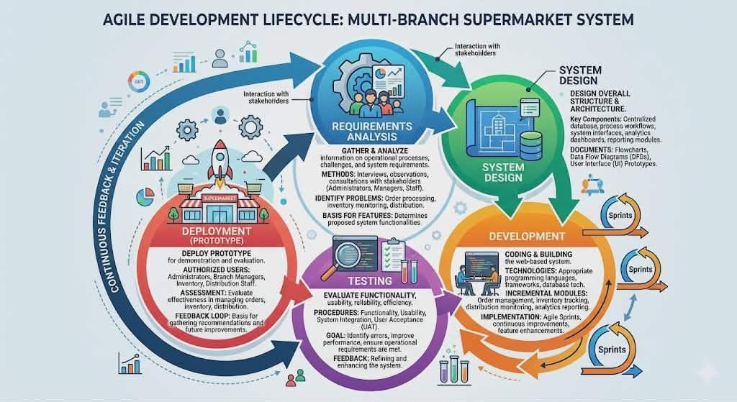

This study will utilize the Agile Software Development Methodology in developing the Analytics-Driven Centralized Admin-Client Order, Inventory, and Distribution Management System for Multi-Branch Supermarkets. Agile is a flexible and iterative software development approach that emphasizes continuous planning, collaboration, testing, and improvement throughout the development process. Unlike traditional development models that rely on rigid and long-term planning, Agile focuses on short and repeatable development cycles known as sprints, allowing the researchers to continuously improve the system based on user feedback and operational requirements.

The Agile methodology is appropriate for this study because it supports adaptability, incremental system enhancement, and continuous user involvement during the development process. Through Agile development cycles, the researchers will be able to identify problems early, improve system functionalities progressively, and ensure that the proposed system effectively addresses the operational needs of multi-branch supermarkets.

The Agile Development Model for this study will consist of the following phases:

- Requirements Analysis - In this phase, the researchers will gather and analyze information regarding the existing operational processes, challenges, and system requirements of multi-branch supermarkets. Data gathering methods such as interviews, observations, and consultations with administrators, branch managers, inventory personnel, and distribution staff will be conducted to identify the problems related to order processing, inventory monitoring, and distribution management. The collected information will serve as the basis for determining the features and functionalities of the proposed system.

- System Design - During this phase, the researchers will design the overall structure and architecture of the system. This includes designing the centralized database, process workflows, system interfaces, analytics dashboards, and reporting modules. The researchers will also prepare flowcharts, data flow diagrams, and user interface prototypes to ensure that the system design aligns with the operational requirements of the supermarket organization.

- Development - In the development phase, the researchers will begin coding and building the proposed web-based system using appropriate programming languages, frameworks, and database technologies. The system modules, including order management, inventory tracking, distribution monitoring, analytics reporting, and user management, will be developed incrementally through Agile sprints. Continuous improvements and feature enhancements will be implemented based on testing results and user feedback.

- Testing - The testing phase will involve evaluating the functionality, usability, reliability, and efficiency of the developed system. Different testing procedures such as functionality testing, usability testing, system integration testing, and user acceptance testing will be conducted to identify errors, improve system performance, and ensure that the system meets the operational requirements of the users. Feedback gathered during testing will be used to refine and enhance the system further.

- Deployment (Prototype) - In this phase, the developed prototype of the system will be deployed for demonstration and evaluation purposes. Authorized users such as administrators, branch managers, inventory personnel, and distribution staff will be allowed to use the system to assess its functionality and effectiveness in managing orders, inventory, and distribution operations. The deployment phase will also serve as the basis for gathering additional feedback and recommendations for future system improvements and enhancements.

System Architecture

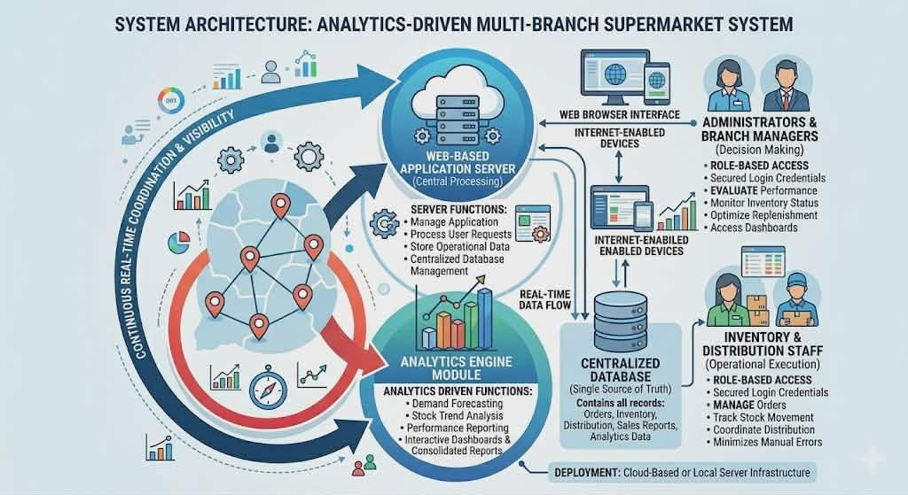

The proposed Analytics-Driven Centralized Admin-Client Order, Inventory, and Distribution Management System will utilize a web based client-server architecture designed to support centralized data management, real-time monitoring, and efficient operational coordination among multiple supermarket branches. In this architecture, the server will serve as the central processing unit responsible for managing the application, processing user requests, storing operational data, and maintaining the centralized database. The centralized database will contain all records related to orders, inventory, distribution transactions, sales reports, and analytics information from all participating supermarket branches.

On the client side, authorized users such as administrators, branch managers, inventory personnel, and distribution staff will access the system through web browsers using internet-enabled devices such as desktop computers and laptops. Each user will be provided with secured login credentials and role-based access permissions to ensure data security and controlled access to system functionalities. Through the web-based interface, users will be able to manage orders, monitor inventory levels, track stock movement, coordinate distribution activities, generate reports, and access analytics dashboards in real time.

The server will process all user requests and facilitate communication between the client interface and the centralized database. It will handle operations such as data validation, transaction processing, report generation, analytics computation, and inventory synchronization across branches. Real-time data processing will allow users to monitor operational activities instantly, improving inventory visibility, order coordination, and distribution efficiency. The system will also support automated data retrieval and storage to minimize manual encoding errors and improve operational accuracy.

In addition, the proposed architecture will integrate analytics-driven functionalities such as demand forecasting, stock trend analysis, inventory monitoring, and performance reporting. The analytics module will collect and analyze operational data to provide meaningful insights that support managerial decision making. Interactive dashboards and consolidated reports will enable administrators and branch managers to evaluate sales performance, monitor inventory status, identify stock trends, and optimize replenishment and distribution planning.

Furthermore, the centralized client-server architecture will improve communication and coordination among supermarket branches, warehouses, and distribution personnel by ensuring that operational data are consistently updated and accessible in real time. The system may be deployed using either a cloud-based server or a local server infrastructure depending on the operational requirements of the organization. Overall, the proposed system architecture is designed to provide scalability, accessibility, operational efficiency, data security, and centralized management for multi-branch supermarket operations.

User Interface Wireframe Design

The following wireframes present the proposed user interface layouts of the system. They illustrate the arrangement of navigation menus, dashboards, forms, reports, and transaction-related components before the actual interface development. The wireframes cover the major administrative functions of the proposed Analytics-Driven Centralized Admin-Client Order, Inventory, and Distribution Management System.

Figure 1. Admin Login Wireframe



Figure 2. Admin Dashboard Wireframe



Figure 3. Admin Branch Management Wireframe

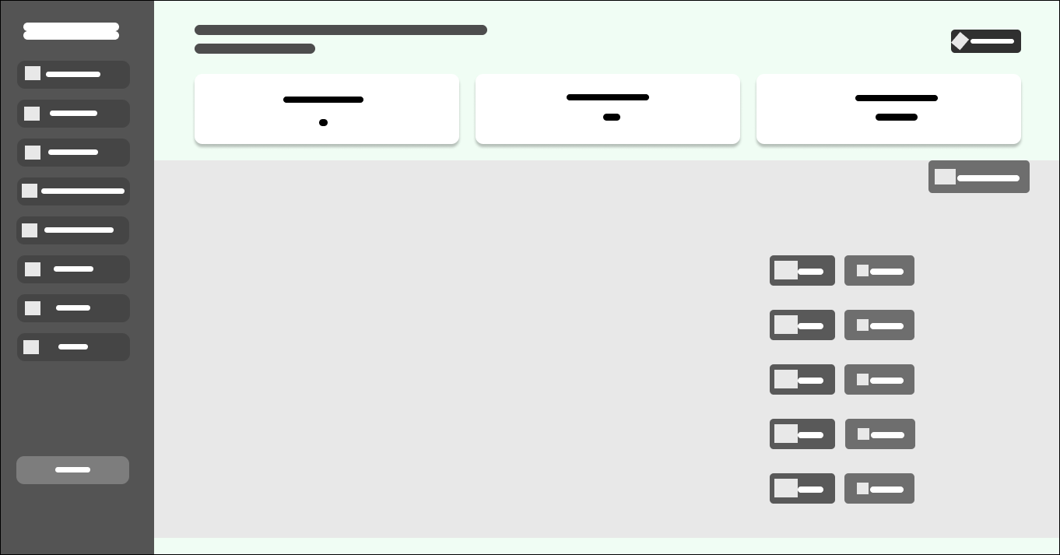

Figure 4. Admin Add Branch Wireframe



Figure 5. Admin Branch View Wireframe

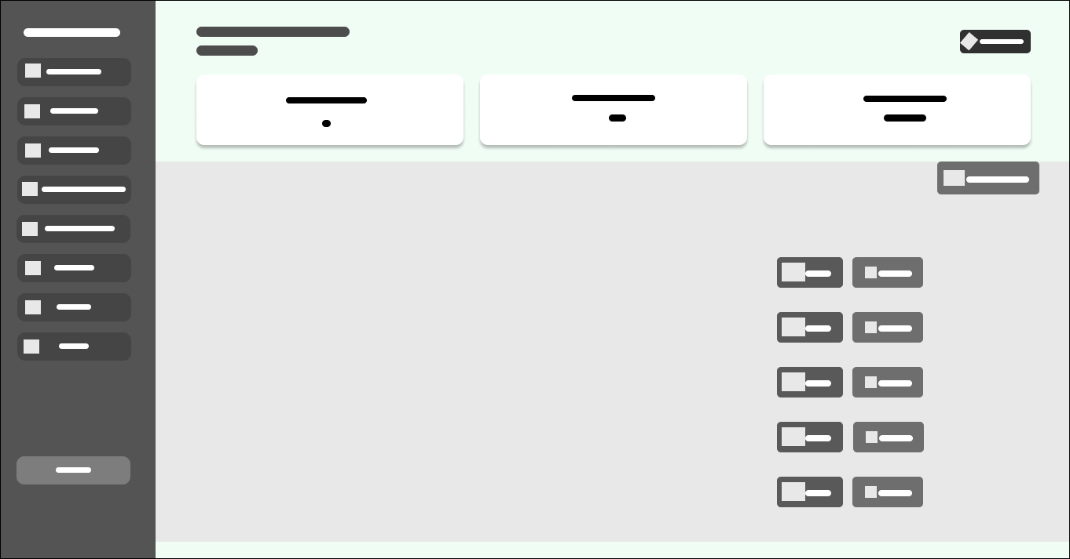

Figure 6. Admin Branch Delete Confirmation Wireframe

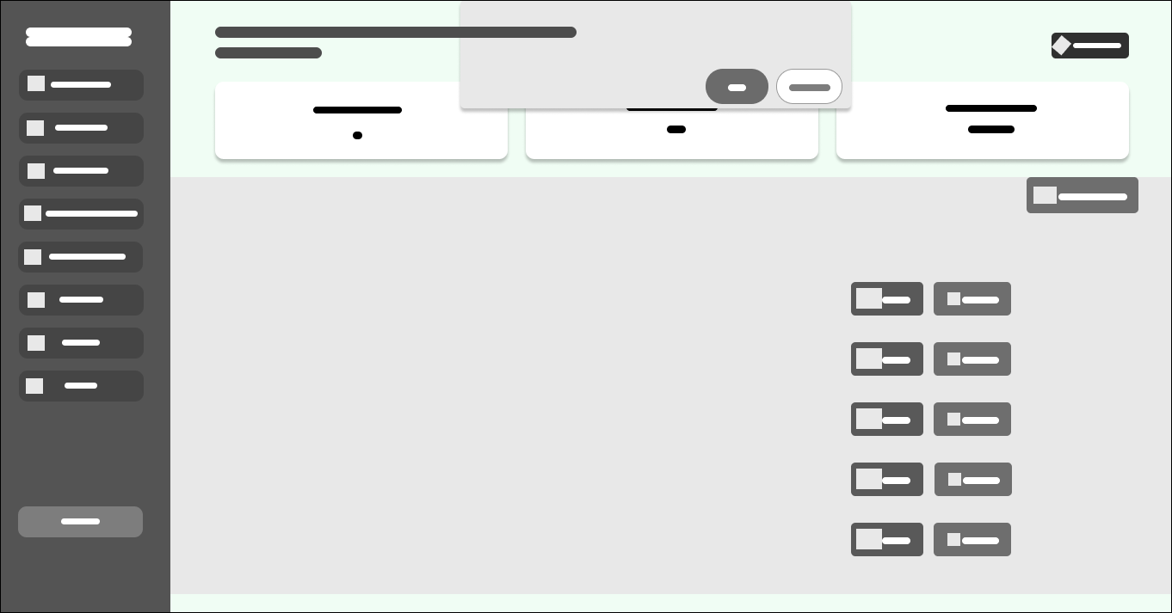

Figure 7. Admin Purchase Orders Wireframe

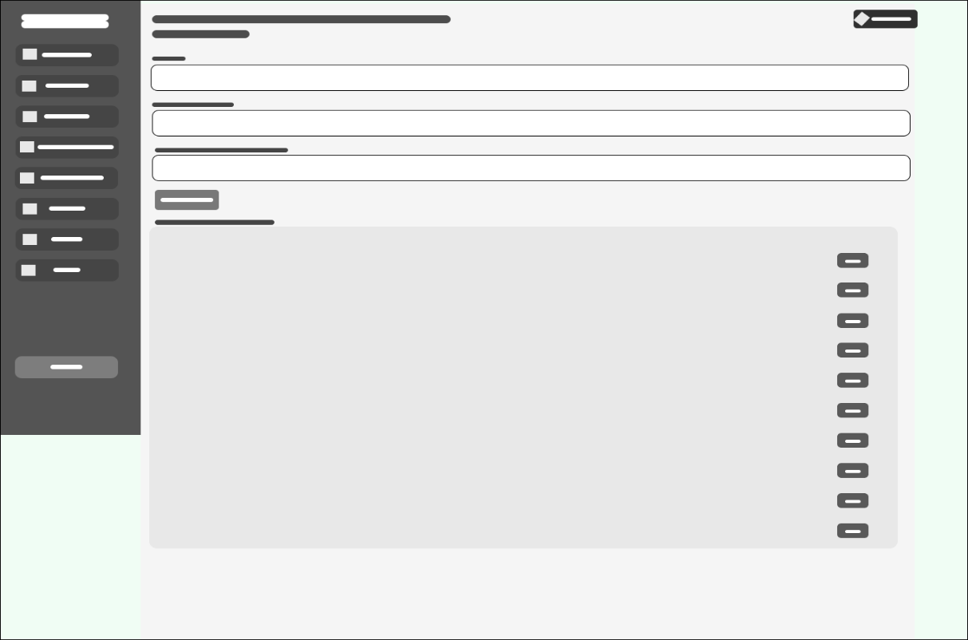

Figure 8. Admin Deliveries Wireframe

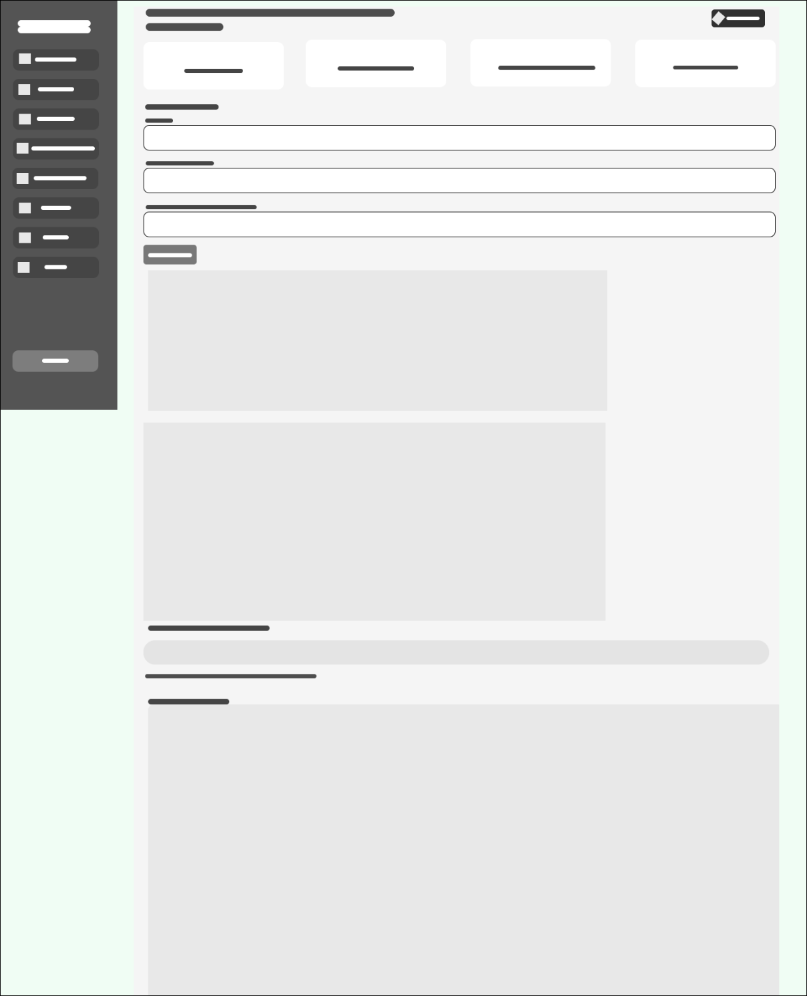

Figure 9. Admin Delivery Recorded Wireframe

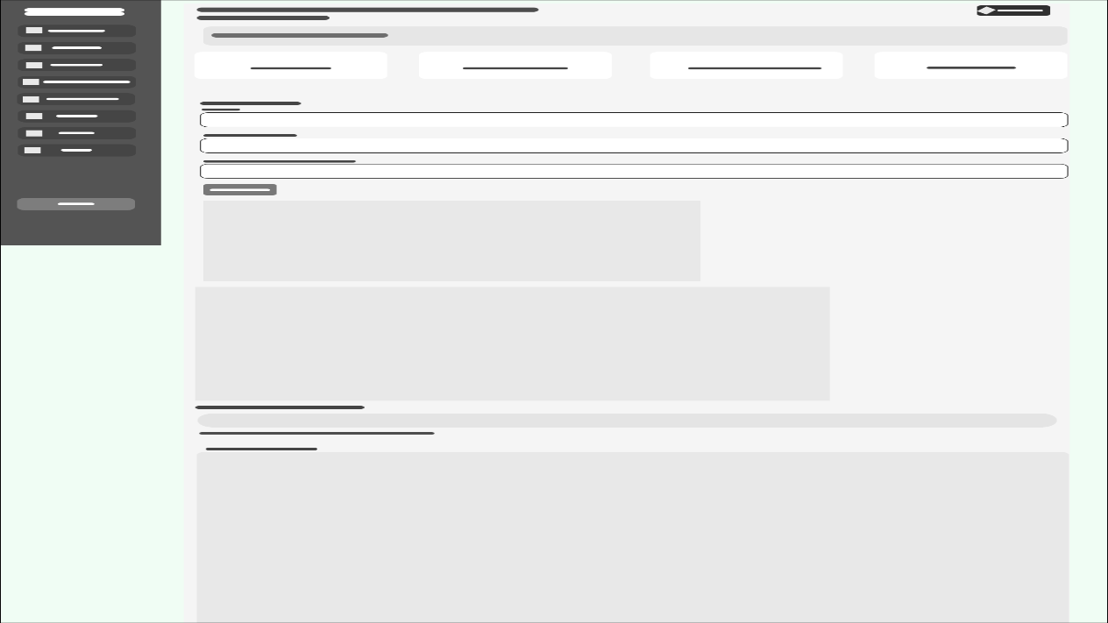

Figure 10. Admin Reports Wireframe

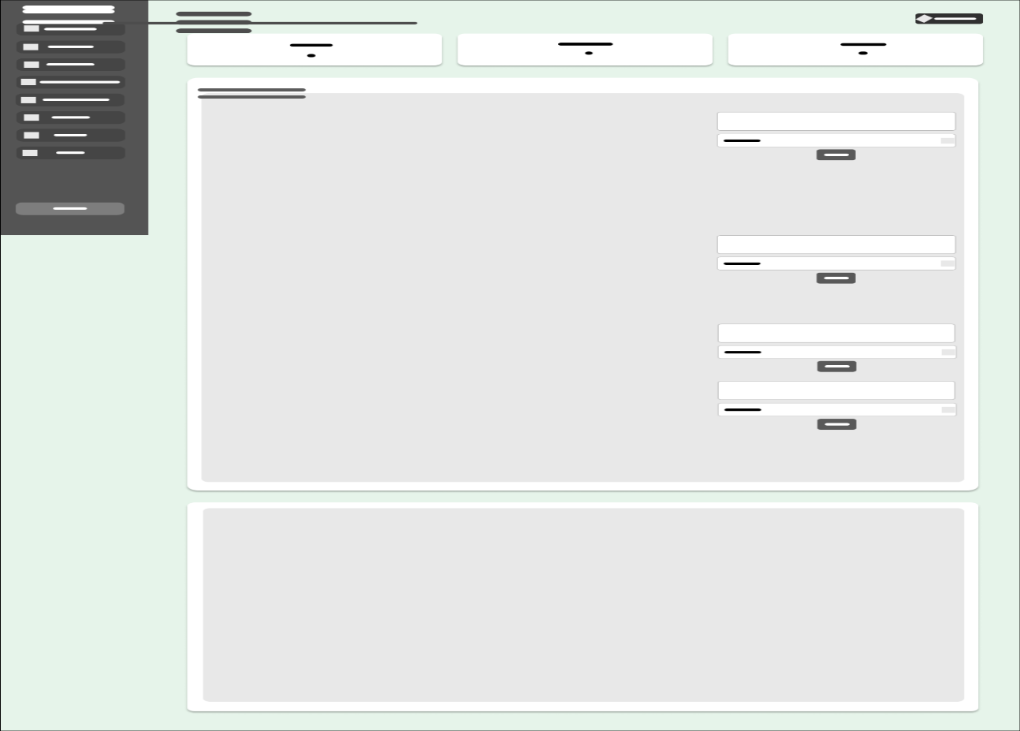

Figure 11. Admin Reports Request Wireframe


Figure 12. Admin Sales Report Wireframe

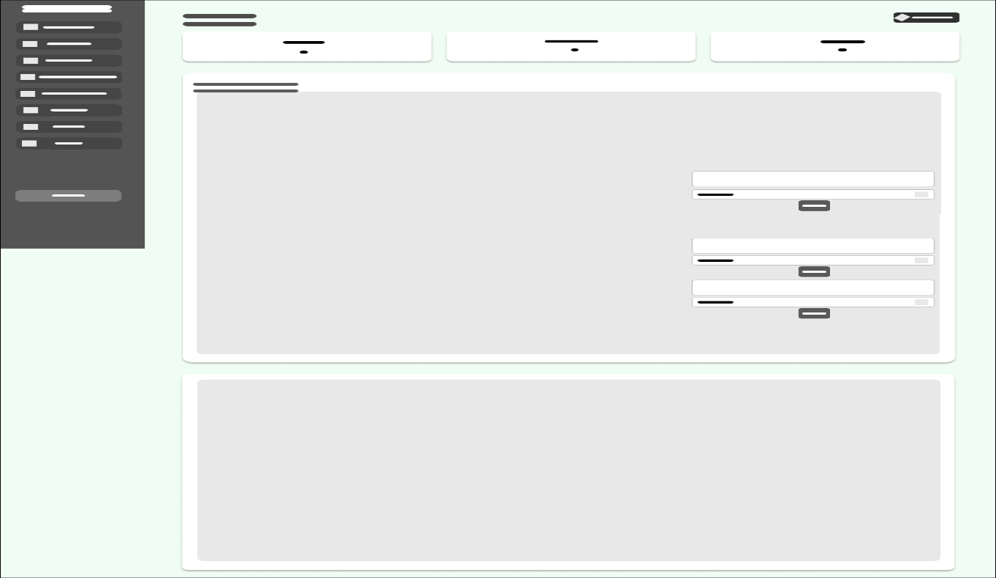

These wireframes serve as the interface prototypes for the System Design phase and provide a visual basis for the subsequent development and refinement of the web-based system.

Tools and Technologies Used

- Frontend: HTML, CSS, JavaScript
- Backend: PHP
- Database: MySQL
- Development Tools: Visual Studio Code

Data Gathering Techniques

To gather the necessary information and operational requirements for the development of the proposed Analytics-Driven Centralized Admin-Client Order, Inventory, and Distribution Management System, the researchers will utilize the following data gathering techniques:

- Interviews

The researchers conducted interviews with Mrs. Joan Castro Bagaforo and other involved personnel to gather relevant information regarding the current operational processes of the business. The interview focused on identifying the challenges encountered in the existing manual inventory system, manual request processing, and the absence of a centralized appointment and distribution management system.

Furthermore, the researchers gathered information regarding the daily distribution of egg trays and pieces, inventory monitoring practices, order coordination, and operational workflow between branches and management. The interview also helped the researchers determine the specific system requirements, operational needs, and possible improvements necessary for the development of the proposed system.

- Observations

The researchers conducted direct observations of the business operations over several weeks to closely monitor the existing inventory management, order processing, and distribution procedures. The observation focused on how inventory stocks were manually monitored, recorded, and updated during daily operations. In addition, the researchers observed how branch requests, inventory records, delivery schedules, and distribution activities were managed by the owner and personnel using manual processes.

Through observation, the researchers were able to identify operational inefficiencies such as delays in inventory monitoring, difficulties in tracking stock movement, inaccuracies in manual recording, and challenges in coordinating deliveries and branch requests. The information gathered through observation served as a basis for identifying system improvements and designing a more efficient and centralized management system.

Testing Procedures

Testing Procedure

To ensure that the proposed Analytics-Driven Centralized Order, Inventory, and Distribution Management System for Multi-Branch Supermarkets operates effectively and meets the requirements of its users, a series of testing procedures were conducted. These testing activities were designed to identify system errors, verify functionality, evaluate performance, and ensure that the system satisfies user expectations.

Unit Testing

Unit testing will be conducted to verify the functionality of individual modules and components of the system. Each feature will be tested independently to ensure that it performs according to its intended purpose and produces the expected outputs based on the provided inputs. The testing process will focus on validating the correctness of the program logic, database transactions, and user interactions within each module.

The modules subjected to unit testing include the user authentication module, order management module, inventory management module, distribution management module, reporting module, and analytics module. For example, the login module will be tested to ensure proper user authentication and role-based access control, while the inventory module will be tested to verify stock updates, inventory adjustments, and product movement recording functionalities.

System Testing

System testing will be conducted after all modules have been integrated into a complete and operational system. This testing phase aims to evaluate whether the system satisfies all functional and non-functional requirements specified during the requirements analysis phase.

The testing process will include verification of order submission processes, inventory monitoring capabilities, distribution scheduling functionalities, report generation, dashboard visualization, and analytics-driven features such as demand forecasting and stock trend analysis. The system will be tested under normal operating conditions to ensure that all functionalities perform correctly and consistently.

User Acceptance Testing (UAT)

User Acceptance Testing will be conducted with selected participants representing the intended users of the system, including administrators, branch managers, inventory personnel, and distribution staff. The purpose of this testing phase is to determine whether the developed system satisfies user expectations and operational requirements.

Participants will be asked to perform actual business scenarios such as submitting branch orders, updating inventory records, monitoring deliveries, and generating reports. Feedback obtained during this phase will be used to identify areas for improvement and validate the usability and effectiveness of the system in real operational environments.

Evaluation Criteria

The effectiveness and quality of the proposed system were evaluated using internationally recognized software quality attributes. These criteria were used to assess the system's overall performance and determine its suitability for deployment.

Functionality

Functional suitability refers to the degree to which the proposed system provides functions that meet stated and implied user needs when used under specified conditions. In the context of this study, functionality evaluates the system's capability to perform the required operational processes accurately, completely, and appropriately according to the requirements of multi-branch supermarket operations.

The evaluation focused on determining whether the Analytics Driven Centralized Admin-Client Order, Inventory, and Distribution Management System successfully implements the core functionalities necessary to support daily business activities. These functionalities include inventory management, order processing, distribution scheduling, stock monitoring, user management, analytics generation, report creation, and dashboard visualization. Each module was assessed to determine whether it performs its intended purpose efficiently and produces accurate outputs based on user inputs and operational requirements.

Particular attention was given to the inventory management module to verify its ability to monitor stock levels, record inventory movements, update product quantities, and provide real time visibility of inventory information across multiple branches. Similarly, the order management component was evaluated based on its capability to facilitate order submission, approval workflows, transaction monitoring, and order tracking between branch managers and administrators.

The distribution management functionality was also examined to determine whether the system effectively supports delivery scheduling, stock allocation, shipment monitoring, and product movement tracking among branches. Furthermore, the system's user management capabilities were evaluated to ensure proper role-based access control, secure authentication, and appropriate authorization mechanisms for administrators, branch managers, inventory personnel, and distribution staff.

In addition, the analytics-driven components of the system were assessed to determine their effectiveness in generating demand forecasts, identifying inventory trends, supporting inventory optimization, and providing actionable business insights. The report generation module and interactive dashboards were likewise evaluated based on their ability to produce accurate, timely, and meaningful operational reports and visual representations of business performance indicators.

A highly functional system is expected to implement all specified requirements successfully and perform consistently according to system specifications and user expectations. The presence of complete, accurate, and reliable functionalities contributes significantly to operational efficiency, improved decision-making, and effective management of inventory and distribution processes within multi-branch supermarket environments.

Usability

Usability refers to the degree to which the system can be used by specified users to achieve specified goals effectively, efficiently, and satisfactorily within a particular context of use. In this study, usability measures the ease with which administrators, branch managers, inventory personnel, and distribution staff can learn, understand, navigate, and operate the Analytics-Driven Centralized Admin-Client Order, Inventory, and Distribution Management System during their daily operational activities.

This criterion evaluates several aspects of the system's user interaction and overall user experience, including the simplicity of the interface design, clarity of navigation, accessibility of system functions, consistency of screen layouts, readability of displayed information, and ease of performing routine tasks. A user-friendly system enables users to complete their responsibilities efficiently without encountering unnecessary complexity or confusion.

Particular attention was given to the design of menus, forms, buttons, and navigation structures to ensure that users can easily locate and access the functionalities relevant to their roles and responsibilities. The system interface was designed to provide clear labels, organized layouts, and intuitive workflows that guide users throughout various operational processes such as order submission, inventory monitoring, stock updates, distribution scheduling, and report generation.

The evaluation also focused on the learnability of the system, which refers to the ability of new users to quickly understand and operate the application with minimal training or technical assistance. Since the intended users may possess varying levels of technical expertise, the system was designed to minimize the learning curve by providing straightforward navigation, familiar interface elements, and logical process flows that align with existing supermarket operations.

Furthermore, the system's accessibility and operability were assessed to determine whether users could efficiently perform tasks with minimal effort and within a reasonable amount of time. Features such as search functions, filtering options, dashboard shortcuts, and automated processes were incorporated to reduce repetitive tasks and improve user productivity. Error messages and validation prompts were also implemented to guide users in correcting invalid inputs and preventing mistakes during system operation.

The inclusion of interactive dashboards, graphical reports, and visual indicators further enhances usability by allowing users to interpret information quickly and make informed decisions without requiring extensive analysis of raw data. Visual representations such as charts, graphs, and performance metrics improve information comprehension and support more efficient monitoring of inventory levels, branch orders, and distribution activities.

A highly usable system enables users to perform their assigned tasks accurately, efficiently, and confidently while minimizing frustration and operational delays. Therefore, achieving a high level of usability is essential for ensuring user acceptance, encouraging system adoption, and maximizing the overall effectiveness of the proposed Analytics-Driven Centralized Admin-Client Order, Inventory, and Distribution Management System for Multi-Branch Supermarkets.

Reliability

Reliability refers to the degree to which the system consistently performs its intended functions under specified conditions for a specified period of time without failure or significant performance degradation. In this study, reliability evaluates the ability of the Analytics-Driven Centralized Admin-Client Order, Inventory, and Distribution Management System to operate accurately, dependably, and continuously while supporting the daily operational activities of multi-branch supermarkets.

This criterion focuses on the consistency and stability of system operations during routine and continuous usage. The system must be capable of processing inventory transactions, branch orders, stock updates, distribution schedules, and report generation accurately and without interruption. Reliable operation is essential to ensure that administrators and branch personnel can depend on the system when performing critical business processes that directly affect inventory availability and distribution efficiency.

Particular emphasis was placed on the accuracy and integrity of data processing activities performed by the system. Inventory quantities, stock movements, order requests, delivery records, and analytics results must be processed correctly and stored without corruption, duplication, or loss of information. Maintaining accurate records is essential for supporting informed decision-making and ensuring the consistency of operational data across all participating branches.

The evaluation also considered the stability of the system during prolonged periods of operation and repeated transactions. Since supermarket operations involve frequent inventory updates, order submissions, and report generation activities throughout the day, the system must remain responsive and functional even during periods of continuous use. Stable performance minimizes operational disruptions and ensures that users can complete their tasks efficiently and effectively.

Error handling capabilities were also examined as part of the reliability assessment. The system was designed to identify invalid inputs, incomplete transactions, and unexpected operational conditions while providing appropriate notifications and corrective guidance to users. Validation mechanisms, exception handling procedures, and transaction controls were implemented to prevent system failures and minimize the possibility of incorrect data processing or accidental data loss.

Furthermore, the reliability evaluation considered the system's ability to recover from unexpected situations such as temporary connection interruptions, incomplete transactions, or processing errors. Appropriate safeguards such as database integrity checks, transaction validation mechanisms, and backup procedures contribute to maintaining system dependability and protecting operational information from potential inconsistencies.

A highly reliable system ensures uninterrupted business operations, maintains data accuracy, and consistently delivers the expected level of performance under normal operating conditions. By providing dependable access to operational information and minimizing system failures, reliability contributes significantly to inventory accuracy, effective distribution management, and the overall success of multi-branch supermarket operations.

Ultimately, achieving a high level of reliability is essential for building user confidence, encouraging system adoption, and ensuring that the proposed Analytics-Driven Centralized Admin-Client Order, Inventory, and Distribution Management System can effectively support the long-term operational requirements of multi-branch supermarkets.

Efficiency

Performance efficiency refers to the degree to which the system utilizes available resources effectively while maintaining acceptable levels of performance under specified operating conditions. In this study, efficiency evaluates the ability of the Analytics-Driven Centralized Admin-Client Order, Inventory, and Distribution Management System to perform its functions quickly, accurately, and with minimal resource consumption while supporting the operational requirements of multi-branch supermarkets.

This criterion focuses on the responsiveness of the system during various operational activities such as order submission, inventory updates, stock transfers, report generation, dashboard visualization, and distribution scheduling. Since supermarket operations involve frequent transactions and continuous updates across multiple branches, the system must be capable of processing requests within an acceptable amount of time to ensure uninterrupted workflow and operational continuity.

Particular attention was given to system response time, which measures how quickly the application reacts to user requests and displays the required information. Activities such as logging into the system, retrieving inventory records, searching for products, approving branch orders, and accessing reports should be completed promptly to minimize waiting time and improve user productivity. Fast response times contribute significantly to user satisfaction and operational effectiveness, especially in environments where timely information is critical for decision-making.

The evaluation also considered processing speed, particularly in relation to inventory transactions, stock movement recording, order validation, and analytics computation. The system must be able to process large volumes of operational data efficiently without causing delays or interruptions to business activities. Efficient data processing ensures that inventory records remain updated and accurate, allowing administrators and branch personnel to rely on real-time information when making operational decisions.

Database performance was another important aspect of the efficiency assessment. Since the proposed system utilizes a centralized database shared among multiple branches, database queries, record retrieval, data insertion, and update operations must be optimized to maintain acceptable system performance. Efficient database management reduces processing delays and ensures the smooth flow of information among administrators, branch managers, inventory personnel, and distribution staff.

Inventory update speed was also evaluated to determine how quickly stock changes are reflected throughout the system after transactions such as order approvals, inventory adjustments, product transfers, and delivery confirmations are performed. Realtime or near real-time synchronization of inventory information is essential for maintaining inventory accuracy and preventing discrepancies among branch records.

Furthermore, the report generation component was assessed based on its ability to produce consolidated reports, analytical summaries, and visual dashboards within a reasonable period of time. Since managerial decisions often depend on timely access to operational information, reports related to inventory status, branch performance, stock movement, and demand forecasting should be generated efficiently without excessive processing delays.

Another important consideration in the evaluation of performance efficiency is the system's ability to support multiple users accessing the platform simultaneously. Since the proposed system is intended for use by administrators, branch managers, inventory personnel, and distribution staff from different branches, it must be capable of handling concurrent transactions and multiple user requests without significant degradation in performance. The ability to maintain responsiveness under increasing workloads contributes to the scalability and practicality of the system in real-world supermarket environments.

Resource utilization was likewise considered during the assessment process. The system should efficiently use processing power, memory, storage, and network resources to ensure stable and consistent performance. Proper resource management contributes to reduced operational costs and allows the system to function effectively even when deployed on hardware with moderate specifications.

An efficient system minimizes delays, reduces processing bottlenecks, and improves overall productivity by enabling users to complete their tasks quickly and accurately. By ensuring fast response times, optimized database operations, and effective handling of concurrent users, the proposed Analytics-Driven Centralized Admin-Client Order, Inventory, and Distribution Management System can support the demanding operational requirements of multi-branch supermarkets while promoting efficiency, responsiveness, and business continuity.

Security

Security refers to the degree to which the system protects information and data from unauthorized access, modification, disclosure, destruction, or misuse while ensuring that only authorized users can access appropriate system resources and functionalities. In this study, security evaluates the ability of the Analytics-Driven Centralized Admin-Client Order, Inventory, and Distribution Management System to safeguard sensitive operational information and maintain the confidentiality, integrity, and availability of organizational data.

This criterion focuses on the implementation of security mechanisms designed to protect inventory records, order transactions, distribution schedules, analytical reports, and user information from potential threats and vulnerabilities. Since the proposed system stores and manages critical business information across multiple supermarket branches, maintaining a high level of security is essential for ensuring trust, operational continuity, and data reliability.

One of the primary aspects evaluated under this criterion is user authentication. The system requires users to provide valid login credentials before gaining access to system resources and functionalities. Authentication mechanisms ensure that only authorized personnel can access operational information and perform transactions within the system. By verifying user identities during the login process, the system minimizes the risk of unauthorized access and protects confidential organizational data. The evaluation also considers the effectiveness of role-based access control mechanisms implemented within the system. Different categories of users, including administrators, branch managers, inventory personnel, and distribution staff, are assigned specific roles and permissions according to their responsibilities within the organization. This approach ensures that users can only access information and functionalities relevant to their assigned duties, thereby reducing the possibility of accidental modifications, unauthorized transactions, or misuse of sensitive information.

Password protection mechanisms are another important component of the system's security framework. The system encourages the use of secure passwords and implements appropriate password management procedures to strengthen account protection. Password validation rules, account authentication procedures, and session management controls contribute to reducing the likelihood of unauthorized account access and identity misuse.

Data protection measures were also considered during the evaluation process. Sensitive information transmitted between users and the system may be secured through encryption technologies and secure communication protocols to prevent interception and unauthorized disclosure of data during transmission. Likewise, the storage of critical information within the database is protected through appropriate security controls and access restrictions to preserve data confidentiality and integrity.

Furthermore, the system incorporates safeguards designed to prevent common security threats such as unauthorized data modification, accidental deletion, and unauthorized disclosure of information. Input validation mechanisms, transaction verification procedures, and access restrictions help maintain the accuracy and consistency of stored information while minimizing the risks associated with malicious activities or operational errors.

The availability of organizational data was likewise considered as part of the security evaluation. Backup and recovery mechanisms contribute to protecting information from accidental loss, hardware failures, or unexpected system interruptions. Maintaining data availability ensures that authorized users can access critical operational information whenever necessary, thereby supporting business continuity and uninterrupted supermarket operations.

In addition, system monitoring and audit capabilities may assist administrators in tracking user activities, identifying unusual behavior, and maintaining accountability within the organization. Activity logs and transaction histories provide valuable information that can be used for monitoring operational activities and investigating security-related incidents when necessary.

Strong security measures are essential for protecting the confidentiality, integrity, and availability of organizational information while maintaining user trust and operational reliability. By implementing effective authentication, authorization, password protection, data security, and system safeguard mechanisms, the proposed Analytics-Driven Centralized Admin-Client Order, Inventory, and Distribution Management System aims to provide a secure environment for managing inventory, orders, and distribution activities across multiple supermarket branches.

SUPPORTING DIAGRAMS

Entity Relationship Diagram (ERD)
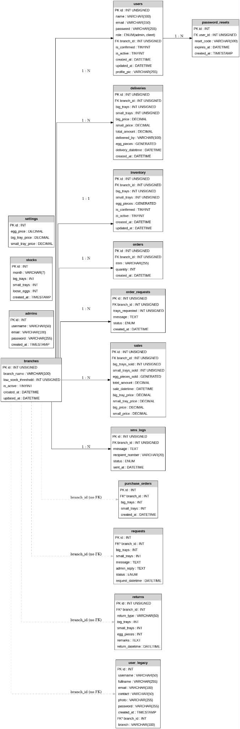

Relationships

The ERD represents an Analytics-Driven Centralized Admin-Client Order, Inventory, and Distribution Management System for Multi-Branch Supermarkets. The system is designed to centralize the management of inventory, sales, deliveries, requests, and branch operations while providing real-time monitoring and analytics across multiple supermarket branches.

At the center of the database structure is the Branches table,
which serves as the primary entity connecting most of the system's operations. Each branch maintains its own inventory, sales records, deliveries, requests, and users, allowing centralized control while preserving branch-level data.

1) Branches Table (Central Entity)

The Branches table serves as the central entity of the system and stores information about all supermarket branches. It contains the unique branch identifier (Id), branch name (Branch_name), low stock threshold (Low_stock_threshold), operational status
(Is_active), and timestamps for record creation and updates (Created_at and Updated_at). This table functions as the foundation of the database because nearly all system transactions are associated with a specific branch. Through this table, the system can manage and monitor operations across multiple branches while maintaining centralized control over inventory, sales, deliveries, and requests.

2) Users Table

The Users table stores the information of personnel who utilize the system within each branch. It includes attributes such as the user’s unique identifier (Id), name (Name), email address (Email), password (Password), role (Role), assigned branch (Branch_id), account verification status (Is_confirmed), account activity status (Is_active), profile picture (Profile_pic), and timestamps for account creation and updates (Created_at and Updated_at). This table enables the management of employee accounts and their responsibilities within the organization. Since each user belongs to a specific branch, a one-to-many relationship exists where one branch can have multiple users, but each user is assigned to only one branch.

3) Inventory Table

The Inventory table is responsible for maintaining real-time records of egg stocks available in each branch. It stores information such as the inventory identifier (Id), branch reference (Branch_id), quantities of big trays (Big_trays), small trays (Small_trays), and egg pieces (Egg_pieces), along with status indicators and timestamps. The primary purpose of this table is to ensure accurate stock monitoring and inventory management. By tracking available quantities, the system helps administrators and branch personnel determine when replenishment is necessary and prevents stock shortages or overstocking situations.

4) Sales Table

The Sales table records all sales transactions conducted by the branches. It includes attributes such as the sales identifier (Id), branch reference (Branch_id), quantities of big trays sold (Big_tray_sold), small trays sold (Small_trays_sold), egg pieces sold (Egg_pieces_sold), total sales amount (Total_amount), and the date and time of the transaction (Sale_datetime). This table plays a significant role in monitoring branch performance, generating sales reports, analyzing customer demand, and supporting forecasting activities. Since a branch can process numerous sales transactions, a one-to-many relationship exists between branches and sales records.

5) Deliveries Table

The Deliveries table stores information regarding stock deliveries received by each branch. It contains details such as the delivery identifier (Id), branch reference (Branch_id), quantities delivered in big trays, small trays, and egg pieces, as well as delivery and creation timestamps. This table ensures that all incoming stock movements are properly documented and tracked. It helps maintain inventory accuracy by recording replenishments received from suppliers or the central warehouse. One branch may receive multiple deliveries over time, creating a one-to-many relationship between branches and deliveries.

6) Orders Table

The Orders table records official orders placed by branches when additional inventory is required. The table contains the order identifier (Id), branch reference (Branch_id), order quantity (Quantity), and the date the order was created (Created_at). This table serves as a formal record of branch purchasing activities and helps administrators monitor stock requests and procurement processes. Since branches can place multiple orders, a one-to-many relationship exists between branches and orders.

7) Order Requests Table

The Order Requests table manages requests for inventory replenishment submitted by branches. It contains information such as the request identifier (Id), branch reference (Branch_id), quantity of trays requested (Trays_requested), request message
(Message), request status (Status), and creation date
(Created_at). The status field may indicate whether a request is pending, approved, or rejected. This table streamlines communication between branches and administrators by providing a structured process for requesting additional stock. Each branch may submit multiple order requests over time.

8) Requests Table

The Requests table stores operational and inventory-related concerns raised by branch personnel. It includes attributes such as the request identifier (Id), branch reference (Branch_id), requested quantities of big trays and small trays, request message
(Message), administrator response (Admin_reply), request status (Status), and request date and time (Request_datetime). This table facilitates effective communication between branches and administrators by allowing issues, concerns, and stock-related needs to be formally documented and addressed. A branch may generate many requests, resulting in a one-to-many relationship.

9) SMS Logs Table

The SMS Logs table records all SMS notifications sent by the system. It contains the SMS identifier (Id), branch reference (Branch_id), message content (Message_text), recipient phone number (Recipient_number), delivery status (Status), and timestamp indicating when the message was sent (Sent_at). The table serves as an audit trail for notifications such as low-stock alerts, delivery confirmations, order approvals, and request status updates. By maintaining these records, the system ensures transparency and accountability in communication activities.

10) Admins Table

The Admins table stores information about system administrators who oversee the entire platform. It includes the administrator identifier (Id), username (Username), email address (Email), password (Password), and account creation date (Created_at). Administrators are responsible for managing branches, approving requests, monitoring inventory levels, generating reports, and maintaining system operations. Unlike regular users, administrators are not assigned to a specific branch, enabling them to manage the entire network of branches from a centralized perspective.

11) User Table (Separate Table)

The separate User table appears to function as an alternative authentication or client account table. It stores information such as the user identifier (Id), username (Username), email (Email), password (Password), creation date (Created_at), and branch reference (Branch_id). This table may be used to manage client or customer accounts independently from employee accounts stored in the Users table. Through this structure, one branch can be associated with multiple user accounts.

12) Stocks Table

The Stocks table stores historical stock information used for analytics and forecasting. It includes attributes such as the stock identifier (Id), month (Month), quantity of big trays (Big_trays), quantity of pieces (Pieces), and creation date (Created_at). The purpose of this table is to preserve historical inventory data that can be analyzed to identify trends, predict future demand, and support data-driven decision-making. This historical information contributes to the system’s analytical capabilities and improves inventory planning.

13) Password Resets Table

The Password Resets table provides a secure mechanism for account recovery. It contains the reset request identifier (Id), associated user identifier (User_id), reset code (Reset_code), expiration date (Expires_at), and creation date (Created_at). This table ensures that users can safely reset forgotten passwords while maintaining system security. A user may generate multiple password reset requests over time, creating a one-to-many relationship between users and password reset records.

System Flow of the Analytics-Driven Centralized Admin-Client Order, Inventory, and Distribution Management System

The system begins when the Administrator creates and manages branch records in the Branches Table and registers branch personnel through the Users Table. Once the user accounts are created and verified, branch personnel can securely log in to the system and access branch-specific operations. The system maintains account security through the Password Resets Table, which allows users to recover their accounts when necessary.

After logging in, branch personnel can monitor the current stock levels through the Inventory Table. Whenever new egg supplies arrive from the central warehouse or supplier, the delivery information is recorded in the Deliveries Table. The system then updates the inventory quantities by adding the delivered stocks to the existing inventory records. This process ensures that inventory data remains accurate and up-to-date across all branches.

As customers purchase products, branch personnel record the transactions in the Sales Table. Every sale automatically deducts the corresponding quantity from the inventory. The system continuously monitors stock levels and compares them with the predefined Low Stock Threshold stored in the Branches Table. If the available inventory falls below the threshold, the system generates an automatic notification and records it in the SMS Logs Table. SMS alerts may be sent to branch managers and administrators to inform them of the low-stock situation.

When a branch requires additional inventory, branch personnel submit a request through the Order Requests Table. The request contains the number of trays needed and a supporting message. The request is then forwarded to the administrator for evaluation. The administrator reviews the request and updates its status as Pending, Approved, or Rejected. Once approved, an official order is generated and recorded in the Orders Table, initiating the stock replenishment process.

In addition to stock requests, branch personnel may submit operational concerns or special inventory requests through the Requests Table. These requests are reviewed by administrators, who can provide responses through the Admin Reply field. This communication mechanism ensures proper coordination between branches and central management while maintaining a complete record of all requests and responses.

After an order is approved, the central warehouse prepares and distributes the requested inventory to the branch. The shipment details are recorded in the Deliveries Table, and the inventory is updated accordingly. At the same time, SMS notifications regarding delivery status, order approval, and inventory updates are logged in the SMS Logs Table to keep all stakeholders informed.

The system also maintains historical stock information through the Stocks Table. Data from inventory, deliveries, sales, and stock movements are stored and analyzed to identify trends, forecast future demand, and support strategic decision-making. These analytics enable administrators to optimize stock distribution, prevent shortages, reduce excess inventory, and improve overall operational efficiency across multiple supermarket branches

Data Flow Diagram Level 0 (ERD)
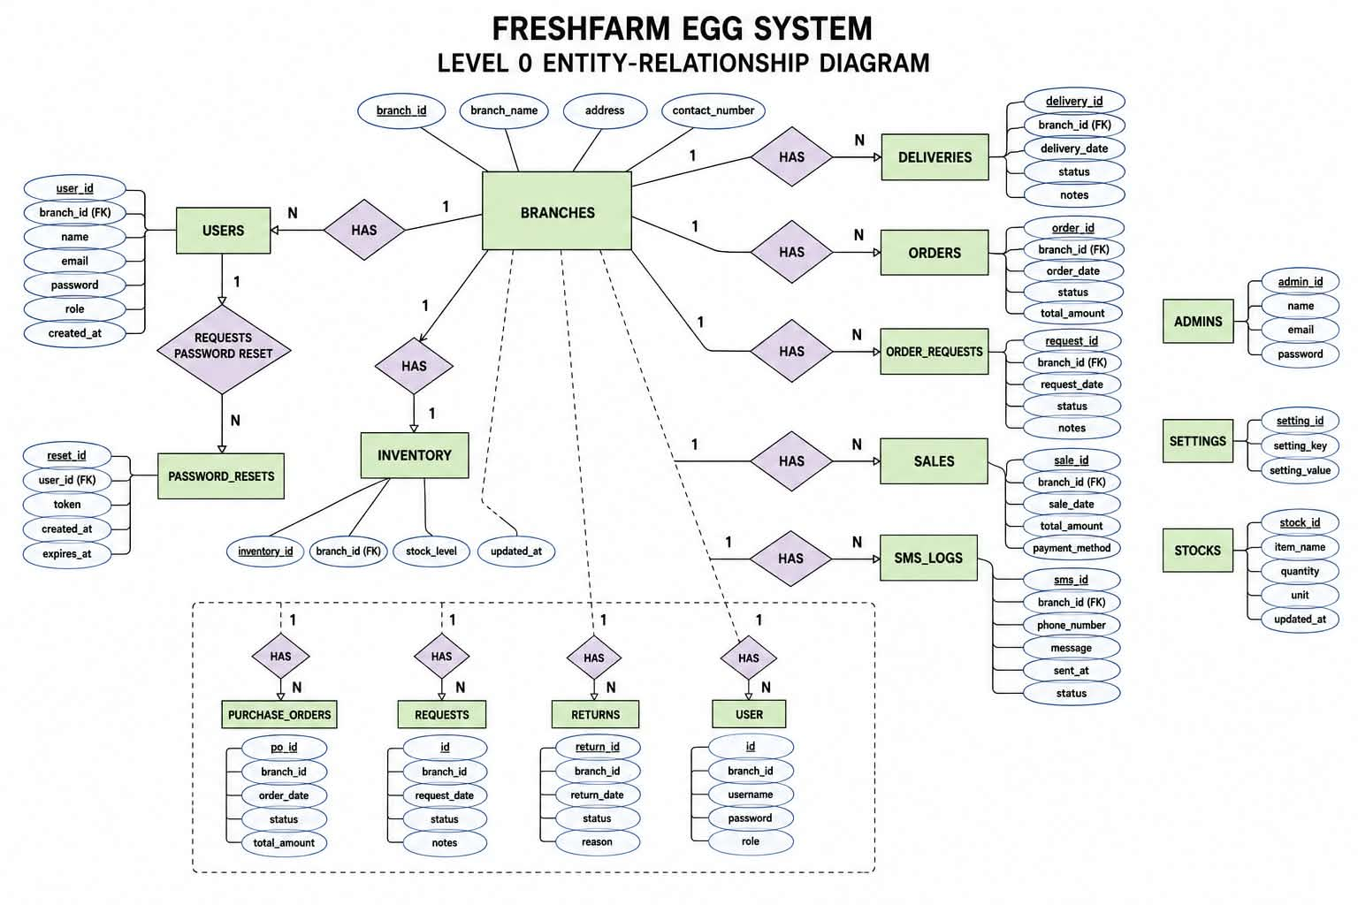

Analytics-Driven Centralized Order, Inventory, and Distribution

Management System

The Data Flow Diagram (DFD) Level 0 presents a high-level overview of how information moves between the major users of the Analytics-Driven Centralized Order, Inventory, and Distribution Management System. It illustrates the interactions among the external entities—namely the Branch Manager, Inventory Staff, Admin, and Distribution Staff—and the central system process. The diagram provides a conceptual representation of the system's functionality by showing the flow of data entering and leaving the system without revealing its internal processes.

At the center of the diagram is Process 0, labeled as the Analytics-Driven Centralized Order, Inventory, and Distribution Management System. This process serves as the core platform responsible for receiving, processing, storing, analyzing, and distributing information related to inventory management, order processing, stock monitoring, and distribution activities. The system acts as a centralized hub that connects all stakeholders involved in supermarket operations, ensuring that information is shared efficiently and accurately across multiple branches.

Branch Manager

The Branch Manager is one of the primary external entities interacting with the system. The branch manager is responsible for monitoring inventory levels and ensuring that adequate stock is available to meet customer demand. When stock levels become low or replenishment is required, the branch manager submits order requests to the system. These requests contain details regarding the quantity of products needed and any additional information relevant to the replenishment process.

Once the request is submitted, the system forwards it to the administrator for evaluation. After the request has been reviewed, the system sends the approval or rejection status back to the branch manager. This feedback mechanism enables branch managers to track the progress of their requests and make appropriate operational decisions based on the response received from the administration.

Inventory Staff

The Inventory Staff is responsible for maintaining accurate inventory records within the system. Their primary interaction with the system involves updating stock levels whenever products are received, transferred, sold, or adjusted. By continuously updating inventory data, the inventory staff ensures that the system reflects real-time stock availability across all branches. The information provided by inventory personnel plays a critical role in maintaining inventory accuracy. The updated stock records serve as the basis for inventory monitoring, stock forecasting, low-stock detection, and analytics generation. Through this process, the system can identify inventory trends and assist management in making informed replenishment and distribution decisions.

Admin

The Admin serves as the central decision-maker and supervisory authority within the system. Administrators receive order requests submitted by branch managers through the centralized platform. After evaluating inventory availability, branch requirements, and distribution capacity, the administrator either approves or rejects the requests.

In addition to managing requests, administrators utilize the system's analytical capabilities to generate reports and access dashboards. These reports provide valuable insights into sales performance, inventory levels, stock movement, order history, branch performance, and distribution efficiency. The analytics dashboard enables administrators to monitor operational activities across all branches in real time, facilitating strategic planning and data-driven decision-making.

Distribution Staff

The Distribution Staff is responsible for handling the physical movement of products from the central warehouse or distribution center to individual branches. Once an order request has been approved, the system communicates the delivery requirements to the distribution staff. Using the information provided, distribution personnel schedule and coordinate deliveries to ensure that requested products reach the designated branches on time.

The scheduling information generated by the distribution staff is then recorded within the system, allowing administrators and branch managers to monitor delivery status and distribution progress. This process helps ensure efficient product allocation and minimizes delays in stock replenishment.

Overall Data Flow

The overall data flow begins when inventory staff update stock records and branch managers monitor inventory levels through the system. When inventory shortages are identified, branch managers submit order requests to the centralized system. These requests are evaluated by the administrator, who then approves or rejects them based on organizational requirements and inventory availability. Approved requests trigger distribution activities, prompting distribution staff to schedule deliveries. Throughout this process, the system continuously records transactions, updates inventory information, and generates analytical reports that support managerial decision-making.

The centralized architecture of the system ensures that all branches operate using a single, integrated source of information. This integration improves communication among departments, reduces delays in inventory replenishment, minimizes human errors associated with manual processes, and enhances the overall efficiency of inventory and distribution management.

Significance of the DFD Level 0

The DFD Level 0 demonstrates how the proposed system facilitates seamless coordination among branch managers, inventory personnel, administrators, and distribution staff. By centralizing data management and incorporating analytics-driven functionalities, the system enables real-time inventory monitoring, efficient order processing, optimized distribution scheduling, and comprehensive reporting. Consequently, the system contributes to improved operational efficiency, better inventory control, enhanced decision-making, and increased service quality across all supermarket branches.

System Flow

The process begins when the Inventory Staff updates the stock levels in the system. Based on the inventory records, the Branch Manager monitors product availability and submits an order request whenever additional stock is needed. The request is then sent to the Admin, who reviews and either approves or rejects it. If approved, the system forwards the request to the Distribution Staff, who schedules and processes the delivery of stocks to the requesting branch. Throughout the process, the system records all transactions and generates reports and analytics to support inventory monitoring, decision-making, and efficient distribution management.

Use Case Diagram Actors:

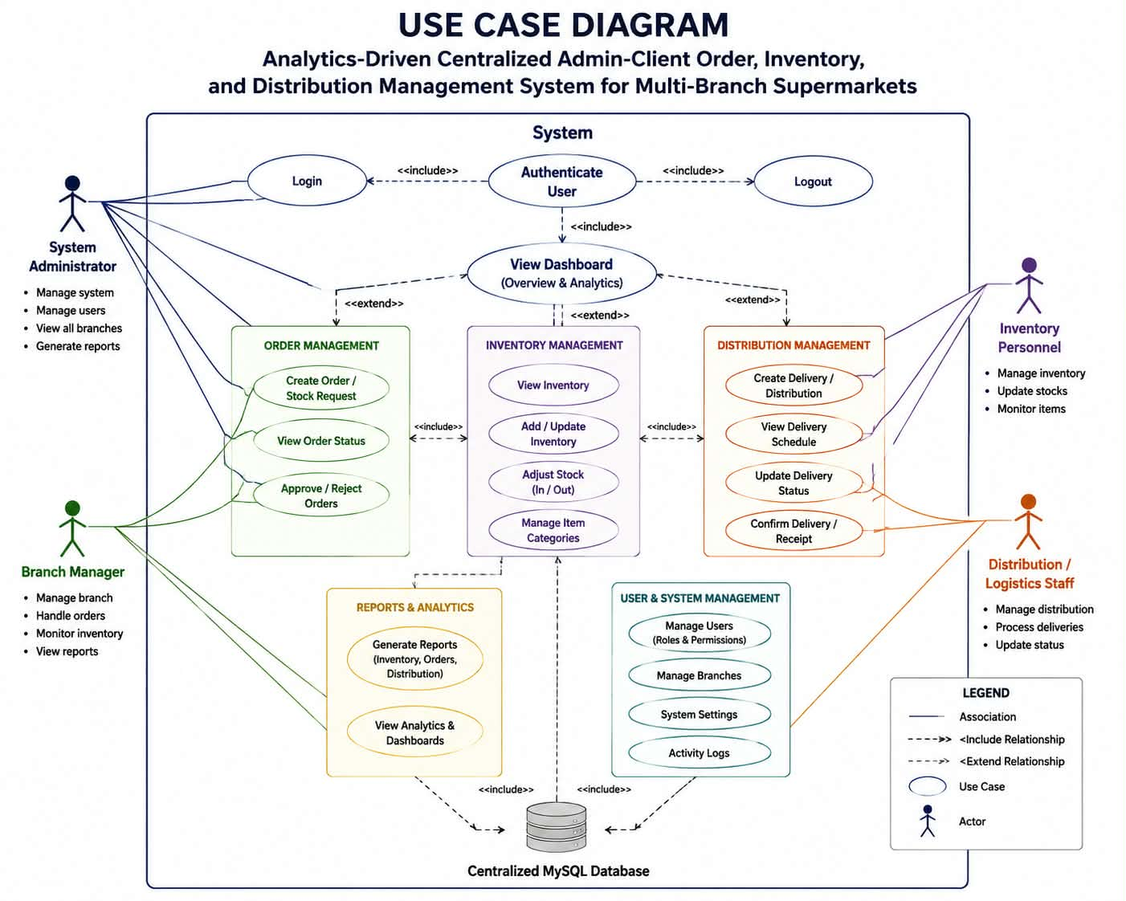

The System Use Case Diagram illustrates the interactions between the users (actors) and the proposed Analytics-Driven Centralized Order, Inventory, and Distribution Management System. It identifies the major functions of the system and shows how different users interact with these functionalities to support inventory management, order processing, delivery coordination, and

The System Use Case Diagram illustrates the interactions between the users (actors) and the proposed Analytics-Driven Centralized Order, Inventory, and Distribution Management System. It identifies the major functions of the system and shows how different users interact with these functionalities to support inventory management, order processing, delivery coordination, and data analytics. The diagram provides a clear representation of the system's scope and demonstrates how each actor contributes to the overall operation of the system.

The system consists of four primary actors: the Admin, Branch Manager, Inventory Staff, and Distribution Staff. Each actor has specific responsibilities and privileges that enable them to perform designated tasks within the system. These interactions help streamline operations, improve inventory control, and facilitate effective communication among all stakeholders.

Admin

Admin serves as the primary controller and decision-maker within the system. The administrator is responsible for managing user accounts through the Manage Users function, which includes creating, updating, activating, and deactivating user profiles. This ensures that authorized personnel can securely access the system according to their assigned roles.

Another major responsibility of the administrator is handling stock replenishment requests through the Approve/Reject Order Requests function. When branch managers submit requests for additional inventory, the administrator evaluates the requests based on inventory availability and operational requirements before making a decision. The administrator also uses the Generate Reports feature to produce reports related to sales, inventory levels, deliveries, and branch performance. Furthermore, the View Analytics Dashboard function provides real-time insights and visual representations of business operations, enabling data driven decision-making and strategic planning.

Branch Manager

The Branch Manager is responsible for overseeing branch-level inventory operations and ensuring that sufficient stock is available to meet customer demand. Through the Create Order Requests function, branch managers can submit requests for additional inventory whenever stock levels become low. This feature facilitates timely replenishment and prevents stock shortages.

The branch manager can also access the View Inventory Levels function, which provides real-time information regarding current stock quantities available within the branch. This allows managers to monitor inventory conditions and anticipate future stock requirements. Additionally, the Track Deliveries feature enables branch managers to monitor the status of approved orders and incoming deliveries, ensuring transparency and efficient coordination between branches and distribution personnel.

Inventory Staff

The Inventory Staff plays a vital role in maintaining accurate inventory records within the system. Through the Update Stock Records function, inventory personnel record inventory changes resulting from sales, deliveries, stock adjustments, or other inventory movements. This ensures that stock information remains accurate and up to date.

The inventory staff is also responsible for verifying incoming products through the Confirm Deliveries function. Upon receiving delivered items, inventory personnel inspect and confirm the shipment before updating the inventory database. This process helps maintain inventory accuracy and ensures that delivered quantities match the approved requests and delivery records.

Distribution Staff

The Distribution Staff is responsible for managing the logistics and movement of inventory between the warehouse and branch locations. Through the Schedule Deliveries function, distribution personnel organize delivery schedules based on approved requests and branch requirements. Proper scheduling helps optimize delivery routes, improve efficiency, and ensure timely stock replenishment.

In addition, distribution staff utilize the Update Delivery Status function to record the progress of deliveries. Status updates may include information such as scheduled, in transit, delivered, or completed. These updates allow branch managers and administrators to monitor delivery activities in real time and ensure accountability throughout the distribution process.

Overall System Interaction

The use case diagram demonstrates a coordinated workflow among all actors within the system. The process begins when inventory staff maintain accurate stock records and branch managers monitor inventory levels. When additional stock is required, branch managers create order requests that are reviewed by the administrator. Upon approval, distribution staff schedule and process deliveries, while inventory staff confirm receipt of the delivered items. Throughout this process, the administrator oversees operations through reports and analytics dashboards, ensuring that inventory and distribution activities are aligned with organizational goals.

Significance of the Use Case Diagram

The System Use Case Diagram highlights the functional requirements of the proposed Analytics-Driven Centralized Order, Inventory, and Distribution Management System. It clearly defines the roles and responsibilities of each actor and illustrates how they interact with the system to perform essential business processes. By integrating inventory management, order processing, delivery coordination, and analytics into a centralized platform, the system enhances operational efficiency, improves inventory accuracy, strengthens communication among stakeholders, and supports informed managerial decision-making. Consequently, the use case diagram serves as an important blueprint for understanding the overall functionality and user interactions within the proposed system.

CHAPTER 4

4.2 Overview of the Developed System

The developed system is a web-based centralized management system designed for multi-branch supermarket operations. It connects administrators and branch personnel through a single platform where they can manage orders, inventory, and distribution-related activities.

The system was designed based on the operational problems identified in the study. Multi-branch supermarkets handle a large amount of information every day. Each branch may have different inventory levels, orders, stock movements, and delivery requirements. When these records are handled separately, it becomes difficult for the central administration to obtain an accurate view of the overall operation.

The developed system addresses this problem by consolidating important information into a centralized database. The system allows authorized users to view updated records and perform tasks according to their assigned roles.

The major functions of the developed system include:

- User authentication and account management;
- Role-based access control;
- Branch management;
- Centralized inventory monitoring;
- Order and stock request processing;
- Inventory movement tracking;
- Distribution and delivery scheduling;
- Delivery status monitoring;
- Demand forecasting;
- Stock trend analysis;
- Inventory optimization support;
- Interactive dashboards; and
- Automated report generation.

The system is intended to support the daily activities of administrators, branch managers, inventory personnel, and distribution staff. Each user is provided with access to the features related to their responsibilities.

The overall system workflow begins when an authorized user logs into the system. After authentication, the system identifies the user's role and provides access to the appropriate dashboard and functions. Users can then perform activities such as submitting orders, updating inventory records, checking stock levels, monitoring delivery status, or viewing analytical information.

The information entered into the system is stored in the centralized database. The system then uses the available operational data to generate summaries, reports, charts, and other analytical information. This allows the users to see not only individual transactions but also broader patterns in inventory and distribution activities.

Figure 4.1

System Interface
The Fresh Farm Egg system provides each branch with a centralized way to monitor available egg stock, record sales, request additional stock from the administrator, review branch activity, and maintain branch account information and it helps reduce manual recording and gives the branch a clearer view of current inventory and transactions.
The system uses forms, buttons, tables, menus, status indicators, and confirmation messages to help users complete tasks and understand the information displayed.

Client Registration
- Click the User Registration

- Enter the required account information

- Select the assigned Branch

- Enter and confirm your password

- Click Register.

Once the account has been successfully registered, the client can proceed to the Login page and use the registered credentials to access the Client Dashboard.



The Login page allows registered clients or branch users to securely access the Fresh Farm Egg website using their account credentials. Once logged in, the client can access the functions available to their assigned branch



Branch Dashboard
The branch dashboard provides a summary of the branch's current operational information.
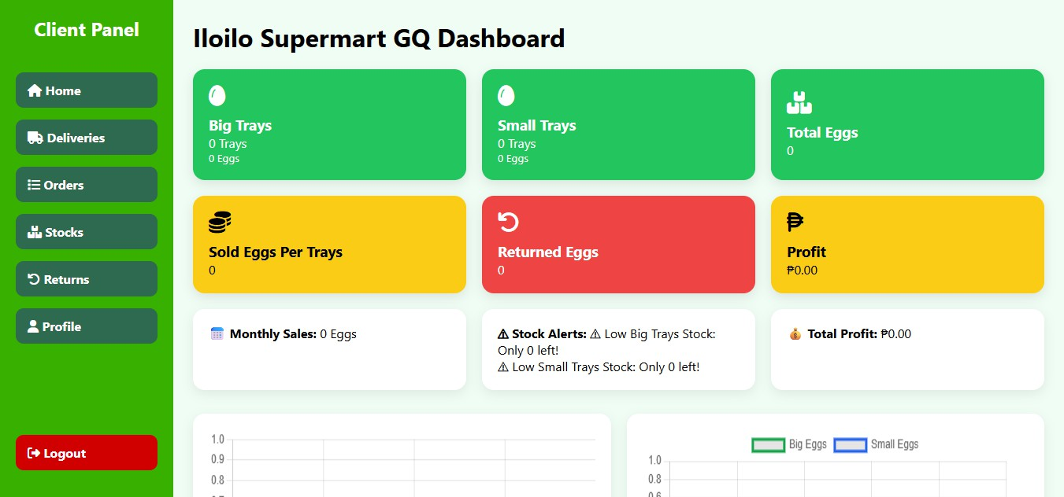
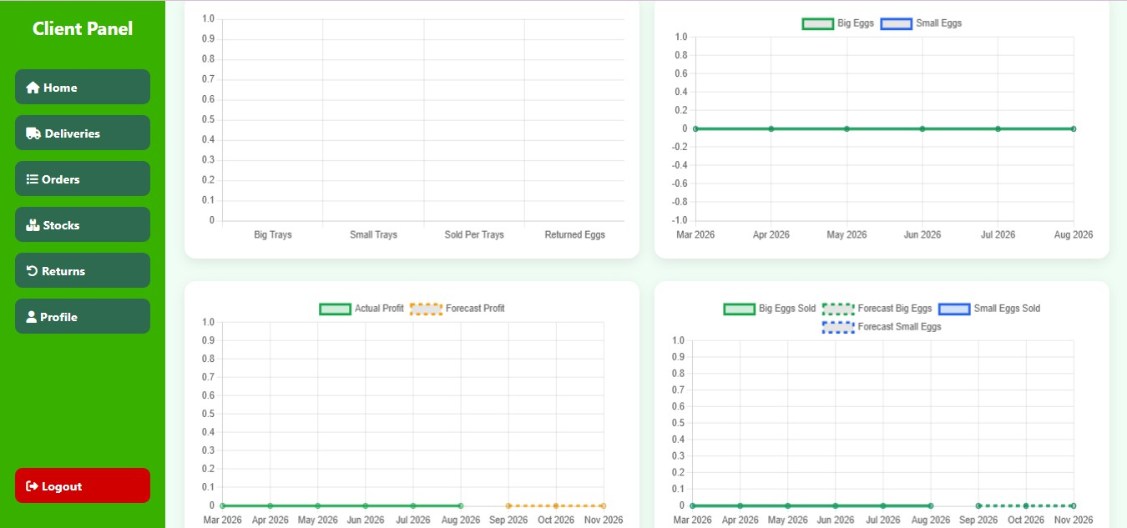

Deliveries

The branch delivery information allows the client side to retrieve delivery-related information associated with the branch. Use delivery records to compare received stock with physical quantities. When a delivery arrives, verify the number of big and small trays before relying on the record for inventory checking.

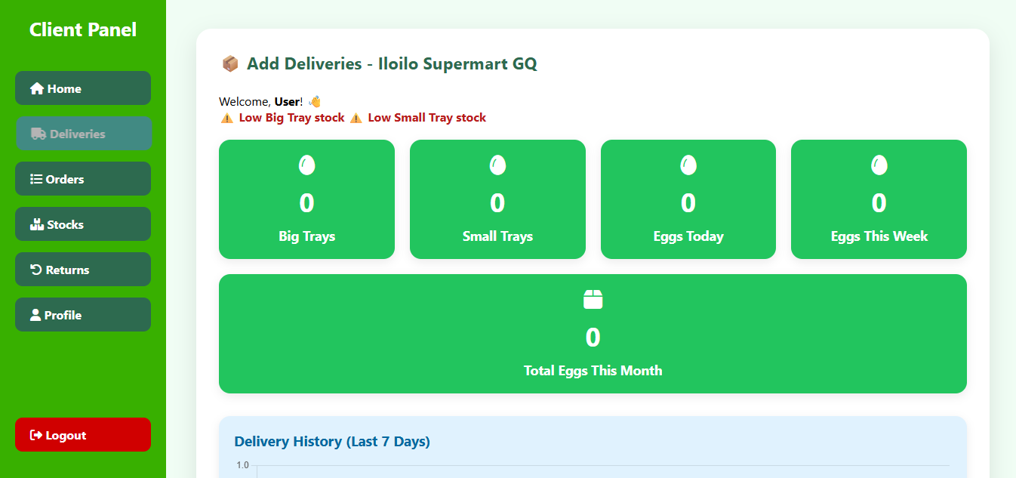
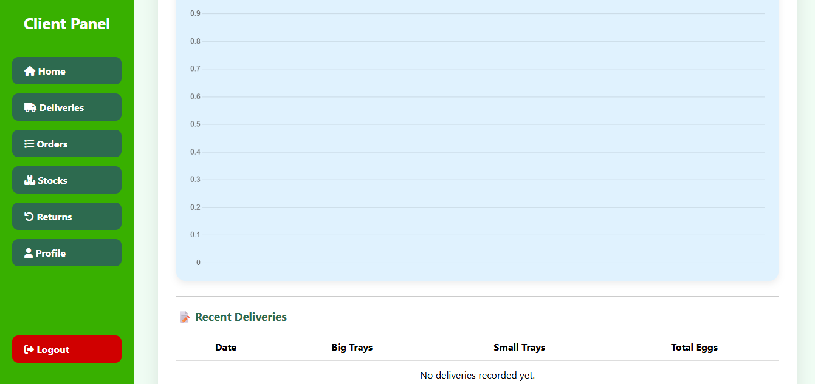

Orders

On the Sales/Record Sale section, the system calculates the egg quantity from the tray quantities and records the transaction with its total amount(optional/ you can leave it blank). Confirm that the quantities do not exceed the branch's available inventory.
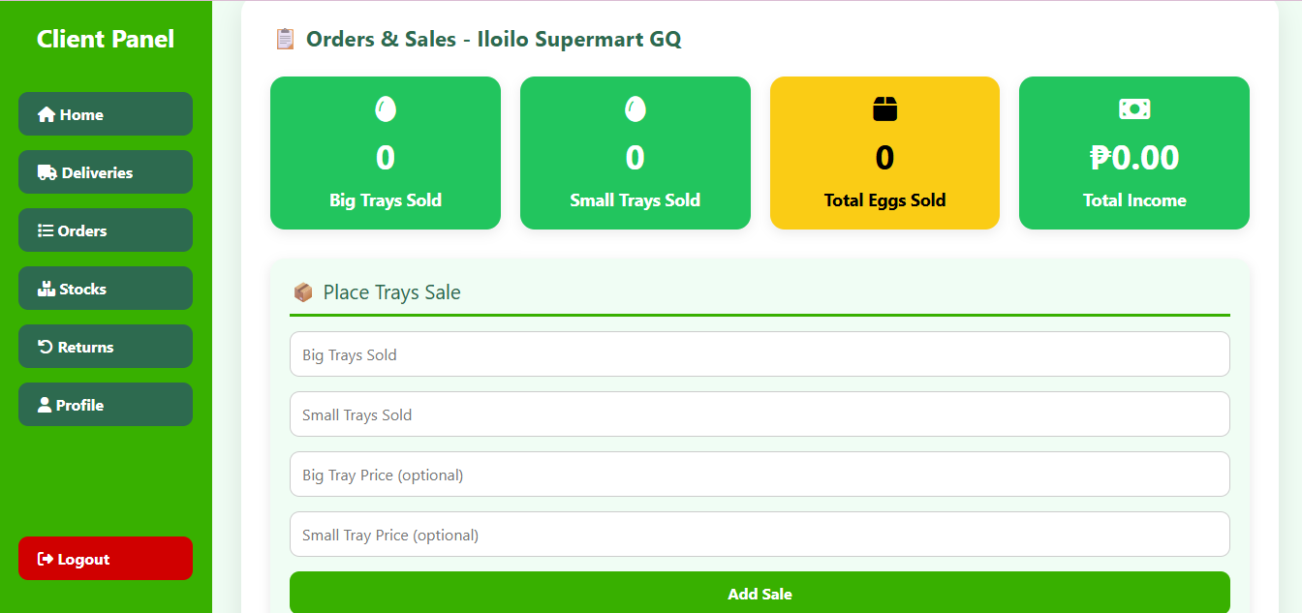

Requesting Additional Stocks
- On the Request Stock/Request section.

- Enter the requested number of Big Trays and Small Trays.

- Enter a clear message explaining the request when needed.

- Submit the request.

- Wait for the administrator to review the request.

The request is stored for administrator processing. The administrator can confirm or reject the request and can provide a reply.
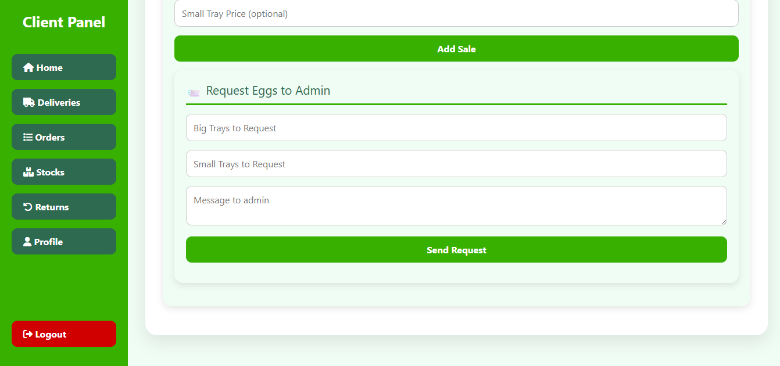

Stocks
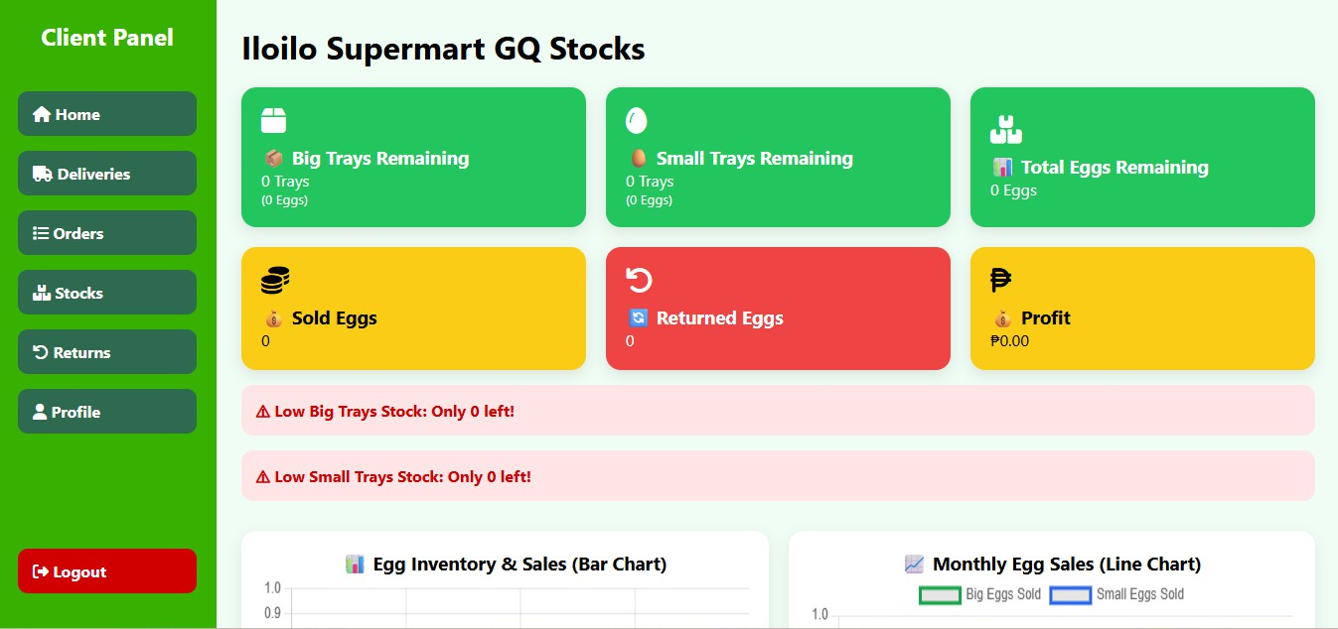
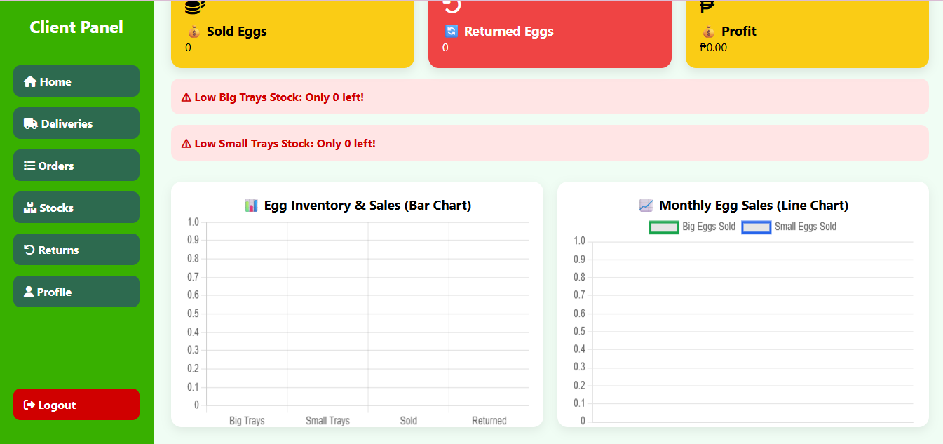
The stocks allow the client to view the egg stock. Before recording a sale, check the available big-tray and small-tray quantities. Do not record quantities greater than the available inventory. The client can view its own submitted requests and their current status. A request may be shown as Pending, Confirmed, or Rejected depending on the administrator's action.

Returns

The Returned Eggs section allows the administrator to monitor eggs returned by each brand.

- Select the appropriate Return Type(Expired, Cracked, Damaged)

- Enter the Big Trays and/or Small Tray quantity.

- Enter the reason or Remarks for the return.

- Click Submit/Return button.

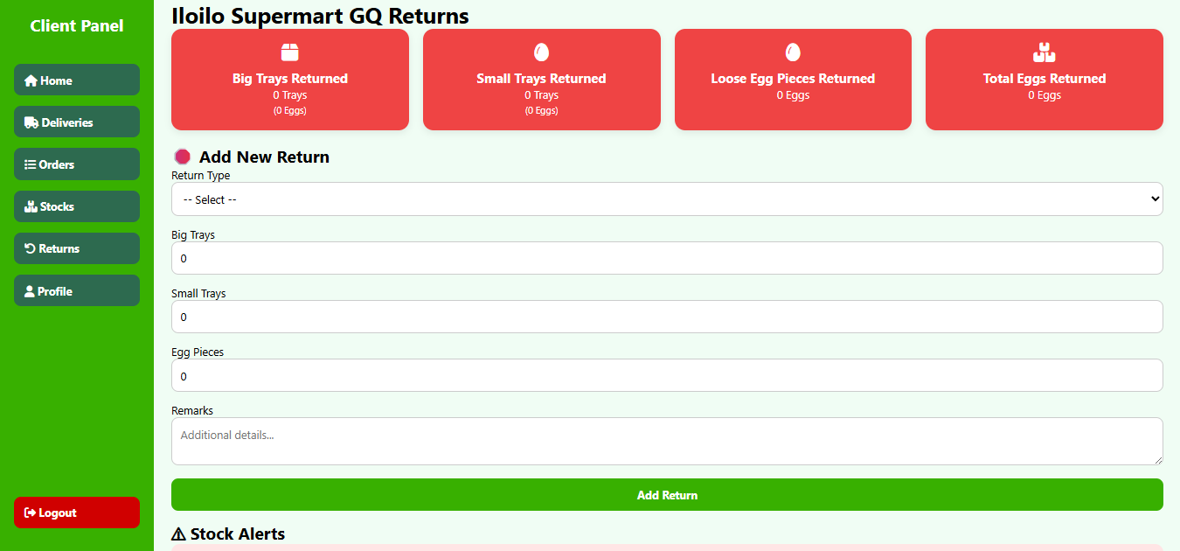
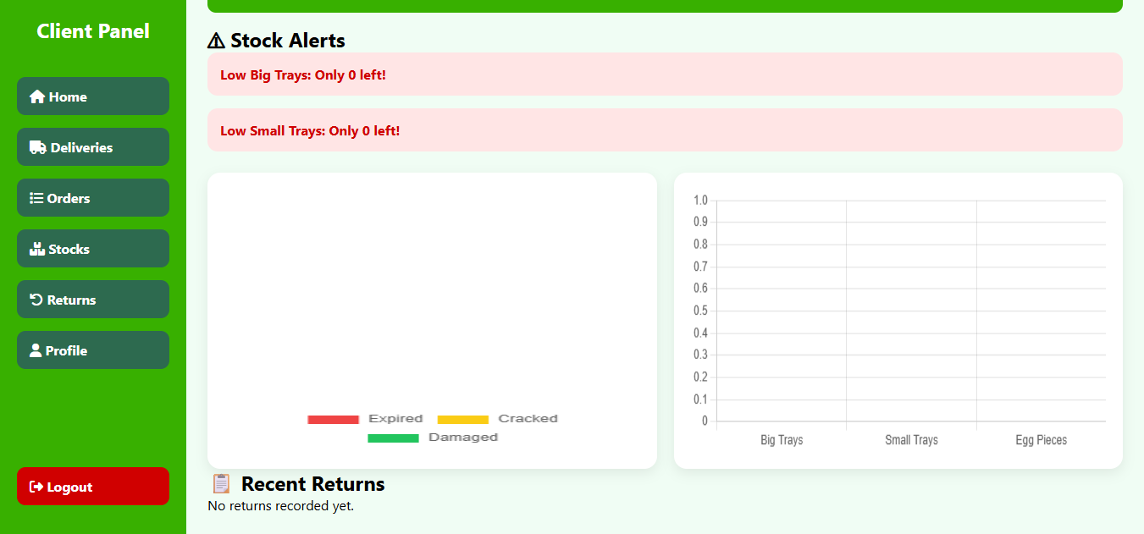

Profile
The client profile allows the branch user to maintain account information associated with the branch account. Supported profile information includes username, full name, email, contact information, and password fields as implemented by the system. To update profile information: open Profile, edit the required fields, provide a new password and confirmation only when changing the password, then submit the update.
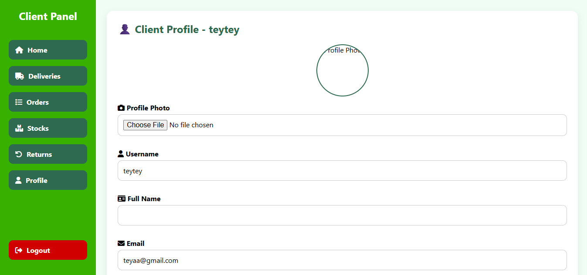
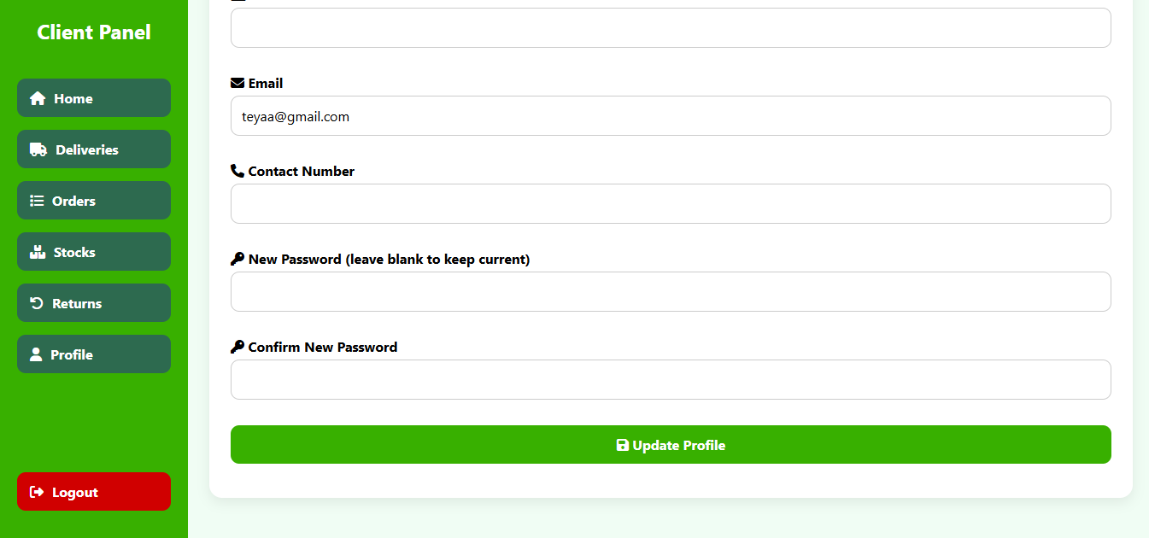

4.3 System Development Methodology

The system was developed using the Agile Software Development Methodology. Agile was selected because it allows the researchers to develop the system gradually while continuously checking whether the features meet the requirements of the intended users.

Instead of developing the entire system at once, the system was divided into smaller components. Each component was developed, tested, reviewed, and improved before the researchers proceeded to the next part.

This approach was appropriate for the study because the system contains several interconnected modules. Changes or improvements identified during the development process could be addressed without having to redesign the entire system.

The development process consisted of the following phases:

Requirements Gathering

The first phase involved identifying the actual operational needs of the system. The researchers gathered information through interviews, direct observations, and consultations with the client and intended users.

The purpose of this phase was to understand how orders, inventory, and distribution activities were currently being handled. The researchers also identified the difficulties encountered in recording information, monitoring inventory, processing requests, and coordinating deliveries.

The information gathered during this phase served as the basis for identifying the system's functional requirements.

The identified requirements included:

- Centralized data storage;
- User account management;
- Branch management;
- Inventory monitoring;
- Order processing;
- Distribution scheduling;
- Delivery tracking;
- Analytics;
- Dashboard visualization; and
- Report generation.

System Planning

After the requirements were identified, the researchers planned the overall development of the system.

The planning phase included the preparation of:

- System objectives;
- Project scope;
- System requirements;
- Development schedule;
- System modules;
- Database requirements;
- Hardware requirements; and
- Software requirements.
The researchers also identified the possible limitations of the system and determined which features would be included in the project.
The planning phase helped ensure that the development process remained focused on the problems identified in the study.

System Design

During the design phase, the researchers prepared the structure of the system.

This included the development of:

- System architecture;
- Database structure;
- Entity Relationship Diagram;
- Data Flow Diagram;
- Use Case Diagram;
- System workflows; and
- User interface designs ;
The design served as a guide for the actual development of the system. It also helped the researchers understand how information would move between the users, system processes, and database.

Software Development

During the development phase, the researchers converted the system designs into a working application.
The system was developed by creating the individual modules and connecting them to the centralized database. The development process was performed gradually, beginning with the basic system functions and continuing with the more advanced management and analytics features.

The main functions developed included:

- Login and authentication
- User management
- Branch management
- Inventory management
- Order management
- Distribution management
- Delivery tracking
- Analytics
- Dashboard visualization; and
- Report generation.
Each module was tested as it was developed to identify errors at an early stage.

4.3.5 Testing

Testing was conducted throughout the development process. The researchers tested the individual functions and later tested the system as a whole. Testing was conducted to determine whether the system performed according to the identified requirements.
The testing process included:

- Functionality testing;
- Integration testing;
- System testing; and
- User evaluation.
The system was also evaluated according to functionality, usability, reliability, efficiency, and security.

Deployment

After the system had been developed and tested, it was prepared for use in the intended environment. The deployment process involved configuring the system, preparing the database, setting up user accounts, and making the system accessible to authorized users.
The system was designed to be accessed through a web browser. This allows users to access the system without needing to install a separate application on every device.

Maintenance

Maintenance involves making improvements to the system after implementation.

Possible maintenance activities include:

- Correcting errors;
- Updating system components;
- Improving system performance;
- Enhancing security;
- Updating reports;
- Improving analytics features; and
- Adding new features based on future requirements.
Maintenance is important because operational needs may change over time.

The Agile methodology used in this study supports continuous improvement and allows future changes to be introduced as new requirements are identified. The reference methodology also follows an iterative process in which modules are developed, tested, reviewed, and improved before continuing to the next stage.

System Architecture

The developed system uses a three-tier client-server architecture. The architecture separates the user interface, application processes, and database.

Figure 4.2
Three-Tier Architecture of the Developed System

The three main layers are:

- Presentation Layer;
- Application Layer; and
- Data Layer.

Presentation Layer

The presentation layer is the part of the system that users interact with.

It includes the interfaces used by administrators and branch personnel to perform their assigned tasks.

The major interfaces include:

- Login page;
- Admin dashboard;
- Branch dashboard;
- Inventory management;
- Order management;
- Distribution management;
- Delivery monitoring;
- Analytics dashboard; and
- Reports.
The presentation layer displays information in a way that is easy for users to understand. Tables are used for detailed records, while charts and visual summaries are used to present analytical information.

Application Layer

The application layer contains the main logic of the system.
It processes the information entered by the users and applies the rules required by the system.

Its main responsibilities include:

- User authentication;
- Role verification;
- Order processing;
- Inventory updating;
- Stock monitoring;
- Distribution scheduling;
- Delivery status updating;
- Analytics processing;
- Forecasting;
- Dashboard generation; and
- Report generation.
This layer serves as the connection between the user interface and the centralized database.

For example, when a branch submits an order, the application layer checks the submitted information, processes the request, and saves the appropriate records in the database.

Data Layer
The data layer stores the information used by the system.

The centralized database contains records related to:

- Users;
- Branches;
- Products;
- Inventory;
- Orders;
- Sales or stock movements;
- Deliveries;
- Distribution activities; and
- Analytics results.
The centralized database is important because the system is intended for multiple branches. Instead of keeping separate and disconnected information, the system allows operational data to be managed in a single database.

This supports better data consistency and makes it easier for authorized users to monitor information from different branches.

4.5 Hardware and Software Requirements

The successful implementation of the Analytics-Driven Centralized Admin-Client Order, Inventory, and Distribution Management System for Multi-Branch Supermarkets requires appropriate hardware and software resources. Since the system manages information from multiple supermarket branches and includes inventory monitoring, order processing, distribution management, analytics, dashboards, and report generation, the selected resources should be capable of supporting regular data processing and system access.

The hardware and software requirements presented in this section provide the minimum and recommended specifications for accessing, developing, and operating the system. These requirements help ensure that the system can perform its functions properly without unnecessary delays during regular use.

4.5.1 Hardware Requirements
Table 4.1 presents the minimum and recommended hardware specifications for accessing and operating the developed system.

Table 4.1
Hardware Requirements
Component | Minimum Specification | Recommended  Specifications
Processor | Intel Core i3 or equivalent | Intel Core i5 or higher
Memory (RAM) | 4 GB
  8 GB or higher
Storage
  256 GB
  512 GB SSD
Monitor | 1366 × 768 resolution | Full HD display
Internet Connection | 10 Mbps
  50 Mbps or higher

The minimum hardware specifications are sufficient for basic access to the web-based system and its regular functions. The recommended specifications provide better performance when users are working with larger amounts of inventory, order, distribution, and analytics data. A faster processor and larger memory capacity can also help improve the experience when viewing dashboards, generating reports, and working with multiple system functions.

Since the system is web-based, users do not necessarily need high-end computers to access it. However, the device should have enough processing power, memory, and a stable internet connection to ensure smooth system operation.

4.5.2 Software Requirements

The system also requires appropriate software tools for its development, operation, and database management. Table 4.2 presents the software requirements used or needed for the development and operation of the system.

Table 4.2
Software Requirements
Software | Purpose
Windows 10/11 or equivalent operating system | Provides the environment for system access and development
Visual Studio Code | Used for writing and editing the system's source code
Web Browser | Used to access and operate the web-based system
MySQL
  Used to store and manage the centralized database
XAMPP | Provides the local server environment during development, if applicable
Git/GitHub
  Used for source code management and version control, if applicable

The software requirements support both the development and operation of the system. A modern web browser is required for users to access the system, while the database management system is used to store and organize information related to users, branches, inventory, orders, deliveries, and other system records.

The software tools used during development may vary depending on the final technologies selected by the researchers. Therefore, the final version of this section should reflect the actual programming languages, frameworks, database systems, and development tools used in the completed system.

4.6 Database Design

The database serves as the foundation of the Analytics-Driven Centralized Admin-Client Order, Inventory, and Distribution Management System for Multi-Branch Supermarkets by organizing and storing information related to users, supermarket branches, products, inventory, orders, deliveries, distribution activities, and analytics. A well-designed database allows the system to retrieve information efficiently, reduce unnecessary duplication, and maintain consistency among related records.

The researchers employed a relational database model to organize the system's information. Database normalization techniques were applied to minimize data redundancy and maintain consistency among related tables. Since the system is designed for multiple supermarket branches, the database also provides a centralized structure for managing operational information from different branches.

Figure 4.4 presents the Entity Relationship Diagram (ERD) of the system.

(Insert ER Diagram Here)

The primary entities of the database include:
- Users
- Branches
- Products
- Categories
- Inventory
- Orders
- Order Details
- Deliveries
- Distribution Records
- Inventory Movements
- Analytics Results

Analytics Table

The analytics table stores the results generated by the system after processing data from inventory, orders, and distribution activities. Instead of simply storing records, the system analyzes the collected information to provide useful insights that can help administrators monitor inventory levels, identify product demand, and make better decisions about stock replenishment and distribution.

Depending on how the system is implemented, the Analytics table may store computed results directly or reference data that is generated whenever reports or dashboards are viewed. These insights are displayed through the system's analytics dashboard and reports, making it easier for users to understand inventory performance and operational trends across different supermarket branches.
Table 4.X
Analytics Table
Field | Description
analytics_id | Primary Key
branch_id | Foreign Key
product_id | Foreign Key
total_orders | Total number of orders received
inventory_level | Current quantity of available stock
demand_forecast | Estimated future demand for the product
stock_status | Indicates whether the stock level is Normal, Low, or Critical
generated_date | Date when the analysis was generated

CHAPTER 5

CONCLUSION AND RECOMMENDATIONS

5.1 Introduction

This chapter presents the conclusion of the study and highlights the key findings gathered during the development and evaluation of the Analytics-Driven Centralized Admin-Client Order, Inventory, and Distribution Management System for Multi-Branch Supermarkets. It also discusses how the system met the objectives of the study and provides recommendations that may help improve the system in the future.

The main goal of this study was to develop a centralized web-based system that makes it easier for supermarket administrators and branch personnel to manage orders, inventory, and distribution. The system also includes analytics features that provide useful insights to support planning and decision-making. This chapter summarizes what was achieved throughout the study and suggests possible improvements that future researchers and developers may consider.

5.2 Summary of Findings

The development of the proposed system produced positive results that addressed the problems identified in the study.

The system successfully centralized the management of orders, inventory, and distribution records from different supermarket branches into one database. Instead of maintaining separate records for each branch, users can now access updated information through a single platform. This makes monitoring and managing daily operations much easier.

The inventory management module allows users to check stock levels in real time and quickly identify products that need replenishment. This helps reduce the chances of running out of stock or ordering more products than necessary.

The order and distribution modules also made the process of requesting, approving, and tracking orders more organized. Branches can submit requests directly through the system, while administrators can monitor deliveries and update their status without relying on manual communication.

Another important feature of the system is the analytics module. By processing inventory and order data, the system can present useful information through reports and dashboards. These insights help administrators understand inventory trends, monitor product demand, and make better decisions when planning future stock requirements.

Based on the evaluation conducted, the system performed well in terms of functionality, usability, reliability, efficiency, and security. The results show that the developed system is capable of supporting the daily operations of multi-branch supermarkets while providing users with a simple and organized way of managing information.

5.3 Conclusion

The Analytics-Driven Centralized Admin-Client Order, Inventory, and Distribution Management System for Multi-Branch Supermarkets was successfully developed to address the challenges identified at the beginning of the study. The system provides a centralized platform where administrators and branch personnel can manage inventory, process orders, coordinate distribution, and access analytical reports more efficiently.

By replacing separate and manual record-keeping with a centralized database, the system helps improve the accuracy and accessibility of information. Users no longer need to check different records from different branches because important data can be viewed in one place. This allows administrators to respond more quickly to inventory concerns and monitor branch operations more effectively.

The analytics features also add value to the system by turning operational data into meaningful information. Instead of simply storing records, the system helps users understand inventory movement, monitor product demand, and identify trends that can support planning and decision-making.

Overall, the objectives of the study were achieved. The developed system offers a practical solution for improving inventory management, order processing, and distribution coordination in multi-branch supermarkets. While the system performs its intended functions, its effectiveness still depends on the accuracy and completeness of the data entered by users. As more operational data becomes available, the analytics features can provide even more reliable insights.

5.4 Recommendations
Although the system achieved its intended objectives, there are still several areas that can be improved in future versions.

System Improvements

Future developers may consider adding automatic notifications that alert users whenever products reach their reorder level or when inventory becomes critically low. This would allow administrators to respond more quickly and avoid stock shortages.
The analytics module can also be enhanced by including more detailed reports, branch performance comparisons, and improved demand forecasting. These additional features could provide more accurate insights and further support inventory planning.

To improve security, future versions of the system may include features such as two-factor authentication, stronger password requirements, and detailed activity logs. These improvements would provide additional protection for sensitive business information.

Another useful enhancement would be the ability to export reports in different formats, such as PDF, Excel, and CSV. This would make it easier for users to print, save, and share reports whenever needed.

Developing a mobile-friendly version of the system would also make it more convenient for administrators and branch managers to monitor operations even when they are away from their computers.

Future Research

Future researchers may explore the use of artificial intelligence or machine learning to improve demand forecasting and inventory prediction. These technologies could help the system provide more accurate recommendations based on historical data and changing customer demand.

Researchers may also study the possibility of integrating the system with Point-of-Sale (POS) systems, accounting software, supplier management systems, or warehouse management systems. Doing so could further improve the efficiency of supermarket operations.

Another possible area for future research is evaluating the long-term impact of the system after it has been used in actual supermarket operations. This could provide a better understanding of how the system affects inventory accuracy, operational efficiency, and overall business performance.

Implementation Recommendations

Organizations planning to use the system should provide proper training for all users before implementation. This helps ensure that everyone understands how to use the system correctly and consistently.

Users should also practice accurate and consistent data entry because the quality of reports and analytics depends on the accuracy of the information stored in the database.
Finally, regular database backups and system maintenance should be performed to protect important business data and ensure that the system continues to operate smoothly.

5.5 Impact of the Study

This study shows how technology can help improve the way multi-branch supermarkets manage their daily operations. By combining inventory management, order processing, distribution monitoring, and analytics in one system, the researchers developed a tool that supports faster access to information and more organized decision-making.

For administrators, the system provides a centralized view of operations across different branches, making it easier to monitor inventory levels, approve orders, and track deliveries. For branch managers and inventory personnel, it simplifies routine tasks by providing updated information through an organized and user-friendly interface.

The study also contributes to the field of Information Technology by demonstrating how analytics can be applied to solve real operational challenges. Instead of using data only for record-keeping, the system transforms it into useful information that supports planning and decision-making.

Although the system still has limitations, particularly in forecasting accuracy and its reliance on complete and accurate data, it provides a strong foundation for future improvements. As the system continues to develop, it has the potential to become an even more effective tool for managing supermarket operations.

5.6 Summary

This study successfully developed an Analytics-Driven Centralized Admin-Client Order, Inventory, and Distribution Management System for Multi-Branch Supermarkets that helps improve inventory management, order processing, distribution coordination, and operational monitoring.

By storing information in a centralized database, the system allows users to access updated records from different branches through a single platform. Its analytics features provide meaningful insights that help administrators monitor inventory trends and make better decisions when planning future operations.

Overall, the study demonstrates that combining centralized information management with analytics can improve the efficiency and organization of supermarket operations. The developed system not only addresses the problems identified in the study but also provides a foundation for future enhancements that can further support the growing needs of multi-branch supermarkets.

