Design Document

Meal Planning Calendar

Document Version: 1.0

**Team Members:** Jonah Backfish, Michael Anderson-Liggett

# **Introduction**

The introduction should include information describing the intended software project (including the hardware and software that the software application will run on) - this introduction should be at least 50 words in length.

# **Architecture**

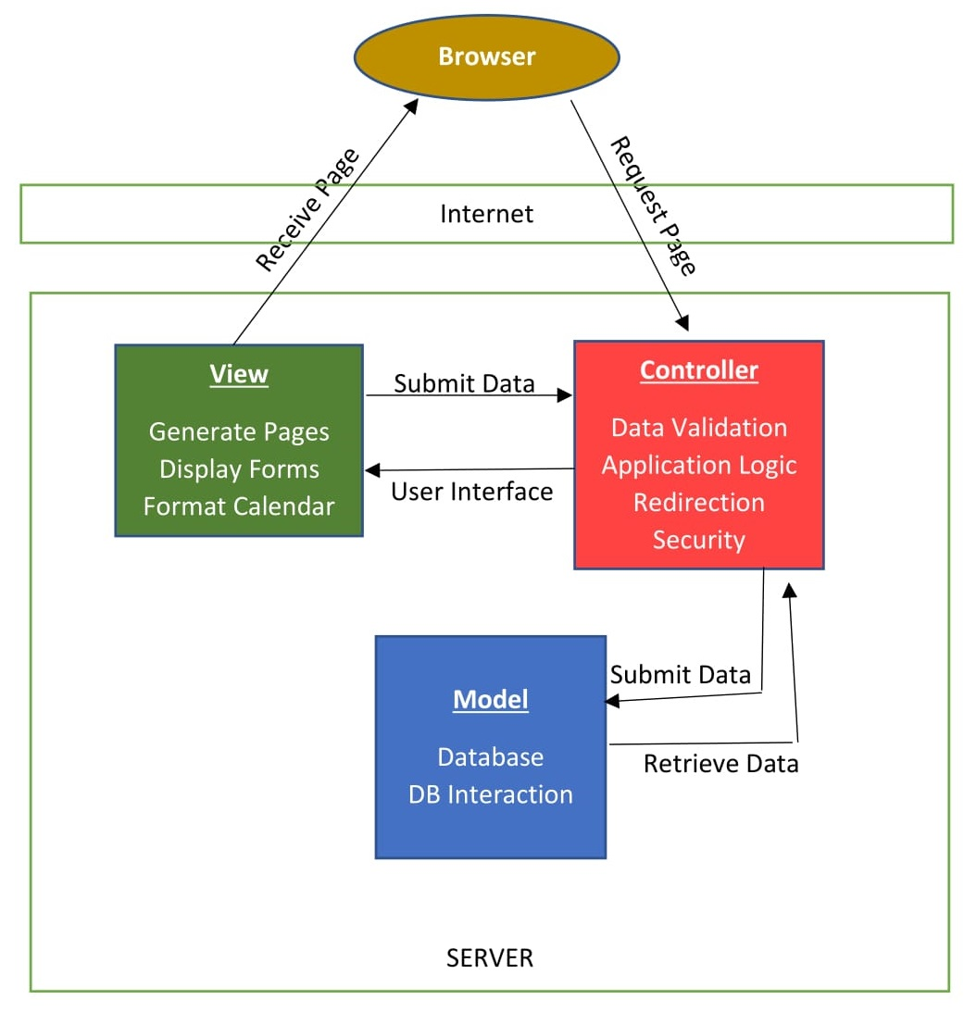

# **Use Cases**

There should be a section that includes use cases for the software development project. There should be at least one use case for each requirement that you identified on the requirements analysis document for your software project.

# **UML**

there should be a section that includes the currently identified classes that you intend on using (see chapter 7). The UML should also include the relationships between the various classes.

# **Test Cases**

There should be a section that includes test cases for the software development project. There should be at least one test case for each requirement that you identified on the requirements analysis document for your software project.

# **Summary**

the design document should conclude with a summarization of the project. The summary should be at least 50 words in length.