Project Plan

Meal Planning Calendar

Document Version: 1.0

**Team Members:** Jonah Backfish, Michael Anderson-Liggett

# **Introduction**

The meal planning software is intended to assist child care facilities that participate in the CACFP food program. The primary objective of this software is to streamline the creation of meal plans that meet CACFP standards.

The software is intended to be developed over the span of two months with a team of two people. Time will be the primary constraint with no budget being allocated for development.

# **Project Organization**

|  |  |
| --- | --- |
| **Team Member** | **Roles** |
| Jonah Backfish | * Back-end scripting * Database design and management |
| Michael Anderson-Liggett | * Front-end scripting * UI and CSS Design |

# **Risk Analysis**

|  |  |  |  |
| --- | --- | --- | --- |
| **Risk Identification** | **Level** | **Possible Causes** | **Threat** |
| The software does not implement appropriate food safety precautions | 1 | The software fails to properly meet CACFP standards or does not address food safety concerns, such as allergies | High |
| The software fails because it is not user-friendly | 2 | Poor user interface or poor integration into existing system | Moderate |
| The software does not meet the user’s needs | 3 | The software does not implement the appropriate level of flexibility in the food planning system | Moderate |
| The software does not remain up to date with changes in CACFP standards | 4 | The team is unable to provide the on-going maintenance needed to support the software over time due to other projects or life circumstances | Low |
| Loss of a team member prevents completion of development | 5 | Illness or other unplanned changes | Low |

# **Hardware and Software Requirements**

**Software Requirements**

The primary objective of this software is to streamline the creation of meal plans that meet CACFP standards by offering the following functionality:

* Simple interface to create meal plans that meet CACFP standards
* Generation of a formatted meal plan calendar for printing
* Easy integration into an existing website with features for inline-display of the most up-to-date version of the calendar
* Ability to add and remove foods to be used in meal plans
* Authenticated access to administration tools

**Development Environment**

* Web technologies: HTML, CSS, Javascript, PHP, and MySQL
* GitHub for source control
* Buddy for deployment pipeline
* XAMPP for local testing
* 000WebHost for test server
* Bobbi for final deployment

# **Work Breakdown**

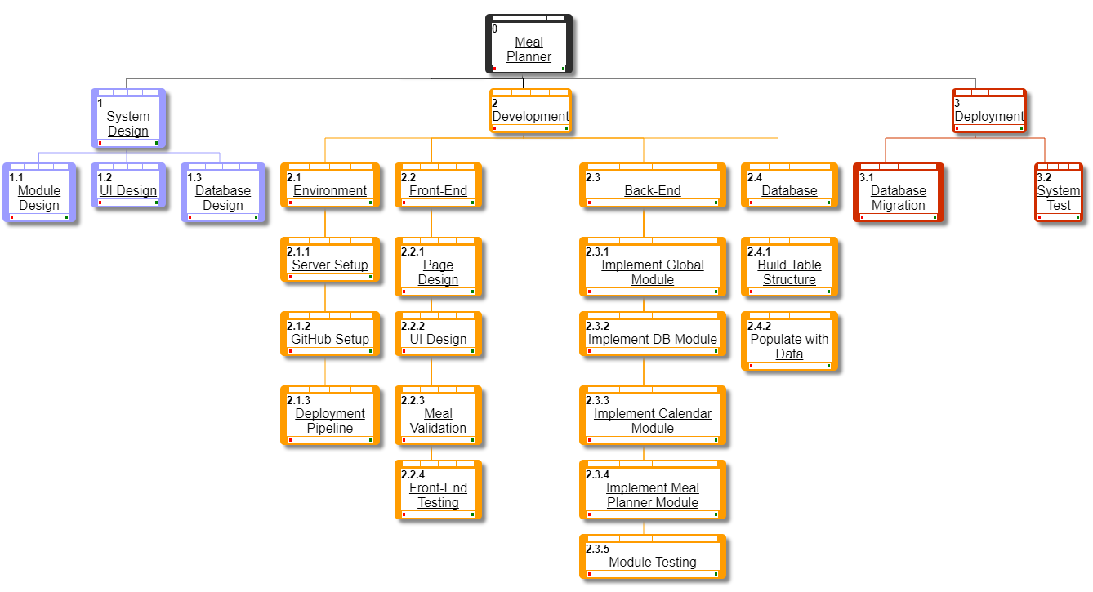

# **Project Schedule**

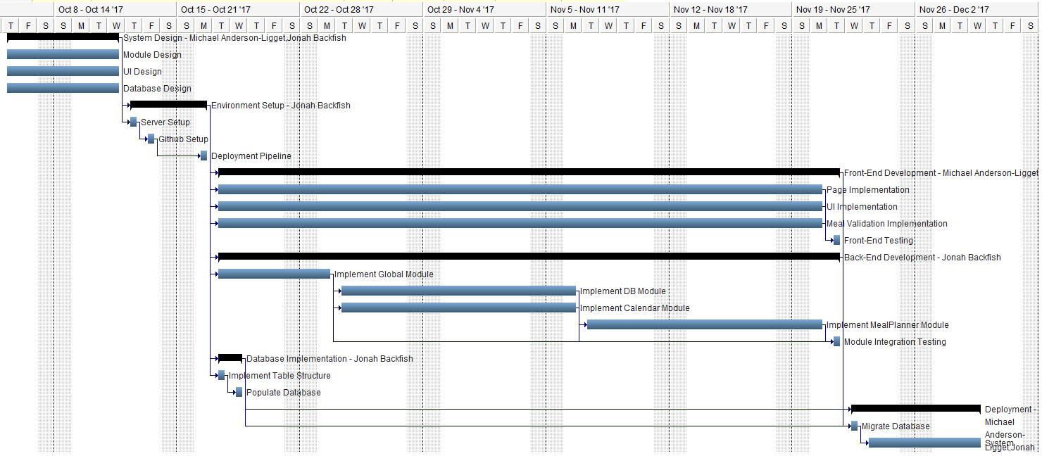

# **Monitoring and Reporting Mechanisms**

Weekly status reports will be generated collaboratively by both team members. These reports will primarily address work completed, development status, and any comments or concerns raised by team members. The document will serve as a weekly evaluation to ensure that the project is progressing smoothly and on-schedule. Any task that falls behind schedule will be discussed among the team members, possibly resulting in alterations to the project schedule or work flow to facilitate the completion of the task.

# **Appendix**

|  |  |  |  |  |  |
| --- | --- | --- | --- | --- | --- |
|  |  | **Activity Name** | **Duration** | **Dependencies** | **Resources** |
| 1 |  | **System Design** | 5d |  | Michael Anderson-Liggett,  Jonah Backfish |
| 2 |  | Module Design | 5d |  |  |
| 3 |  | UI Design | 5d |  |  |
| 4 |  | Database Design | 5d |  |  |
| 5 |  | **Environment Setup** | 3d | 1 | Jonah Backfish |
| 6 |  | Server Setup | 1d | 1 |  |
| 7 |  | Github Setup | 1d | 6 |  |
| 8 |  | Deployment Pipeline | 1d | 7 |  |
| 9 |  | **Front-End Development** | 26d | 5 | Michael Anderson-Liggett |
| 10 |  | Page Implementation | 25d | 5 |  |
| 11 |  | UI Implementation | 25d | 5 |  |
| 12 |  | Meal Validation  Implementation | 25d | 5, 17 |  |
| 13 |  | Front-End Testing | 1d | 10,11,12 |  |
| 14 |  | **Back-End Development** | 26d | 5 | Jonah Backfish |
| 15 |  | Implement Global Module | 5d | 5 |  |
| 16 |  | Implement DB Module | 10d | 15 |  |
| 17 |  | Implement Calendar Module | 10d | 15 |  |
| 18 |  | Implement MealPlanner  Module | 10d | 17 |  |
| 19 |  | Module Integration Testing | 1d | 15,16,17,18 |  |
| 20 |  | **Database Implementation** | 2d | 5 | Jonah Backfish |
| 21 |  | Implement Table Structure | 1d | 5 |  |
| 22 |  | Populate Database | 1d | 21 |  |
| 23 |  | **Deployment** | 6d | 9,14,20 | Michael Anderson-Liggett,  Jonah Backfish |
| 24 |  | Migrate Database | 1d | 9,14,20 |  |
| 25 |  | System Testing | 5d | 24 |  |