Requirements Document

Meal Planning Calendar

Document Version: 1.0

**Team Members:** Jonah Backfish, Michael Anderson-Liggett

# **Introduction**

State licensed childcare facilities in Indiana have the option to enroll in a food reimbursement program known as the Child and Adult Care Food Program (CACFP). A central goal of this program is to offer meal planning guidance to meet the nutritional needs of children that are enrolled in childcare programs. One stipulation of this program requires participating facilities to pre-plan meals in accordance with the CACFP’s meal pattern requirements. These meal plans must be created in advance and made available to parents.

This document outlines the requirements of a web application that streamlines the meal planning process. This program will be used to create meal plans that meet CACFP standards, generate a document containing a meal plan calendar, and print the document for distribution to parents.

# **User Requirements Definition**

1. The system shall utilize a database of various CACFP approved foods and their corresponding food group(s) for the user to select from when planning meals.
   1. The user shall also have the option of adding custom items to the food database.
   2. The system shall be designed with CACFP guidelines for children ages 1-12 in mind. The system will not utilize CACFP standards recommended for adults or infants.
2. The system shall provide a meal entry interface whereby the user selects a date on a calendar, then arranges a meal plan for that date by selecting foods from the food database.
   1. Each date shall contain an entry field for breakfast, lunch, dinner, morning snack, and afternoon snack. A comment field should also be available for placing additional comments on the calendar for that date. All fields shall be optional.
   2. The system should validate meal choices as the user is entering them to ensure they meet CACFP nutritional guidelines. The validation system should provide real time feedback to notify the user of specific requirements that the meal has or has not met.
   3. Any meals that have already been planned for the month should be displayed somewhere on the meal entry tool to provide context for the meal that is currently being planned.
3. The system shall generate a calendar featuring all the planned meals assigned to each day of the month.
   1. The calendar should be available as a downloadable document
   2. The calendar shall be formatted so that it may print out on a single page
   3. The system should offer tools to allow web administrators to display the most up-to-date version of the calendar on a web page.
4. The system should offer optional authorization security, requiring a username and password to be entered before the meal planning tools can be accessed.
   1. Additional authorization, such as authorization from an external administration panel, should also be an option.
5. The design of the system shall focus on modularity and easy integration into an existing web site for a childcare facility.

# **System Architecture**

The following diagram lists the fundamental modules that the system will be built upon. These modules divide the software into four primary branches: data management, calendar management, meal planner, and global system settings/functions.

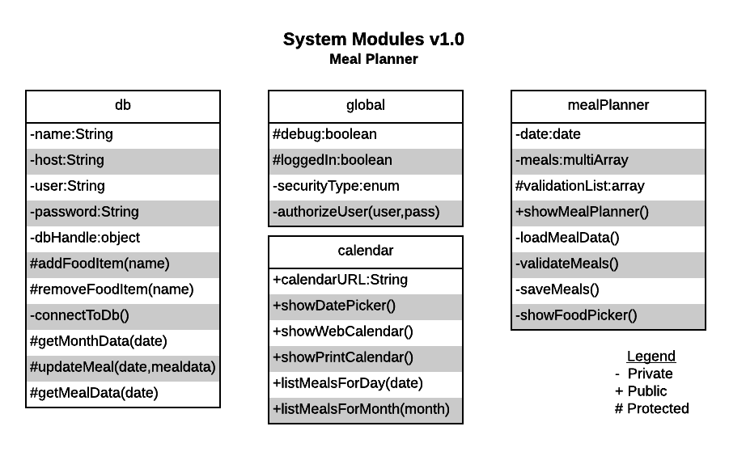

# **System Evolution**

While web development has a general tendency to grow and change at a rapid pace, support for the technologies employed in this project is expected to remain stable throughout the lifecycle of the system. The CACFP standards are periodically revised to reflect the most up-to-date research on nutrition. At the time of this writing, the CACFP is currently issuing a revision to take effect in October of 2017. Such revisions tend to alter serving sizes and leave basic food group recommendations alone. Maintenance of the meal planner system will require on-going review of CACFP guidelines and may require future updates to the validation system.

# **Appendices**

The following is a list of proposed software and hardware technologies to be used in the development of the system.

**Programming**

* HTML5
* CSS
* PHP
* JavaScript

**Other Tools**

* Lucid Chart for diagramming
* XAMPP for local testing
* Deployment server (possibly IvyTech’s Bobbi server)

**Database Software**

* MySQL

**Database Implementation**