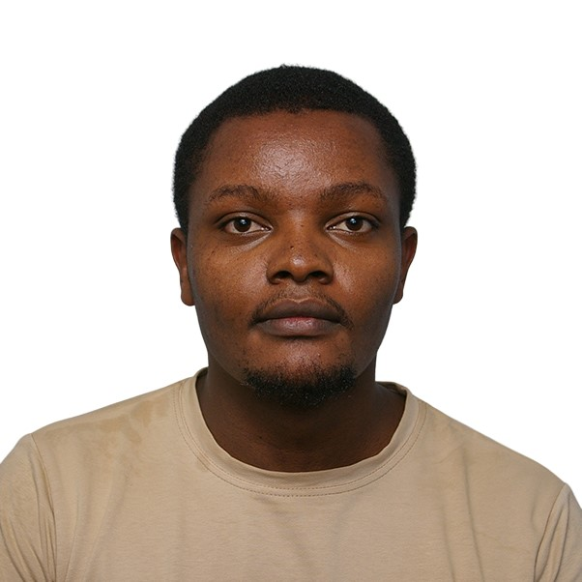

Kelvin W. Maina

Enthusiastic and detail-oriented Web Developer with a BSc in Mathematics and Computer Science from JKUAT. Skilled in front-end development with foundational knowledge in PHP, HTML, CSS, and JavaScript. Experienced in UI/UX design and responsive web development, with hands-on exposure to CMS platforms and SEO. Passionate about building interactive, user-friendly web solutions and eager to contribute to impactful digital projects. Currently seeking a Web Developer Internship to gain further experience in a collaborative and innovative IT environment.

Phone Number: +254758297857

Email: kelvinmainahh@gmail.com

Address: P.O Box 215, Kahiraini, Nyeri.

**CORE SKILLS**

* **Languages:** HTML5, CSS3, PHP, JavaScript (basic)
* **Frameworks/Tools:** React.js, Figma, WordPress, Locofy
* **Database:** MySQL (basic)
* **Other Tools**: Git/GitHub, VS Code, SEO Tools (basic), CMS platforms
* **Concepts:** Responsive Design, UI/UX Principles, CMS Integration, SEO Fundamentals, Agile Framework

**Education**

**BSc Mathematics and Computer Science**  
*Jomo Kenyatta University of Agriculture and Technology* | September 2018 – December 2022

* Second Class Honors, Upper Division

### **Referee**

Amos Muhonza Ndunda – Technical Supervisor, Maathai Supermarket.

Contact - +254 702 514 033

Email - muhonzaamos271@gmail.com.

Gedion Kiptoo Koech – Network Engineer Huawei Technologies

Contact - +254 746 609 057

Email - gidieptoo2017@gmail.com

**PROJECT EXPERIENCE**

**E-Commerce Website for SME Chicken Business — *Final Year Project*  
*Team Lead & Front-End Developer* | JKUAT**

* Designed UI using Figma and translated it into responsive web pages using React and Locofy.
* Integrated SEO practices to optimize product visibility.
* Collaborated with team members to connect front-end to back-end APIs.

**DNS Configuration Project — *Internship Project*  
*Intern* | JKUAT IT Department**

* Configured domain name servers for institutional websites.
* Gained foundational understanding of web hosting and server-side setup.

**PROFESSIONAL EXPERIENCE**

**Customer Service Representative  
Maathai Supermarket, Thika | May 2017 – Sep 2018**

* Assisted customers and promoted sales in the Plastics and Carpets section, increasing department revenue by 20%.
* Developed strong interpersonal and time management skills.