Stage 1:
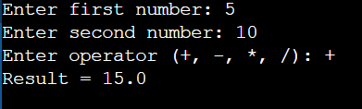

Stage 2:
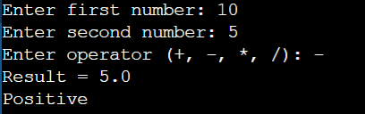

Stage 3:
