User guidelines for Advanced Model Diagnostics with ss3diags

Hennig Winker (JRC-EC)

Felipe Carvalho (NOAA)

Massimiliano Cardinale (SLU)

Laurence Kell (Sea++)

25 May, 2021

Table of Contents

# 1 Getting started

This vignette introduces you to the ss3diags R package, which accompanies the paper “A cookbook for using model diagnostics in integrated stock assessments” by Carvalho, Winker et al. (2021).

The ss3diags comprises a explains set of functions for applying advanced model diagnostics for Stock Synthesis models. with the ss3diags R package for model. The ss3diag R package accompanies the paper “A cookbook for using model diagnostics in integrated stock assessments” by [Carvalho, Winker et al. (2021)](https://www.sciencedirect.com/science/article/pii/S0165783621000874). The ss3diags package builds on the widely used R package r4ss [(Taylor et al. 2021)](https://www.sciencedirect.com/science/article/abs/pii/S0165783621000527), which is designed to support the use of the Stock Synthesis software modeling framework [(Methot and Wetzel, 2013)](https://www.sciencedirect.com/science/article/abs/pii/S0165783612003293). This vignette is divided into four sections. Section 1 consists of installing ss3diags and loading the data from the two case studies presented in the cookbook. Section 2 describes the plotting of various model diagnostics as described in the [Cookbook](https://www.sciencedirect.com/science/article/pii/S0165783621000874). Section 3 provides a detailed explanation on how to assess model uncertainty using ss3diags. In Section 4 we provide a series “cookbook recipes” on how to implement selected model diagnostics in Stock Synthesis.

## 1.1 Installation

Both ss3diags and r4ss can be installed from gihtub using library(devtools):

installed.packages("devtools")  
  
devtools::install_github("JABBAmodel/r4ss")  
  
devtools::install_github("JABBAmodel/ss3diags")

library(r4ss)  
library(ss3diags)

## 1.2 Loading built-in example data

The package contains two fully worked examples of Stock Synthesis assessments as presented in the [Cookbook](https://www.sciencedirect.com/science/article/pii/S0165783621000874).

### 1.2.1 The Pacif hake (*Merluccius productus*) base case model

data("pac.hke")

Individual list objects generated using R package [r4ss](https://github.com/r4ss/r4ss):

* ss3phk: output from Stock Synthesis as read by r4ss::SS_output()

dir.path = "C:/Users/henni/Dropbox/ss3diags_demo/PacificHake"  
ss3pke = r4ss::SS_output(file.path(dir.path, "Reference_Run"))

* retro.phk: list of retrospective runs with r4ss:SS_doRetro() as read by r4ss::SSgetoutput()

The retrospective runs, produced with r4ss:SS_doRetro(), were located in the subfolders /Retro_Reference_Run and named “retro0”,“retro-1”,…, “retro-7” and so on. To load those at once we use the r4ss::SSgetoutput(). Eight retrospective runs were conducted, where “retro0” corresponds to the “Reference_Run” and “retro-1” to “retro-7” are “peels”. To assign the model names, specify start.retro = 0 and end.retro = 7 below.

start.retro = 0  
end.retro = 7  
retro.runs = "Retro_Reference_Run"  
# load models  
retro.phk <- r4ss::SSgetoutput(dirvec = file.path(dir.path, retro.runs, paste0("retro",   
 start.retro:-end.retro)))

The list object retro.phk[[1]] (“retro0”) corresponds to the reference run ss3phk

* aspm.phk: Comprises of two runs the “Reference_Run” and the “ASPM”, which can be loaded together using r4ss::SSgetoutput() and then summarized with r4ss::SSsummarize()

asem.phk <- r4ss::SSgetoutput(dirvec = file.path(dir.path, paste0("Reference_Run",   
 "APSM")))  
asem.phk <- r4ss::SSsummarize(asem.phk)

### 1.2.2 North Atlantic shortfin mako (*Isurus oxyrinchus*)

data("natl.sma")

Individual list objects generated using R package [r4ss](https://github.com/r4ss/r4ss):

* ss3sma: output from Stock Synthesis as read by r4ss::SS_output()
* retro.sma: list of retrospective runs with r4ss:SS_doRetro() as read by r4ss::SSgetoutput()
* aspm.sma: list of Stock Synthesis referece and aspm created with r4ss::SSsummarize()

# 2 Model Diagnostics with ss3diags

## 2.1 Residual diagnostics

The plotting options are kept mainly to those provided by [r4ss](https://github.com/r4ss/r4ss). Like with [r4ss](https://github.com/r4ss/r4ss), if, for example, `SSplotRunstest() called with no further specifications several windows will open, which depends on the number abundance indices.

SSplotRunstest(ss3sma)

To visiualize the runs test for multiple indices, it is recommended to use of the function sspar(). The option plot add=TRUE in sspar() facilitates setting the graphic parameters so that they are suitable for ss3diags plots. The option add=TRUE prevents the plotting functions from over-writing sspar().

sspar(mfrow = c(3, 2), plot.cex = 0.8)  
rt = SSplotRunstest(ss3sma, add = T, verbose = F)

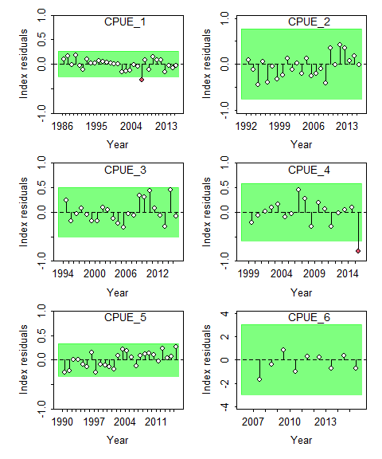

It is also possible to select the indices that should be plotted. For example, we excluded CPUE2 as it was not fitted (zero weight to the likelihood). This creates space to add the joint-residual plot SSplotJABBAres to summarize all selected indices.

sspar(mfrow = c(3, 2), plot.cex = 0.8)  
rt = SSplotRunstest(ss3sma, add = T, indexselect = c(1, 3:6), legendcex = 0.8, verbose = F)  
jr = SSplotJABBAres(ss3sma, add = T, indexselect = c(1, 3:6), legendcex = 0.55, verbose = F)

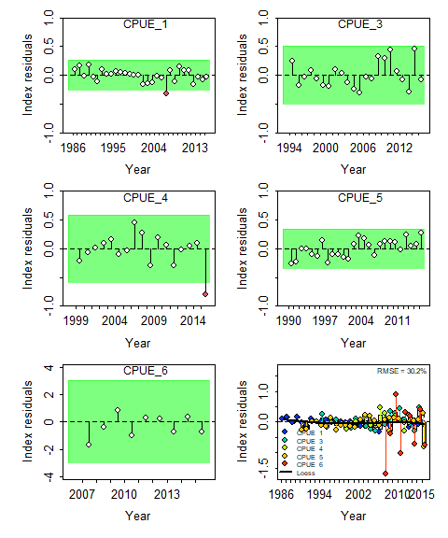

Runs test plot and Joint residual plot for fits to CPUE indices, where the vertical lines with points show the residuals, and solid black lines show loess smoother through all residuals. Boxplots indicate the median and quantiles in cases where residuals from the multiple indices are available for any given year. Root-mean squared errors (RMSE) are included in the upper right-hand corner of each plot.

The default for SSplotRunstest() and SSplotJABBAres() is plot the residual runs for the abundance indices. However, it is also possible to plot the composition data by specifying subplots="len" (or “age”)

sspar(mfrow = c(3, 2), plot.cex = 0.8)  
rt = SSplotRunstest(ss3sma, add = T, legendcex = 0.8, subplot = "len", verbose = F)  
jr = SSplotJABBAres(ss3sma, add = T, legendcex = 0.55, legendloc = "bottomright",   
 subplot = "len", verbose = F)

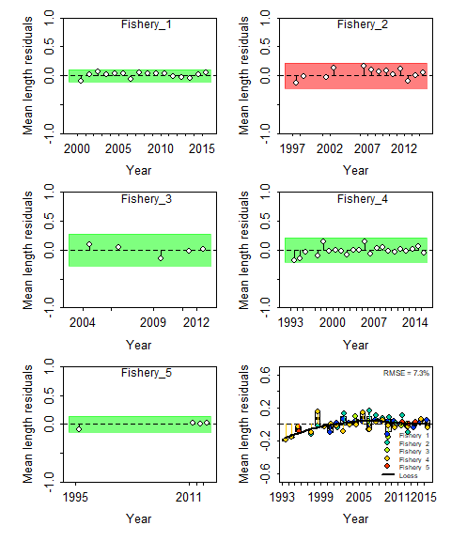

Runs test plot and Joint residual plot for mean lengths from fits length composition data

To facilitate automated processing, results from several diagnostic tests can also be called without plotting

rti = SSrunstest(ss3sma, quant = "cpue", verbose = F)  
rtl = SSrunstest(ss3sma, quant = "len", verbose = F)  
rbind(rti, rtl)  
 Index runs.p test sigma3.lo sigma3.hi type  
 1 CPUE_1 0.069 Passed -0.2605783 0.2605783 cpue  
 2 CPUE_2 0.717 Passed -0.7630777 0.7630777 cpue  
 3 CPUE_3 0.229 Passed -0.5033328 0.5033328 cpue  
 4 CPUE_4 0.406 Passed -0.5868380 0.5868380 cpue  
 5 CPUE_5 0.065 Passed -0.3369695 0.3369695 cpue  
 6 CPUE_6 0.870 Passed -3.0226356 3.0226356 cpue  
 7 Fishery_1 0.127 Passed -0.1103741 0.1103741 len  
 8 Fishery_2 0.040 Failed -0.2156036 0.2156036 len  
 9 Fishery_3 0.331 Passed -0.2759992 0.2759992 len  
 10 Fishery_4 0.806 Passed -0.2141490 0.2141490 len  
 11 Fishery_5 0.159 Passed -0.1407228 0.1407228 len

The Pacific hake assessment provides an example of fits to age composition instead of length composition data, which can visualized by specifying subplots="age"

sspar(mfrow = c(2, 2), plot.cex = 0.8)  
rti = SSplotRunstest(ss3phk, add = T, legendcex = 0.8, subplot = "cpue", verbose = F)  
rta = SSplotRunstest(ss3phk, add = T, legendcex = 0.8, subplot = "age", verbose = F)  
jra = SSplotJABBAres(ss3phk, add = T, legendcex = 0.7, subplot = "age", verbose = F)

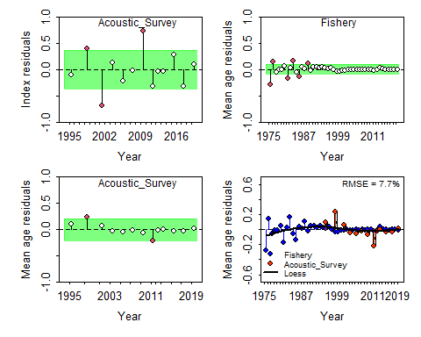

Runs test plot and Joint residual plot for a survey abudance index and mean ages from fits to survey and fisheries dependent age-composition data

## 2.2 Retrospective and Forecast bias

In Stock Synthesis, retrospective analysis can be routinely using r4ss:SS_doRetro() (see Section 4.1). ss3diags provides the function SSplotRetro() to visualize the retrospective patterns of SBB and F and compute the associated Mohn’s rho value (i.e. retrospective bias). This would require first loading the retrospective runs (Section 1.2]), which are already inbuilt into ss3diags in this case. The next step is to summarize the list of retrospective runs using r4ss::SSsummarize().

retroI.phk <- r4ss::SSsummarize(retro.phk, verbose = F)

We use notation “retroI” because r4ss::SSsummarize() summarizes the modeled quantities and abundance indices, but not length or age composition data. Using retroI.phk it is possible to produce some basic retrospective plots.

sspar(mfrow = c(1, 2), plot.cex = 0.8)  
rb = SSplotRetro(retroI.phk, add = T, forecast = F, legend = F, verbose = F)  
rf = SSplotRetro(retroI.phk, add = T, subplots = "F", ylim = c(0, 0.4), forecast = F,   
 legendloc = "topleft", legendcex = 0.8, verbose = F)

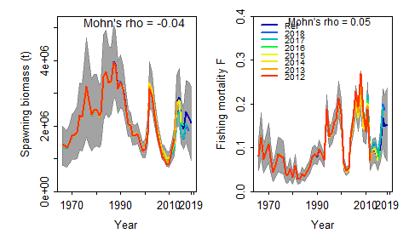

Retrospective analysis of spawning stock biomass (SSB) and fishing mortality estimates for Pacific hake conducted by re-fitting the reference model (Ref) after seven years, one year at a time sequentially. Mohn’s rho statistic are denoted on top of the panels. Grey shaded areas are the 95 % confidence intervals from the reference model in cases where the analysis was run with Hessian

An intuitive extension of the retrospective analysis is to assess potential forecast bias by adding the additional step of forward projecting quantities, such as SSB, over the truncated years. In Stock Synthesis the forecasts are automatically done when using r4ss:SS_doRetro().The forecasts are based on the settings specified in ‘forecast.ss’, which are also evoked when conducting future projections with the same model. The observed catches are used for the retrospective forecasts. Retrospective forecasts with Stock Synthesis are therefore only a matter of visualization, which can be done by setting the SSplotRetro() option forecast=TRUE.

sspar(mfrow = c(1, 2), plot.cex = 0.8)  
rb = SSplotRetro(retroI.phk, add = T, forecast = T, legend = F, verbose = F, xmin = 2000)  
rf = SSplotRetro(retroI.phk, add = T, subplots = "F", ylim = c(0, 0.4), forecast = T,   
 legendloc = "topleft", legendcex = 0.8, verbose = F, xmin = 2000)

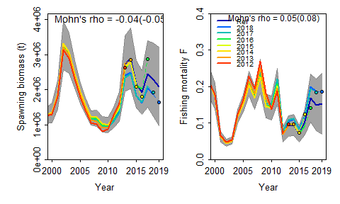

Retrospective results shown for the most recent years only. Mohn’s rho statistic and the corresponding ‘hindcast rho’ values (in brackets) are now printed at the top of the panels. One-year-ahead projections denoted by color-coded dashed lines with terminal points are shown for each model.

The statistics from the retrospective analysis with forecasting, mohn’s rho and forecast bias, can be called without plotting using the function SShcbias()

SShcbias(retroI.phk, quant = "SSB", verbose = F)  
 type peel Rho ForcastRho  
 1 SSB 2018 -0.189511890 -0.21290187  
 2 SSB 2017 -0.138534518 -0.16468977  
 3 SSB 2016 0.048946154 0.17079324  
 4 SSB 2015 -0.017403026 -0.06301299  
 5 SSB 2014 -0.032761073 -0.03298098  
 6 SSB 2013 0.001623057 -0.01285596  
 7 SSB 2012 0.059944948 -0.03946034  
 8 SSB Combined -0.038242335 -0.05072981  
  
SShcbias(retroI.phk, quant = "F", verbose = F)  
 type peel Rho ForcastRho  
 1 F 2018 0.235928805 0.22117119  
 2 F 2017 0.154620273 0.22678319  
 3 F 2016 -0.096502898 -0.16382344  
 4 F 2015 -0.008902238 0.20182834  
 5 F 2014 0.034769554 0.02664839  
 6 F 2013 0.003690925 0.02342468  
 7 F 2012 0.049728943 0.04693738  
 8 F Combined 0.053333338 0.08328139

## 2.3 Hindcast Cross-Validation and prediction skill

Implementing the Hindcast Cross-Validation (HCxval) diagnostic in Stock Synthesis requires the same model outputs generated by r4ss:SS_doRetro() as described in Section 3.1. Therefore, no additional step is needed for HCxval if conducted in conjunction with retrospective analysis. As a robust measure of prediction skill, we implemented the mean absolute scaled error (MASE). In brief, the MASE score scales the mean absolute error (MAE) of forecasts (i.e., prediction residuals) to MAE of a naïve in-sample prediction, which is realized in the form of a simple ‘persistence algorithm’, i.e. tomorrow’s weather will be the same as today’s (see Eq. 3, p.5 in [Carvalho and Winker et al. 2021](https://www.sciencedirect.com/science/article/pii/S0165783621000874)). A MASE score > 1 indicates that the average model forecasts are worse than a random walk. Conversely, a MASE score of 0.5 indicates that the model forecasts twice as accurately as a naïve baseline prediction; thus, the model has prediction skill.

HCxval is implemented using function SSplotHCxval(), which produces the novel HCxval diagnostic plot and computes the MASE scores for CPUE indices, mean lengths or mean ages that have observations falling within the hindcast evaluation period.

Plotting HCxval for abundance indices requires the same step of summarizing the list of retrospective runs as for the retrospective analysis, which therefore only needs be done once. Below is a summary of the retrospective runs for shortfin mako.

retroI.sma <- r4ss::SSsummarize(retro.sma, verbose = F)

sspar(mfrow = c(3, 2), plot.cex = 0.8)  
hci = SSplotHCxval(retroI.sma, add = T, verbose = F, ylimAdj = 1.3, legendcex = 0.7)

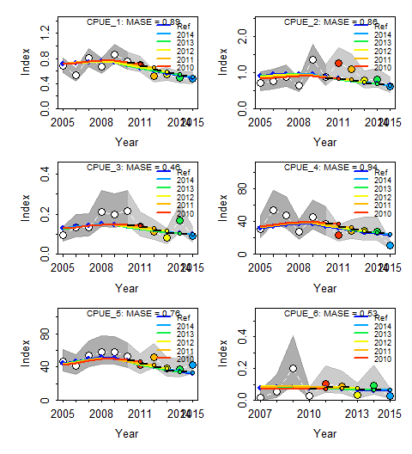

Hindcasting cross-validation (HCxval) results from CPUE fits, showing observed (large points connected with dashed line), fitted (solid lines) and one-yearahead forecast values (small terminal points).HCxval was performed using one reference model (Ref) and five hindcast model runs (solid lines) relative to the expected CPUE. The observations used for crossvalidation are highlighted as color-coded solid circles with associated 95 % confidence intervals. The model reference year refers to the endpoints of each one-year-ahead forecast and the corresponding observation (i.e., year of peel + 1). The mean absolute scaled error (MASE) score associated with each CPUE

The forecast length- and age-composition are located in the Stock Synthesis report.sso as “ghost files”. To extract and summarize the composition data in the form of observed and expected mean lengths and age ss3diags provides the function SSretroComps().

retroC.sma = SSretroComps(retro.sma)

sspar(mfrow = c(1, 2), plot.cex = 0.8)  
hcl = SSplotHCxval(retroC.sma, subplots = "len", add = T, verbose = F, ylimAdj = 1.3,   
 legendcex = 0.7, indexselect = c(1, 2))

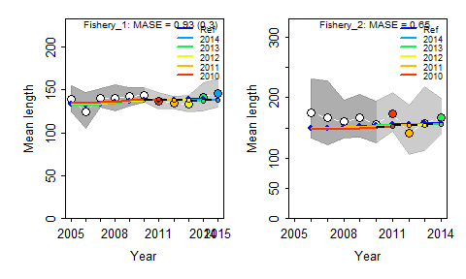

Hindcasting cross-validation (HCxval) results for mean lengths. Note that MASE values in breakets are adjusted MASE values for cases where naive predictions have a Mean-Absolute-Error below 0.1

The Figure above provides some additional, so called adjusted MASE values, in brackets. This gets invoked in cases where the inter-annual variation in the observed values is very small (default MAE < 0.1 for naive predictions log(y[t+1])-log(y[t])). The reasoning is that prediction residuals must be already very accurate to fall below this threshold. The adjusted MASE essential keep the naive prediction MAE denominator of the MASE to a maximum. Below we show the effect of changing adjustment threshold from the default MAE.base.adj = 0.1

mase1 = SSmase(retroC.sma, quant = "len", MAE.base.adj = 0.1, indexselect = c(1:2))  
  
Computing MASE with all 5 of 5 prediction residuals for  
Index Fishery_1  
  
Computing MASE with only 4 of 5 prediction residuals for  
Index Fishery_2  
  
Warning: Unequal spacing of naive predictions residuals may  
influence the interpretation of MASE  
  
MASE stats by Index:  
mase1  
Index Season MASE MAE.PR MAE.base MASE.adj n.eval  
1 Fishery_1 1 0.9265301 0.02981727 0.03218165 0.2981727 5  
2 Fishery_2 1 0.6504563 0.07615571 0.11708045 0.6504563 4

to a larger value MAE.base.adj = 0.15

SSmase(retroC.sma, quant = "len", MAE.base.adj = 0.15, indexselect = c(1:2))  
  
Computing MASE with all 5 of 5 prediction residuals for  
Index Fishery_1  
  
Computing MASE with only 4 of 5 prediction residuals for  
Index Fishery_2  
  
Warning: Unequal spacing of naive predictions residuals may  
influence the interpretation of MASE  
  
MASE stats by Index:  
Index Season MASE MAE.PR MAE.base MASE.adj n.eval  
1 Fishery_1 1 0.9265301 0.02981727 0.03218165 0.1987818 5  
2 Fishery_2 1 0.6504563 0.07615571 0.11708045 0.5077048 4

where MASE is the ratio of the mean absolute error of the prediction residuals MAE.PR to the residuals of the naive predictions MAE.base

mase1$MAE.PR/mase1$MAE.base  
 [1] 0.9265301 0.6504563  
mase1$MASE  
 [1] 0.9265301 0.6504563

and MASE.adj

mase1$MAE.PR/pmax(mase1$MAE.base, 0.1)  
 [1] 0.2981727 0.6504563  
mase1$MASE.adj  
 [1] 0.2981727 0.6504563

Applying HCxval for composition data requires correctly specifying the composition data type fitted in the model. For example, age composition data need to be specified as “age” in SSplotHCxval and SSmase, as shown below for the Pacific hake model.

retroC.phk = SSretroComps(retro.phk) # summarize comps  
  
sspar(mfrow = c(1, 2), plot.cex = 0.8)  
hcl = SSplotHCxval(retroC.phk, subplots = "age", add = T, verbose = F, ylimAdj = 1.3,   
 legendcex = 0.7, indexselect = c(1, 2))

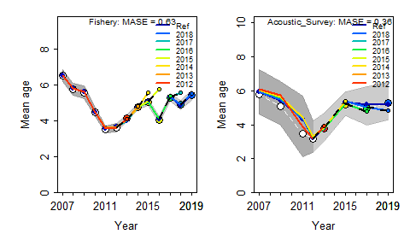

Hindcasting cross-validation (HCxval) results for mean lengths. Note that MASE values in brackets are adjusted MASE values for cases where naive predictions have a Mean-Absolute-Error below 0.1

SSmase(retroC.phk, quants = "age")  
   
 Computing MASE with all 7 of 7 prediction residuals for Index Fishery   
   
 Computing MASE with only 4 of 7 prediction residuals for Index Acoustic_Survey   
   
 Warning: Unequal spacing of naive predictions residuals may influence the interpretation of MASE   
   
 MASE stats by Index:  
 Index Season MASE MAE.PR MAE.base MASE.adj n.eval  
 1 Fishery 1 0.6319721 0.09063054 0.1434091 0.6319721 7  
 2 Acoustic_Survey 1 0.3556384 0.05181084 0.1456841 0.3556384 4

# 3 Model uncertainty

The management advice frameworks increasingly require translating the estimated uncertainty about the stock status into probabilistic statements (Kell et al. 2016). A classical example is the Kobe framework used in tuna Regional Fisheries Management Organisations (tRFMOs) around the world. The key quantities of interest are typically the ratios $SSB/SSB_{MSY}$ and $F/F_{MSY}$. It is reasonably straight forward in Stock Synthesis to approximate uncertainty of individual quantities (e.g. $SSB$ ) from the asymptotic standard errors (SE) derived from the Hessian matrix using the delta method. However, the joint distribution of $SSB/SSB_{MSY}$ and $F/F_{MSY}$  
requires to adequately account for the covariance structure between these two derived quantities. Joint distributions were typically constructed using bootstrap or Markov Chain Monte-Carlo (MCMC) methods. However, these methods can be computationally intense and time-consuming in integrated assessments.

As an alternative, ss3diags implements a rapid delta-Multivariate lognormal approximation with SSdeltaMVLN() to generate joint error distributions for $SSB/SSB_{ref}$ and $F/F_{ref}$,where the $ref$ may refer to $MSY$, but also other reference points (e.g., $SSB_{40}$ and $F_{40}$). In Stock Synthesis, these ratios are determined by the derived quantities Bratio and F, where either can take the form of ratios (e.g. $F/F_{ref}$ ) or absolute value (e.g. absF) depending on settings in the starter.ss file.

Let Bratio be $u=SSB/SSB_{ref}$, F be $v=F$, and $w=F_{ref}$ be the F reference point of interest (e.g. $F_{MSY}$ ), with $x=\text{log}(u)$, $y=\text{log}(v)$ and $z=\text{log}(w)$, then the variance-covariance matrix $VCM$ has the form:

$$VCM_{x,y,z}=\left(\begin{matrix}σ_{x}^{2} & cov_{x,y} & cov_{x,y} \\ cov_{x,y} & σ_{y}^{2} & cov_{y,z} \\ cov_{x,z} & cov_{y,z} & σ_{z}^{2}\end{matrix}\right)$$

where, e.g., $σ_{x}^{2}$ is the variance of $x$ and $cov_{x,y}$ is the covariance of $x$ and $y$. Deriving those requires conducting a few normal to lognormal transformations. First, the variances are approximated as:

$$σ_{x}^{2}=\text{log}\left(1+{\left(\frac{SE_{u}}{u}\right)}^{2}\right)$$

where $SE_{u}$, $SE_{v}$ and $SE_{z}$ are the asymptotic standard error estimates for $u=SSB/SSB_{ref}$, $v=F$ and $z=F_{ref}$.

The corresponding covariance for $x$ and $y$, can then be approximated on the log-scale by:

$$COV_{x,y}=\text{log}\left(1+ρ_{u,v}\sqrt{σ_{x}^{2}σ_{y}^{2}}\right)$$

where $rho_{u,v}$ denotes the correlation of $u$ and $v$.

To generate a joint distribution of $\tilde{u}$ = $SSB/SSB_{ref}$, $\tilde{v}$ = $F$ and $\tilde{z}$ = $F_{ref}$, a multivariate random generator is used, which is available in the R package ‘mvtnorm’, to obtain a large number (e.g. nsim = 10,000) iterations, such that

$$JD(\tilde{u},\tilde{v},\tilde{w})=\text{exp}(MVN(μ_{x,y,z},VCM_{x,y,z}))$$

so that

$$\tilde{SSB}/{\tilde{SSB}}_{MSY}=\tilde{u}$$

and

$$\tilde{F}/{\tilde{F}}_{MSY}=\tilde{v}/\tilde{w}$$

The reference points depend on the settings in the starter.ss file that determine the derived quantities Bratio and Fvalue.

In the first example, we consider the ss3sma Stock Synthesis model, which was run with starter.ss settings that are common to produce target Kobe plot estimates of $SSB/SSB_{MSY}$ and $F/F_{MSY}$ in tRFMO assessments:

2 # Depletion basis: 2=rel SPBmsy; 3=rel X*SPB_styr; 4=rel X*SPB_endyr

2 # F_report_basis: 0=raw_F_report; 1=F/Fspr; 2=F/Fmsy ; 3=F/Fbtgt

To generate a joint MVLN of $SSB/SSB_{MSY}$ and $F/F_{MSY}$, the default options can be used.

mvln = SSdeltaMVLN(ss3sma, run = "SMA")  
   
 starter.sso with Bratio: SSB/SSBMSY and F: (F)/(Fmsy)

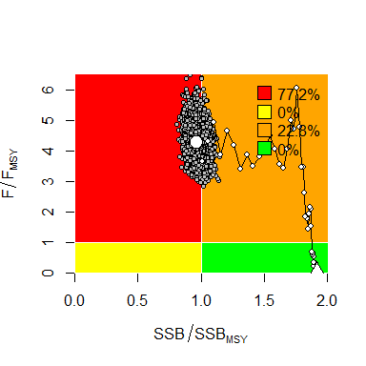

Kobe phase plot showing MVLN Kobe probability distributions of $SSB/SSB_{MSY}$ and $F/F_{MSY}$ for North Atlantic shortfin mako Stock model.

We provide the function SSsettingsBratioF(ss3sma) to the starter.ss settings:

SSsettingsBratioF(ss3sma)  
 $Bratio  
 [1] "SSB/SSBMSY"  
   
 $F  
 [1] "(F)/(Fmsy)"  
   
 $Bref  
 [1] 0.4

This function is also inbuilt in the SSdeltaMVLN() to prevent misleading results. The SSdeltaMVLN() output include the maximum likelihood estimates (mles) and the MVLN monte-Carlo distributions $kb of $SSB/SSB_{MSY}$, $F/F_{MSY}$ and $F$. Note the additional quantities $SSB$ and $Rec$ are generated independently from lognormal distributions for practical reasons. These can be plotted by

sspar(mfrow = c(3, 2), plot.cex = 0.7)  
SSplotEnsemble(mvln$kb, ylabs = mvln$labels, add = T, verbose = F)

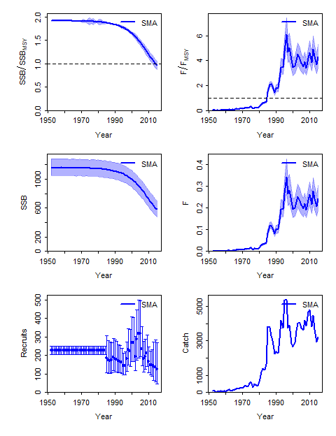

Distributions of $SSB/SSB_{MSY}$, $F/F_{MSY}$, $SSB$, $F$,Recruitment and Catch trajectories for the North Atlantic shortfin mako SS3 model

The SSdeltaMVLN() provides the option to set alternative Fref values, but this is only possible for the recommended starter.ss option 0 for F_report_basis. For option 2, SSdeltaMVLN() prompts an error if Fref is changed.

By comparison, the Pacific Hake base case model ss3phk is run with settings that are common in NOAA assessments, with Bratio set $SSB/SSB_{0}$ and F is typically kept at absolute quantity.

1 # Depletion basis: 2=rel SPBmsy; 3=rel X*SPB_styr; 4=rel X*SPB_endyr

0 # F_report_basis: 0=raw_F_report; 1=F/Fspr; 2=F/Fmsy ; 3=F/Fbtgt

The management quantities in this case are $SSB/SSB_{40}$ and $F/F_{spr40}$, where the target of 40% is specified in the forecast.ss file.

0.4 # SPR target (e.g. 0.40) 0.4 # Biomass target (e.g. 0.40)

mvln = SSdeltaMVLN(ss3phk, run = "Pac.Hake", Fref = "SPR", plot = TRUE)  
   
 starter.sso with Bratio: SSB/SSB0 and F: _abs_F

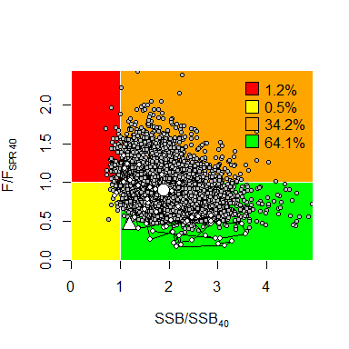

Kobe phase plots showing MVLN Kobe probability distributions of $SSB/SSB_{40}$ and $F/F_{SPR40}$ for North Atlantic shortfin mako Stock model.

sspar(mfrow = c(3, 2), plot.cex = 0.7)  
SSplotEnsemble(mvln$kb, ylabs = mvln$labels, add = T, verbose = F)

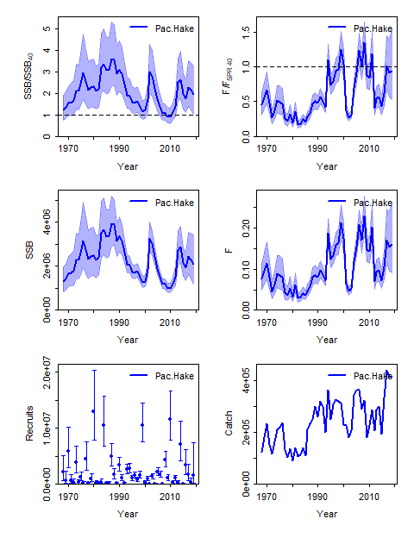

Distributions for $SSB/SSB_{40}$, $F/F_{SPR40}$, $SSB$, $F$, Recruitment and Catch trajectories for the Pacific Hake SS3 model

It is important to note that MVLN approximation differs notably from MCMC posterior for this model as documented in [Stewart et al. (2013)](https://www.sciencedirect.com/science/article/abs/pii/S0165783612002081) and [Taylor et al. (2021)](https://www.sciencedirect.com/science/article/abs/pii/S0165783621000527). Such differences may be more likely to occur in cases where key parameters such as steepness $h$ or natural $M$ are estimated using informative priors, which can result in left skewed (non-lognormal) distributions of the benchmarks $F_{ref}$ and $B_{ref}$.

In other instances, mismatches between theSSdeltaMVLN and MCMC may also be caused by the latter’s poor performance due to poor regularization [(Monnahan et al., 2019)](https://academic.oup.com/icesjms/article/76/6/1477/5475859?login=true).

To facilitate a comparison between the SSdeltaMLVN() and MCMC outputs, we provide the function SSdiagsMCMC(), which is illustrated on the example of the Stock Synthesis model for the ICES Gulf of Bothian Herring stock [(ICES, 2021)](https://www.ices.dk/sites/pub/Publication%20Reports/Stock%20Annexes/2021/her.27.3031_SA.pdf).

SSdiagsMCMC() requires loading both the report.sso and MCMC output in the posterior.sso file, where the MCMC was in this case run in the subfolder of the assessment file /mcmc.

# Alread loaded to ss3diags  
ss3her = SS_output("gob_her")  
mcmc.her = SSreadMCMC("gob_her/mcmc")

The options and output of SSdiagsMCMC() are largely identical to SSdeltaMVLN. In this case, the starter.ss is the same as for ss3phk, only we use Fref = “Btgt” for illustration with $SB_{50}$ and $F_{SB50}$ for this illustration.

mvln = SSdeltaMVLN(ss3her, Fref = "Btgt", plot = F, run = "mvln")  
   
 starter.sso with Bratio: SSB/SSB0 and F: _abs_F   
   
mcmc = SSdiagsMCMC(mcmc.her, ss3her, Fref = "Btgt", plot = F, run = "mcmc")  
   
 starter.sso with Bratio: SSB/SSB0 and F: _abs_F

Comparing delta-MVLN with MCMC simply requires combining the $kb outputs by, e.g.,

sspar(mfrow = c(1, 1), plot.cex = 0.8)  
SSplotKobe(rbind(mvln$kb, mcmc$kb), joint = F, xlab = mvln$labels[1], ylab = mvln$labels[2],   
 fill = F)

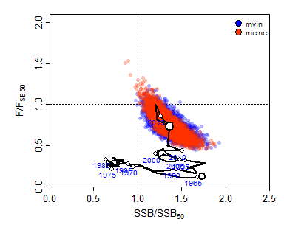

Kobe phase plot comparing MVLN and MCMC posterior distributions of $SSB/SSB_{50}$ and $F/F_{50}$ for the ICES Gulf of Bothia Herring SS3 model

Quadrant Percent  
 1 Red 0.08002401  
 2 Orange 2.97089127  
 3 Yellow 0.01000300  
 4 Green 96.93908172

sspar(mfrow = c(2, 2), plot.cex = 0.7)  
SSplotEnsemble(rbind(mvln$kb, mcmc$kb), ylabs = mvln$labels, add = T, subplots = c("stock",   
 "harvest", "SSB", "F"), verbose = F)

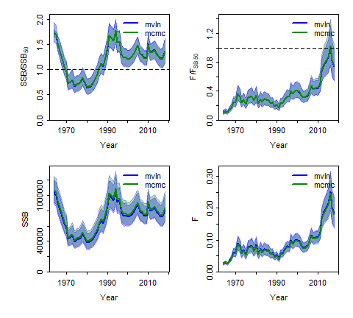

Comparison of MVLN and MCMC posterior distributions for $SSB/SSB_{40}$, $F/F_{SB40}$, $SSB$ and $F$ for the ICES Gulf of Bothia Herring SS3 model

This works equally for joining a model ensemble.

# 4 Cookbook Recipies

## 4.1 Retrospectives with hindcasts

Retrospective analysis can be run for Stock Synthesis using the function r4ss::SS_doRetro() available in [r4ss](https://github.com/r4ss/r4ss). This setup of the retrospective analysis has the advantage that forecasts are conducted automatically given the catch. This makes it possible to apply retrospective forecasting and hindcast cross-validations of observations based on the same output.

library(r4ss)

Below is a step-by-step cookbook recipe for retrospective analysis in Stock Synthesis.

### 4.1.1 Step1: Identify restrospective period

Specify the range pf peels that will then determine the end.yr.vec of runs in r4ss::SS_doRetro()

start.retro <- 0 # end year of reference year  
end.retro <- 7 # number of years for retrospective e.g.,

### 4.1.2 Step 2: Identify the base directory

Specify the path directory that holds the folder with the base case run. In this case the Pacific Hake folder with a model folder `Reference_Run"

dirname.base = "C:/Users/henni/Dropbox/ss3diags_demo/PacificHake"  
run = "Reference_Run"  
  
model.run <- file.path(dirname.base, run)  
  
model.run

### Step 3: DAT and CONTROL files

Specify the names of the data and control files. Note these files are named differently from the DATA.ss and CONTROL.ss. In this case

DAT = "phk.dat"  
CTL = "phk.ctl"

The names of the DAT and CONTROL are declared on the top of the ’starter.ss`, e.g.

#C Hake starter file phk.dat phk.ctl

### 4.1.3 Step 4: Create a subdirectory for the Retrospectives

There are several ways to organize the retrospective output structure. First create a new subfolder for the retrospective runs output

dir.retro <- paste0(dirname.base, "/Retro_", run)  
  
dir.create(path = dir.retro, showWarnings = F)

Also create a subdirectory for the retrospective model folders

dir.create(path = file.path(dir.retro, "retros"), showWarnings = F)

then copy model run files to the new retrospective folder

file.copy(file.path(model.run, "starter.ss_new"), file.path(dir.retro, "starter.ss"))  
  
file.copy(file.path(model.run, "control.ss_new"), file.path(dir.retro, CTL))  
  
file.copy(file.path(model.run, "data.ss_new"), file.path(dir.retro, DAT))  
  
file.copy(file.path(model.run, "forecast.ss"), file.path(dir.retro, "forecast.ss"))  
  
file.copy(file.path(model.run, "SS.exe"), file.path(dir.retro, "SS.exe"))  
  
# Automatically ignored for models without wtatage.ss  
file.copy(file.path(model.run, "wtatage.ss"), file.path(dir.retro, "wtatage.ss"))

### 4.1.4 Step 5: Modify Starter.ss file

Modifying the Starter File helps to speed up model runs

starter <- readLines(paste0(dir.retro, "/starter.ss"))  
  
# [8] '2 # run display detail (0,1,2)'  
linen <- grep("# run display detail", starter)  
starter[linen] <- paste0(1, " # run display detail (0,1,2)")  
# write modified starter.ss  
write(starter, file.path(dir.retro, "starter.ss"))

### Step 6: Execute retrospective runs

Run the retrospective analyses using r4SS function r4ss::SS_doRetro Ideally, the runs should be done with Hessian to evaluate the retrospective trajectories with respect to the confidence interval coverage of the reference model.

r4ss::SS_doRetro(masterdir = dir.retro, oldsubdir = "", newsubdir = "", years = start.retro:-end.retro)

However, for larger models it might be desirable to shorten run times, by not inverting the hessian, using the option extras = "-nohess" (much faster)

r4ss::SS_doRetro(masterdir = dir.retro, oldsubdir = "", newsubdir = "", years = start.retro:-end.retro,   
 extras = "-nohess")

### 4.1.5 Step 7: Read SS_doRetro() output

retro.phk <- r4ss::SSgetoutput(dirvec = file.path(dir.retro, paste0("retro", start.retro:-end.retro)))

It is often useful to save the retro model runs as .rdata file for further processing with ss3diags, considering that reading the models with r4ss::SSgetoutput() can be quite time-consuming for more complex models.

save(retro.phk, file = file.path(dir.retro, "retro.phk.rdata"))

### 4.1.6 Step 8: Check

library(ss3diags)  
  
check.retro = r4ss::SSsummarize(retro.phk)  
 Summarizing 8 models:  
 imodel=1/8  
 N active pars = 237  
 imodel=2/8  
 N active pars = 237  
 imodel=3/8  
 N active pars = 237  
 imodel=4/8  
 N active pars = 237  
 imodel=5/8  
 N active pars = 237  
 imodel=6/8  
 N active pars = 237  
 imodel=7/8  
 N active pars = 237  
 imodel=8/8  
 N active pars = 237  
 Summary finished. To avoid printing details above, use 'verbose = FALSE'.  
sspar(mfrow = c(1, 1))  
SSplotRetro(check.retro, forecast = T, add = T, legendcex = 0.7, legendloc = "topleft")  
 Plotting Retrospective pattern

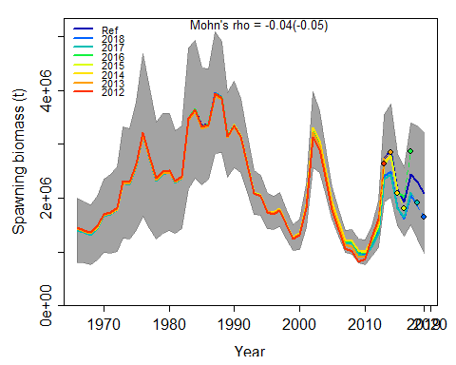

Mohn's Rho stats, including one step ahead forecasts:  
 type peel Rho ForecastRho  
 1 SSB 2018 -0.189511890 -0.21290187  
 2 SSB 2017 -0.138534518 -0.16468977  
 3 SSB 2016 0.048946154 0.17079324  
 4 SSB 2015 -0.017403026 -0.06301299  
 5 SSB 2014 -0.032761073 -0.03298098  
 6 SSB 2013 0.001623057 -0.01285596  
 7 SSB 2012 0.059944948 -0.03946034  
 8 SSB Combined -0.038242335 -0.05072981

## 4.2 R0 profiling

## 4.3 ASPM diagnostic

## 4.4 Jittering