REGISRTY

Whenever a user installs a software program/application, a hardware or a device driver for a newly connected hardware in a Windows based computer system, the initial configuration settings of these are stored as keys and values in a system defined, central hierarchical database repository called Windows Registry.

During the usage of the software or the hardware, the changes made to these configurations are updated in the registry.

Registry is a critical factor for stability, reliability and performance of a computer.

**Use**

The Microsoft **Registry Editor** (regedit.exe) enables you to view, search for, and change settings in your system **registry**, which contains information about how your computer runs.

**Purpose**

The Windows Registry serves as an archive for collecting and storing the configuration settings of Windows components, installed hardware/software/application and more.

### Location

In Windows NT based operating systems like Windows XP, 2000, and 2003, the Registry files are stored in the Windows\System32\Config folder. These files are named:

* Software;
* System;
* SAM;
* Security;
* Default; and
* UserDiff.

Apart from this, in the Documents and Settings folder corresponding to each user of the system, one more Registry file named NTuser.dat is stored.

The NTuser.dat file stores all the preferences/settings specific to the user. These settings will override settings default settings of the system when the user logs-in.

### Structure of the Windows Registry

The Windows Registry has a structure similar to Windows folders and files. Each main folder is named as a **Hive**. Each hive contains sub folders called **Keys**. These keys contain subkeys with configuration values for each software program/system component of the computer. There are five main Hives, whose descriptions are listed below:

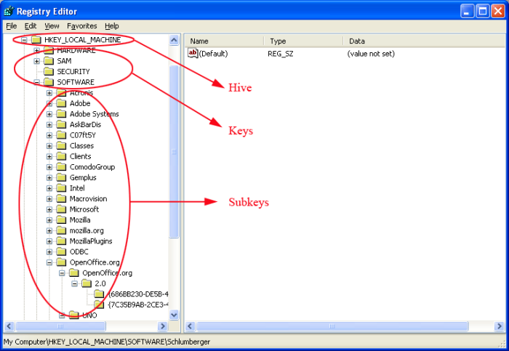

| **File Name** | **Associated Hive** | **Information Contained** |
| --- | --- | --- |
| Software | HKEY_LOCAL_MACHINE\SOFTWARE | Information about all the software items in the system, Windows performance parameters and the default Windows settings. |
| System | HKEY_LOCAL_MACHINE\SYSTEM | Information about all the hardware items in the system. |
| Sam | HKEY_LOCAL_MACHINE\SAM | Information about the Security Accounts Manager service. |
| Security | HKEY_LOCAL_MACHINE\SECURITY | Information about security. Neither of Security and SAM, can be viewed using Regedit, unless you reset the permissions. |
| Default | HKEY_USERS\.DEFAULT | Default user settings. But the Ntuser.dat file corresponding to the currently logged-on user overrides the default user settings. |
| Userdiff | Not associated with any hive. | Information about the corresponding subkeys in the HKEY_USERS Hive for each registered user. |

**Editing in windows registry**

* Add a new key.
* Add a new value.
* Rename a key or value.
* Change an existing value.
* Delete a key or value.

Back up the Registry.

1. Choose File→ Export.

The Export Registry File window appears.

1. Choose a location for the backup.
2. Type a name for the backup. Click Save.

Open the key containing the item you want to modify.

The higher authority tells you the key’s pathname. For example:

HKCUSoftwareMicrosoftWindowsCurrentVersionExplorerAdvanced

Start at the top level, the *hive.* Then open successive folders until you find the key you’re looking for. The key just mentioned contains numerous settings for Windows.

To create a new key:

1. Choose Edit→New→Key.

The new key appears, with its name (New Key #1) selected for editing.

1. Type the key’s name and press Enter.

The key is created, but it’s empty; it contains no values.