**CS5590 APS - Deep Learning Programming**

**ASSIGNMENT 1**

Abdoh Jabbari

**Introduction**

In this lab, we are going to use Logistic Regression which is two possible response whether yes or no, in binary 1 or 0. In this lab we are going to implement logistic regression in TensorFlow environment.

**Objectives**

Our objective in this lab is to practice deep learning, since we already did the same work in machine learning (numpy). We will implement Logistic Regression algorithm in TensorFlow to check the dataset and analysis it, then check the error, and optimize the result to increase the accuracy.

**Approaches/Methods**

In this lab the method is Logistic Regression in TensorFlow, and the steps used in building the model are:

* Importing TensorFlow
* loading the datasets
* Read the datasets and analyze it.
* Determining the number of features, and classes on the datasets.
* Defining variables and placeholders.
* Setting the parameters of the model.
* Training and testing the model.
* Optimizing to minimize the loss or error
* Printing the accuracy

**Datasets**

The datasets were loaded from the tf library, which is MNIST, this dataset has many resources with many explanations which was the easiest model to start with as a beginner in TensorFlow. The dataset is handwriting numbers which a good start for training and testing the image processing models in deep learning

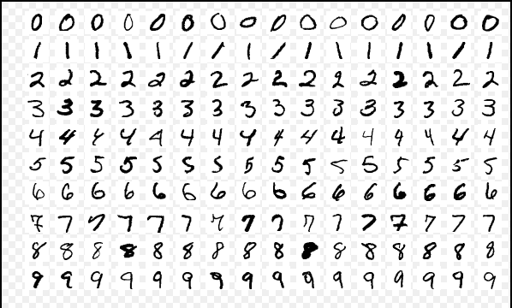

**Workflow**

The TensorBoard was used to show the code workflow as showing in the figure below.

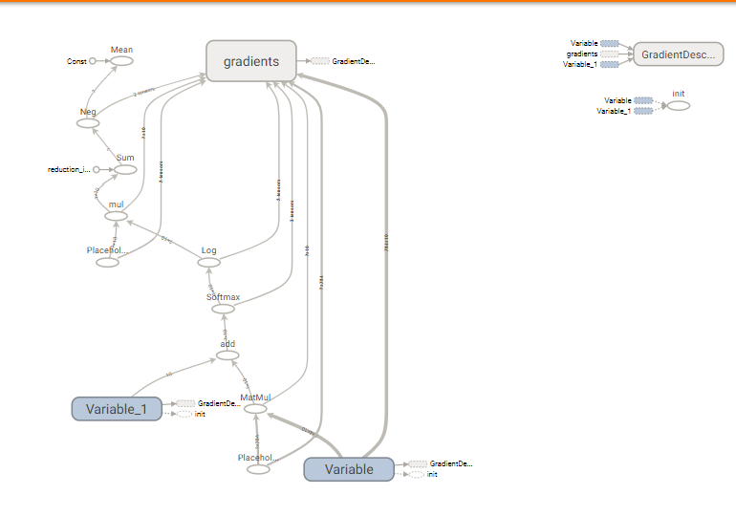

**Parameters**

The parameters in this lab was settled based on the datasets which loaded:

* Learning rate
* training epochs
* batch size
* display step

the parameters in our datasets are 28x28 =784, and the digit recognition is 0 to 9 which equal to 10 classes.

**Evaluation & Discussion**

During the model training the datasets and testing it, to minimize the error and optimize the loss, we modified the hyperparameters in the model and to reach the highest level of accuracy. The screenshots bellow is showing the accuracy increasing until it reaches 92%. To compare between the results, the highest accuracy values reached due the learning rate is high along batch size and training epochs.

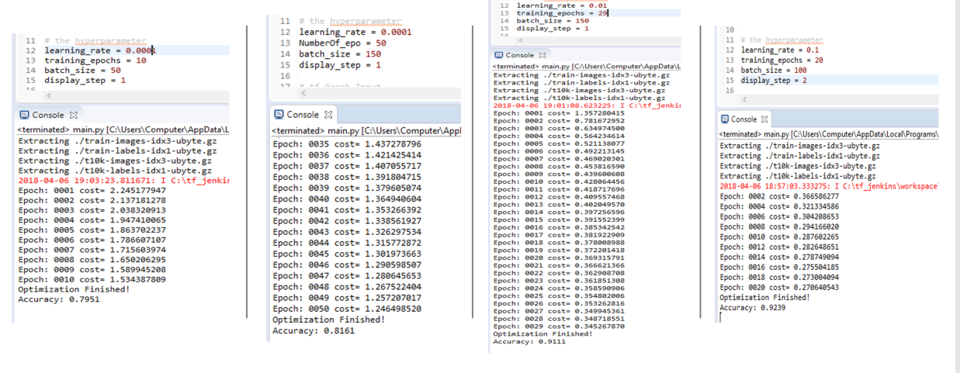

**Conclusion**

Implementing Logistic Regression in TensorFlow to load the datasets from the model library and analyzing it, training the model and testing it with the datasets, optimizing the error to get to higher accuracy. Sometime my system took ling time to run the model when changing the parameters

**References**

* <https://www.kaggle.com/niyamatalmass/logistic-regression-in-tensorflow-for-beginner/notebook>
* <http://machinelearninguru.com/deep_learning/tensorflow/machine_learning_basics/logistic_regresstion/logistic_regression.html>
* <https://www.kaggle.com/autuanliuyc/logistic-regression-with-tensorflow>
* <https://github.com/Kulbear/deep-learning-coursera>
* <https://machinelearningmastery.com/difference-between-a-parameter-and-a-hyperparameter/>