Welcome to ATM java project below are the

Artifacts for the project

Initial Project Run

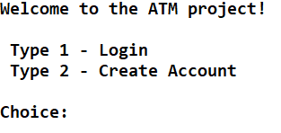

Case1:Login with wrong account number

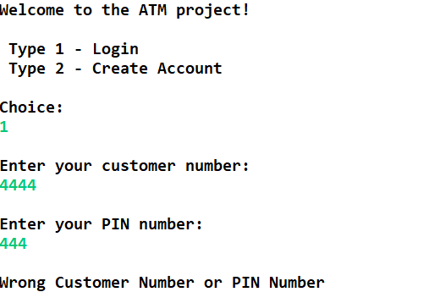

Case2: Entering wrong character

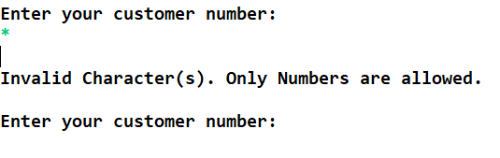

Case3:Entering first customer credentials

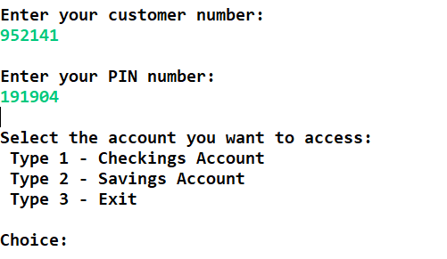

Case4:First customer checking account

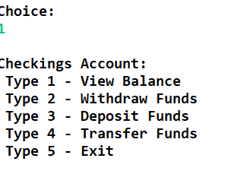

Case5:1st customer account balance

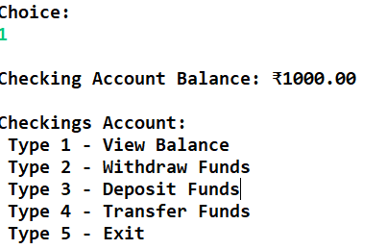

Case6:1st customer transfer Funds

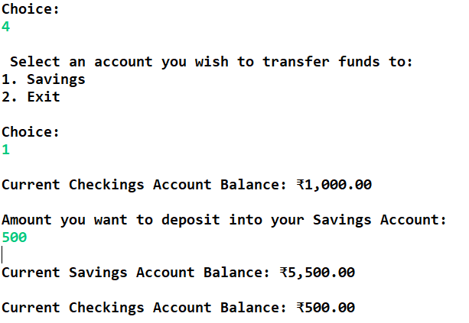

Case7:1st customer check withdraw-Funds

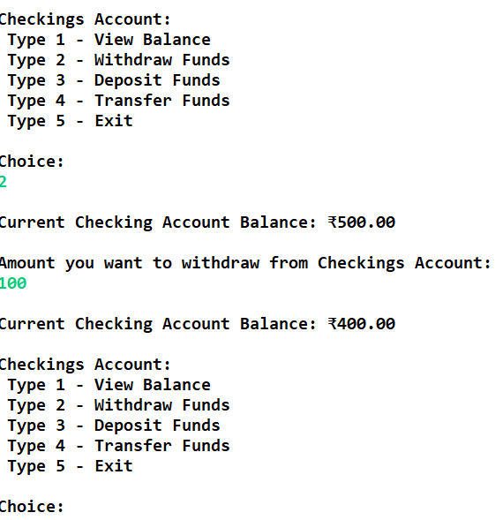

Case8:First customer check deposit Funds

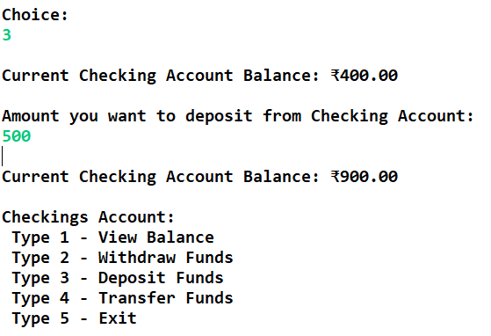

Case9:First customer check-Exit

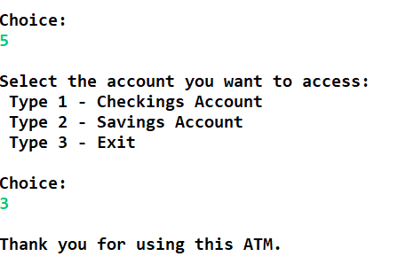

Case10:First customer saving acc view balance

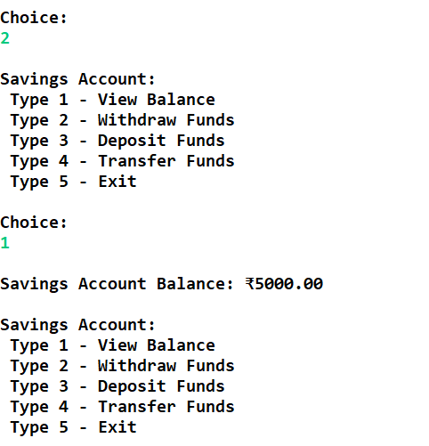

Case11:1st customer saving acc withdraw Funds

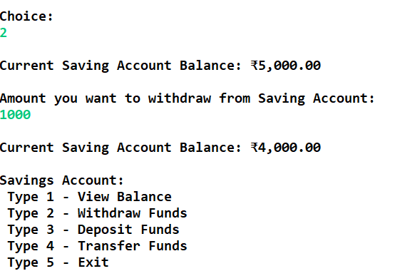

Case12:First customer saving acc deposit Funds

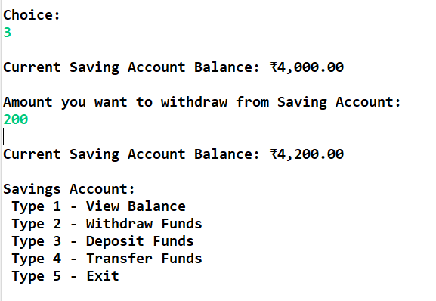

Case13:First customer saving acc Transfer Funds

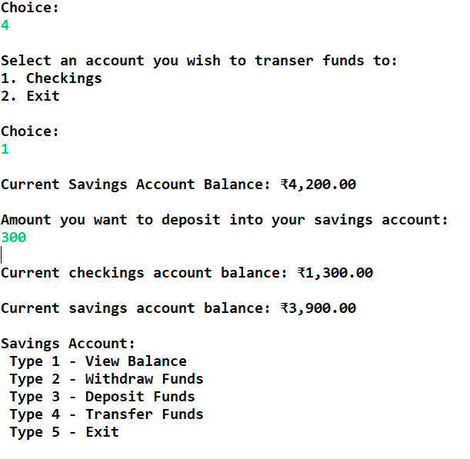

Case14:First customer saving acc exit

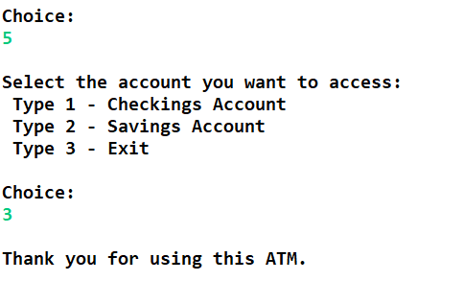

Case15:Login with wrong acc number

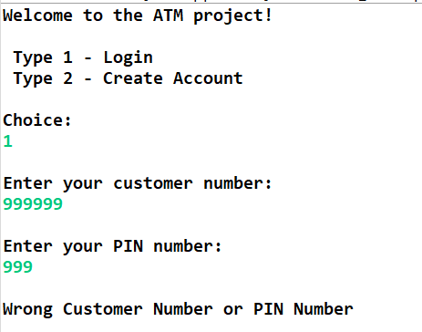

Case16:Entering wrong character

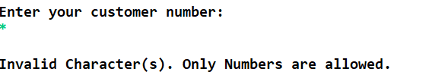

Case17:Entering second customer credentials

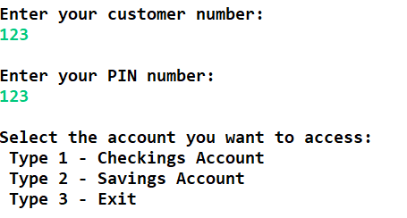

Case18:second customer checking account

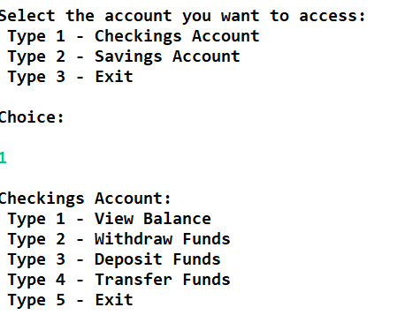

Case19:second customer acc balance

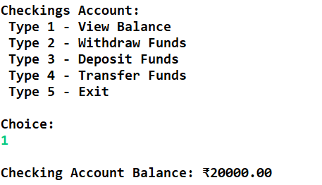

Case20:second customer Transfer Funds

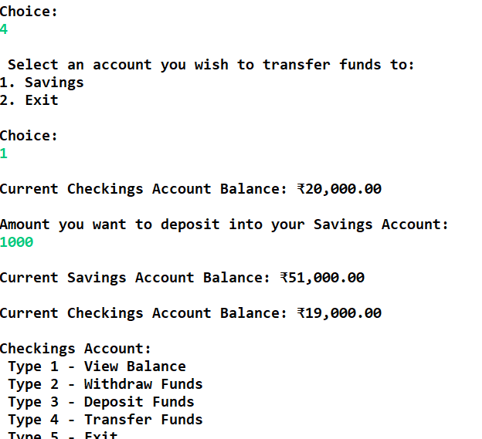

Case21:second customer check withdraw funds

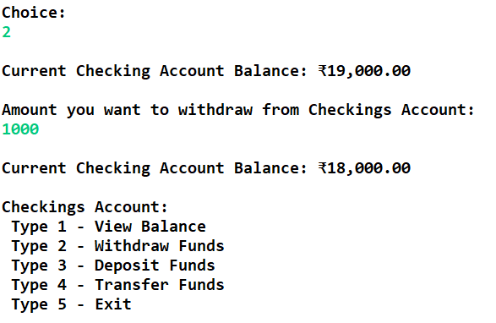

Case22:second customer check Deposit funds

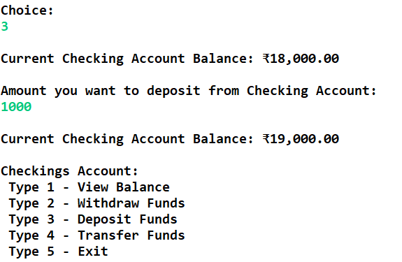

Case23:Second customer check exit

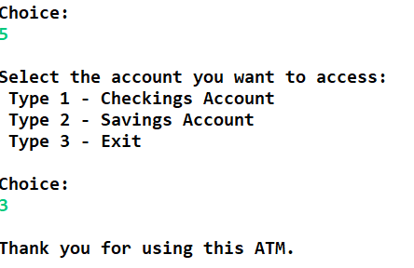

Case24:Second customer saving acc view balance

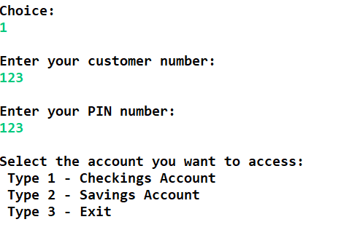

Case25:Second customer saving acc withdraw Funds

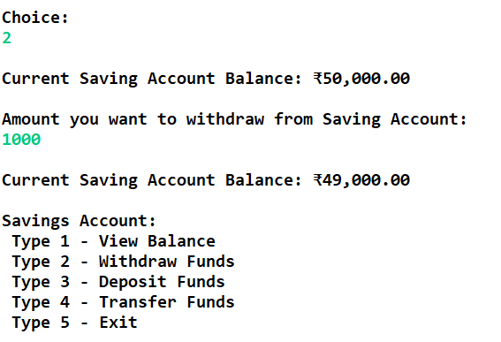

Case26:Second customer saving deposit Funds

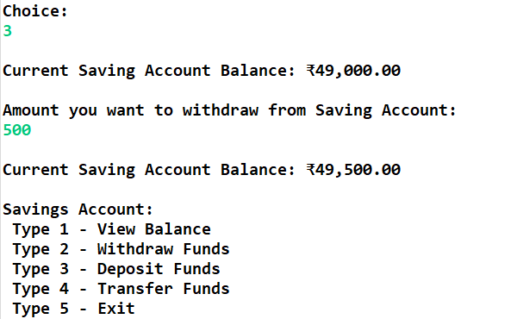

Case27:Second customer saving acc Transfer Funds

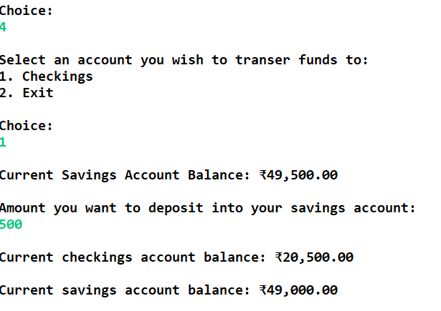

Case28:Second customer saving acc exit

