Abstract
The purpose of this report is to illustrate the schedulability of tasks dedicated to monitoring the flying condition of a small single engine aircraft. The aircraft monitoring system to be developed performs both time-triggered and event-triggered tasks. Different scheduling models have been examined while developing the system to come up with a reasonable solution. The aircraft engine, being discussed in this report, is equipped with sensors that are periodically polled by the software to check the validity of their readings against a predefined set of parameters limits. The smoke detection unit installed on the aircraft board is also monitored by the software.

Introduction:

Aircraft monitoring software is a real-time system developed to closely monitor the health conditions of the single engine aircraft and initiate actions, when required, based on analysis done by the software. The system is supplied with a CRT display and a keyboard for the pilot to interact with it. Temperature, pressure, and fuel level sensors are installed on the aircraft engine to provide the monitoring system with real-time measurement data. These sensors are polled by the monitoring system every one second to examine the validity of their readings against their predefined safe working ranges. A set of dials are driven by the system to display the actual readings of the engine temperature and pressure and fuel level sensors. Two smoke detectors onboard the aircraft are also monitored by the system.
A set of actions are initiated by the system when sensors readings are out of a safe operating range or smoke is detected. The type of action depends on how severe the readings of polled sensors are and the current status of the smoke detection unit. A time out signal is generated when a sensor fails to respond to a poll sequence. A warning lamp switches from green to red when one of the following scenarios happens: three consecutive readings from a sensor are out of a safe working range, three consecutive timed-out readings from a sensor, a smoke detection interrupt takes place, and when the fuel tank level drops to or below 10%. Besides, warning messages are displayed on the CRT stating out of limit readings from sensors or smoke detectors. An interrupt is generated when smoke is no longer detected by the smoke detection unit.
The pilot interacts with the system through the keyboard and the CRT display. He or she can request for sensor readings or measures calculated using a set of data collected from the sensors via the keyboard. The warning messages displayed on the CRT persist until the pilot acknowledges them via the keyboard. Upon acknowledging warning messages, the last request, by the pilot, should be displayed on the CRT. To check the functionality of the smoke detection unit, the pilot can request the system to simulate it.
The system is also supplied with a magnetic medium to store key data collected pre-flight, during flight, and post-flight. Sensors readings, for instance, tagged with date and time at which they are received are stored on the medium. In addition to that all smoke or no smoke interrupts are recorded on the medium. The figure above illustrates the functional requirements of the software developed
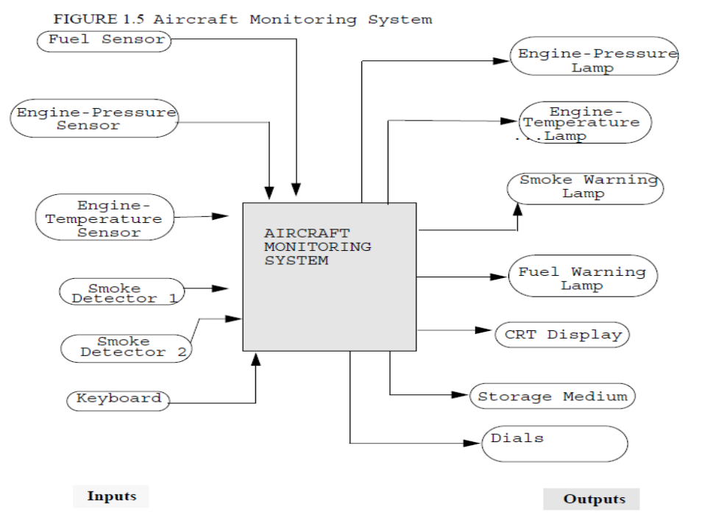
Figure 1. Aircraft monitoring system
Scheduling methodology:

The aircraft monitoring system is developed to schedule both periodic and aperiodic tasks. Different scheduling models have been tested to come up with a solution that ensures the tasks would meet their deadlines. Static-priority preemptive scheduling is commonly used in real-time systems. Thus, it has been chosen to be one of the models to be examined during the development phase of the monitoring system. The periodic tasks associated with the monitoring of the aircraft engine health are scheduled rate monotonically. Different approaches to this kind of scheduling have been adopted. The first being that the aperiodic tasks are assumed to appear within a large period of time and the second approach is to schedule them via a sporadic server of a period of 0.5 seconds and a budget of 0.3 seconds. Both kind of tasks along with interrupt handlers are illustrated as follows:
- Periodic Tasks
- Polling, testing, and sending sensors readings to dials.
- Updating the display.
- Keyboard inputs.
- Displaying readings, requested by the pilot, on the CRT.
- Aperiodic Tasks
- Switching the fuel level lamp from green to red.
- Switching the engine temperature lamp from green to red.
- Switching the engine pressure lamp from green to red.

- Interrupt Handlers
- Smoke detector interrupt.
- Smoke cleared interrupts.

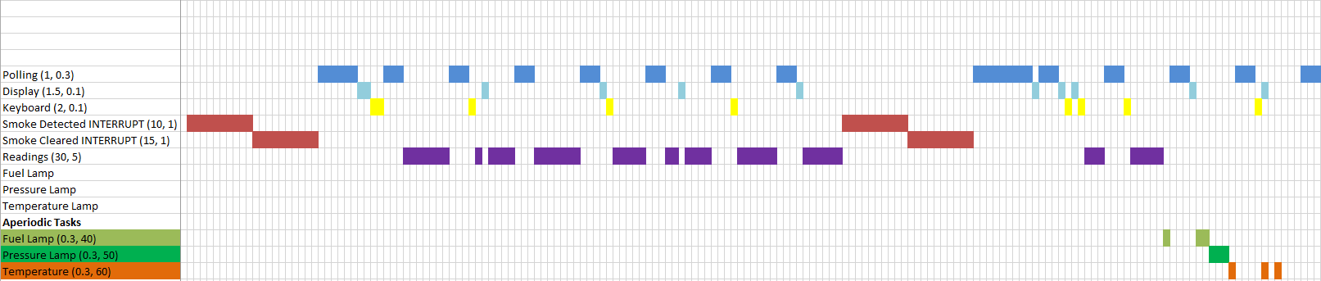
The first approach presumes aperiodic tasks would appear in the ready queue within a large period of time. To ensure schedulability, different periods and execution times have been assumed for each task. The periodic task of polling the sensors (collecting, processing and outputting the readings) has been assigned a period of 1 second and an execution time of 0.3 seconds. The periodic task of updating the display has been assigned a period of 1.5 seconds and an execution time of 0.1 seconds. The periodic task of using the keyboard by the pilot has been assigned a period of 2 seconds and an execution time of 0.1 seconds. The last periodic task which displays the measures calculated from the sensor data has been assigned a long period of 30 seconds to ensure that sensors’ data had already been gathered and processed, and an execution time of 5 seconds. Smoke detected and smoke cleared interrupts have been given periods of 10 and 15 respectively and an execution time of 1 second each. The aperiodic tasks of switching lamps to red in case of readings happen to be out of a safe operating range have been assigned periods of high values. The task of turning the fuel level lamp to red has been assigned a period of 40 seconds and an execution time of 0.3 seconds. The task of switching the lamp of the engine temperature to red has been assigned a period of 60 seconds and an execution time of 0.3 seconds. Finally the task of switching the engine pressure lamp into red has been assigned a period of 50 seconds and an execution time of 0.3 seconds. A Worst case scenario has been created for each scheduling model to check its feasibility, that is, all tasks are assumed to have arrived at the same time.
Timeline of the tasks scheduled according to the first model.

Task | Release Time | Execution time | Maximum Response Time
Smoke detected interrupt | 0 | 1 | 1
Smoke cleared interrupt | 0 | 1 | 2
Polling the sensors | 0 | 0.3 | 2.3
Updating the display | 0 | 0.1 | 2.7
Keyboard inputs | 0 | 0.1 | 2.9
Displaying the readings | 0 | 5 | 14.9
Switching Fuel level lamp | 0 | 0.3 | 15.6
Switching pressure lamp | 0 | 0.3 | 15.9
Switching temperature lamp | 0 | 0.3 | 16.7

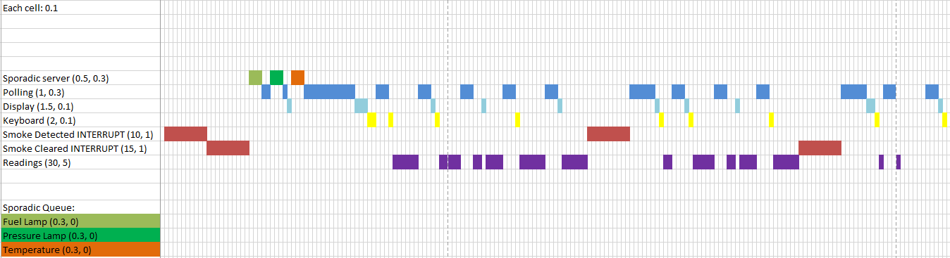
The second model is a static-priority preemptive scheduling using sporadic policy. The aperiodic tasks, in the first model, which are the ones responsible for illuminating the lamps have been considered as sporadic, in this model, because of their importance. Accordingly, a server of a period of 0.5 seconds and a budget of 0.3 seconds has been assigned to schedule them. Two different scenarios aimed at minimizing the response time of the tasks being scheduled, have been studied. In the first case study, both interrupts have been presumed to execute for one second each. As can be seen in the timeline, the response time of the tasks assigned to switch
Timeline of the tasks scheduled using the simple sporadic model.
the lamps has decreased by a large amount because of the priority assigned to the sporadic server.

Task | Release Time | Execution time | Maximum Response Time
Smoke detected interrupt | 0 | 1 | 1
Smoke cleared interrupt | 0 | 1 | 2
Polling the sensors | 0 | 0.3 | 2.9
Updating the display | 0 | 0.1 | 3
Keyboard inputs | 0 | 0.1 | 4.9
Displaying the readings | 0 | 5 | 17.4
Switching Fuel level lamp | 0 | 0.3 | 2.3
Switching pressure lamp | 0 | 0.3 | 2.8
Switching temperature lamp | 0 | 0.3 | 3.3

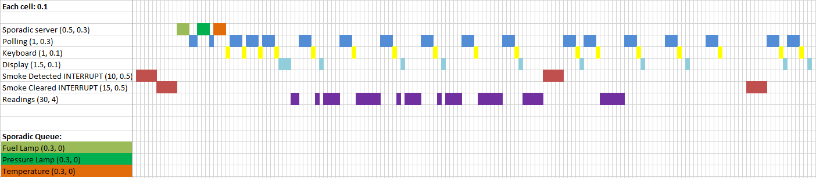
To minimize the response time of the periodic tasks, the execution times of the interrupts have been reduced by half; that is, by 0.5 seconds.
Timeline of the tasks scheduled using the simple sporadic model

Task | Release Time | Execution time | Maximum Response Time
Smoke detected interrupt | 0 | 0.5 | 0.5
Smoke cleared interrupt | 0 | 0.5 | 1
Polling the sensors | 0 | 0.3 | 1.9
Updating the display | 0 | 0.1 | 2.3
Keyboard inputs | 0 | 0.1 | 3.6
Displaying the readings | 0 | 4 | 12
Switching Fuel level lamp | 0 | 0.3 | 1.3
Switching pressure lamp | 0 | 0.3 | 1.8
Switching temperature lamp | 0 | 0.3 | 2.2

The timelines of scheduling the tasks clearly show that the first model results in increasing the response time of the tasks assigned to switch the lamps to unacceptable values. Due to the importance of these tasks, their response times must be decreased so that the pilot gets alerted as soon as there is an issue with one of the key monitoring parameters. To do so, these tasks have been assigned a sporadic server of a high priority so that they get served quickly. Indeed, the response times significantly decreased by a factor of 8. To reduce the response times of the tasks further, the execution time of both interrupts reduced to 0.5 seconds.

Real-life Application
After the theoretical analysis, we implemented the Aircraft Monitoring System into a C/C++ application targeted for the QNX Neutrino real-time operating system.
The Neutrino real-time system internally implements all the necessary functions needed to achieve predictable results by exposing an interface to manually set the priorities of our threads and select an appropriate scheduling scheme.
QNX Neutrino supports 3 scheduling algorithms: Round-robin, Sporadic and First-in First-out. Threads which are assigned higher priorities are guaranteed to preempt lower priority threads and real-time timers allow threads to be woken up in a periodic fashion.

Code
Legend for the following diagrams:
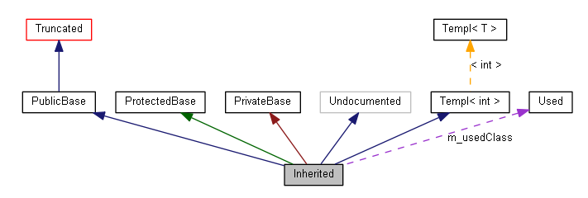

Overview of implementation:
Hierarchical object-oriented class definitions.
Thread for data simulation using random fluctuations.
Multiple threads for polling and handlers: keyboard, display, interrupt, readings. Timers were used for periodic tasks.
Mutexes to protect critical sections such as storage and display.
Interrupt handlers are given max priority to preempt everything.
Header definitions used to easily modify periods, executions, and priorities for the various tasks for testing all scenarios.
Note: A full-fledged class diagram with all member functions would be too large to include here. To get a better idea about the implementation and the functions, please refer to the headers in the code attached.
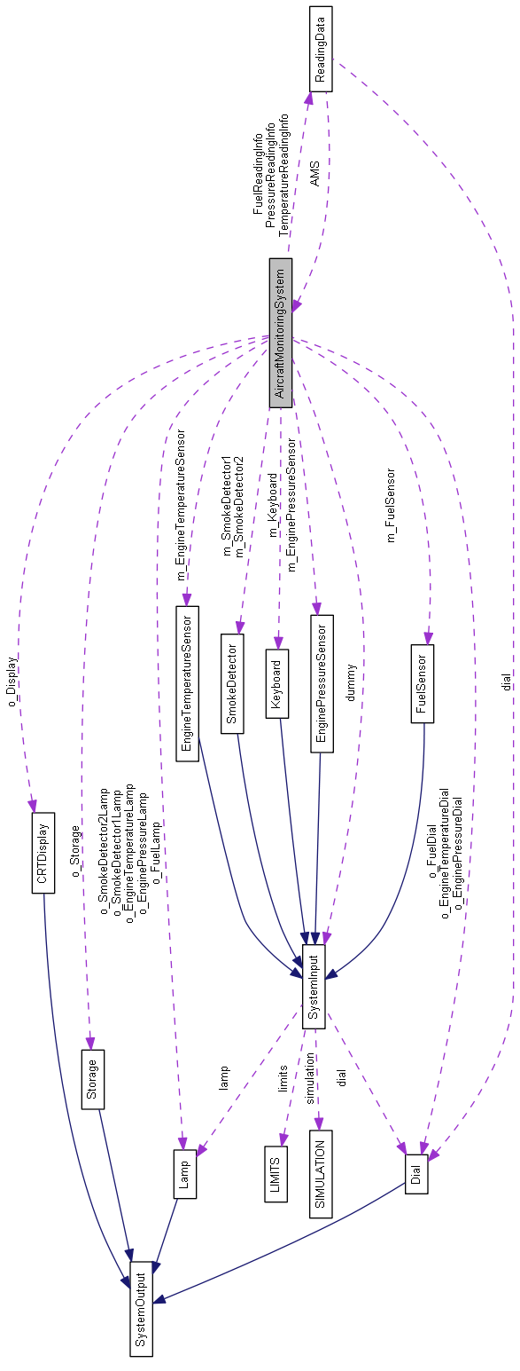
Class structure:
Collaboration Diagram for
AircraftMonitoringSystem:

Inheritance diagram for SystemInput:
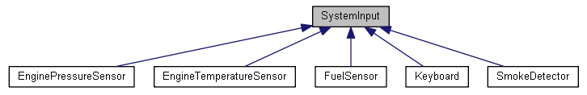
Collaboration Diagram for SystemInput:
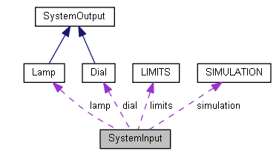

Inheritance diagram for SystemOutput:
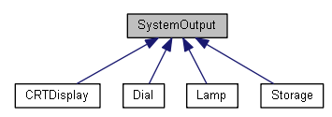

This flexible implementation allows a programmer to easily extend system inputs and system outputs by adding new derived classes for new different kinds of devices. The common interface also allows implementation of common functions to all inputs/outputs.

Display as seen by pilot:
Using the old-fashioned console, we created a persistent interactive display that updates in real-time.

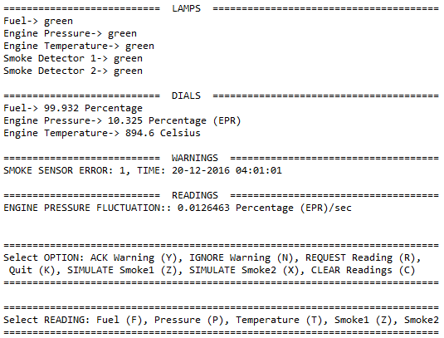

The following menu shows up when the pilot requests a reading:

Scenarios testing:
The program allows to manually adjust all the following key settings and similar specifications exist for the other inputs (engine pressure, temperature, etc..). The ResponseTime class is used to precisely calculate the response time of individual tasks under the different scenarios.

#define SCHEDULING_POLICY SCHED_RR /*Options: SCHED_RR SCHED_SPORADIC SCHED_FIFO*/
#define MAX_PRIORITY sched_get_priority_max(SCHEDULING_POLICY)
#define MIN_PRIORITY sched_get_priority_min(SCHEDULING_POLICY)
#define LOW_PRIORITY int(MAX_PRIORITY * 0.25)
#define MID_PRIORITY int(MAX_PRIORITY * 0.5)
#define HIGH_PRIORITY int(MAX_PRIORITY * 0.75)

#define SimulateData_PRIORITY MID_PRIORITY
#define DisplayHandler_PRIORITY MID_PRIORITY
#define KeyboardHandler_PRIORITY LOW_PRIORITY
#define PollSensors_PRIORITY MID_PRIORITY
#define DialAverageRateReading_PRIORITY LOW_PRIORITY /*all readings lumped together*/
#define InterruptHandler_PRIORITY HIGH_PRIORITY

//============================================
// Simulation Specifications
//============================================
#define SIMULATION_RATE 250 //milliseconds
#define VARIATION_PERCENTAGE 0.0005
#define MAGNETIC_MEDIUM_RESPONSE_TIME 200 //milliseconds
#define POLLING_PERIOD 1000 //milliseconds
#define DISPLAY_REFRESH_RATE 1000 //milliseconds
#define NUM_OF_READINGS 10
#define FREQUENT_FAILURES //1% chance to set danger values
#define INTERRUPT_EXECUTION_TIME 5000 //milliseconds

//============================================
// Fuel Specifications
//============================================
#define FUEL_UNITS "Percentage"
#define FUEL_INITIAL_VALUE 100 //Starting fuel: 100%
#define FUEL_LOWER_LIMIT 25
#define FUEL_UPPER_LIMIT 50
#define FUEL_DANGER_LIMIT 10
#define FUEL_FAILURE_CHANCE 10
#define FUEL_SENSOR_EXECUTION 300 //milliseconds
#define FUEL_CONSUMPTION_RATE 0.001
#define FUEL_TIME_MULTIPLIER 3600
#define FUEL_TIME_UNIT "hr"

class ResponseTime {
public:
std::chrono::steady_clock::time_point begin;
std::chrono::steady_clock::time_point end;
int response_time;
static std::vector<std::string> response_times;

ResponseTime();
void Start();
void Stop();
int Compute(std::string type);
};
Case study 1: A typical case (SCHED_RR)
Task | Priority Assigned
DisplayHandler | MID
KeyboardHandler | LOW
PollSensors | MID
DialAverageRateReading | LOW
InterruptHandler | HIGH

Parameter | Value
POLLING_PERIOD | 500 msec
DISPLAY_REFRESH_RATE | 500 msec
NUM_OF_READINGS | 10
INTERRUPT_EXECUTION_TIME | 5000 msec
FUEL_SENSOR_EXECUTION | 300 msec
ENGINE_PRESSURE_SENSOR_EXECUTION | 200 msec
ENGINE_TEMPERATURE_SENSOR_EXECUTION | 100 msec
SMOKE_SENSOR_EXECUTION | 100 msec
MAGNETIC_MEDIUM_RESPONSE_TIME | 200 msec

Input Event | Output Event | Response Time
Three consecutive sensor readings are out of the safe operating range. | Corresponding lamp switches to red.  Warning message is displayed on the CRT. | 5001 msec
Smoke is detected or no longer detected | Corresponding lamp is toggled.  Warning message is saved on magnetic medium and displayed on the CRT. | 5203 msec
Pilot requests simulation of smoke detection unit | (see above) | 5205 msec
Pilot acknowledges warning | The warning message disappears  Corresponding lamp switches back to green | ~0 sec
Pilot requests reading | Requested reading is displayed on the CRT screen. | 11001 msec (10 readings)

Acceptable response times given the parameters.
Case study 2: All equal priorities (simulating a non-RT OS)
Task | Priority Assigned
DisplayHandler | MIN
KeyboardHandler | MIN
PollSensors | MIN
DialAverageRateReading | MIN
InterruptHandler | MIN

Parameter | Value
POLLING_PERIOD | 500 msec
DISPLAY_REFRESH_RATE | 500 msec
NUM_OF_READINGS | 10
INTERRUPT_EXECUTION_TIME | 5000 msec
FUEL_SENSOR_EXECUTION | 300 msec
ENGINE_PRESSURE_SENSOR_EXECUTION | 200 msec
ENGINE_TEMPERATURE_SENSOR_EXECUTION | 100 msec
SMOKE_SENSOR_EXECUTION | 100 msec
MAGNETIC_MEDIUM_RESPONSE_TIME | 200 msec

Input Event | Output Event | Response Time
Three consecutive sensor readings are out of the safe operating range. | Corresponding lamp switches to red.  Warning message is displayed on the CRT. | 5003 msec
Smoke is detected or no longer detected | Corresponding lamp is toggled.  Warning message is saved on magnetic medium and displayed on the CRT. | 5205 msec
Pilot requests simulation of smoke detection unit | (see above) | 5207 msec
Pilot acknowledges warning | The warning message disappears  Corresponding lamp switches back to green | ~0 sec
Pilot requests reading | Requested reading is displayed on the CRT screen. | 11003 msec (10 readings)

A noticeable decrease in performance is noticed.
Case study 3: A typical case (SCHED_FIFO)
Task | Priority Assigned
DisplayHandler | MID
KeyboardHandler | LOW
PollSensors | MID
DialAverageRateReading | LOW
InterruptHandler | HIGH

Parameter | Value
POLLING_PERIOD | 500 msec
DISPLAY_REFRESH_RATE | 500 msec
NUM_OF_READINGS | 10
INTERRUPT_EXECUTION_TIME | 5000 msec
FUEL_SENSOR_EXECUTION | 300 msec
ENGINE_PRESSURE_SENSOR_EXECUTION | 200 msec
ENGINE_TEMPERATURE_SENSOR_EXECUTION | 100 msec
SMOKE_SENSOR_EXECUTION | 100 msec
MAGNETIC_MEDIUM_RESPONSE_TIME | 200 msec

Input Event | Output Event | Response Time
Three consecutive sensor readings are out of the safe operating range. | Corresponding lamp switches to red.  Warning message is displayed on the CRT. | 5002 msec
Smoke is detected or no longer detected | Corresponding lamp is toggled.  Warning message is saved on magnetic medium and displayed on the CRT. | 5206 msec
Pilot requests simulation of smoke detection unit | (see above) | 5233 msec
Pilot acknowledges warning | The warning message disappears  Corresponding lamp switches back to green | ~0 sec
Pilot requests reading | Requested reading is displayed on the CRT screen. | 11001 msec (10 readings)

These results are very similar to case 1.
There are too many combinations of executions and periods that can be tested via our program. For that reason, we focused the effort on comparing the different scheduling algorithms offered by the QNX neutrino.
All in all, the results are all very comparable and can all be considered acceptable because the differences were only in milliseconds. Milliseconds are generally an acceptable uncertainty although this is running on a very powerful desktop computer whereas embedded systems might not have as much resources.

Note: Under some combinations of execution times and periods, I have noticed pilot readings’ response time becomes unbounded. If you make the execution of the sensors too large for its period, because the readings have a lower priority, they never get completed.
To guarantee schedulability, we must appropriately select the periods and executions of the higher priority tasks and this needs to be done via theoretical analysis for the worst case scenario.

// MISSING “MODELS”?
// Missing explanation of budget choice
// MISSING ASSUMPTIONS!!! (ex: simulation done on powerful desktop (not on an embedded system with limited ressources, no context switching considered, made up numbers,
// Scheduling methodology: too much text, be concise…. (periods can be shown in table)
// Maybe mention that the time units used are relative, not necessarily seconds
// First picture doesn’t have “each cell: 0.1 units”
// MISSING: Discuss under what scenarios your scheduling protocol will guarantee the objectives and under what conditions it may fail to deliver its expected results.

Conclusion:
In the conclusion, the aircraft monitoring system has been built using the sporadic scheduling model. To ensure quick response times of the sporadic tasks, the period of the server has been chosen to be less than that of the periodic tasks. In case a critical instant for a periodic task happens that task will miss its deadline, however, because the periods of these tasks are very short the system will recover so quickly and the readings will get updated soon. Thus, infrequent deadline misses of these tasks are tolerable.

Appendix 1 – Headers

//=============================================================================
// AIRCRAFT MONITORING SYSTEM
//=============================================================================
class AircraftMonitoringSystem {
public:
AircraftMonitoringSystem();
~AircraftMonitoringSystem();

void Start();

static void *SimulateData_ENTRY(void *context);
static void *PollSensors_ENTRY(void *context);
static void *KeyboardHandler_ENTRY(void *context);
static void *DisplayHandler_ENTRY(void *context);
static void *InterruptHandler_ENTRY(void *context);
static void *DialAverageRateReading_ENTRY(void *context);

protected:
SystemInput dummy;

//SYSTEM INPUTS
FuelSensor m_FuelSensor;
EnginePressureSensor m_EnginePressureSensor;
EngineTemperatureSensor m_EngineTemperatureSensor;
SmokeDetector m_SmokeDetector1;
SmokeDetector m_SmokeDetector2;
Keyboard m_Keyboard;

//SYSTEM OUTPUTS
Lamp o_FuelLamp;
Lamp o_EnginePressureLamp;
Lamp o_EngineTemperatureLamp;
Lamp o_SmokeDetector1Lamp;
Lamp o_SmokeDetector2Lamp;

Dial o_FuelDial;
Dial o_EnginePressureDial;
Dial o_EngineTemperatureDial;

CRTDisplay o_Display;
Storage o_Storage;

//FUNCTIONS
void Initialize();
void* PollSensors(void);
void* SimulateData(void);
void* KeyboardHandler(void);
void* DisplayHandler(void);
void* InterruptHandler(InterruptData* reading_data);
void* FuelReading(void);
void* PressureReading(void);
void* DialAverageRateReading(ReadingData *reading_info);
void StartInterrupt(std::string msg, SystemInput* sensor, bool disp = true, bool save = false);

int MilliToMicroseconds(int msec) { return 1000 * msec; };
float RandomValue(const float current_value, const float initial_value, const float danger_value, float percentage);
float SmokeEvent();
void SetPriority(struct sched_param * param, std::string func_name = "");
template <typename T> std::string to_string(T value);

//DATA
bool SMOKE_SIM_1;
bool SMOKE_SIM_2;
bool READINGS_REQUESTED;

ReadingData *FuelReadingInfo;
ReadingData *PressureReadingInfo;
ReadingData *TemperatureReadingInfo;

pthread_t PollSensors_ID, SimulateData_ID, DisplayHandler_ID, KeyboardHandler_ID; /*readings_ID, interrupt_ID not needed: detached threads*/
struct sched_param PollSensors_PARAM, SimulateData_PARAM, DisplayHandler_PARAM, KeyboardHandler_PARAM, DialAverageRateReading_PARAM, InterruptHandler_PARAM;
};

//=============================================================================
// ResponseTime -- Used to compute the response time (milliseconds) of the handlers
//=============================================================================
class ResponseTime {

public:
std::chrono::steady_clock::time_point begin;
std::chrono::steady_clock::time_point end;
int response_time;

static std::vector<std::string> response_times;

ResponseTime();

void Start();
void Stop();
int Compute(std::string type);
};

#endif /* AIRCRAFTMONITORINGSYSTEM_H_ */

//=============================================================================
// SYSTEM INPUT
//=============================================================================
class SystemInput {
friend class SystemOutput;
friend class AircraftMonitoringSystem;

protected:
static SIMULATION simulation;
bool initialized;
bool ignore_errors;
bool message_sent;
std::string latest_error;
int num_consecutive_failures;
LIMITS limits;

Dial *dial;
Lamp *lamp;

protected:
SystemInput();

void AttachDial (Dial * d) { dial = d; }
void AttachLamp (Lamp * l) { lamp = l; }

void Initialize(float initial_value, LIMITS lim);
void SetLimits(LIMITS l);
int MilliToMicroseconds(int msec) { return 1000 * msec; }

bool SimulateExecution(int msecs, int timeout_chance);

void RemoveIgnore();
void ProblemDetected();
void ResetLamp();
void Acknowledge(bool ignore = false);
void ResetErrors();
void SendWarning(std::string msg);
std::string GetLatestError();
int FailureDetected();

template <typename T> std::string to_string(T value);
};

#ifndef _WARNING_
#define _WARNING_
struct WARNING {
SystemInput * sender;
std::string time;
std::string message;
};
#endif

//Derived classes of SystemInput below:

//=============================================================================
// FUEL SENSOR
//=============================================================================
class FuelSensor: public SystemInput {
friend class AircraftMonitoringSystem;

protected:

bool Poll();
};

//=============================================================================
// ENGINE PRESSURE SENSOR
//=============================================================================
class EnginePressureSensor: public SystemInput {
friend class AircraftMonitoringSystem;

protected:

bool Poll();

};

//=============================================================================
// ENGINE TEMPERATURE SENSOR
//=============================================================================
class EngineTemperatureSensor: public SystemInput {
friend class AircraftMonitoringSystem;
protected:

bool Poll();

};

//=============================================================================
// SMOKE DETECTOR
//=============================================================================
class SmokeDetector: public SystemInput {
friend class AircraftMonitoringSystem;

protected:

bool Poll1(float smoke = simulation.smoke1);
bool Poll2();

};

//=============================================================================
// KEYBOARD
//=============================================================================
class Keyboard: public SystemInput {
friend class AircraftMonitoringSystem;
protected:
char getChar();
char getConfirmation();

private:
void clearInputBuffer();

};

#endif /* SYSTEMINPUT_H_ */

//=============================================================================
// SYSTEM OUTPUT
//=============================================================================
class SystemOutput {
friend class AircraftMonitoringSystem;
friend class SystemInput;
protected:
std::string getTimeStamp();
int MilliToMicroseconds(int msec) { return 1000 * msec; }
template <typename T> std::string to_string(T value);
};

//Derived classes of SystemOutput below:

//=============================================================================
// DIAL
//=============================================================================
class Dial: public SystemOutput {
friend class AircraftMonitoringSystem;
friend class SystemInput;
public:

float measurement;
std::string unit_type;

void setUnit(std::string unit);
void setMeasurement(float measure);
float getMeasurement();
std::string printMeasurement();
};

//=============================================================================
// LAMP
//=============================================================================
class Lamp: public SystemOutput {
friend class AircraftMonitoringSystem;
friend class SystemInput;
public:
Lamp();
protected:
std::string color;

void setGreen();
void setRed();
std::string getColor();
};

//=============================================================================
// CRT DISPLAY
//=============================================================================
class CRTDisplay: public SystemOutput {
friend class AircraftMonitoringSystem;
friend class SystemInput;
protected:
std::vector<WARNING> warning_messages;
void send_warning(SystemInput* sender, std::string msg);
WARNING get_top_warning();
void erase_top_warning();

std::vector<std::string> readings_requested;
void send_reading(std::string);
void clear_readings();

void print_screen(std::string fuelColor, std::string pressureColor, std::string temperatureColor,
std::string smoke1Color, std::string smoke2Color, std::string fuelDialMeasurement,
std::string pressureDialMeasurement, std::string temperatureDialMeasurement, bool READINGS_REQUESTED);

void clear_screen();

private:
pthread_mutex_t warnings_mutex;
pthread_mutex_t readings_mutex;
};

//=============================================================================
// STORAGE
//=============================================================================
class Storage: public SystemOutput {
friend class AircraftMonitoringSystem;
friend class SystemInput;

protected:
std::queue<WARNING> magnetic_medium;
void save_warning(std::string msg);

private:
pthread_mutex_t mutex;

};

#endif /* SYSTEMOUTPUT_H_ */

