Day1
https://jimshaver.net/2015/02/11/decrypting-tls-browser-traffic-with-wireshark-the-easy-way/

TCPDUMP

- TCPDump can capture/parse large amounts of traffic
- TCPDump can be run without providing a display of captured
- -X provides Payload information (similar to the Hexadecimal/interpretation window in Wireshark
- Header information can be displayed at various levels of detail (verbosity) with -v, -vv, or -vvv
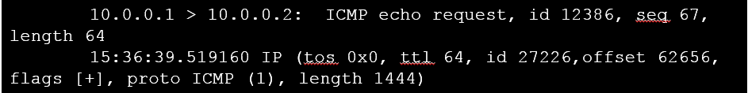

ACTIVITY TIME!
TCPDump Basics and Filters
What is Happening Here
Funny Traffic
Extracting Files

https://jimshaver.net/2015/02/11/decrypting-tls-browser-traffic-with-wireshark-the-easy-way/

TCPDUMP

- TCPDump can capture/parse large amounts of traffic
- TCPDump can be run without providing a display of captured
- -X provides Payload information (similar to the Hexadecimal/interpretation window in Wireshark
- Header information can be displayed at various levels of detail (verbosity) with -v, -vv, or -vvv

ACTIVITY TIME!
TCPDump Basics and Filters
What is Happening Here
Funny Traffic
Extracting Files

https://jimshaver.net/2015/02/11/decrypting-tls-browser-traffic-with-wireshark-the-easy-way/

TCPDUMP

- TCPDump can capture/parse large amounts of traffic
- TCPDump can be run without providing a display of captured
- -X provides Payload information (similar to the Hexadecimal/interpretation window in Wireshark
- Header information can be displayed at various levels of detail (verbosity) with -v, -vv, or -vvv

ACTIVITY TIME!
TCPDump Basics and Filters
What is Happening Here
Funny Traffic
Extracting Files

xfreerdp /v:<FloatingIP> /u:<username> /p:<password> /size:1920x1000 +clipboard

Acronym for Primary Data Units in the OSI Model: Data (x3) Segments Packets Frames Bit "Dad Did Declare Stupid People Feed Bears"

Data Link Layer - OSI Layer 2 - PDU: Frames
------------------------------------------------------
Dealing with MACs, Switches, Hubs
- Switches will attempt to prevent collisions, as every switch port is its own collision domain
- Hubs broadcast all traffic to all attached devices, and thus collisions are common

Ethernet Header – typically has 4 words
- Preamble
- 7 bytes of alternating 1s and 0s
- SFD - Start Frame Delimiter
- 1 byte delimiter that basically just announces the start of the Ethernet frame
- Ethernet Frame
- Destination MAC (6 bytes)
- Source MAC (6 bytes)
- Ethertype (Ethernet Type) (2 bytes)
- Common Ethertypes
- 0x0800 - IPv4
- 0x0806 - ARP
- 0x86DD – IPv6
- 0x08100 – VLAN tagging
- Payload (46-1500 bytes)
- FCS/CRC - Frame Check Sequence / Cyclic Redundancy Check (4 bytes)
- Used for Error Checking

802.1Q VLAN Tagging
- Basically, a 4 byte VLAN tag is placed in the Ethernet Header between the Source MAC and the Ethertype
- Tag Protocol ID - new "effective" Ethertype
- PCP/DEI - USed for QoS
- VLAN ID - identifies which VLAN the taffic belongs to
- Can’t apply a VLAN tag from a switch to a single machine, must be trunk line from router to switch or switch to switch

Network Layer - OSI Layer 3 - PDU: Packets
------------------------------------------
Deals with Layer 3 Switches and Routers

IPv4 Headers
- Ethernet Header has 20 bytes
- Last 2 bytes are the Ethertype code
- e.g. 08 00 IPv4, 08 06 APR, 86 dd IPv6

Fragmentation Process
- The MF states there are more fragments, when it hits 0 it says it’s the last fragment
- The Window size says how big each segment can be
- The fragment data is max window size minus 20 (for the header), and the offset is that number divided by 8
-e.g. if the max window size is 3300 bytes, and we subtract 20 for the ethernet header, that means each segment can have 3280 bytes. This number divided by 8 is 410, so the offset between each fragment is 410.
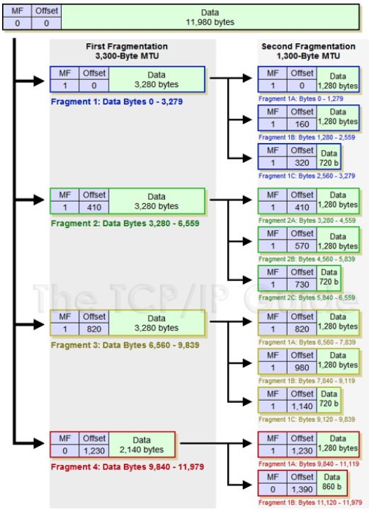
IPv4 vs IPv6 Header Field Comparison
- Type of Service (IPv4) becomes Traffic Class (IPv6)
- Total Length (IPv4) becomes Payload Length (IPv6)
- Time to Live (IPv4) becomes Hop Limit (IPv6)
- Protocol becomes Next Header
- Version, Source Addr, Destination Addr stay the same
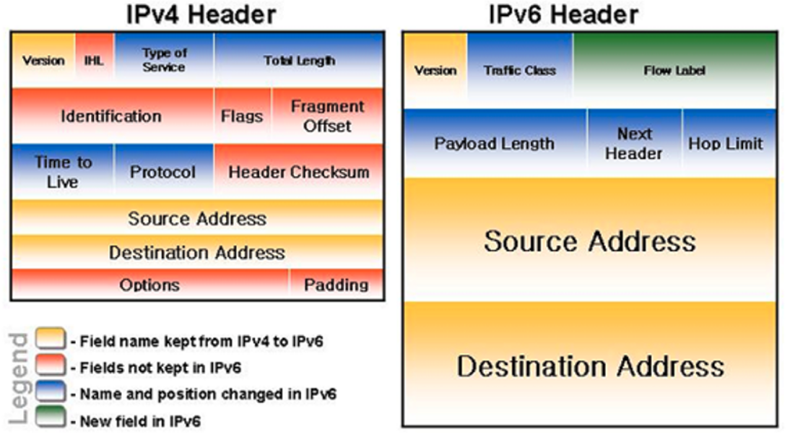
- IHL, Identifcation, Flags, Fragment Offset, Header Checksum, Options, and Padding all disappear in IPv6

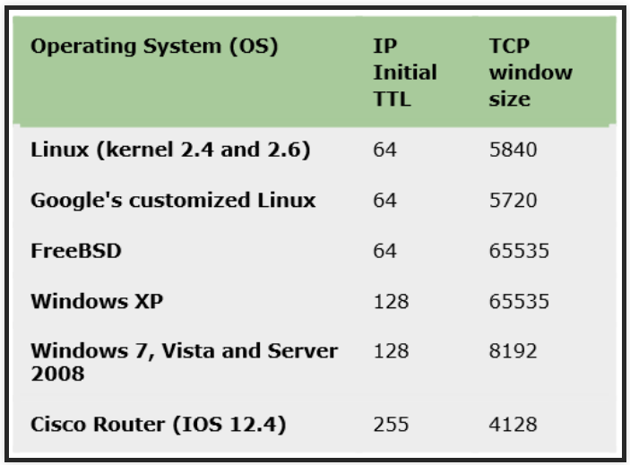
TTL – Time to Live - Generally standardized for specific manufacturers and OS

ICMP Headers
- Much smaller than IPv4 headers

APIPA – Automatic Private IP Address
- System generated when the DHCP server/service can’t be reached
- 169.254.x.x
SLAAC
RFC 4862

ICMP Codes
----------------

Transport Layer – OSI Layer 4 – PDU: Segment/Datagram
-----------------------------------------------------------------------
Transmission Control Protocol – Connection oriented
Universal Datagram Protocol – Connectionless

UDP vs TCP Headers
-------------------------

UDP
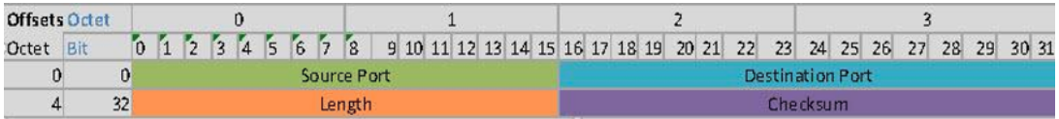
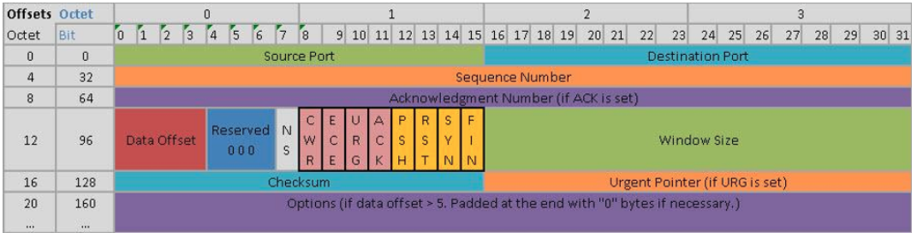
TCP

CWR Flag – Congestion Window Reduce
ECE Flag – Explicit Congestion notification Flag

Operating System Considerations
----------------------------------------
System Memory
- Kernel vs User Space
Sockets
- Families / Types
Tools/Interactions with Sockets

Network Namespaces
- A network namespace is logically another copy of the network stack, with its own routes, firewall rules, and network devices
- By default, a process inherits its network namespace from its parent. Initially, all the processes share the same default network namespace from the init process.

Day 2 – Network Reconnaissance

Reconnaissance
- Identify IP Addresses and Sub-domains
- Identify people
- Identify technologies
- Identify content of interest
- Identify vulnerabilities

Native Tools and Protocols
What do I have, and how can I get….
- DHCP Information
- Sniffing Network Traffic
- ARP Broadcasting to look for hosts
- Net View
- DNS Zone Transfer
  - Ls –d domain.com
  - Host –l domain.com
- DNS Lookups
  - Nslookup/dig, host
  - Set type= mx, ns
- Domain info
  - Grab list of domain controllers from last step for each domain.
  - nslookup -type=SRV _ldap._tcp.
- Traceroute/ping
  - –source route method
  - Route record (ping)
  - Fingerprinting based on response or ttl (see table)
  - firewalls
- Port Scan Known Subnets

OSINT
- Recon often begins with establishing a base of information via OSINT.

Social Engineering
- Pretexting
- Scarcity
- Authority
- Social Proof
- Sympathy
- Can be done via phone/email/in-person
- Mental Buffer-Overflow – layering loop until the subject can’t keep track of what they’ve said, and end up providing the desired information
- Use of questions – people are inherently trained to answer them as a language structure

Port Scanning
Nmap scanning
- host discovery run with root privileges
- can send/rcv raw packets/sockets
- host discovery run w/o root privilege
- can’t use raw sockets
- tries connect to ports 80 and 443
ICMP scanning
- can do ping sweeps, but these are very loud and usually blocked by OS/firewalls

What about IPv6?
- host address space is enormous, scanning prefixes would be out of the questions
- 64bit host space scan with 1 probe/s would take 5 billion years
- identifying address becomes critical
- can scan locally or remote via probe multicast all-node or link local

TCP Flags
- Illegal flag combination can be used to determine OS
- Xmas Tree scanning is one popular example (uses URG/PSH/FIN flags)
- Linux only sends RST if port is closed, no response if open
- Windows/Mac ALWAYS send RSTs if the TCP segment isn’t part of established connections
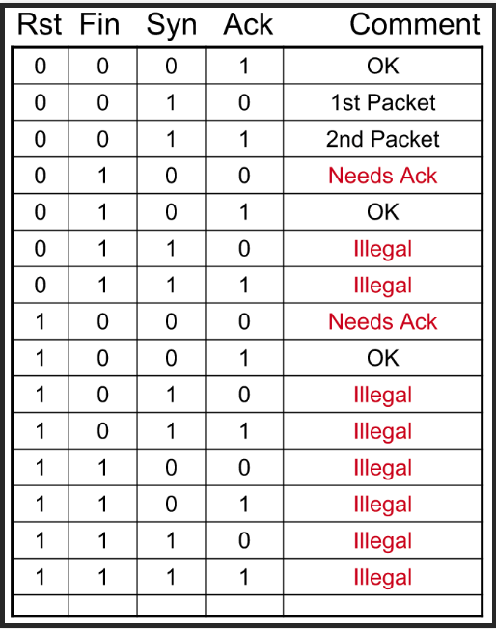

Router Security Concerns and Implications
- Enable password vs. Enable Secret – password is unencrypted, secret it is
- if enable password is done first, then it’s still unencrypted even after enable secret
- Finger Services
- Proprietary Protocols
- Can be used to identify devices or OS if they use proprietary protocols (e.g Cisco IOS)
- IP Gratuitous ARP – vulnerable due to the sheer amount of ARP info going out, but also prevents ARP cache poisoning
- IP Source Route
- Remote Access – Telnet or RDP – very vulnerable
- Logging

- Can use a program called Nipper to run a vulnerability analysis against a router configuration file.
- git clone git://git.kali/org/packages/nipper-ng.git
- nipper –ios-router –input <inputfile> --output=/<outputdirectory>

P0f for Fingerprinting – passive collection, don’t HAVE to be root
- P0f primarily looks at the TCP/IP header attributes to determine
- IP version
- Initial TTL
- IP Options
- MSS
- Windows size
- Window scale
- TCP Options
- Quirks (DF-Flag or IP ID)
- Payload class

Nmap
--scanflags <URG, FIN, etc>
- this flag allows us to put in whatever type of pings we want
- SYN, ACK,RST are not a stealth scan type
- Null, Xmas, or FIN scan are stealthy

Day 3

Movement, Redirection, and Data Transfer
--------------------------------------------------

Secure Copy Protocol (SCP) – travels across port 22
- To send a file from your local to a remote
- scp <path/filename> username@<IPADDR>:/<remote-directory-path>
- To receive a file from a remote to your local
- scp username@<IPADDR>: <path/filename> </local-directory-path>

Covert Channels – hiding information from control mechanisms by using established mechansims
- e.g. Steganography
- Protocol Headers – modulation, manipulation, options
- can only hold a limited amount of covert information due to size limitations
- Data Field
- can hold substantially more than the protocol headers
-e.g. ICMP allows you to write hex to the data portions with the -p switch

Botnets – another example of covert channel
- Used for Spamming, DDoS, Spyware, Viruses, Clickfraud, etc
- Master/Zombies
- Notorious examples: Conflicker, Zeus, TDL-4, Alureon, Mirai
- Commonly used protocol for C2:
- HTTP
- IRC
- UDP
- DNS over TCP
- Emphasis on making sure whatever channel is selected makes sense for the machine
- e.g. does it make sense to have a lot of DNS over TCP traffic if the machine isn’t a server?

Protocol Swapping – using known common protocols to hide devious action
- e.g. DNSCAT2 – encrypted C2 channel that goes over DNS that creates a tunnel between the master and zombie

Data Exfiltration
--------------------
Covertness – function of capacity of the medium/transmission rate
- the slower you go, the less obvious you are
Most common methods of data exfiltration:
- HTTP/HTTPS
- DNS
- FTP
- RDP
- SMTP/email
- SMB
- TOR
Techniques to help obfuscate the exfiltration
- Compression
- Encoding
- Encryption

File Transfer Basics
- STDIN – channel 0
- STDOUT – channel 1
- STDERR – channel 2
- Pipes
- FIFO in nature
- Can live longer than the process it facilitates
- Can use it for a pass-through in data transfers

Netcat
- Client to Listener file transfer
- Client (sends file)
- nc <TargetIP><Port> < <filename>
- Listener (receive file)
- nc -l -p <Port> > <newfilename>
- Listener to Client file transfer
- Listener (sends file)
- nc -l -p <Port> < <filename>
- Client (receive file)
- nc <ListenerIP> <Port> > <newfilename>

Netcat Relays – using 3 or more machines to communicate SEE THE ACTIVITY
- On Client Relay (relays info from Listener2 to Listener1)
- mknod {pipename} p
- nc {IPADDR_Listener2} {Port#2} > {pipename} | nc {IPADDR_Listener1} {Port#1} 0< {pipename}

- On Listener2 (sends info)
- nc -l -p {Port#2} < {filename}

- On Listener1 (receives info)
- nc -l -p {Port#1} > {newfilename}

Port Forwarding and Tunneling
------------------------------------
Tunneling is necessary to bypass firewalls and other defense mechanisms
- e.g. you’re at work, but you want to see a gambling website, how do you access that site?

Local Port Forwarding
- ssh -L {LocalPort}:{TargetIP}:{TargetPort} {PivotMachineUsername}@{PivotMachineIP} -NT
- e.g., ssh -L 1228:3.3.3.3:80 root@2.2.2.2 -NT
- This creates a tunnel from me to 3.3.3.3 port 80 by going thru 2.2.2.2
- once connected, open a browser, go to http://localhost:{LocalPort}, so http://localhost:1228
-For IPV6:
- ssh -L {LocalPort}:\[{TargetIPv6}\]:{TargetPort} {PivotUsername}@{PivotIP}
- We use the escape character and brackets around the TargetIPv6 primarily because the colons used to separate the port and target port from the IP will be perceived as part of the IPv6

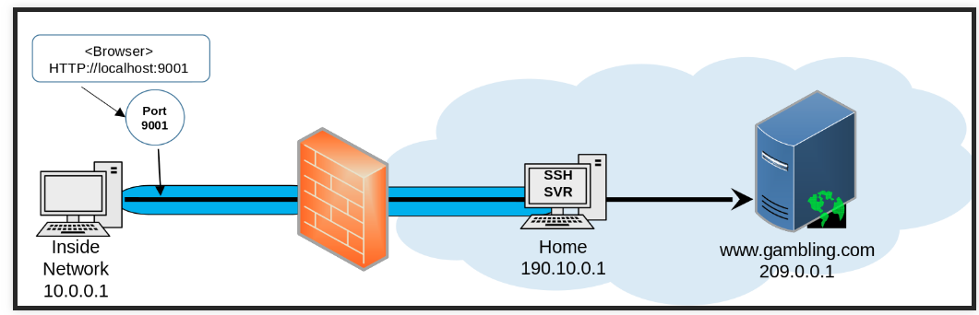

Tunnel within a Tunnel
- ssh -L {LocalPort}:{TargetIP}:22 {PivotUsername}@{PivotIP} -NT
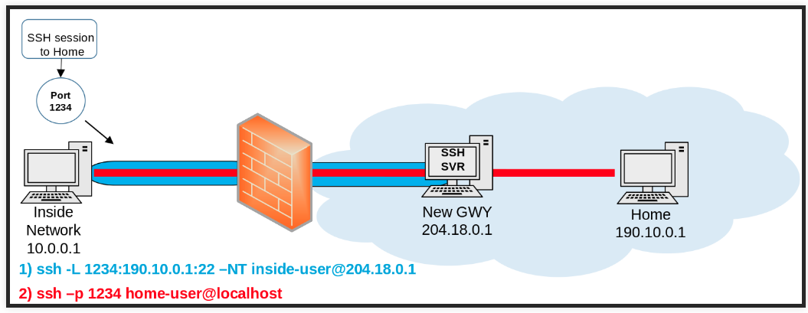
- then, ssh -p {LocalPort} {TargetUsername}@localhost

Tunnel within a Tunnel within a Tunnel – Tunnel Inception
- ssh -L {LocalPort}:{Gateway2IP}:22 {Gateway1User}@{Gateway1IP} -NT
- ssh -L {LocPort2}:{TargetIP}:22 -p {LocalPort} {Gateway2User}@locahost -NT
- ssh -p {LocPort2} {TargetUser}@localhost

Dynamic Port Forwarding
-------------------------------
- Dynamic Port forwarding over a a SSH tunnel
- Needs a “wrapper” to specify the endpoint. This can be proxy settings inside a browser, or a program like proxychains.

To conduct dynamic port forwarding:
- ssh -D {Port} {PivotUser}@{PivotIP} (Optional -p port) -NT
- The only time you’ll use the -p is if you’re creating a dynamic port forwarding after a series of local port forwards
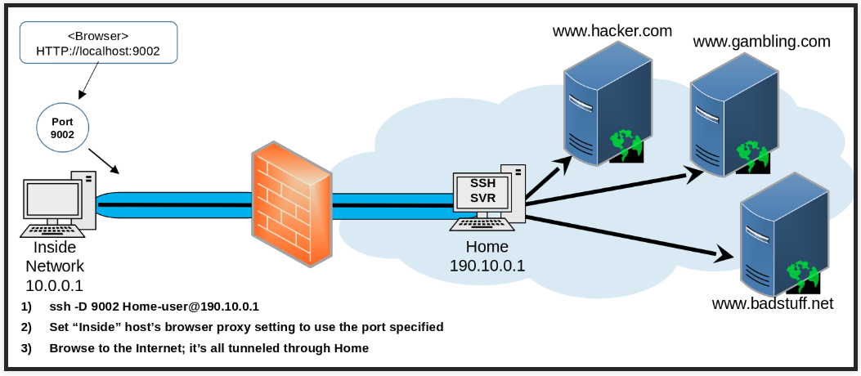
- ssh -p {port} {TargetUser}@{TargetIP}

ProxyChains
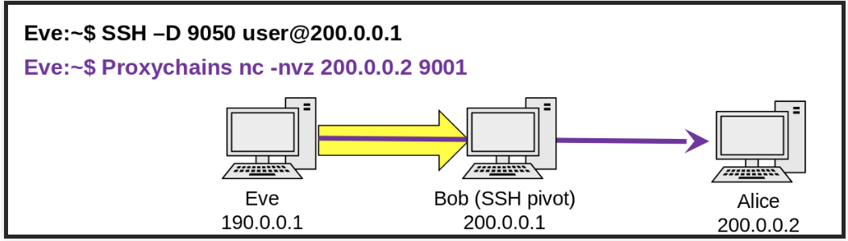
- Basically, a program that uses SSH forwarding to allow you to access and run TCP/IP programs on remote systems. Default uses port 9050.

Remote Port Forwarding
-------------------------------------
Basically, creating tunnels from the pivot box back to the attacker box and the target box
- (On Pivot Box) ssh -R {LocalPort}:{targetIP}:{targetport} {AttackerUser@AttackerIP} -NT
- e.g. ssh -R 1888:3.3.3.3:80 attacker@1.1.1.1 -NT
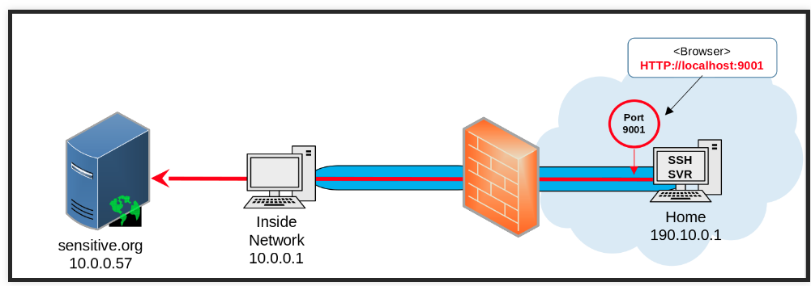
- (On Attacker Box) http://localhost:18888

Local AND Remote SSH Tunneling
-----------------------------------------
(On target computer) ssh -R {LocalPort}:localhost:{TargetPort} {PivotUser@PivotIP} –NT
(On attacker computer) ssh -L {LocalPort2}:localhost:{LocalPort} {PivotUser@PivotIP} -NT
(On attacker computer) http://localhost:{LocalPort2}
- could also execute proxychains or other attacks

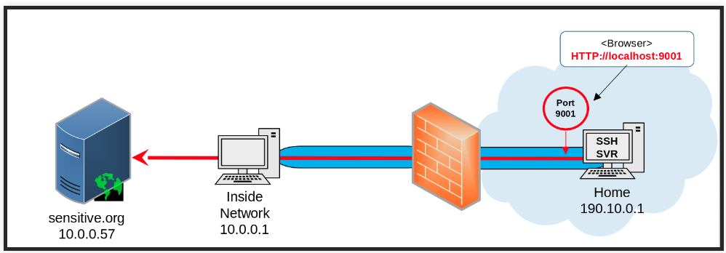

Day 4 – Watching The Wire

Network Sniffing Basics
--------------------------
Software vs Hardware Sniffing
- Hardware sniffers come in many forms, such as IDS/IPS/firewalls, or taps
- Software can be TCPdump or Wireshark
Mirrored Port vs Tap
- Mirrored ports are usually found on switches, where all traffic coming into the switch is copied and output on a mirrored port. This is also called Spanning. Mirrored ports are usually less complete and less efficient than Taps are, because they are limited in what the switch can output per port.
NIC Modes
- Promiscuous mode settings allow for all traffic to be captured on the NIC. In other words, it listens for any/all traffic, as opposed to only listening to traffic destined for that specific NIC address.

Wireshark
- Tool designed to view detailed traffic information in a graphical format
- Not well suited for large Pcaps
- Remote Capture (Windows only)
- Allows for packet capturing via WinPCAP on remote devices
- Connect remote interface on wireshar via <targetIP>:2002
- Can help with geo-location
- download databases from maxmind.com; Wireshark→Edit→Preference→Name Resoultion

- Analyzing and Decrypting Traffic
- Several different filtering tools available
- In particular, Analyze → Expert Information
- Can also carve out specific objects using File→Export Objects→ HTTP/SMB/etc
- Decrypting
- You must have the RSA keys that are used to decrypt SSL/TLS
- If Diffie-Hellman Ephemeral (DHE) or RSA ephemeral are used, the RSA keys are only used to secure the DH or RSA exchange, NOT also encrypt the data
- To decrypt, you can go Edit→Preferences→Protocols→SSL and you can add in keys, pre-master secret, or server’s private keys
- https://jimshaver.net/2015/02/11/decrypting-tls-browser-traffic-with-wireshark-the-easy-way/

TCPDump
- CLI-based packet capturing
- Really good at capturing/parsing large amounts of traffic
- -X provides payload information similar to Hexadecimal/interpretation window in Wireshark
- Header information can be displayed at various levels of detail with -v -vv -vvv

Day 5 – Filtering Network Traffic Outputs
--------------------------------------------------
Why Filter Outputs?
- Reduce resource consumption (CPU or storage)
- Limit scope of captured traffic
- Target traffic capture down to the bit!

How do I filter outputs?
- Programs like TCPDump can use built-in “Primitives” to help, and qualifiers like src or dst
- Primitives are user-friendly shortcuts to Berkeley Packet Filters, but they can NOT target traffic as granularly as a pure BPF

Berkeley Packet Filters (BPF)
- BPF allows a user-space program (like TCPDump or IPTables) to attach a custom filter onto any socket
- The filter code is sent directly to the kernel via the SO_ATTACH_FILTER option
- Libpcap is how this happens using TCPDump for example
- The libpcap internal compiler takes the user input filter and generates a structure that can be loaded via SO_ATTACH_FILTER to the kernel
- Everything done with byte code is counted FROM THE START of the ETHERNET HEADER
- byte code acronyms
- ldh = load header
- ldb = load byte
- jeq = jump equal to
- jt = true
- jf = false
- ret = return

Berkeley Packet Filter with Indexing
- tcpdump <HeaderType>[byte:#ofBytes] & mask condition
- HeaderType – e.g. ip
- byte – you specify the bytes you’re looking for
- mask – specify the mask you want to use to specify which bytes you want to pay attention to (1) and which ones you want to ignore (0)
- condition – add in =, >, <, !=
- if the mask is written in decimal the condition must also be decimal, or hex/hex
- BPF Examples
- IPV4 header where options are set
- tcpdump ‘ip[0:1] & 0x0F > 0x05
- tcp data offset less than 5
- tcpdump ‘tcp [12:1} & 0xF0 < 0x5
- tcp header where FIN and ACK are set, but any other flags are acceptable
- tcpdump ‘tcp[13:1] & 0x11 = 0x11
- Adding in combos
- tell me what ports are listening on the 10.2.0.0/24 network that returned a SYN and ACK flag
- tcpdump -nr <pcapfile> “(tcp[13] = 0x12) && (net 10.2.0.0/24)” | awk ‘{print $3}’ | cut -d . -f 5 | sort | unique

Flow Analysis
- netflow – proprietary design by Cisco, IP traffic ONLY, aggregates “flows” and sends statistics to a collection point for analysis
- sflow – industry standard, it is NOT restricted to only IP, can monitor interface statistics and performs sampling 1/n packets and sends to a collection point -- built into ASIC

Server Identification
- OS detection helps to determine what exploits could work on what vulnerabilities
- Back-porting – often vendors will take a fix/patch from a recent version of software and apply it to older versions

Signatures
- TTL – helps give us a good guess to the OS, see chart above
- DF bit – Don’t Fragment – only packet coming in this stream
- TOS – Type of Service bit
- IP identification numbers
- TCP Options (Window size/scale/MSS)
- Selective Acknowledgement, such as RFC 2018, which is commonly used by Windows and Linux, but not usually used by FreeBSD or Solaris

Fragmented Packet – the IP Identification number holds for all fragments IOT relate them, byte offset is represented as (data bytes/8)
Fragment Reassembly
- First – always accept the first value received for each offset in the packet
- Last – Always take the last value received for each offset in the packet
- BSD – this policy left-trims fragments to existing fragments with an offset; overlapping fragments with a greater offset are discarded or trimmed
- BSD-Right – same as BSD, except fragments are right-trimmed, so new fragments take precedence over those with a lesser or equal offset
- Linux – the Linux policy is almost the same as BSD, except existing fragments with = offset will be overwritten in part
- https://www.sans.org/reading-room/whitepapers/detection/ip-fragment-reassembly-scapy-33969
- Good graphic to explain reassembly

Packet Injection
- Edge and Core ISPs
- Used for censorship, advertising, malware or notifications
- Comcast released RFC in 2011 explaining their packet injection/redirection techniques

Network Monitoring
- IDS/IPS
- Packet analysis (wireshark/tcpdump)
- Log analysis
- Sensors

Day 6 – Network Exploitation

Cyber Threat Groups
- Nation State Threat
- Transnational Actor Threat
- Criminal Organization Threat
- Individual Actor or Small Group Threat

Cyber Threat Actors
- Cyber Criminals
- State Sponsored
- Hacktivist
- Insider Threats
- Partner

Cyber Threat Actions
- Malware – alters the state or function of a machine without the user’s consent
- Hacking
- Social Tactics
- Misuse
- Physical
- Error
- Environmental

Cyber Kill Chain (steps taken by a malicious actor)
- Reconnaissance
- Weaponization
- Delivery
- Exploitation
- Installation
- Command and Control
- Actions on the Objective

Cyber Methodology (steps we take as offensive cyber operators)
- Target Discovery – footprinting, scanning, enumeration, net mapping
- Fingerprinting/Enumeration – OS and Service Identification
- Port Scanning – Identify all ports available
- Gaining Access – Determine vulnerabilities to use, test tools in a controlled environment
- Privilege Escalation
- Post Exploitation – Target Survey, Remote Forensics, Data Collection, Establish Persistence
- Cover Tracks/Cleanup

Compromised Asset Characteristics
- Information Technology Assets – “Physical Assets”
- Hardware, Network Maps, Storage Media, Design Specs, VPNs, and People
- Critical Information Assets - “Intellectual Assets”
- Intellectual Property, Product Development Info, Business Plans, Policies, etc.

Credentials
- Commonly stolen
- Social Engineering, reusing stolen passwords and/or shared credentials, brute force
- Stolen credentials provide the adversary with
- Remote access
- Admin/Domain Admin Credentials
- Need to be audited
- Should require secondary approval prior to altering or auditing log files
- Access Controls
- Behavioral analysis
- Context Awareness
- Multi-factor authentication

Network Attack Strategies
- Social Engineering
- Phishing, Whaling, Watering Hole, Baiting, Pretexting
- DoS/DDoS
- Ping Flood, Ping of Death, SYN Flood, Smurf Attack
- Injection
- Web-based (SQL, XSS, File Inclusion), Code (SQL, XSS), Process (DLL)
- Network Infrastructure Based
- MitM, Session Hijacking, Spoofing, Buffer Overflow, Bluetooth
- Malware
- Adware, Viruses, Worms, Polymorphic
Internal vs External Exploitation
- Internal
- Less common, more options, harder to detect, can reach more assets
- External
- Most common, easily detected, often guarded against

Exploit Components
- Techniques
- the goal is to divert the execution of the vulnerable program
- Payload
- Shellcode
- Types: Local and Remote

Privilege Escalation
- Types
- Vertical - “get root”
- Horizontal - “swap from one regular user to another”
- Methods
- Dump the SAM file
- Retrieve /etc/passwd and crack it with JTR,etc
- Weak permissions on processes
- Sensitive Information in Shared Folders

Persistence
- Allows for continued and future access to the exploited target by bypassing normal restrictions
- Netcat – can be setup as a service, listening on a specified port eternally
- Meterpreter – metsvc is the Windows service that Meterpreter creates on Windows
- Registry – setup on boot services or keys

Exfiltration
- Very commonly done via outbound connections, making it hard to counter at the perimeter
- Common protocols used: HTTP/HTTPS, FTP, and DNS blends into normal outbound network traffic, making it hard to detect the specific data being exfiltrated
- In band – Point to Point communication (e.g. SCP or FTP GET)
- Out of Band – Adds an additional 3rd point to obfuscate the attacker
- e.g. Data leaves target system, goes to a server, then attacker takes it from the server, no direct link between attacked target and attacker

Collateral Effects
- Accidental
- When the attacker makes a mistake
- Attributed Actions, which could lead to criminal charges
- Loss of tools
- War
- Purposeful
- Effects wanted by the attacker
- Data is leaked
- Identity Theft
Day 7 – ICS/SCADA

Information Technology vs. Operational Technology
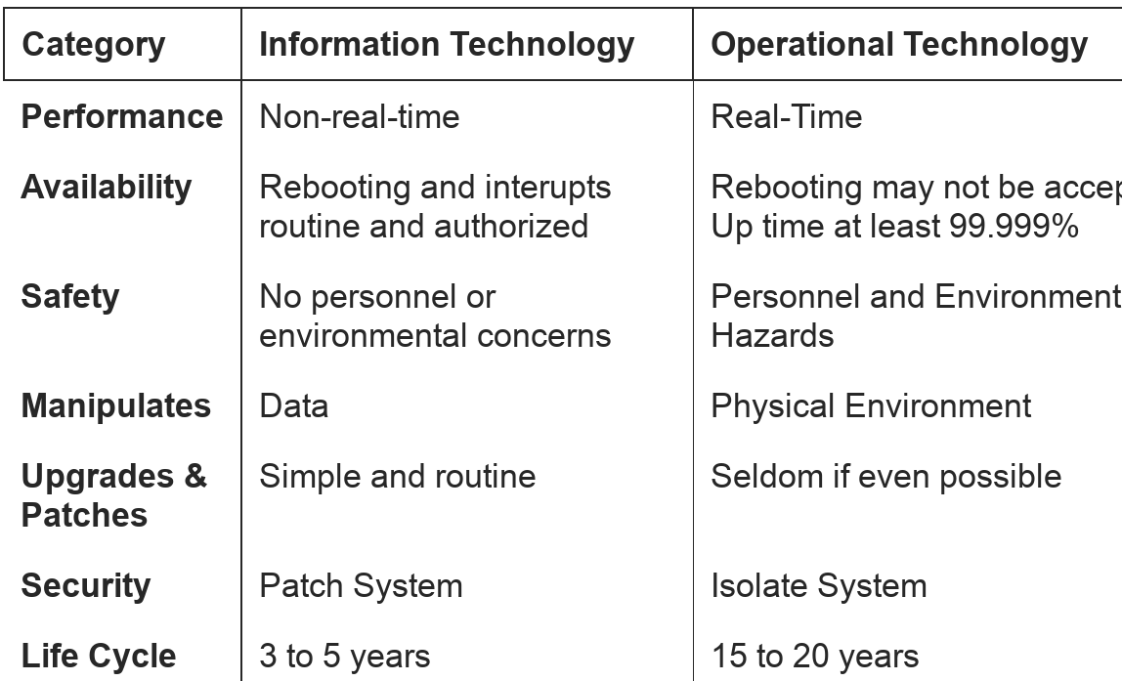

- Examples of OT – Nuclear Plants, Electrical Grids, Critical Infrastructure

Industrial Control System Hardware Components
- Human Machine Interface
- Controllers
- Analog Relays – Pneumatic devices that use air or gas to operate
- Programmable Logic Controller – Digital control units
- Microcontroller – smaller form factor digital controllers that can make small changes
- Remote Terminal Unit – Connected back to the master control unit, but at endpoints of the network, provides remote access
- Intelligent Electronic Device – Hardened microcontroller on remote sites, conducts endpoint control functions to help minimize the amount of SCADA traffic between the Master Control Unit and endpoints
- Controlled Process – the machines that perform functions, the dam gates, pumps, etc
- Sensors – report back on specified conditions, e.g. location, pressure, temperature, etc.
- Data Historians – Servers that log SCADA traffic
- Engineering Workstation – where sensors and devices can be reprogrammed
- Supervisory Workstation

Control System Operation
- Control Theory
- Open Loop Control
- The HMI sends command to the PLC, who sends it to the Controlled Process who conducts the Command
- Closed Loop Control
- The HMI sends to a PLC, who sends to the Controlled Process which conducts the Command, BUT NOW the sensor sends feedback back to the PID Controller
- PID Controller
- Sum of:
- Proportional – current value
- Integral – average of all past values
- Differential – current rate of change in value
- Basically, the sensor sends feedback back… and the PID compares the current value to the commanded value of a variable, and makes additional commands automatically to the PLC to make the Controlled Process match the commanded value.

ICS Software and Programming
- Controllers often don’t have operating systems
- They run single programs written for the specific application. These programs are uploaded from the engineering workstation to the controller.
- ICS Programming Languages
- Ladder Diagram – Looks like a Ladder
- Function Block Diagrams – Think Vista diagram with colored blocks and nodes
- Sequential Flow Chart – Similar to Function Block, but basically allows for loops back
- Structured Text – Basically, looks like a regular program but without a formal language
- Very Similar to C
- Instruction List – Series of instructions
- Very similar to Assembly
- C
- Assembly

Real Time Operating Systems (RTOS)
- The more powerful controllers will use RTOS that are lightweight OSs optimized to handle real time and deterministic functions
- Examples
- Windows Embedded
- Blackberry QNX
- Blackberry’s solution for embedded HMI and controller
- VXWorks
- Has both an integrated HMI and controller

ICS Industrial Control Applications
- Distributed Control Systems
- Multilevel control across a LAN
- Automotive manufacturing, Printing Plants, Chemical Plants, Water Treatment facility
- Supervisory Control and Data Acquisition
- Multilevel control across a WAN
- Electrical Grid, Pipelines, Railroad Systems, Traffic Lights
- Process Control Systems
- A subset of Distributed Control Systems
- Usually focuses on Refineries, Chemical Treatment Plants
- Building Management System
- Access Control Systems, Automated Backup Power, Fire Suppression, HVAC
- Energy Management Systems
- Automated Lighting systems, can work with HVAC
- Industrial Internet of Things
- Heavy Machinery, Transportation, Smart Cities
- Mesh connected networks, usually wireless

Common ICS Protocols
- Industrial Control Network Protocols
- Use a combination of proprietary and open standard protocols
- MODBUS – older and insecure, widely used across hundreds of vendors, NO SECURITY
- OPC and OPC Unified Architecture are used to bridge between IT and OT networks. OPC is very insecure
- Distributed Network Protocol 3 (DNP3) – used in the electrical grid
- Ethernet/Industrial Processes – on Layers 5-7, implements Common Industrial Protocol over both TCP and UDP. Primarily used on Distributed Control Systems.
- PROFIBUS/PROFINET – Layer 2 protocol used between Controllers, Sensors, and Actuators

ICS Security
- Functionality
- Profit
- Legal Compliance
- Personnel Safety
- Environmental Impact
- Security
ICS Security Priorities
- While the traditional priorities follow the CIA triad, ICS reverses it and adds safety
- So, Safety, Availability, Integrity, and Confidentiality

ICS Functional Zones
- Purdue Model
- Enterprise Zone, Manufacturing Zone (that contains Cell/Area Zone), and Safety Zone
- Enterprise IT Zone – Levels 4-5
- Normal IT infrastructure connected to the internet
- Level 5 – Corporate HQ – usually offsite
- Level 4 – Where the IT and Supervisory personnel work onsite
- Supervisory Manufacturing Zone / OT Zone – Levels 0-3
- Level 3 is Site Manufacturing, Data Historians, and Engineering Workstations
- Cell/Field Zone (subset of Manufacturing zone)
- Level 2 is Area Supervisory Control – HMIs
- Level 1 is Basic Control – Process Controllers
- Level 0 is Sensors and Actuators
- Safety Instrumented Systems Zone
- Hot and Cold Site type mentality; Instructions for dealing with catastrophic failures

Day 8 – Network Filtering

Firewall Basics
- Routed Mode
- Firewall can conduct some routing, but Routed Mode means the firewall is seen as a hop along the route
- Transparent Mode
- “Bump in the Wire” - the firewall does not show up as a hop along the route
- Whitelist vs Blacklist logic
- Whitelist means “block everything except what I specifically say is allowable”
- Blackslist means “allow everything except what I specifically say is denied”
- Where/how to arrange firewalls in Enterprise Topology?
- Answer is based on what your network needs are
- Host-based versus Network-based Firewalls
- Host-based: IPTables, Windows Defender
- Network-based: pfSense, etc
- Three Techniques of Filtering
- Packet Filtering: Layer 3 – looking at IP Header, least-resource heavy
- Stateful Inspection: Layer 4 – looking at TCP or UDP header
- Application level Gateway: Layer 7 – looking at protocols and ports, and application- specific data, most-resource heavy

Fire Walking – probing the firewall to see what blocking rules are in place, what ports are open, etc.
- Use ICMP, UDP, or TCP packets to test whether ports/protocols are allowed through filtering devices
- Incrementing TTL – TTL expirations trigger ICMP “TTL exceeded” replies
- Defense – block outgoing ICMP time exceeded packets at the perimeter or use NAT to hide all internal network addresses

Traceroute Tricks
- Traceroute uses ICMP (Windows) and UDP (Linux)
- On Linux, options include:
-T = sends TCP syn
-m = sets max TTL
- p = sets destination ports (on UDP, it starts at this port and increments, TCP remains constant)
-U= sets constant UDP port

Intrusion Detection vs Intrusion Prevention
- IDS
- Does NOT need to be inline
- Logs and Alerts ONLY
- IPS
- Must be inline
- Drops, Blocks, Resets, and can Sandbox (quarantine) the packet
- Signatures
- Atomic – more specific, e.g. “traffic from THIS IP address over THIS port of XX size”
- Stateful – less specific, e.g. “block all SMTP traffic”

Standard ACLs – Closest to the edge of the network, “as far away from you as possible”
- Least restrictive
- Standard Access Lists are numbered from 0-99
- Basically, Standard lists just block based on IP and Subnet/CIDR

Extended ACLs – Closes to the hosts as possible, “keep your enemies close”
- Extremely granular and detailed, most restrictive
- Extended Access Lists run from 100+
- EALs can filter for specific protocols, specific hosts or destination IPs, specific ports, etc

Sample ACL input
- access-list 101 permit tcp 192.168.0.0 0.0.0.255 any eq domain
- This says it’s extended (since the ACL is #101)
- permitting TCP traffic from any host within the 192.168.0.0/24 network
- the 0.0.0.255 is wildcard that represents the /24 CIDR
- going to any host
- via DNS

Day 9 – IPTables

IPTables – not just for filtering!
- Conducts IP Accounting, collecting statistics on byte/packet counts for each rule
- Can be used for NAT
- Can perform packet mangling to modify fields in headers
- Big for exfiltration and obfuscation

IPTables Chains
- Prerouting – when packets come into a host, but before they’re processed and delivered
- Usually, you use this to change the destination
- Input – Traffic coming to a host, meant for that host
- Output – Traffic leaving a host, meant for a different host
- Postrouting – usually used to change the SOURCE NAT/IP, so that responses go back to a different source
- Forward – Traffic coming into a host, meant for a different host

Inside IPTables...tables
- MANGLE Table – used to mangle/alter the header info, so this table has all 5 IPTables Chains
- NAT Table – only uses Output, Pre-routing, Post-Routing chains
- FILTER Table – only uses Input, Output, Forward chains
- This helps protect the host from receiving or sending traffic that it’s not intended to do
- Filter is the DEFAULT TABLE, so if you don’t specify when creating a rule, it will go to FILTER

Building Rules:

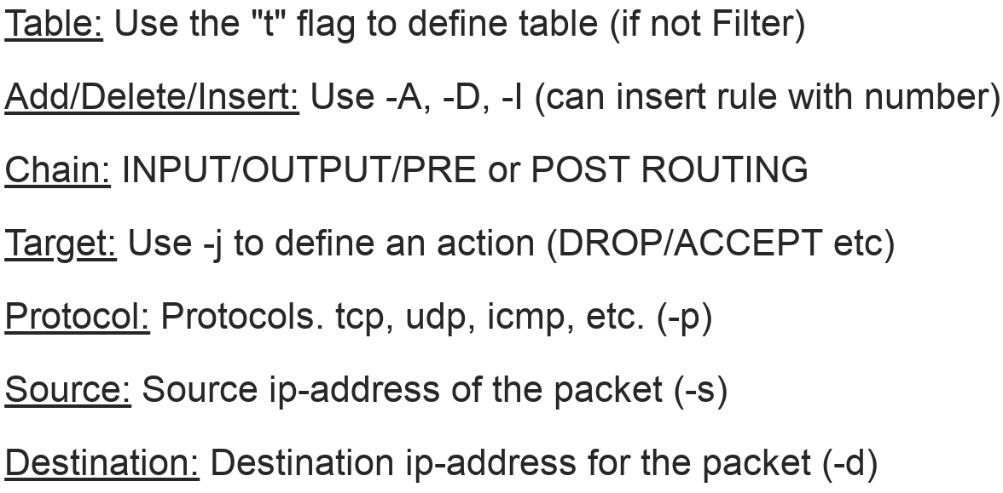
Targets and Rules
- Rules
- If criteria is matched, it goes to the rules specified in the target or executes the special values mentioned in the target
- If the criteria is NOT matched, is moves on sequentially to the next rule
- Policy – default rule, can be changed with “P”
- Targets
- ACCEPT – accepts the packet
- DROP – drop the packet with no error response
- REJECT – is used to send back an error packet in response to the matched packet, and drops

IPTables is defaulted to be BLACKLIST mentality
- In other words, everything is ok unless it’s explicitly told not to be ok

IP Tables Examples
- Syntax
- iptables -t <table> -<A/D/I/P> <CHAIN> <rule> -p <protocol> -j <TargetAction>
- Policy Change
- iptables -P INPUT DROP = this makes it a default deny taffic
- Filtering Rules
- iptables -A OUTPUT -d <destinationIP> -p tcp –dport 80 -j ACCEPT
- This would accept any traffic leaving the host over http to the destination IP
- iptables -a INPUT -s <sourceIP> -p udp –dport 69 -j DROP
- This would deny any traffic coming into the host from the source IP over udp port 69
- Adding a rule using bytecode
- iptables -A OUTPUT -m bpf –bytecode ‘4,48 0 0 9,21 0 1 6,6 0 0 1,6 0 0 0’ -j ACCEPT
More examples:
- Drop traffic from MAC address “DE:AD:BE:EF:CA:FE”
- iptables -A INPUT -m mac --mac-source DE:AD:BE:EF:CA:FE -j DROP
- Accept any NEW connections from a range of ports from 20-23
- iptables -A INPUT -m state –state NEW -m tcp -p tcp –dport 20-23 -j ACCEPT

NAT with IPTables
- Source NAT (IP only)
- Change the source address to 1.1.1.1
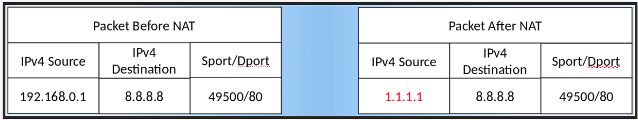
- iptables -t nat -A POSTROUTING -o eth0 -j SNAT –to 1.1.1.1

- Source NAT + PAT (IP & Port)
- Change the source address to 1.1.1.1 and the port to 9001
- iptables -t nat -A POSTROUTING -p tcp -o eth0 -j SNAT –to 1.1.1.1:9001
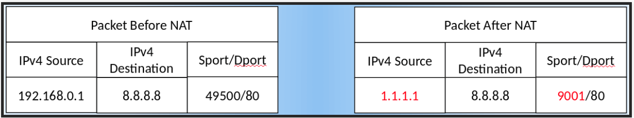
- Destination NAT (IP only)
- Change the destination to 10.0.0.1
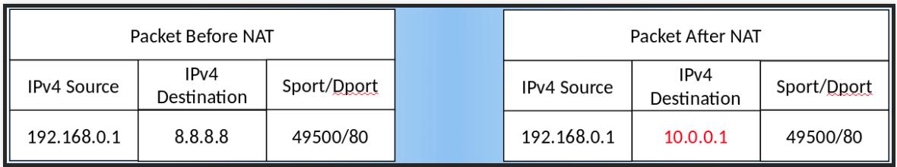
- iptables -t nat -A PREROUTING -i eth0 -j DNAT –to 10.0.0.1

- Destination NAT (Port Forwarding)
- Forward traffic to an internal or private IP on port 8080
- iptables -t nat -A PREROUTING -p tcp -i eth0 -j DNAT –to 10.0.0.1:8080
