terminal
scapy

a=Ether()
a.show()
a.src= "fa:16:3e:ab:e9:90"
a.dst= "ff:ff:ff:ff:ff:ff"
a.type=0x0806

b=ARP()
b.op=0x0001
b.hwsrc= "fa:16:e3:ab:e9:90"
b.psrc= "10.1.0.2"
b.pdst= "10.1.0.3"

sendp(a/b, iface="eth0" )

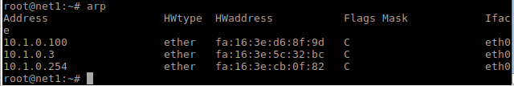

Challenge

touch scapyforarp.py #creates python script

from scapy.all import * #this imports scapy into the python script

Packet = Ether() #this defines the variable Packet
Packet.src=”<HostMAC>” #set the source MAC as our host
Packet.dst=”ff:ff:ff:ff:ff:ff” #set the destination as broadcast MAC
Packet.type=0x0806 #this is the ethertype code for ARP
ProtoARP = ARP() #defines the next variable ProtoARP
ProtoARP.op=1 #this is the ARP op code for ARP request
ProtoARP.hwsrc=”<HostMAC>” #sets the hardware source as our host mac
ProtoARP.psrc= “<HostIP>” #sets the hardware IP as our host IP

for dstIP in range(1,254): #this defines variable dstIP in the range of 1-254
ProtoARP.pdst= “10.1.0.” + str(dstIP) #this sets the IP range from 10.1.0.1-10.1.0.254
sendp(Packet/ProtoARP, iface=”eth0” ) #this executes the ARP packet send

