Laboratoriya 13
Mavzu: JavaScript elementlari bilan ishlash (click, submit, change)
Ish maqsadi
Ushbu laboratoriya ishining maqsadi — JavaScript orqali HTML elementlarida yuz beradigan click, submit va change kabi asosiy hodisalarni (eventlarni) qabul qilish, ularni qayta ishlash va foydalanuvchi bilan interaktiv muloqotni tashkil qilishni o‘rganish. Shuningdek, event listenerlardan to‘g‘ri foydalanish, forma ma’lumotlarini tekshirish va element holatini dinamik ravishda o‘zgartirish ko‘nikmalarini shakllantirish.
Nazariy qism
JavaScriptda hodisalar (Events) tushunchasi
JavaScriptda hodisa (event) — bu foydalanuvchi yoki brauzer tomonidan sodir bo‘ladigan harakatdir. Masalan:
tugmani bosish (click),
matn kiritish (input),
forma yuborish (submit),
sahifa yuklanishi (load),
tanlash maydonining o‘zgarishi (change) va boshqalar.
Hodisalarni ushlash orqali interaktiv veb-sahifalar yaratiladi.
Event Listener
Hodisalarni kuzatish uchun JavaScriptda addEventListener() funksiyasi qo‘llaniladi:
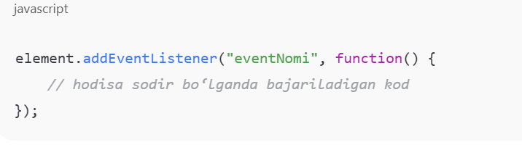

Click hodisasi
click — foydalanuvchi elementni sichqoncha bilan bosganda ishga tushadi.
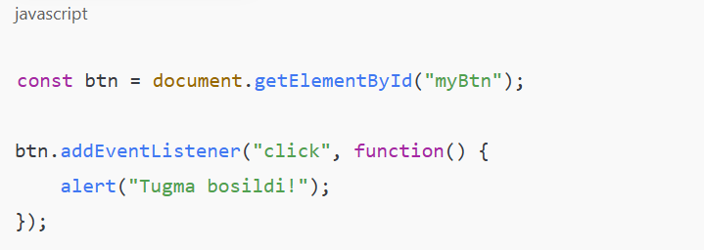
Change hodisasi
change — input yoki select elementi qiymati o‘zgartirilganda sodir bo‘ladi.
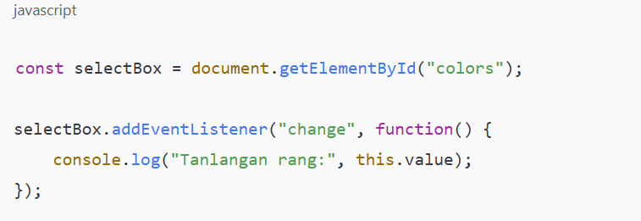

Nazariy qism:
Index.php
<!DOCTYPE html>
<html lang="uz">
<head>
<meta charset="UTF-8">
<meta name="viewport" content="width=device-width, initial-scale=1.0">
<title>Forma</title>
<style>
body { font-family: sans-serif; padding: 20px; }
form { max-width: 400px; margin: 0 auto; }
div { margin-bottom: 15px; }
label { display: block; margin-bottom: 5px; }
input { width: 100%; padding: 8px; box-sizing: border-box; }
button { padding: 10px 15px; background-color: #28a745; color: white; border: none; cursor: pointer; }
button:hover { background-color: #218838; }
</style>
</head>
<body>

<h2 style="text-align:center;">Ma'lumotlarni kiriting</h2>

<form action="2.php" method="POST">
<div>
<label for="ism">Ism:</label>
<input type="text" id="ism" name="ism" required>
</div>

<div>
<label for="email">Email:</label>
<input type="email" id="email" name="email" required>
</div>

<div>
<label for="telefon">Telefon:</label>
<input type="tel" id="telefon" name="telefon">
</div>

<div>
<label for="manzil">Manzil:</label>
<input type="text" id="manzil" name="manzil">
</div>

<button type="submit">Yuborish</button>
</form>

</body>
</html>
2.php
<?php
if ($_SERVER["REQUEST_METHOD"] == "POST") {
$ism = isset($_POST['ism']) ? htmlspecialchars($_POST['ism']) : '';
$email = isset($_POST['email']) ? htmlspecialchars($_POST['email']) : '';
$telefon = isset($_POST['telefon']) ? htmlspecialchars($_POST['telefon']) : '';
$manzil = isset($_POST['manzil']) ? htmlspecialchars($_POST['manzil']) : '';

echo "<h1>Qabul qilingan ma'lumotlar:</h1>";
echo "<p><strong>Ism:</strong> " . $ism . "</p>";
echo "<p><strong>Email:</strong> " . $email . "</p>";
echo "<p><strong>Telefon:</strong> " . $telefon . "</p>";
echo "<p><strong>Manzil:</strong> " . $manzil . "</p>";
} else {
echo "<h1>Iltimos, formani to'ldiring.</h1>";
}
?>

Natijani chiqarish:
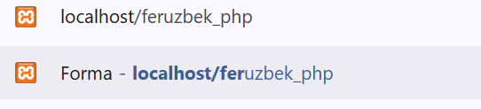
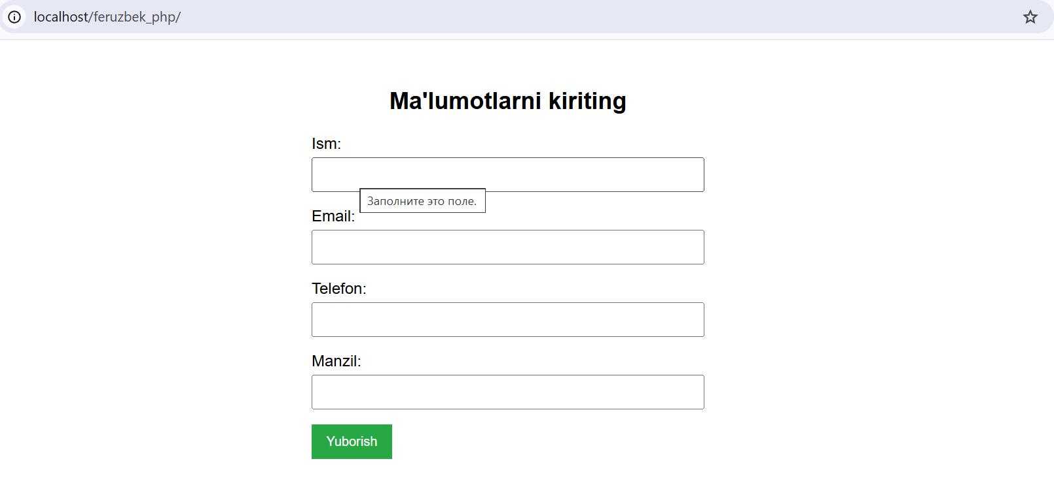

Malumot yuborish:
