System Architecture Design

System Components

Tech Stack
Frontend: React native, can be used on iOS and Android
Backend: Node.js for custom backend code
Database: PostgreSQL
APIs: OCR Image analysis API

Database Architecture
One manager to many staff.
One staff to many expense.
One manager to many expense.

Two tables:
- Staff
- Expense

Staff:
- staff_id: (primary key) int
- first_name: string
- last_name: string
- manager_id: (foreign key from Staff table) int

Expense:
- expense_id: (primary key) int
- date: time stamp
- approved: boolean
- approval_comment: string
- amount: float
- currency: enum
- image: blob
- staff_id: (foreign key from Staff table) int

Component Interactions
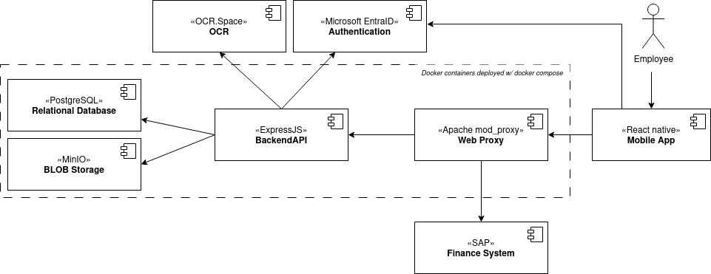

Security
Use Azure Active Directory (MSAL package) for authorisation.

