Hypoxia Induced Microglial Activation in a Neonatal Rat Inflammation Model

Rhaya L. Johnson¹, Jovicarole Raya?, Simone D. Moore³, Christopher G. Wilson^{1,2}

Keywords: Microglia, Sholl analysis, hypoxia, inflammation

1. Lawrence D. Longo MD Center for Perinatal Biology, Dept. of Basic Sciences, Loma Linda University
2. Department of Pediatrics, Loma Linda University
3. Oakwood University Huntsville, Alabama
?. do i put La Sierra University (since I have already graduated)

Corresponding Author:
Christopher G. Wilson, PhD
Center for Perinatal Biology
Loma Linda University
24941 Stewart St
Loma Linda, CA 92350
Email: cgwilson@llu.edu

1. Why microglia
Glia are “first responders”
There are different phenotypes of microglia
We feel that morphology is not well characterized for inflammation
We want to use a qualitative way to show microglial activation

2. Context for neonates
Apnea of prematurity, cyclic breathing, etc.

3. Inflammation
Jafri shows that neurons, not microglia are more implicated in immune response. So if they aren’t secreting cytokines, what are they doing?
Hypoxia upregulates microglia
We want to do sholl analysis to see if there is a difference between the hypoxia

Background: Preterm babies don’t breathe well, susceptible to infection and hypoxic events, LPS causes blunted hypoxic ventilatory response…… Look at Short comm, R21 grant, apnea of prematurity, monica carson

Abstract
Premature infants have a poorly developed immature immune system and are at increased risk of infection after birth. Systemic infection can lead to sepsis which kills 40–50% of infected infants and causes pronounced perturbations in autonomic control (breathing, cardiac, and temperature regulation). Because of these problems with autonomic control, preterm babies breathe poorly and are subject to hypoxemic/hypoxic events. Microglia are central nervous system immune cells that respond to inflammation by producing pro- and anti-inflammatory cytokines. Several studies have shown that microglia morphology changes from a resting/ramified state to an amoeboid/simplified profile when activated. We used Sholl analysis to quantify the arborization of microglial cells in response to LPS, a glycoprotein found in the coat of E. coli, and hypoxia—both stimuli that increase neuroinflammation. We then used the microglia-specific immunohistochemical marker, Iba-1, to stain microglia in brain stem regions that are important for cardiorespiratory control. We hypothesized that hypoxia (10% O₂) and LPS work synergistically to induce activation in microglia cells found in the autonomic control regions of the brainstem including the nTS (airway control) and hypoglossal motor nucleus (tongue). We believe our model represents a “2-hit model” for inflammation that shows increased microglial activation that may serve to help us understand the role of multiple inflammatory events in curing chronic inflammation.

Hypothesis:

1) Hypoxia induces microglial activation
2) LPS induces microglial activation
3) LPS+ Hypoxia induces the most microglial activation
4) More activation is correlated with increased entropy and breathing dysregulation.

1. Introduction

Microglia are the resident immune cells of the central nervous system and have often been referred to as the resident CNS macrophages; however, recent evidence suggests that they have a distinct lineage separate from circulating monocytes (Loane- read orig ref. Butovsky 2014, Ginhoux 2010, Hickman 2013). Microglia appear quite early in the brains of mammals during the prenatal period of development (Khozhai 2014), and compose 10-20% of the glial cells in the brain (Nimmerjahn 2005). They have a myeloid origin and can have widely varying functions and morphology in response to changes in homeostasis in the brain (Boche). Resting morphology of microglia is usually described as ramified—the soma is surrounded by multiple fine processes- which creates a network for them to monitor their surroundings (Boche). Activated microglia tend to retract their processes, creating a more amoeboid, ball-like shape [Ref].

Premature infants are susceptible to respiratory distress due to their underdeveloped immune system. Bacterial exposure in utero, or shortly after birth can cause infection and inflammation that worsens an immature baby’s breathing control, leading to hypoxic events. Previous studies by our lab (Balan 2011) have shown that P10-12 rat pups exposed to Lipopolysaccharide (LPS) have a blunted hypoxic ventilatory response. Further work by our laboratory showed increased levels of IL-6 and TNFa in the nTS and XII in response to LPS injection [Johnson 2016]. In 2013, Jafri and colleagues stained for microglia, and saw no change in numbers of microglia pre and post LPS injection, but they did not assess morphology. We therefore wanted to test the effect of combining LPS and hypoxia in a two-hit model of microglial morphology as an indicator of activation.

Relate back to clinical story-intermittatn hypoxia events, there is background with upregulation.

Hypoxic events on top of inflammatory load.

VHA results from both the peripheral response by O2-reactive carotid bodies and the central
cellular plasticity in the nucleus tractus solitarius (NTS). (tadmouri 2014)

NTS is the primary site of carotid body afferent terminals (Powell and Fu, 2008) responsible for the reflex responses to hypoxia. (tadmouri 2014)

2. Methods

2.1 Animal Preparation

Animal procedures were done in accordance with NIH guidelines and were approved by LLU institutional Animal Care and Use Committee. Injections were performed on Sprague Dawley rats aged 10-12 postnatally. Briefly, animals were anesthetized (2-4% isoflurane), and the trachea was exposed via a midline incision. Animals were given an intratracheal injection of LPS (0.5mg/kg in saline) or sterile saline (10uL total volume). Sham procedures had a midline incision, with the trachea exposed, but no injection. The incisions were closed, and the animals allowed to recover until sternal. After 90 minutes of recovery the animals were placed into a plethysmography chamber. Animals given a hypoxic challenge were exposed to room air for ten minutes, then oxygen was decreased to 10% for ten minutes, the animals were then allowed ten minutes of recovery at room air. Another group of animals was exposed to 100% oxygen for 15 minutes.

After plethysmography recording, animals were deeply anesthetized, and transcardially perfused with saline (0.9%), and 4% paraformaldehyde (PFA). The brains were extracted and stored in 4% PFA for 48 hours, then transferred to 30% sucrose for cryoprotection. The brains were then frozen in Tissue-Tek OCT and sectioned at 20microns on a Leica 3050S cryostat.

2.2 Immunohistochemistry

Sections were stained using immunohistochemistry for IBA-1. To begin, sections were warmed on a slide warmer, then circled with a hydrophobic barrier pen. Slides were rinsed with 100% ethanol, and then washed with 1X PBS. Sections were incubated with .3% hydrogen peroxide to quench endogenous peroxidases. Sections were incubated in dilution buffer containing bovine serum albumin, Triton-X, and sodium phosphate buffer. They were then blocked in 5% goat and 5% donkey serum for 30 minutes. The sections were incubated in 5% goat serum with primary antibody (IBA-1, Wako, 1:500) overnight at 4 ◦C. Sections are incubated for one hour at 25 ◦C with biotinylated secondary antibody (Vector Labs, Burlingame, CA). After a 30 min incubation with VECTASTAIN Elite ABC Kit (Vector Labs, Burlingame, CA), reactions are visualized using diaminobenzidine (DAB). Washes with 1X PBS were done between each of the steps. Sections are dipped in ethanol to dehydrate, xylene to clean and coverslipped using permount mounting media.

2.3 Imaging

Images were taken using a Keyence BZ-9000 microscope at 2X and 40X (with a 2X digital zoom and a step size of 0.6). Images were taken bilaterally of the nTS and XII, using an atlas for reference. Single image stacks were used with one image every 2um in the z-direction. Color correction and post processing were done in FIJI/imageJ.

2.4 Sholl Analysis

ImageJ (https://imagej.nih.gov/ij/) was used along with the Sholl analysis plug-in (Ferreira et al. 2014) to process the images and perform 2D measurements. Image stacks were converted to z-projections, then the microglia (soma and projections) were selected and isolated. Thresholding was applied and the microglia were measured. Measurements obtained include maximum number of intersections (max intersections), radius at which maximum number of intersections occur (max intersection radius), ramification index (the ratio between max intersections and the number of primary branches), and enclosing radius (the largest radius at which a dendrite intersects) (http://imagej.net/Sholl_Analysis).
We also obtained soma data using the same procedures, but selected only the soma. Measurements included soma enclosing diameter, perimeter and area.

We had 3 animals in each of the 6 groups (LPS, saline, sham, with 100% O2 or hypoxia). Two sections from each brain were imaged, and two-three microglia from each of the two sections were analyzed. This gave us a total of 24-36 microglia per treatment group. Because the saline caused retraction of the microglial processes, the sholl analysis plug-in was unable to process some of the microglia. This led to a lower n in the saline group. However, we were able to analyze the saline microglia using only soma data.

2.5 Statistics
We tested the data for normality using the Kolmogorov–Smirnov test. We used the Kruskall-Wallace one way anova for non-parametric data to assess pairwise comparisons for all data. We used SPSS version 25 (https://www.ibm.com/products/spss-statistics) for all statistics.

Defining Terms, https://imagej.net/Sholl_Analysis

Radius step size | The sampling interval between radii of consecutive sampling circles/spheres. This value may be set to zero for continuous (1-voxel increment) measurements
Enclosing Radius | Enclosing radius is the widest of Intersecting radii
Primary Branches | The number of primary branches (i.e., those originating directly from cell soma when the center of analysis is the perikaryon)
Maximum Intersections | # of intersections including primary & secondary  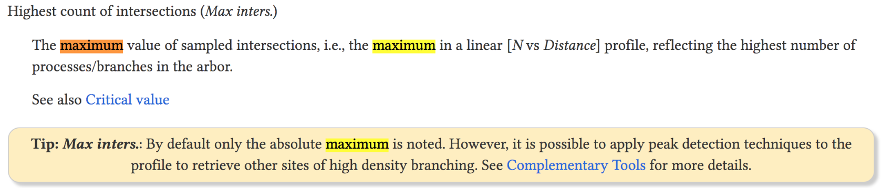
Maximum Intersection Radius | 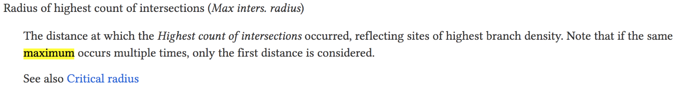
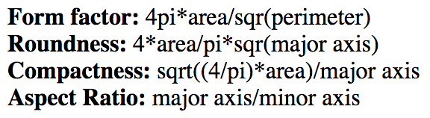

3. Results

Morphological changes

To estimate the activation of the microglia in response to hypoxia or LPS, we measured size using enclosing radius, which is the largest radius at which a dendrite intersects. Smaller radius (in microns) indicates a more activated microglial phenotype.
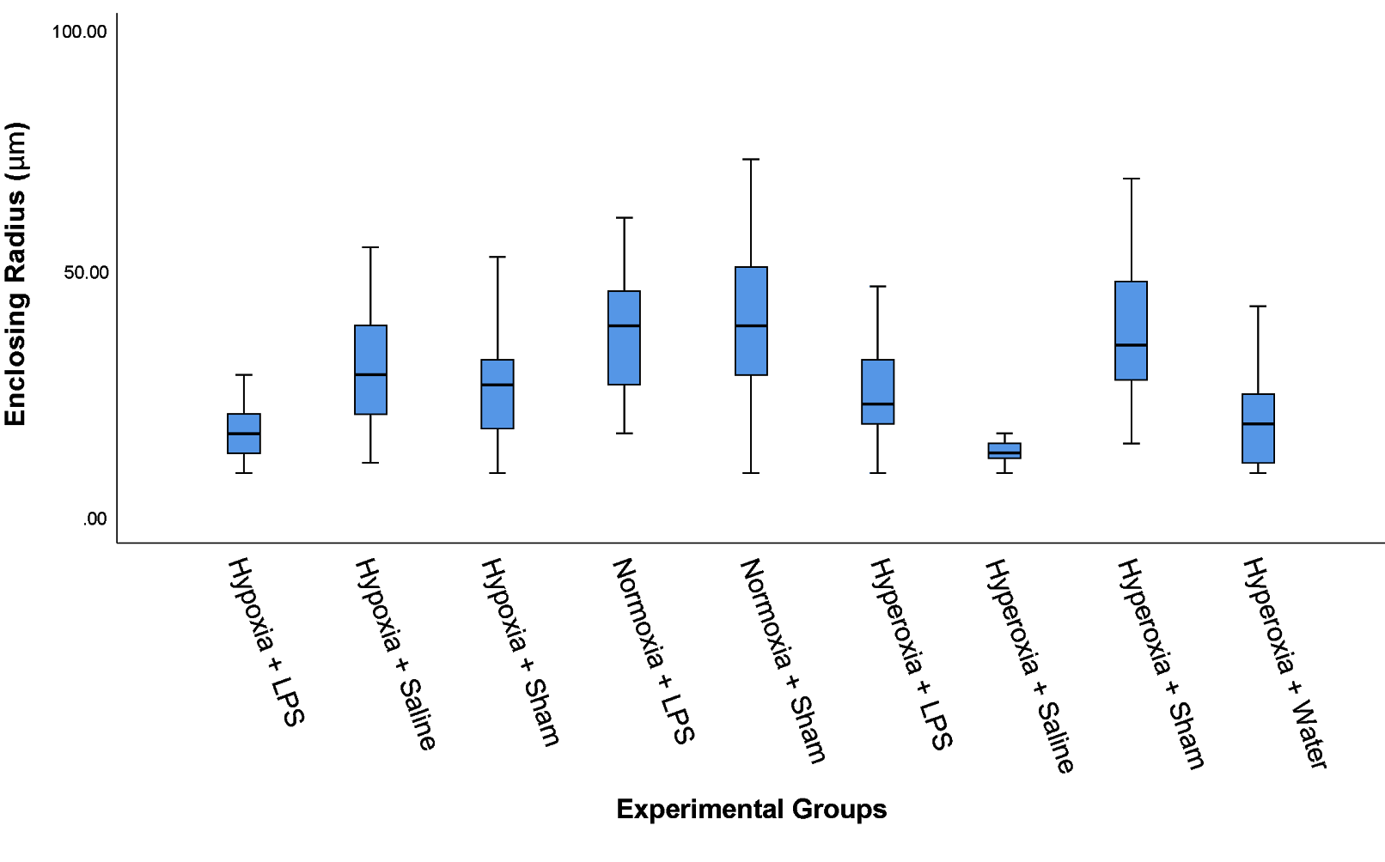
Figure 1. Comparison of Enclosing Radius of microglia in hypoxic, normoxic and
hyperoxic environments. The Normoxia + Sham group had the largest enclosing radius
with a mean of 176.25μm. The largest group of the enclosing radius was 17.00
with N=19, composing 7.4% of the data set. Total number of microglia used, n=258.

Table 1. Enclosing Radius statistically significant changes of the pairwise comparisons. Pair comparisons of the microglia from different experimental groups indicate that different sizes can be distinguished, particularly when Hyperoxia + Saline are compared to other samples.

(Experimental Group 1) — (Experimental Group 2) | Test Statistic | Standard (Std.) Error | Std. Test Statistic | Significance | Adjusted Significance
(Hyperoxia + Water) —  (Normoxia + LPS) | -96.159 | 19.844 | -4.846 | .000 | .000
(Hypoxia + LPS) — (Normoxia + LPS) | -105.302 | 17.107 | -6.156 | .000 | .000
(Hyperoxia + Water) — (Normoxia + Sham) | -98.607 | 20.934 | -4.710 | .000 | .000
(Hypoxia + LPS) — (Normoxia + Sham) | -107.750 | 18.359 | -5.869 | .000 | .000
(Hyperoxia + Water) — (Hyperoxia + Sham) | -96.265 | 21.688 | -4.439 | .000 | .000
(Hypoxia + LPS) — (Hyperoxia + Sham) | -105.407 | 19.215 | -5.486 | .000 | .000
(Hyperoxia + Saline) — (Normoxia + LPS) | 140.886 | 24.336 | 5.789 | .000 | .000
(Hyperoxia + Saline) — (Normoxia + Sham) | 143.333 | 25.232 | 5.681 | .000 | .000
(Hyperoxia + Saline) — (Hyperoxia + Sham) | -140.991 | 25.861 | -5.452 | .000 | .000
(Hyperoxia + Saline) — (Hypoxia + Saline) | 106.394 | 24.763 | 4.297 | .000 | .001
(Hypoxia + LPS) — (Hypoxia + Saline) | -70.811 | 17.709 | -3.999 | .000 | .002
(Hyperoxia + Saline) — (Hypoxia + Sham) | 88.376 | 25.586 | 3.454 | .001 | .020
(Hyperoxia + LPS) — (Normoxia + LPS) | 61.824 | 19.256 | 3.211 | .001 | .048

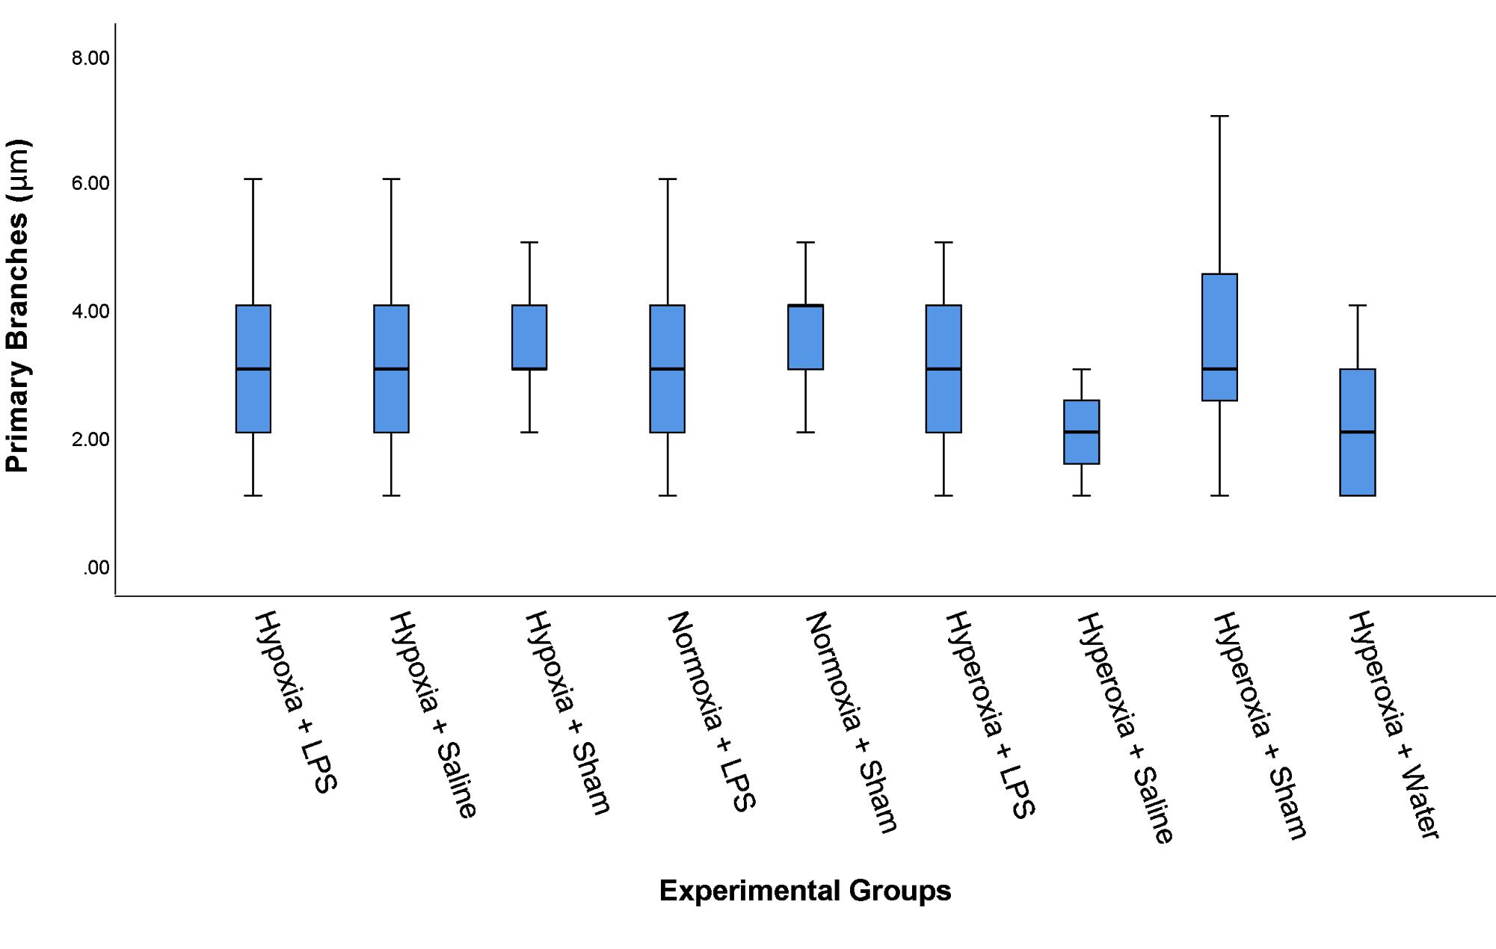
Figure 2. Comparison of Primary Branches of microglia in hypoxic, normoxic and
hyperoxic environments. The largest group of primary branches was 3.00 inferred
branches with N=68, composing 26.4% of the data set. Total number of microglia used,
n=258.

Table 2. Primary Branches statistically significant changes of the pairwise comparisons. Pair comparisons of the microglia from different experimental groups indicate that different inferred branches can be distinguished, particularly when Hyperoxia + Saline/Water are compared to other samples.
(Experimental Group 1) — (Experimental Group 2) | Test Statistic | Standard (Std.) Error | Std. Test Statistic | Significance | Adjusted Significance
(Hyperoxia + Water) —  (Normoxia + Sham) | -83.014 | 20.484 | -4.053 | .000 | .002
(Hyperoxia + Saline) —  (Normoxia + Sham) | 97.609 | 24.690 | 3.953 | .000 | .003
(Hyperoxia + Saline) —  (Hyperoxia + Sham) | -82.500 | 25.306 | -3.260 | .001 | .040
(Hyperoxia + Water) —  (Hyperoxia + Sham) | -67.905 | 21.222 | -3.200 | .001 | .050

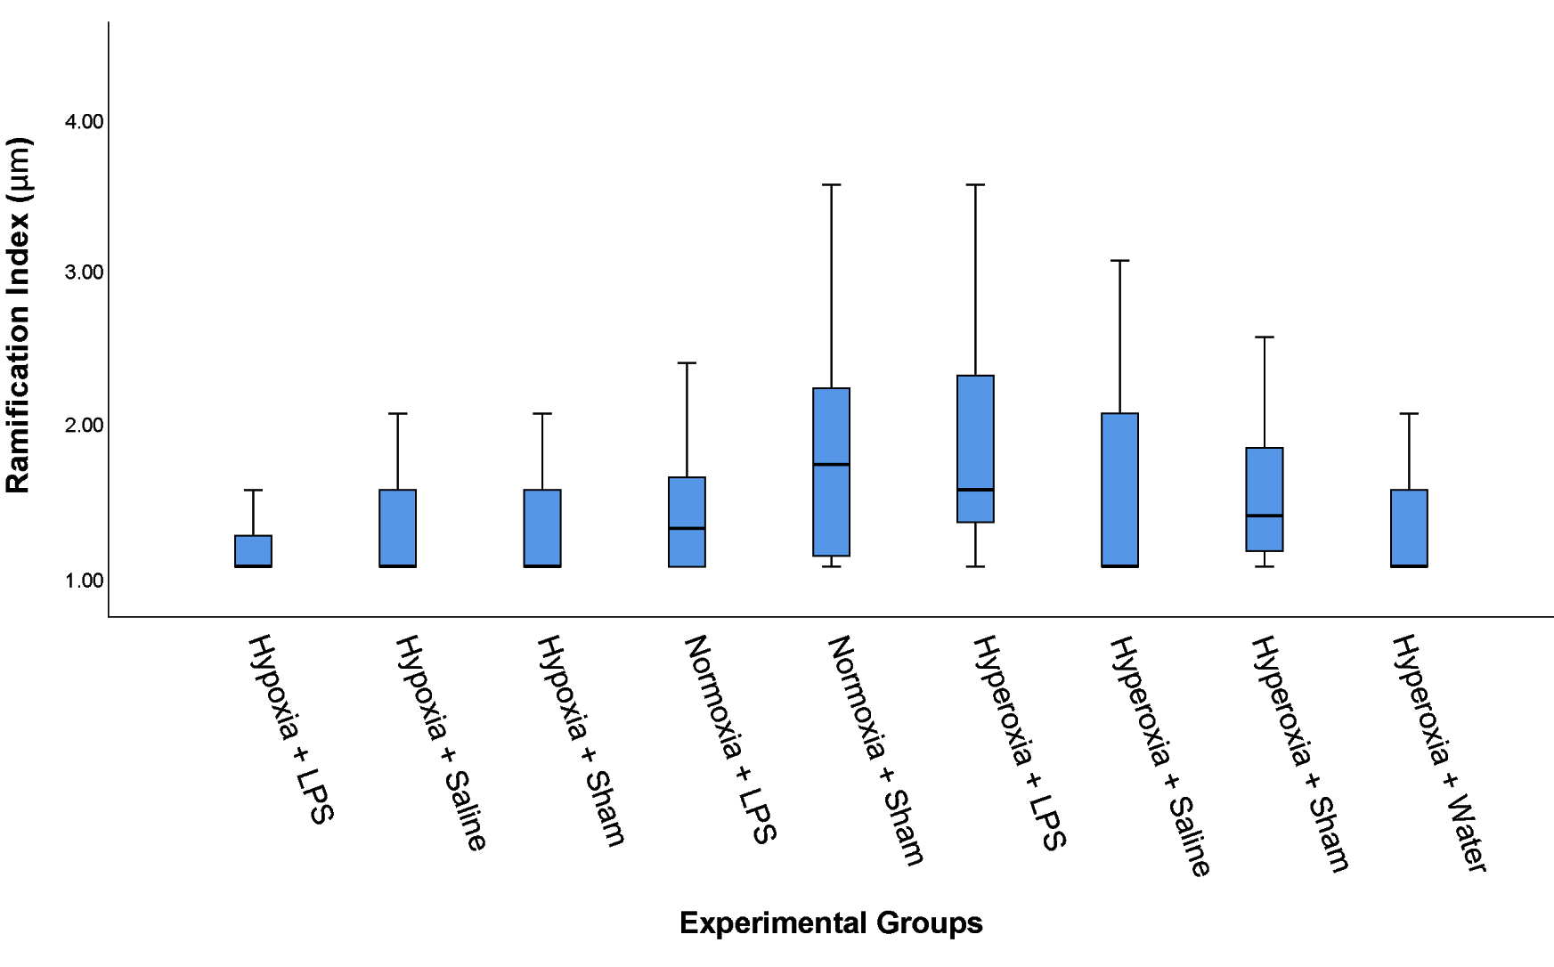
Figure 3. Comparison of Ramification Index of microglia in hypoxic, normoxic and
hyperoxic environments. The Hyperoxia + LPS group had the largest ramification index
sampled with a mean of 168.39 μm. The largest group was sampled at 1.00
ramification index with N=123, composing 47.7% of the data set. Total number of
microglia used, n=258.

Table 3. Ramification Index Sampled statistically significant changes of the pairwise comparisons. Pair comparisons of the microglia from different experimental groups indicate that specific branching out can be distinguished, particularly when Hypoxia + LPS are compared to other samples.
(Experimental Group 1) — (Experimental Group 2) | Test Statistic | Standard (Std.) Error | Std. Test Statistic | Significance | Adjusted Significance
(Hypoxia + LPS) —  (Normoxia + Sham) | -74.543 | 17.337 | -4.300 | .000 | .001
(Hypoxia + LPS) —  (Hyperoxia + LPS) | -75.700 | 19.005 | -3.983 | .000 | .002
(Hypoxia + Sham) —  (Normoxia + Sham) | -59.941 | 18.048 | -3.321 | .001 | .032

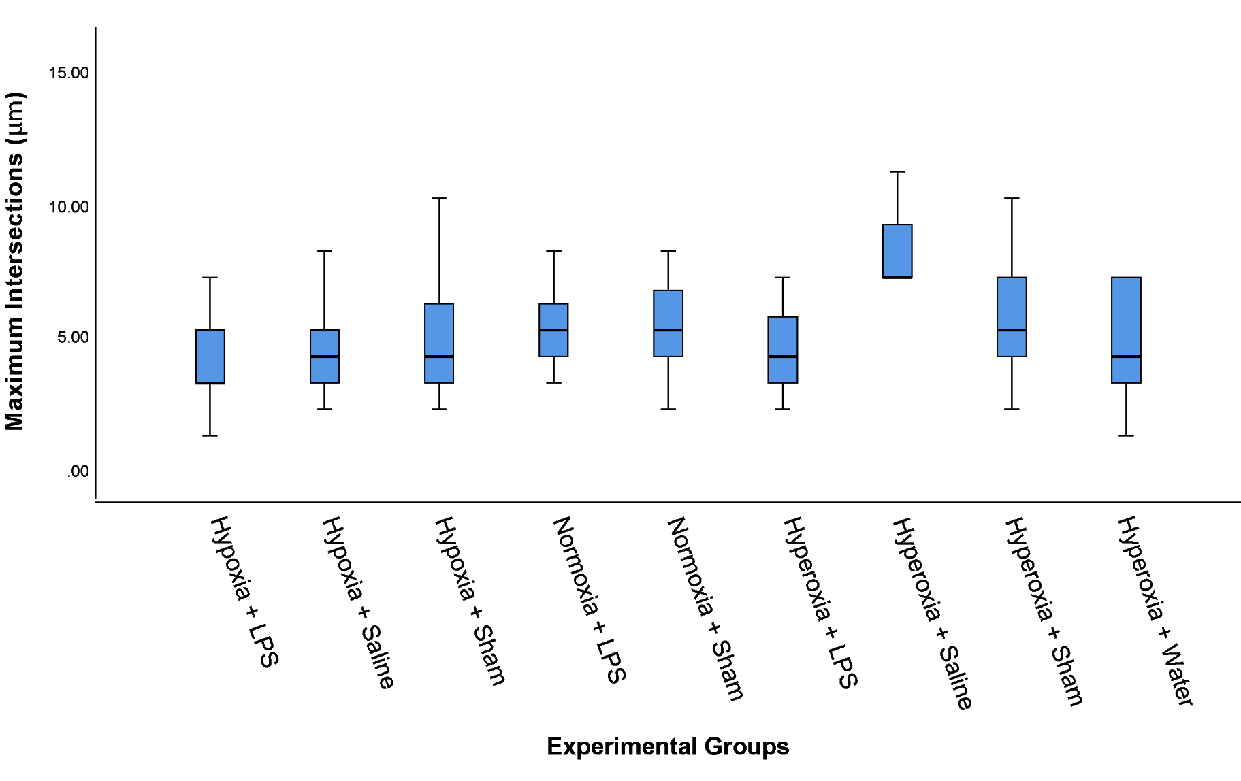
Figure 4. Comparison of Maximum Intersections of microglia in hypoxic, normoxic and
hyperoxic environments. The Hyperoxia + Saline group had the largest maximum
intersections with a mean of 214.12 μm. The largest group was sampled at 3.00
maximum intersections with N=54, composing 20.9% of the data set. Total number of
microglia used, n=258.

Table 4. Maximum Intersections statistically significant changes of the pairwise comparisons.
(Experimental Group 1) — (Experimental Group 2) | Test Statistic | Standard (Std.) Error | Std. Test Statistic | Significance | Adjusted Significance
(Hypoxia + LPS) —  (Hyperoxia + Saline) | -135.581 | 24.715 | -5.486 | .000 | .000
(Hypoxia + LPS) —  (Hyperoxia + Sham) | -80.178 | 18.974 | -4.226 | .000 | .001
(Hypoxia + Saline) —  (Hyperoxia + Saline) | -104.098 | 24.452 | -4.257 | .000 | .001
(Hypoxia + LPS) —  (Normoxia + LPS) | -67.654 | 16.892 | -4.005 | .000 | .002
(Hypoxia + LPS) —  (Normoxia + Sham) | -72.893 | 18.129 | -4.021 | .000 | .002
(Hyperoxia + LPS) —  (Hyperoxia + Saline) | -99.690 | 26.211 | -3.803 | .000 | .005
(Hypoxia + Sham) —  (Hyperoxia + Saline) | -91.487 | 25.265 | -3.621 | .000 | .011
(Hyperoxia + Water) —  (Hyperoxia + Saline) | -95.387 | 26.636 | -3.581 | .000 | .012

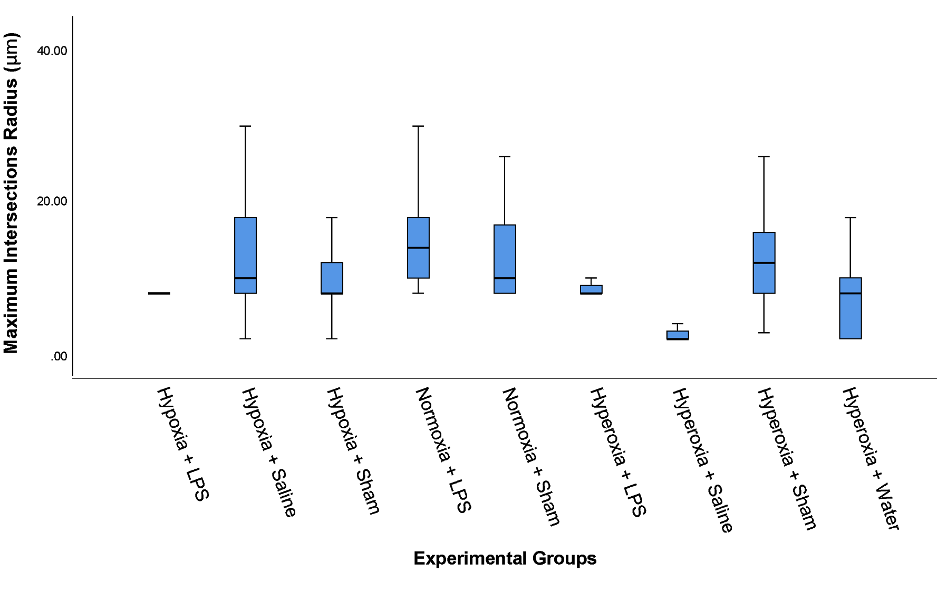
Figure 5. Comparison of Maximum Intersections Radius of microglia in hypoxic,
normoxic and hyperoxic environments. The Normoxia + LPS group had the largest
maximum intersection radius with a mean of 176.27 μm. The largest group was sampled
at 7.00 maximum intersection radius with N=101, composing 39.1% of the data set.
Total number of microglia used, n=258.

Table 5. Maximum Intersection Radius statistically significant changes of the pairwise comparisons.
(Experimental Group 1) — (Experimental Group 2) | Test Statistic | Standard (Std.) Error | Std. Test Statistic | Significance | Adjusted Significance
(Hyperoxia + Water) —  (Normoxia + LPS) | -87.529 | 19.224 | -4.553 | .000 | .000
(Hypoxia + LPS) —  (Normoxia + LPS) | -76.091 | 16.571 | -4.592 | .000 | .000
(Hyperoxia + Saline) —  (Normoxia + LPS) | 123.240 | 23.988 | 5.138 | .000 | .000
(Hyperoxia + Saline) —  (Normoxia + Sham) | 154.142 | 23.575 | 6.539 | .000 | .000
(Hyperoxia + Saline) —  (Normoxia + Sham) | 135.219 | 24.443 | 5.532 | .000 | .000
(Hyperoxia + Saline) —  (Hyperoxia + Sham) | -131.634 | 25.052 | -5.254 | .000 | .000
(Hyperoxia + LPS) —  (Normoxia + LPS) | 75.854 | 18.654 | 4.066 | .000 | .002
(Hyperoxia + Saline) —  (Hypoxia + Sham) | 95.875 | 24.785 | 3.868 | .000 | .004
(Hyperoxia + Water) —  (Normoxia + Sham) | -68.606 | 20.279 | -3.383 | .001 | .026
(Hypoxia + Sham) —  (Normoxia + LPS) | -58.267 | 17.351 | -3.358 | .001 | .028
(Hyperoxia + Saline) —  (Hypoxia + LPS) | 78.051 | 24.246 | 3.219 | .001 | .046
(Hypoxia + LPS) —  (Normoxia + Sham) | -57.167 | 17.785 | -3.214 | .001 | .047

Most interestingly, each of the groups treated with hypoxia was significantly different from its 100% oxygen counterpart, with the exception of sham v. hypoxia sham. This shows that when there is an existing inflammatory stressor (saline or LPS) the hypoxia causes an additional increase in activation. Additionally, animals treated with LPS+Hypoxia were significantly more activated than those treated with LPS alone, indicating that hypoxia works synergistically with LPS to increase activation.

To estimate the roughness of the soma in response to hypoxia or LPS, we measured the form factor provided from the soma data. The equation for the form factor is . Smaller form factor indicates a more rough soma due to the increase of the denominator, the perimeter.

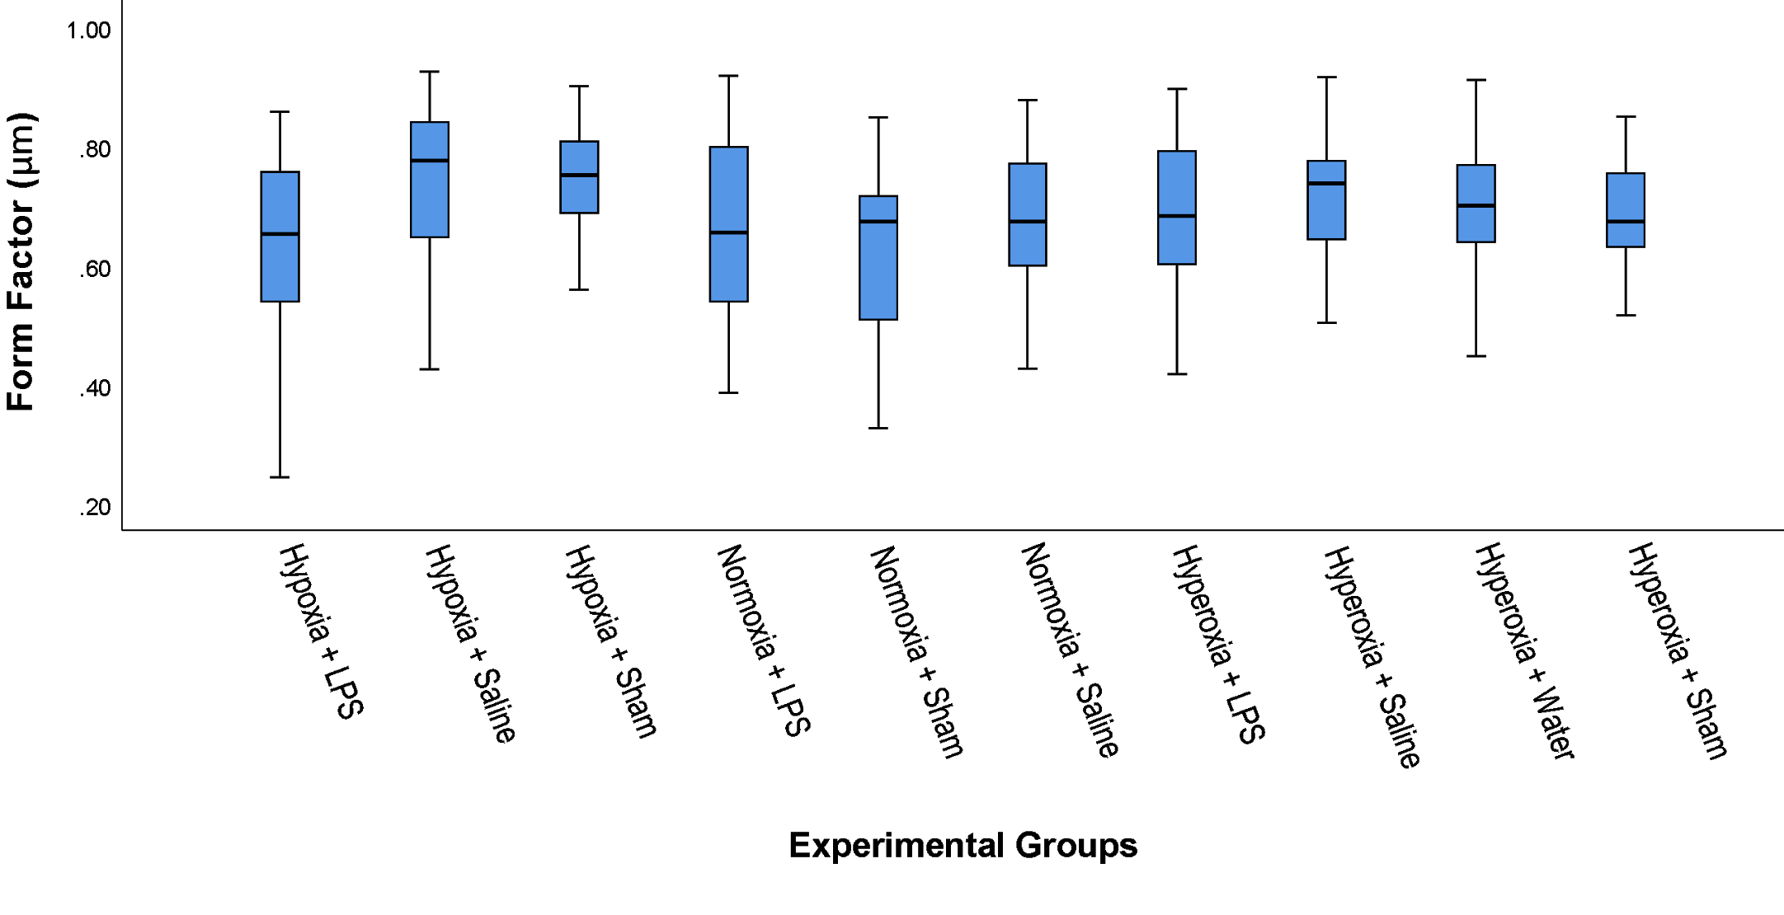
Figure 6. Comparison of Form Factor of the soma in hypoxic, normoxic and hyperoxic
environments. The Hypoxia + Saline group had the largest form factor with a mean of
153.79 μm. The data for the form factor was spread evenly throughout with no more than
N=1 per count. Total number of soma used, n=249.

Table 6. Form Factor statistically significant changes of the pairwise comparisons.
(Experimental Group 1) — (Experimental Group 2) | Test Statistic | Standard (Std.) Error | Std. Test Statistic | Significance | Adjusted Significance
(Normoxia + Sham) — (Hypoxia + Saline) | 64.895 | 19.809 | 3.276 | .001 | .047

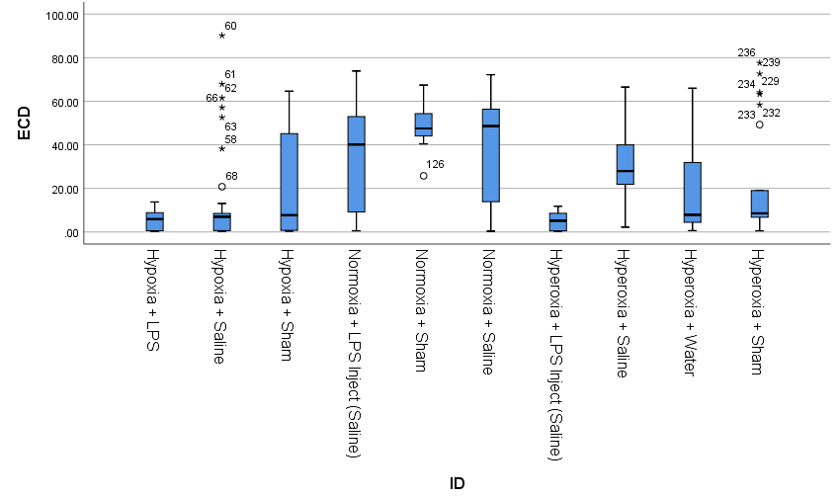
Figure 7. Comparison of Equivalent Circular Diameter in hypoxic, normoxic and
hyperoxic environments. The Normoxia + Sham group had the largest ECD with a mean
of 200.97 μm. The data for the ECD was spread evenly similar to the form factor, with
the exception of six groups with N=2. Total number of soma used, n=249.

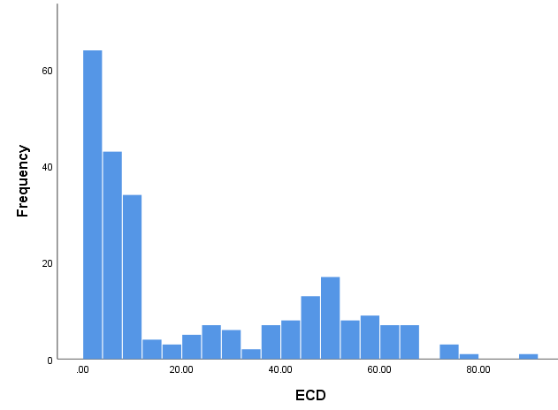
Figure 7.1 Grubbs analysis histogram of Equivalent Circular Diameter, testing standard
deviation to identify outliers in the data set. The mean was 22.38, standard deviation was
23.014, with n=249.

Table 7. Equivalent Circular Diameter statistically significant changes of the pairwise comparisons.
(Experimental Group 1) — (Experimental Group 2) | Test Statistic | Standard (Std.) Error | Std. Test Statistic | Significance | Adjusted Significance
(Hypoxia + LPS) — (Normoxia + Sham) | -127.308 | 20.792 | -6.123 | .000 | .000
(Hypoxia + LPS) — (Normoxia + Saline) | -92.753 | 19.504 | -4.756 | .000 | .000
(Hypoxia + Saline) — (Normoxia + Sham) | -105.642 | 19.809 | -5.333 | .000 | .000
(Hyperoxia + LPS Inject, Saline) — (Normoxia + Sham) | 129.825 | 22.776 | 5.700 | .000 | .000
(Hyperoxia + LPS Inject, Saline) — (Normoxia + Saline) | 95.270 | 21.607 | 4.409 | .000 | .000
(Hypoxia + LPS) — (Hyperoxia + Saline) | -82.453 | 19.504 | -4.227 | .000 | .001
(Hypoxia + LPS) — (Normoxia + LPS Inject, Saline) | -87.472 | 21.473 | -4.074 | .000 | .002
(Hypoxia + Sham) — (Normoxia + Sham) | -85.708 | 20.792 | -4.122 | .000 | .002
(Hyperoxia + LPS Inject, Saline) — (Hyperoxia + Saline) | -84.970 | 21.607 | -3.932 | .000 | .004
(Hypoxia + Saline) — (Normoxia + Saline) | -71.087 | 18.453 | -3.852 | .000 | .005
(Hyperoxia + LPS Inject, Saline) — (Normoxia + LPS Inject, Saline) | 89.989 | 23.400 | 3.846 | .000 | .005
(Hyperoxia + Sham) — (Normoxia + Sham) | 71.715 | 21.607 | 3.319 | .001 | .041
(Hypoxia + Saline) — (Hyperoxia + Saline) | -60.787 | 18.453 | -3.294 | .001 | .044

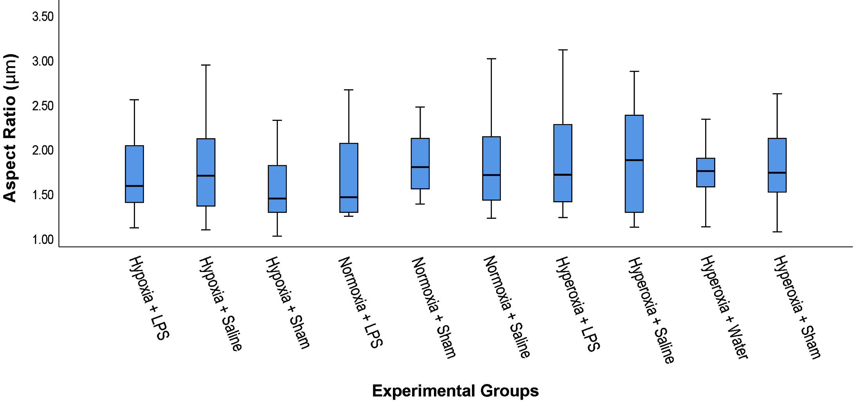
Figure 8. Comparison of Aspect Ratio in hypoxic, normoxic, and hyperoxic
environments. There were no statistically significant changes between the groups for the
aspect ratio. Total number of soma used, n=249.

4. Discussion

Our data suggests the correlations between various experimental groups and responses of microglia. Using Sholl analysis, the results show similar patterns with the various figures found above. Figure 1

McFarlane
We used ionized calcium binding adaptor molecule (IBA-1) staining to identify microglia. IBA-1 is independent of state, staining both resting and activated microglia. (Imai Y, 1996)

Classical activation (M1) is defined by the response
of macrophages to challenge by micro-organisms resulting
in the expression of high levels of pro-inflammatory
cytokines and an enhanced microbicidal capacity.
Interferon-g causes M1 activation, a response usually
associated with host defence to intracellular pathogens
[27–29]. Classical activation has been the activation state
most widely explored in animal models.

Alternative activation (M2) was originally defined following
exposure to the Th2 cytokine, interleukin (IL)-4,
and upregulation by macrophages of the mannose receptor
[30]. The mannose receptor can bind structures on…. Boche

5. Acknowledgments:

Imaging was performed on the Keyence Microscope in the lab of Dr. Johnny Figueroa [Grant?]
We would also like to thank LLUSM students Jay Hwang and Peter Chun for their assistance in sectioning and staining the tissue.

6. Financial

Experiments

LPS, Sham, and saline, 100% oxygen
LPS, sham and saline, 10% oxygen
LPS, sham and saline, 21% oxygen- Pleth only
Pleth and staining.

Hypothesis:

1) Hypoxia induces microglial activation
2) LPS induces microglial activation
3) LPS+ Hypoxia induces the most microglial activation
4) More activation is correlated with increased entropy and breathing dysregulation.

2- hit papers.
Neonates- kids often have compromised breathing and then get infection, then they are more susceptible to sepsis… other inflammation.

