Headline-Only News Topic Classification: TF-IDF Logistic Regression versus Pretrained Sentence Embeddings
Mohammed Saeed Alamodi (2240009007), Abdulaziz Mohammed Alkhlawi (2240006095), Jaber Saleh Alsaikhan (2240006539)
Department of Computer Engineering, College of Computer Science and Information Technology, Imam Abdulrahman Bin Faisal University
Natural Language Processing course project · Section 1 · Group 2 · Option 3: News Topic Classification

Abstract—News aggregators, feed readers and newsroom tools often have to tag a story when only its headline is available. We study headline-only topic classification on AG News (World, Sports, Business, Sci/Tech), focusing on the hardest pair of classes, Business and Sci/Tech. We repaired encoding leftovers, removed label-revealing source tags and built a duplicate-aware split: 105,569 training, 11,692 development and 6,357 test headlines, with no headline shared between splits. On this data we compare TF-IDF features with logistic regression against frozen all-MiniLM-L6-v2 sentence embeddings with logistic regression, both tuned on the development set. On the test set TF-IDF reaches 86.5% accuracy and 86.3 macro-F1; the embedding model reaches 82.9% and 82.7. The embedding model makes 346 Business↔Sci/Tech confusions against 264 (McNemar p < 0.001), so for the approved design the answer to our question is negative. The gap disappears on headlines that contain words unseen in training. An extra experiment shows that the representation is not the problem: a 10-nearest-neighbour vote over the same frozen embeddings reaches 88.2 macro-F1, significantly above TF-IDF.
Index Terms—text classification, news headlines, TF-IDF, logistic regression, sentence embeddings, MiniLM, AG News.

I. Introduction
Online news reaches readers through aggregators, RSS feed readers and newsroom systems that must sort a constant stream of stories into sections. Often the only text available at that moment is the headline: the article has not been fetched, is behind a paywall, or has not yet been processed. A headline is short (about seven words in our data) and is dominated by the names of companies, products, places and people, so the topic has to be inferred from very little context.
This project follows Option 3 of the course brief, News Topic Classification. We built a notebook that accepts one English headline and returns one of the four AG News topics: World, Sports, Business or Sci/Tech. The intended users are developers of news aggregators and feed readers, and newsroom staff who triage incoming wire stories: the predicted topic can tag, route or filter a story before it is read. The notebook compares a traditional method, TF-IDF features with logistic regression, with a method built on a pretrained language model, frozen MiniLM sentence embeddings with logistic regression. Both are trained on the same data and tested on the same held-out headlines. A “Try it” cell classifies any new headline with the saved models, without retraining.

II. Project Goals and Objectives
Challenge profile: headline-only input. Headlines are short, rely on names and give little context. Business and Sci/Tech overlap the most: stories about technology companies, earnings, mergers and markets could belong to either. We therefore expected most errors to involve these two classes.
Experimental question. If only the headline is available, does a pretrained sentence-embedding classifier separate Business and Sci/Tech headlines more reliably than TF-IDF logistic regression? Besides accuracy and macro-F1 (which weights the four classes equally) we report the F1 of Business and Sci/Tech and count the Business↔Sci/Tech confusions of each method.
Input and output. Input: one English news headline (usually 5–12 words). Output: one of World, Sports, Business, Sci/Tech, with a probability for each.
Objectives. (1) Build a reproducible data pipeline in which no headline is shared between the training, development and test sets. (2) Implement both methods and tune them on the development set only. (3) Compare them once on the same test headlines, with paired significance tests. (4) Analyse the challenge factors (unfamiliar words, very short headlines) and explain individual errors. (5) Deliver a usable prediction cell. The investigation is meant to show whether the general language knowledge in a pretrained encoder helps exactly where a word-matching model is weakest.

III. Related Works
Zhang et al. [1] introduced AG News as a benchmark. They took the four largest classes of Gulli’s AG corpus of more than one million news articles [4] and used the title and description of each article. Their n-gram TF-IDF model with multinomial logistic regression reached 92.36% test accuracy (7.64% error), better than their character-level convolutional networks on this dataset. This told us that TF-IDF with logistic regression is a strong baseline, not a weak one, and it gives a reference point: with the title only, both of our methods should score lower, and the question is which one loses less on the Business/Sci-Tech boundary. Our cleaned test set differs from theirs, so the numbers are not directly comparable.
Reimers and Gurevych [2] proposed Sentence-BERT, which trains BERT in a siamese set-up so that each sentence is mapped to one fixed-size vector whose cosine similarity reflects meaning. Such vectors can feed a simple downstream classifier, which motivated Method 2: encode each headline once with a frozen model and train only a linear classifier on top. Wang et al. [3] introduced MiniLM, which compresses a large transformer into a small one by deep self-attention distillation. The all-MiniLM-L6-v2 model we use is a six-layer MiniLM that was further trained with the sentence-transformers contrastive objective on over one billion sentence pairs. We chose it because it can encode all 120,000 headlines quickly while keeping much of the quality of larger encoders. Its knowledge of words and names beyond our training data is the reason we expected it to help on unfamiliar company and product names.

IV. Data Acquisition and Preprocessing

A. Source, Labels and Class Counts
We use the AG News CSV files with separate Title and Description columns published on Kaggle (train.csv and test.csv) [9]. We keep only the Title column and the class label; the description is never shown to either model. The official files are balanced, with 30,000 training and 1,900 test articles per class (Table I). Titles have 6.8 words on average (median 7; 5th–95th percentile 4–10 words). The notebook downloads the files with kagglehub, which needs no Kaggle account, and falls back to a GitHub copy of the original CSV files.
TABLE I
AG News Class Counts before and after Cleaning
Split | World | Sports | Business | Sci/Tech | Total
Official train | 30,000 | 30,000 | 30,000 | 30,000 | 120,000
Official test | 1,900 | 1,900 | 1,900 | 1,900 | 7,600
Train (ours) | 26,565 | 26,855 | 26,072 | 26,077 | 105,569
Dev (ours) | 2,927 | 2,965 | 2,907 | 2,893 | 11,692
Test (ours) | 1,639 | 1,735 | 1,537 | 1,446 | 6,357

B. Data-Quality Problems and Cleaning
Checking the downloaded files showed five problems (Table II). First, 17 rows (15 training, 2 test) have the title “#NAME?”. The original titles start with a dash (for example “-Posted by dan.farber”), and a spreadsheet program evidently read them as formulas; these rows are not headlines and are dropped. Second, 12,967 training titles contain HTML entities whose ampersand was lost, such as “Google #39;s” for “Google’s” or “AT amp;T”. Of these, 2,559 end with an escaped RSS cut-off marker “<b>...</b>”, and 2,646 titles contain an escaped dollar sign “\$”. A repair function restores normal text in all 15,318 affected titles. Third, 16,849 training titles end with a publisher tag. The proposal named (Reuters), (AP) and (AFP); these account for 13,878 titles (the proposal’s estimate was about 16,100), but there are 30 more tags. Several are almost pure label signals: (AFP) is World 77% of the time, (Canadian Press) 100% World, (PC World), (Ziff Davis) and (SPACE.com) 100% Sci/Tech, and Bloomberg-style (Update1) markers 78% Business. A model would learn the publisher instead of the headline, so we remove every tag in the list. Section VI-F shows what keeping them would have done.
TABLE II
Data-Quality Problems Found and Actions Taken
Problem (training file) | Titles | Action
Spreadsheet error “#NAME?” | 15 (+2 test) | rows dropped
HTML entity remnants | 12,967 | repaired
Escaped dollar sign “\$” | 2,646 | repaired
Publisher / update tags | 16,849 | tags removed
Conflicting labels (cleaned) | 1,149 | removed from training
Test titles also in training | 1,235 | removed from test

The fourth and fifth problems are duplicates and conflicting labels. Counted on raw lower-cased titles, as in the proposal, we reproduce its figures exactly: 6,361 training rows repeat an earlier title, 652 titles carry more than one label, and 764 test titles also occur in training. The models, however, see the cleaned text. We therefore recount on a normalised key (lower-case letters and digits only) after cleaning. Removing a tag merges copies such as “X (Reuters)” and “X (AP)”, so the counts rise (Table III).
TABLE III
Duplicates and Conflicts: Raw versus Cleaned Titles
Count | Raw (proposal) | Cleaned (used)
Repeated training rows | 6,361 | 10,827
Distinct repeated titles | 5,207 | 8,666
Conflicting titles | 652 | 1,149
Rows with a conflicting title | 1,523 | 2,724
Test titles also in training | 764 | 1,235

C. Duplicate-Aware Train/Development/Test Split
Training titles with conflicting labels are label noise and are removed (1,149 titles, 2,724 rows). From the test file we remove every title that also occurs anywhere in the training file (1,235 rows) and the three titles that carry two labels inside the test file (6 rows). This leaves 6,357 test headlines, fewer than the proposal’s estimate of 6,800 because duplicates are now detected after cleaning. Repeats with the same label stay together: we split the unique headlines 90/10, stratified by label, and then map the rows back, so all copies of a headline fall in the same split. The result is 105,569 training and 11,692 development rows (Table I). The notebook asserts that no normalised headline is shared between any two splits. The development set is used to choose settings; the test set is used once, for the final comparison.

V. Model Development and Training

A. Method 1: TF-IDF with Logistic Regression
Each cleaned headline is lower-cased, accent-stripped and split into word tokens with scikit-learn’s default pattern [5]. Each n-gram t that occurs in at least two training headlines receives the weight (1 + ln tf)·idf(t), where idf(t) = ln((1 + N)/(1 + df(t))) + 1. Each headline vector is L2-normalised. A multinomial logistic regression with an L2 penalty learns one weight per n-gram and class; the regularisation strength is set by C (a larger C means weaker regularisation). Following the proposal, we tuned the n-gram range (unigrams, or unigrams and bigrams) and C ∈ {0.25, 0.5, …, 16} on the development macro-F1, 14 settings in total. The best setting uses unigrams and bigrams with C = 8 (development macro-F1 87.15, 100,466 features); the best unigram model reached 86.98 (Fig. 1). The highest-weighted features are mostly entity names, for example oil, dollar, enron, yukos for Business and nasa, microsoft, linux, firefox for Sci/Tech. We use the saga solver, which gave the same scores as the default lbfgs solver several times faster.
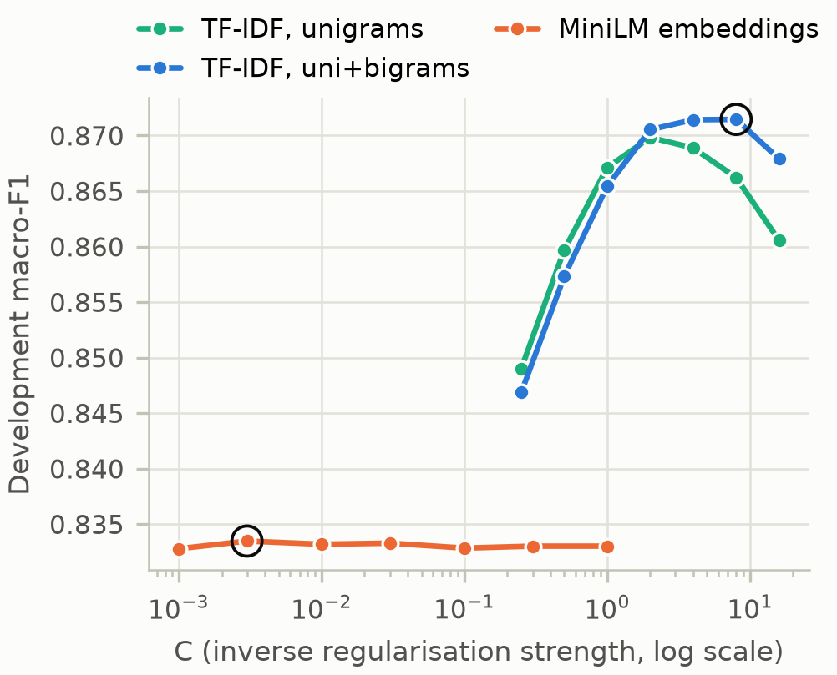
Fig. 1. Development-set macro-F1 for every setting tried. The selected setting of each method is ringed. The MiniLM curve is flat, so regularisation is not what limits that model.

B. Method 2: MiniLM Sentence Embeddings with Logistic Regression
all-MiniLM-L6-v2 [2], [3] is a six-layer transformer with about 22 million parameters. It averages its token vectors (mean pooling) and L2-normalises the result to a 384-dimensional sentence embedding. We load the published weights through the sentence-transformers library and keep them frozen. Every cleaned headline is encoded once, in batches of 256, and the embeddings are cached to disk. Each dimension is then standardised (zero mean and unit variance, fitted on the training split), and a multinomial logistic regression is trained on top. Standardising does not change what the model can learn, but it makes the optimiser converge in seconds instead of many minutes. C was tuned over {0.001, …, 1}. The development macro-F1 hardly moves (83.28–83.35); the best is C = 0.003 with 83.35.

C. From Input Text to Prediction
A new headline passes through the same clean_title() function as the training data. TF-IDF then vectorises it, or MiniLM encodes and standardises it. The logistic regression outputs a probability for each topic, and the most probable topic is returned. Both trained models are saved with joblib (4.1 MB and 16 kB). The “Try it” cell loads them from disk and shows the prediction of the selected model (the one with the higher development macro-F1, TF-IDF) with the other model as a second opinion. Existing libraries provide the TF-IDF vectoriser, logistic regression and metrics (scikit-learn [5]), the pretrained encoder and its weights (sentence-transformers and Hugging Face), and the binomial test (SciPy). The cleaning, duplicate-aware split, tuning loops, statistical tests, error-analysis tools and prediction cell are our own code.

VI. Evaluation and Analysis

A. Overall Results
TABLE IV
Test-Set Results (6,357 Headlines)
Metric | TF-IDF + LR | MiniLM + LR | MiniLM + 10-NN*
Accuracy (%) | 86.49 | 82.95 | 88.38
Macro-F1 (%) | 86.25 | 82.69 | 88.16
F1 World (%) | 87.33 | 84.49 | 89.70
F1 Sports (%) | 91.20 | 88.63 | 92.84
F1 Business (%) | 82.58 | 77.36 | 83.96
F1 Sci/Tech (%) | 83.89 | 80.28 | 86.14
Business → Sci/Tech | 139 | 191 | 126
Sci/Tech → Business | 125 | 155 | 130
Business ↔ Sci/Tech | 264 | 346 | 256
*Extra experiment added after the error analysis (Section VI-D); k chosen on the development set. Confusions are counts of test headlines.
Table IV lists the test results. TF-IDF reaches 86.49% accuracy and 86.25 macro-F1; MiniLM with logistic regression reaches 82.95% and 82.69. For both methods Sports is the easiest class and Business the hardest. The confusion matrices (Fig. 2) show that the largest error for both is the Business/Sci-Tech pair: 264 of TF-IDF’s 859 errors and 346 of MiniLM’s 1,084.

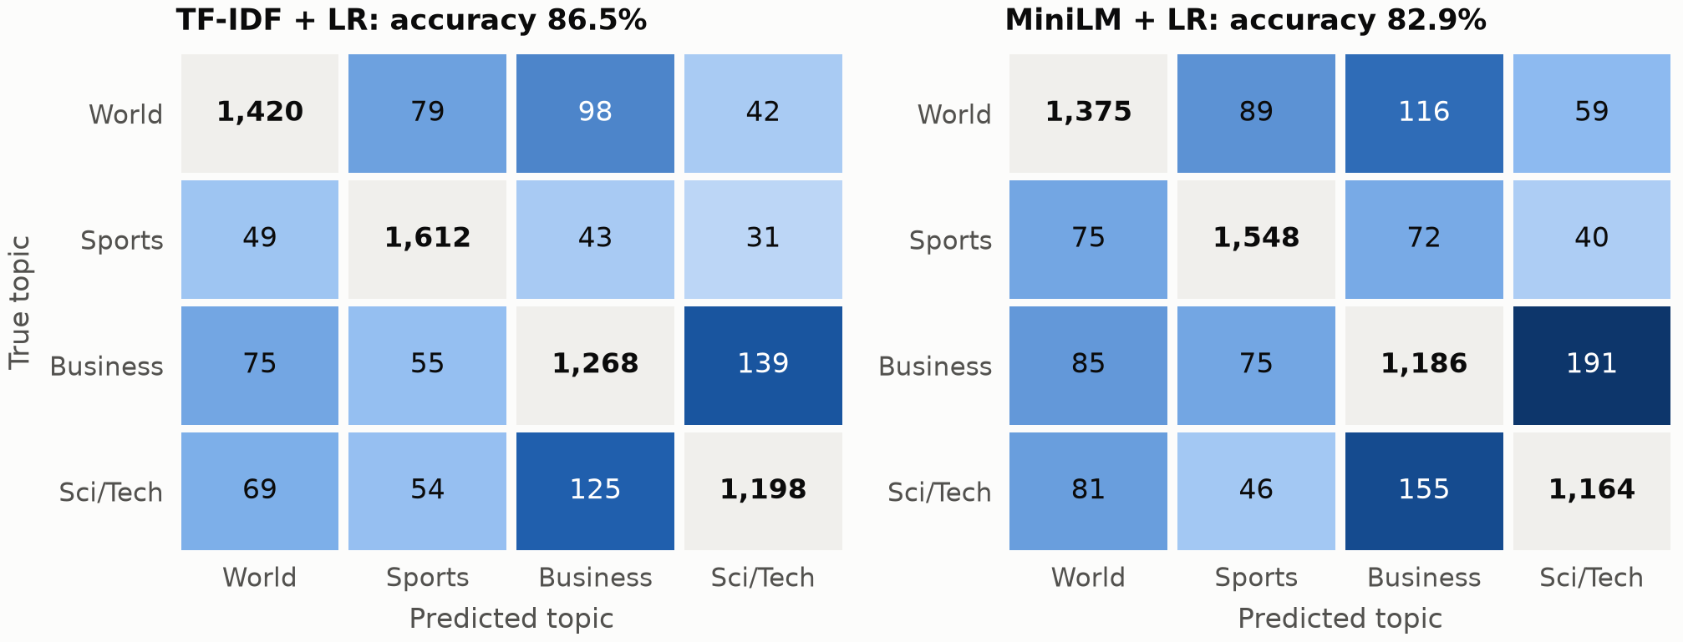
Fig. 2. Test-set confusion matrices. Correct predictions (diagonal) are grey; errors are shaded by count on one shared scale. The darkest cells, Business↔Sci/Tech, are the focus of our question.

B. Answer to the Experimental Question
The approved pretrained method separates Business and Sci/Tech less reliably, not more. It makes 346 Business↔Sci/Tech confusions against 264, that is 82 more (+31%), and its F1 is 5.2 points lower for Business and 3.6 points lower for Sci/Tech (Fig. 3). Because both methods label the same headlines, we use paired tests (Table V): McNemar’s exact test [6] on the headlines where exactly one method is right, and a paired bootstrap [7] with 2,000 resamples for 95% confidence intervals. All intervals exclude zero, and on the 2,983 Business and Sci/Tech headlines TF-IDF alone is right 301 times against 185 (p = 1.6×10⁻⁷). The answer for the approved design is therefore no.
TABLE V
Paired Comparison, MiniLM + LR minus TF-IDF + LR
Quantity | Difference | 95% CI or p
Accuracy (points) | -3.54 | [-4.39, -2.66]
Macro-F1 (points) | -3.56 | [-4.45, -2.66]
F1 Business (points) | -5.21 | [-6.75, -3.69]
F1 Sci/Tech (points) | -3.62 | [-5.16, -2.09]
B↔S/T confusions | +82 | [+50, +116]
McNemar, all (531 vs 306) | – | p = 6.7×10⁻¹⁵
McNemar, B + S/T (301 vs 185) | – | p = 1.6×10⁻⁷
McNemar counts are “only TF-IDF right” vs “only MiniLM right”.
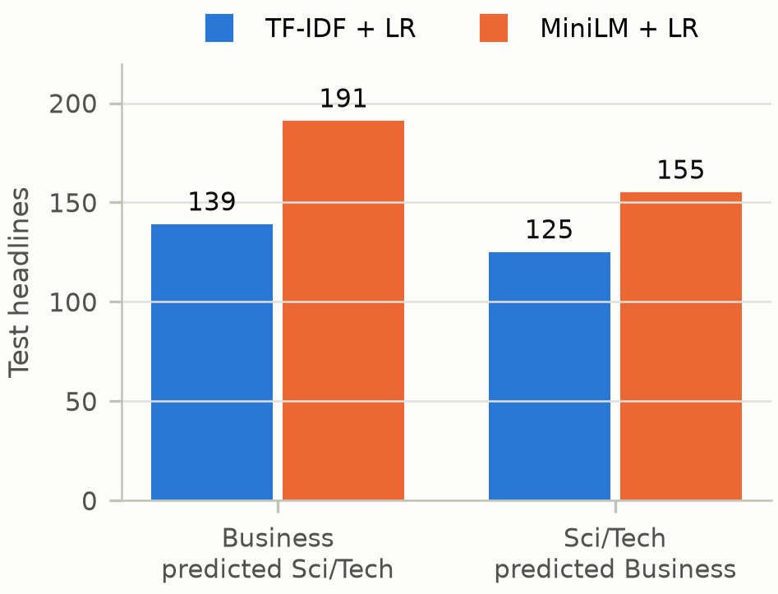
Fig. 3. Business↔Sci/Tech confusions on the test set, by direction.
Why does the pretrained model lose? TF-IDF learns sharp, dataset-specific word cues. In this 2004 news corpus many company and product names belong almost entirely to one class (yukos, enron and treasuries to Business; nasa, linux and firefox to Sci/Tech). The frozen embedding compresses the overall meaning of the headline into 384 numbers. “A technology company did something involving money” lands between the two classes, and a linear classifier on top cannot recover the single word that decides the label.

C. Challenge Factors: Unfamiliar Words and Short Headlines
TABLE VI
Test Accuracy (%) by Challenge Factor
Group | n | TF-IDF | MiniLM | Diff.
No unseen word | 5,173 | 87.9 | 84.1 | -3.8
1+ unseen word | 1,184 | 80.3 | 78.1 | -2.2
1–4 words | 922 | 81.1 | 78.3 | -2.8
5–6 words | 2,458 | 86.0 | 81.6 | -4.4
7–8 words | 1,974 | 88.7 | 84.8 | -3.9
9+ words | 1,003 | 88.3 | 86.9 | -1.4
An unseen word is a word outside the TF-IDF vocabulary (fewer than two training headlines).
The proposal expected the embeddings to help most with names never seen in training. Table VI supports this in part. On the 1,184 test headlines that contain a word outside the TF-IDF vocabulary, both methods drop, but TF-IDF drops more (87.9% to 80.3%) than MiniLM (84.1% to 78.1%). There the difference is no longer significant (McNemar p = 0.09 over all topics; on Business/Sci-Tech headlines 64 against 62 wins, p = 0.93). MiniLM catches up but does not overtake. Very short headlines (1–4 words) are the hardest for both methods, and the gap between them shrinks for the longest headlines (1.4 points at 9+ words), where the embedding has more context to work with.

D. Extra Experiment: Is the Linear Classifier the Bottleneck?
In the error analysis (Section VI-E) we noticed headlines whose nearest training headlines in MiniLM space all carry the correct label while the logistic regression answers wrongly. We therefore replaced the logistic regression with a cosine-weighted k-nearest-neighbour vote [8] over the same frozen embeddings. This was not in the proposal. As with the main methods, k was chosen on the development set (k ∈ {1, 5, 10, 20, 50}; best k = 10, development macro-F1 88.62), and the model was scored once on the test set. It reaches 88.38% accuracy and 88.16 macro-F1, the best of the three, and beats TF-IDF significantly (365 against 245 wins, p = 1.3×10⁻⁶). It also has the best Business and Sci/Tech F1 (84.0 and 86.1), and on Business/Sci-Tech headlines it wins 215 against 146 (p = 0.0003). The number of direct Business↔Sci/Tech swaps, however, is about the same as TF-IDF’s (256 vs 264; the bootstrap interval includes zero). The gain is not only repeated stories: k-NN is ahead both on test headlines that have a very similar training headline (cosine ≥ 0.8: 93.2% vs 92.2%) and on the rest (86.5% vs 84.3%). The pretrained representation therefore does contain more usable topic information than TF-IDF, but the topics form local groups that a linear boundary cannot separate. Because this variant was chosen after looking at errors, we treat it as a finding to confirm rather than as our main result.

E. Error Analysis
TABLE VII
Five Explained Test Errors
Headline | True | TF-IDF | MiniLM
(1) Greenspan: Debt, home prices not dangerous | Sci/Tech | Business | Business
(2) 34 tech firms sued for alleged LCD patent theft | Business | Sci/Tech | Sci/Tech
(3) Exploring Andromeda | Sci/Tech | Business | Sci/Tech
(4) Before the Bell - ESS Technology drops 4.4 pct | Business | Business | Sci/Tech
(5) Yahoo Debuts Mobile Search | Business | Sci/Tech | Sci/Tech

Table VII lists five errors. For each, the notebook shows the evidence each model used: TF-IDF’s strongest n-grams and MiniLM’s nearest training headlines. (1) “Greenspan: Debt, home prices not dangerous” is labelled Sci/Tech, but its words and all its nearest training headlines (e.g. “Greenspan: Don’t Fear US Household Debt, Home Prices”, labelled Business) are about the economy. The label is almost certainly wrong, so some test errors are not model failures. (2) In “34 tech firms sued for alleged LCD patent theft” (Business) the event is a lawsuit, but lcd, patent and tech are strong Sci/Tech cues. The training data contain the same Honeywell LCD-patent story under both labels, so no headline-only model can always be right; this is the overlap we anticipated. (3) In “Exploring Andromeda” (Sci/Tech) TF-IDF knows only the word exploring and guesses Business with 46%. MiniLM knows from pre-training that Andromeda is a galaxy, and its nearest training headlines are about space. This is the case the pretrained model was chosen for. (4) “Before the Bell - ESS Technology drops 4.4 pct” (Business) is right for TF-IDF, which relies on bell, the bell and pct from a recurring pre-market stock column. MiniLM answers Sci/Tech with 96% because of the company name, even though all four of its nearest training headlines are Business “Before the Bell” stories. This is the error that motivated Section VI-D. (5) “Yahoo Debuts Mobile Search” (Business) is a four-word product launch by a technology company. Three of MiniLM’s four closest training headlines are Sci/Tech and a near-identical one is Business, so whether such a story counts as business or technology depends on the source’s editor, not on the words.

F. Check: Keeping the Source Tags
To show why the tags were removed, we retrained the selected TF-IDF model on the same training rows with the tags left in and scored it on the development set, without touching the test set. Development accuracy rises from 87.19% to 87.88%, Business F1 by 1.2 points, and Business↔Sci/Tech confusions fall from 493 to 465. Those points come from the publisher, which a headline-only tool cannot rely on.

G. New Input
TABLE VIII
Our Own Headlines (Not Part of the Test Scores)
Headline | Intended | TF-IDF | MiniLM
Central bank raises interest rates for the third time this year | Business | Business | Business
Astronomers detect water vapour on a planet orbiting a nearby star | Sci/Tech | Sci/Tech | Sci/Tech
Striker scores twice as underdogs reach the cup final | Sports | Sports | Sports
Chip maker’s profit triples on demand for AI servers | Business | Sci/Tech | Sci/Tech
New phone app translates sign language into text in real time | Sci/Tech | Sci/Tech | Sci/Tech
Ceasefire talks resume as aid convoys cross the border | World | World | World

Each member wrote two new headlines (Table VIII). They are kept separate from the test scores and show the saved models working on unfamiliar text. Both models agree with the intended label on five of six. The miss, “Chip maker’s profit triples on demand for AI servers”, was meant as Business (a profit report) but both models say Sci/Tech, the same ambiguity as in the test errors. In the “Try it” cell, empty or blank input prints a request for a headline instead of failing. For example, “Electric carmaker’s shares slide after battery recall” returns Business with 85% (TF-IDF) and Business with 68% (MiniLM).

H. Limitations
(i) AG News labels follow the source’s section, not only the content: the same story can appear under both Business and Sci/Tech, and some labels are plainly wrong. All scores are therefore pessimistic, and no headline-only model can resolve every Business/Sci-Tech case. (ii) The articles date from 2004–2005. Cues such as yukos or enron will not transfer to today’s news, and our six new headlines are only anecdotal evidence about current text. (iii) We used one split and one seed; the paired tests treat test headlines as independent, although some are related stories. (iv) The k-NN variant was chosen after the error analysis and must store all 105,569 training embeddings (about 160 MB) and compare each new headline with them. (v) The encoder was frozen; fine-tuning was beyond our compute budget. (vi) The input must be English.

VII. Conclusion and Future Work
We asked whether, with headline-only input, a pretrained sentence-embedding classifier separates Business and Sci/Tech more reliably than TF-IDF logistic regression. After cleaning AG News and building a duplicate-aware split, we found that the approved design, frozen MiniLM embeddings with logistic regression, does not: it makes 31% more Business↔Sci/Tech confusions and is 3.5 points less accurate overall, a statistically significant gap. Its pretrained knowledge helps on headlines with unseen words, where the two methods tie, but not enough to compensate. A nearest-neighbour vote over the same embeddings beats TF-IDF, which shows that the limitation lies in the linear classifier rather than in the representation.
In practice, the TF-IDF model is a sensible default for a feed reader or newsroom tool: it is small (4.1 MB), fast and 86.5% accurate on unseen headlines. Low-confidence Business/Sci-Tech predictions could be flagged for a human editor. The most realistic improvement suggested by our results is to fine-tune the small MiniLM encoder on the training headlines, so that its embedding space becomes separable for these four labels without storing every training example. Confirming the k-NN result on a second split, or on recent headlines, would be the first step.
Acknowledgment. Parts of this project’s code and text were drafted with the help of an AI assistant (Claude, Anthropic). All members reviewed, ran and verified the code and results and are responsible for the content. The completed team appendix is submitted with this report.

References
[1] X. Zhang, J. Zhao, and Y. LeCun, “Character-level convolutional networks for text classification,” in Advances in Neural Information Processing Systems 28, 2015, pp. 649–657.
[2] N. Reimers and I. Gurevych, “Sentence-BERT: Sentence embeddings using Siamese BERT-networks,” in Proc. EMNLP-IJCNLP, 2019, pp. 3982–3992.
[3] W. Wang, F. Wei, L. Dong, H. Bao, N. Yang, and M. Zhou, “MiniLM: Deep self-attention distillation for task-agnostic compression of pre-trained transformers,” in Advances in Neural Information Processing Systems 33, 2020.
[4] A. Gulli, “AG’s corpus of news articles.” [Online]. Available: http://groups.di.unipi.it/~gulli/AG_corpus_of_news_articles.html
[5] F. Pedregosa et al., “Scikit-learn: Machine learning in Python,” J. Mach. Learn. Res., vol. 12, pp. 2825–2830, 2011.
[6] Q. McNemar, “Note on the sampling error of the difference between correlated proportions or percentages,” Psychometrika, vol. 12, no. 2, pp. 153–157, 1947.
[7] B. Efron and R. J. Tibshirani, An Introduction to the Bootstrap. New York, NY, USA: Chapman & Hall, 1993.
[8] T. M. Cover and P. E. Hart, “Nearest neighbor pattern classification,” IEEE Trans. Inf. Theory, vol. 13, no. 1, pp. 21–27, 1967.
[9] “AG News classification dataset,” Kaggle (uploaded by amananandrai). [Online]. Available: https://www.kaggle.com/datasets/amananandrai/ag-news-classification-dataset

