PEDIATRICS FOCUSED HISTORY TAKING
(MY PROTOCOL)

*WHAT IS FOCUSED HISTORY?

Focused history does not mean taking part of the history and leaving the other parts.

FOCUSED HISTORY IS A FULL DETAILED HISTORY
That helps you to reach a diagnosis to help your patient
NOT JUST FILLING A FORM and the end result is NO THING

*History Taking Techniques:

- Adopt a personal, conversational style and don’t confuse patients and parents with medical jargon.
- When asking specific questions relating to symptoms, avoid leading questions which might compromise the quality of information obtained.

*Top ten technique tips:
1. Give the patient or parents your undivided attention.
2. Keep your note-taking to a minimum when the patient or parents is talking.
3. Use language which the patient or parents can understand.
4. Let patients or parents tell their own story in their own way.
5. Steer patients or parents towards the relevant.
6. Use open questions initially and specific (closed) questions later.
7. Clarify the meaning of any lay terms or diagnoses patients or parents use.
8. Remember that the history includes events up to the day of interview.
9. Summarize (reflect back) the story for the patient to check.
10. Utilize all available sources of information help you to reach a diagnosis.

*History taking Sequence:

(1) PATIENT’S PROFILE
(2) PRESENTING COMPLAINTS
(3) HISTORY OF PRESENT ILLNESS
(4) BIRTH HISTORY
(5) Nutritional HISTORY
(6) IMMUNIZATION
(7) DEVELOPMENTAL HISTORY
(8) PAST MEDICAL HISTORY
(9) FAMILY HISTORY
(10) DRUG HISTORY
(11) SOCIO-ECONOMIC HISTORY

*Factors in establishing rapport:

- Introduce yourself in a warm, friendly manner.
- Maintain good eye contact.
- Listen attentively.
- Facilitate verbally and non-verbally.
- Touch patients appropriately.
- Discuss patient's or parents personal concerns.

I. PATIENT’S PROFILE:

(1) Name.
(2) Age (Date of Birth).
(3) Sex.
(4) Address of parents.
(5) Origen (tripe????).
(6) Date of admission.
(7) Informant.

NB: There is three types of patients :
*Patient with a previously good health presenting with acute problem.
*Patient with chronic problem presenting with acute complaint.
*Patient with chronic problem presenting for follows up.

II. PRESENTING COMPLAINTS:

(Use parents’ own words + chronological order)

When you are dealing with a patient with a known diagnosis, this information should appear before the presenting complaint.

(Example :This patient known to have sickle cell anemia since the age of one year, diagnosed based on HB electrophoresis ,now presenting complaining of ……………….,……………)

*Important questions to ask yourself:
-What is the differential diagnosis of the presenting complaints?
-What is the main part of the history to concentrate on?

(Please don't start history taking before you answer these two questions)

III. HISTORY OF PRESENT ILLNESS

  - Enquire as to when patient was last entirely well?
  - Presenting complaints
    - Time (onset , duration , frequency , course)
    - Place (site)
    - Quality (character e.g. of pain , composition of vomitus)
    - Quantity (severity of pain , amount of vomitus)
    - Provocative / alleviative factors / variations (diurnal or seasonal)
    - Associated symptoms
    - Treatment if any (any doctor consulted or you are the first one to evaluate the patient)

  - Systemic inquiry
When you are dealing with a patient with a known diagnosis, put in your mind the related problems when doing systemic inquiry.
    - General (weight loss , appetite ,level of daily living activity)
    - CVS (shortness of breath on sever exertion or on mild exertion or at rest ,shortness of breath on lying flat , shortness of breath and sweaty on feeding, bluish discoloration, squatting, body swelling ,chest pain /palpitation***)
    - Respiratory system (sore throat, runny nose ,earache or discharge , noisy breathing, cough, wheeze, difficulty breathing)
    - Gastrointestinal system (abdominal pain, vomiting, yellowish discoloration, diarrhea/constipation,)
    - CNS :
*Symptoms of higher function affection: (headache, fits, loss of consciousness, abnormal behavior)
*Symptoms of cranial nerves affection : (loss of vision ,squint, ptosis ,Facial numbness***, mouth deviation , inability to close one eye , ,hearing loss ,difficulty swallowing , drooling of saliva ,nasal tone )
*Symptoms of motor system affection :( weakness, difficulty walking, inability to move any part of the body)
*Symptoms of sensory system affection :( numbness, parasthesia, loss of sensation***)
*Symptoms of increase intracranial pressure: (Headache, blurring of vision, vomiting, photophobia)
*Symptoms of meningeal irritation: (neck or back pain or stiffness)
    - Genitourinary system (stream, Crying during micturition , frequency, nocturia /enuresis, change in urine color ,change in urine odor, flank pain )
    - Rheumatological system (limp, joint swelling, hair loss, skin rash)

IV. BIRTH HISTORY:
- When to take it in details?
- Neonates and young infants.
- Genetic diseases.
- When the cause seems to be related to pregnancy or delivery.
- Child present with developmental delay.

      - ANTENATAL HISTORY (H/O PREGNANCY)
      - FIRST TRIMESTER:
(1) Health and nutritional status of the mother.
(2) X-ray (h/o irradiation).
(3) Drugs (folic acid, other drugs).
(4) Infections (fever, rashes, jaundice or contact with patient with such infections)
(5) Follow up, early scan?
      - SECOND TRIMESTER:
(1) Health and nutritional status of the mother.
(2) Illness during pregnancy (HTN, DM, others)
(3) Iron and folic acid and calcium supplement.
(4) Fetal movements, anomaly scan.
(5) Follow up and maternal vaccination against tetanus.

      - THIRD TRIMESTER:
(1) Health and nutritional status of the mot
(2) Illness during pregnancy (HTN, DM, others)
(3) Iron and folic acid and calcium supplement.
(4) Drainage of liquor, vaginal discharge or UTIs.
(5) Infections (fever, rashes, jaundice or contact with patient with such infections).
(6) Follow up.

Past obstetric (problems with previous pregnancies, stillbirths, miscarriages, birth weight of previous children, prematurity, blood transfusions)

      - NATAL HISTORY (H/O DELIVERY)

- Place of delivery (hospital/home)
- Conducted by (midwife /trained health visitor/doctor)
- Gestation age at delivery.
- Time of rupture of membranes
- Labour time (duration)
- Fever during labour.
- Smelly liquor.
- Mode of delivery (SVD, forceps, vacuum extraction or C-section)
- Sedation/analgesics during labour
- Complications (abnormal bleeding)

      - POSTNATAL HISTORY

- 1ST cry (immediately or delayed and for how long)
- Basic problems (need for resuscitation, problem with respiration)
- Breast fed immediately (problems with suckling and swallowing)
- Birth weight
- Birth injury
- Pass urine and meconium in the first 24 hour.
- Need for NICU admission(Convulsions, cyanosis, jaundice, fever, rash)

V. NUTRITIONAL HISTORY:

When to take it in details?
- Child < 2 years.
- Child present with failure to gain weight (malnourished).

- Onset of feeding (after how many hours)
- Type of feed
  - Breast-fed.
*How frequent (At least 8 times /day).
*Night feeding.
*Duration of each feed. (Not less than 20 min or until satisfaction)
*Both breasts each feed.
*Sign of satisfaction (sleep for at least one hour, calm after feed, gaining weight).
*Exclusive or not (ask about water specifically).

  - Bottle-fed ( Why ????,at what age, composition of formula, amount, frequency, dilution)

3) Supplementary feeding:
*When started: (6 months, at 4 months only if: (1) not satisfied. (2) Not gaining weight (3) show interest in food.)
*What type of food: ((1) milk and milk products are not good starting food (2) fruits vegetables and beans are good choice (introduction of one type of food every week to avoid allergies and food intolerance)
* How many meals/day? (2-3 meals till the age of 9 months increase the number of meals gradually; by the age of 2 years the number of meals should be 3 main meals + 2 snacks/ day at least).
*Separate meal or shared with other family members?
*Who feed the child (either fed by the mother or observed during feeding, to be encouraged)?
*When breast feeding stopped
- Current diet/change in diet during illness

VI. IMMUNIZATION:
When to take it in details?
- Child < 5years.
- Child present with one of the immunizable disease.

1) Check vaccination card or ASK:
2) When started (BCG, zero dose of polio vaccine)
3) How many visits, time of each visit.
4) Ask about each vaccination visit (how many vaccines the child receive during each visit).
5) Side effect of each vaccine, if any.
6) Last dose of vitamin A.
7) How many boosters of polio vaccine.
8) Disease specific related vaccines (DM and influenza virus vaccine, SCA and pneumococcal vaccine)

VII. DEVELOPMENTAL HISTORY:

When to take it in details?
- Child present with developmental delay.
- Previously normal child, who regress after the current illness.

*PLEASE DON'T ASK SCATTERED QUESTIONS.
Gross motor skills:
- Head support.
- Rolling from back to front and from front to back.
- Sits supported.
- Sits unsupported.
- Crawl.
- Pull to stand.
- Cruise.
- Walk independently.
(Till you reach the developmental age of the child, then ask yourself, is it appropriate for age or not?)

Vision and fine motor skills:
- Fix and follow.
- Reaches for objects.
- Mouthing.
- Transfers from hand to hand.
- Throws.
- Scribble. Till you reach a developmental age

Hearing and speech:
- Startled by sudden noise quietens to human voice.
- Plays with voice.
- Turns to sound
- Responds to name.
- Mama, baba non-specifically.
- Says wards. Till cretin developmental age.

Social development:
*Dressing and undressing:
- help with dressing by arms.
- help with dressing by legs.
- Remove pants.
- Remove shoe.
- Dress with help.
*Toilet training:
- In nappies.
- Indicate wants.
- Go to toilet with prompting.
- Dry by day.
*Feeding and drinking:
- hold a piece of bread or biscuit.
- Drink from a cub with miss.
- indicate wants.
- Lift a cub, drink and put it again.
- Feed self easily.
*Play and behavior:
- Social smile.
- Respond to interactive play.
- Stranger anxiety.
- Explore environment without fear.
- Imitate adult activity.
- Temper tantrums.
- Play beside kids, but not with them (never share toys).

*Then give in a clear way the developmental age of the child in each area of development, and comment is this child is developmentally normal or not.

*Then ask about the effect of the illness on the child's development. What happen after this illness?

(Example: the child regresses regarding his gross motor and fine motor skills to the age of 6 months, no regression regarding hearing and speech or social development)

VIII. PAST MEDICAL HISTORY:

1) History of similar complaints in the past.
2) Significant illness in the past.
3) History of hospital admission, Blood transfusion or surgery.
When you are dealing with a patient with a known diagnosis, take brief history about the first diagnosis:
- When was the first diagnosis?
- What was the presentation at that time?
- Investigation done to reach the diagnosis.
- Need for referral or consultation?
- Follow up since that time? (Till the day of the new presentation).
- Frequency of hospital admission, Why?

IX. FAMILY HISTORY:

(Important in chromosomal, hereditary, infectious diseases)

- Name and age of mother, age of the father? How long married?
- Consanguinity ***
- Parents’ health (present and past)
- Siblings
  - Number
  - Age and sex
  - Illness (similar condition or others)
  - Any death (cause if known or symptoms of illness before death)
  - Stillbirths, miscarriages

- Grand parents’ health (esp. if living with family)
- Health of uncles, aunts and their children ,any similar condition (if inherited disorder suspected)
- DO MAKE A FAMILY pedigree ***
Pedigree symbols

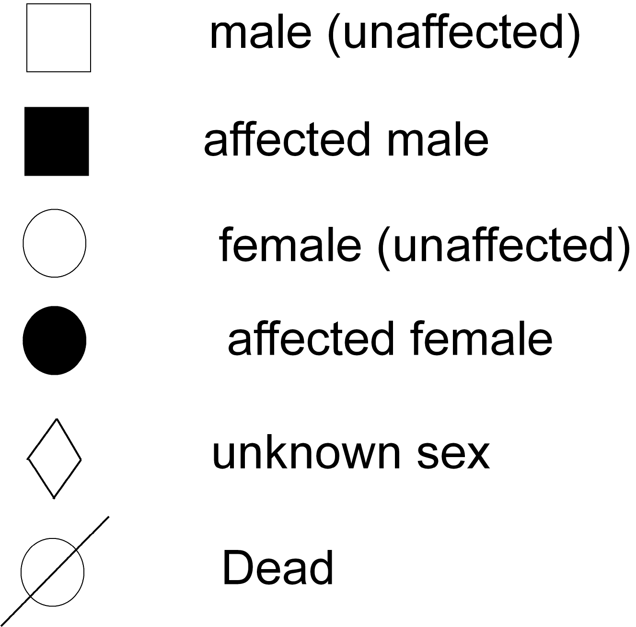

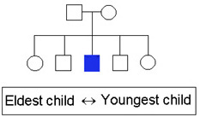

X. DRUG HISTORY:

- Any medications used (frequency, dose, adverse effects)
- Allergy to any drug
- H/o Mom drug usage ** (in neonate or breast fed baby)

XI. SOCIO-ECONOMIC HISTORY:

- Parents’ education and occupation
- Family income
- House (made of, persons living)
- Cleanliness and general hygienic conditions
- Source of drinking water
- Electricity
- Any pets at home
- Effect of the disease:
*The child:
-Schooling.(frequent absence ,academic achievement)
-Psychologically (takes medicines in school, depressed mood, loss of friends, low self-steam)
*The parents:
-Socially (Marriage stability, who takes care of other kids, who help her to take care of the her child)
-Financially (health insurance)
-Psychologically (fear of future)
*The sibling:
-Financially.
-Sibling rivalry.
-Life style restrictions (diabetes, asthma, celiac disease)
9) Coping strategies:
-Education about their child's problem.(DM ,celiac disease)
-Health insurance.
-Remove carpets and animals in asthma.
-Home nebulizer or inhaler and spacer device.
-Remove animals.
-Refrigerator for insulin.
-A car to reach the hospital in emergencies.

